Explanatory notes on changes proposed by the Secretariat to the Commission VMS Standard Operating Procedures (SOPs) - these are draft changes for discussion and consideration through the VMS SWG (as at 16 July 2021)
Table 1 below provides an overview of changes the Secretariat is proposing be made to the document compared to the currently-in-force version of the VMS SOPs (Dec 2018 - https://www.wcpfc.int/doc/commission-vms-standard-operating-procedures), and considering some of the discussion with the VMS-SWG Co-Chairs. Where changes in the SOPs were editorial, the revised SOP text remains in black, and a brief note may also be included in the table below. Where there are additions or changes in the SOPs that are more substantive, brief notes about the change are included in the table below and the new or changed SOP text will be coloured red. Highlighted text reflects text that may likely be updated prior to TCC17.
Table 1. Notes on changes proposed by the Secretariat to the VMS SOPs - as at 28 June 2021
Section 2 Overview | Non-substantive edits and tidying of formatting in the introductory section.  Add new Section 2.4 Update of these SOPs: As there are a number of statements throughout that mean an update will be required sooner rather than later. The reference to section 6.9 of the VMS SSPs is to provide clarity about the process for amending and reviewing the SOPs.
Section 3 - VMS Software applications | 3.1 Trackwell - non-substantive edits to improve the clarity of the description of the Trackwell system and its key features for Secretariat and CCM VMS Operators. Section 3.3 Monitoring view was merged into this section.  3.2 Manual reporting - addition of a placeholder note from the Secretariat providing updates on work that is currently in progress.  Add new Section 3.4 VMS Reporting Status Tool (VRST):
Section 4 Operational Procedures | Add new overview to provide the list of subsections under Section 4.
4.1 Trackwell - VMS Client User Access | Add “Trackwell” to the heading for clarity.  Replace text related to password requirements, with a placeholder note from the Secretariat providing updates on work that is currently in progress.
4.2 Vessel Tracking Data to be submitted by CCMs (VTAF) | Replacement of “type approved by the CCM” with “on the WCPFC Approved ALC/MTU List”.  Add that VTAF for vessels on FFA Good Standing List will be held on file by the Secretariat.  Replace references to “FFA Vessel Register” with “FFA Good Standing List”
4.3 MTU/ALC Activation procedure for WCPFC VMS | Update the list of WCPFC VMS gateways  Add a new sub-title “Vessel activation procedure for specific gateways”  Add new VMS activation procedures:  * Inmarsat BGAN  * Iridium  * Iridium (mini Leo)  * Iridium SBD  * Skywave - with a placeholder note from the Secretariat providing updates on what is currently possible.
4.4 VMS Reporting Status Tool (VRST) | New section that explains the current functionality of the VRST, and how it is intended to provide updates for CCMs on the VMS Reporting Status of their vessels, including FFA Good Standing Status, CCM updates on whether the vessel is in port or outside the Convention Area, progress of MTU activations by the Secretariat and confirming VMS reporting
4.5 Manual Reporting | addition of a placeholder note from the Secretariat providing updates on work that is currently in progress.
4.6 Routine Reports from the Secretariat on VMS reporting anomalies and WCPFC VMS | Modification of first paragraph to refer to Section 4.4 on VRST
4.7 Secretariat processes to identify and follow-up on VMS reporting issues | New section that explains the Secretariat procedure to identify and follow-up on VMS reporting issues
4.8 Proposals for Inclusion of Additional ALC makes and models on the Approved MLC/ALC List | Expanded to more clearly explain the Secretariat procedure to process requests for MTU approval. This includes the addition of a new Annex providing a checklist and associated process for the Secretariat.
4.9 Removal of ALC/MTU from the Approved ALC/MTU List | New section that explains the Secretariat procedure and provides a cross-reference to the new checklist procedure for the Secretariat.
4.10 Commission VMS Helpdesk Support | Updates made

Commission VMS Standard Operating Procedures
(SOPs)
1. Version notes
Version | WCPFC decision reference | Description of updates | Effective date
1.0 | WCPFC6 | Approved by the Commission of the SOP, as per requirement of VMS SSPs section 6.9 | Feb 19 2010
2.0 | WCPFC15 | Updates made to include versioning and to streamline and improve the focus of the SOPs and better reflect current Secretariat practices including reference to the present VMS service provider/s | Feb 13 2019
3.0 | DRAFT – for review by VMS-SWG prior to consideration by TCC17 | Update made to clarify current procedures for adding and removing ALC/MTU on the approved list. Additional functions to resolve non-reporting and MTU approval checklist | Proposed Feb 08 2022
2. Overview
The WCPFC operates a Vessel Monitoring System (Commission VMS) to assist in the management and conservation of highly migratory fish stocks in the Western and Central Pacific Ocean.
In December 2008, a Service Level Agreement (SLA) was formalised with FFA for the provision of the WCPFC VMS services. The contracted system that provides VMS information to the FFA VMS and the WCPFC VMS systems is referred to as the “Pacific VMS”. The WCPFC VMS came into operation on April 1, 2009.
The approved structure of the WCPFC VMS system allows vessels to report to the WCPFC through two ways: i) directly to the WCPFC VMS, or ii) to the WCPFC through the FFA VMS. In respect of the latter, it is recognized that there may be additional requirements for VMS reporting which arise from FFA requirements and national VMS requirements that are relevant.
The WCPFC has more than 3,000 WCPFC-registered vessels that report to the WCPFC VMS through the Pacific VMS. In addition, the WCPFC VMS receives, through the SLA with FFA, high seas VMS information relating to FFA-registered vessels.
The Commission VMS requires the use of Mobile Transceiver Units (MTUs)/Automatic Location Communicators (ALCs) that are on the Commission’s approved list of MTU/ALC. This list is based on the Secretariat’s assessments of ALCs against minimum standards for the Commission VMS. These standards are set out in Annex 1 of CMM 2014-02 (or its successor measure) and WCPFC SSPs. The Secretariat assess whether the ALC make and model has the ability to successfully report to the Commission VMS.
2.1 Purpose of these Standard Operating Procedures
These standard operating procedures (SOPs) have been developed to provide uniform guidance for Commission personnel in the management and operation of the Commission VMS.
2.2 Specific Commission Decisions and Guidelines governing the Commission VMS and access to VMS data
- Rules and Procedures for the Protection, Access to, and Dissemination of Data Compiled by the Commission (2007 data RaP) – December 2007;
- Service Level Agreement (SLA) with FFA for the provision of the WCPFC VMS services – December 2008 (WCPFC VMS came into operation on April 1, 2009);
- Rules and Procedures for the Protection, Access to, and Dissemination of High Seas Non-Public Domain Data and Information Compiled by the Commission for the Purpose of Monitoring, Control or Surveillance (MCS) Activities and the Access to and Dissemination of High Seas VMS Data for Scientific Purposes. (2009 MCS data RaP) – December 2009;
- WCPFC Standards Specifications and procedures (SSPs) for the fishing vessel monitoring system (VMS) of the Western and Central Pacific Fisheries Commission (WCPFC) – December 2018 (or its update);
- WCPFC Agreed Statement describing Purpose and Principles of the WCPFC VMS – December 2011;
- WCPFC9 decision regarding application of Commission VMS to national waters of Members (WCPFC9 Summary Report paragraph 238) – December 2012;
- Conservation and Management Measure for the Commission VMS – CMM 2014-02 (or its replacement CMM) – December 2014;
- WCPFC VMS Reporting Requirement Guidelines – May 2018 (or its update); and
- The last update of the list of approved MTU/ALCs can be accessed from the website: https://www.wcpfc.int/vessel-monitoring-system
2.3 General Information Security Policy and Administrative Procedures for the Secretariat
The Secretariats WCPFC Information Security Policies and Guidelines, as well as Administrative Procedures apply to the administration and access to the Commission VMS.

2.4 Update of these SOPs
VMS SSPs 6.9 states: “A set of Standard Operating Procedures, elaborated by the Secretariat, and subject to approval by the Commission on the recommendation of the TCC, will be developed to deal with all operational anomalies of the VMS, such as interruption of position reports, downloading of DNIDs and their equivalent and responding to reports providing incoherent data (e.g. vessel on land, excessive speed, etc.).” In 2021, the Secretariat is in the process of enhancing the VMS procedures, and online user experience and helpdesk. For this reason, this document will be reviewed no later than TCC18 in 2022.
3. VMS Software Applications
3.1 Trackwell
The Trackwell VMS user interface is implemented as a suite of web modules selectable from the main menu.
The main modules are:
- Monitoring - Secretariat and CCM VMS operators main view;
- Vessel – the vessel registry database synchronized with the Record of Fishing Vessels (RFV)
- Events and Actions – used to define the events to be monitored and the actions to be taken when an event occurs;
- Reports – provide a list of pre-programmed reports for Secretariat and CCM VMS operators eg. A count of position reports per day by area per month or a date range; and
- Live Map – An interactive map display showing vessels’ position and zones in near real-time.
The Monitoring View is the operator’s main view. All important events and alerts handled by the system are listed in this view as issues. An operator can select an “Issue” to work on or record actions taken in relation to the selected issue until it is closed.
3.2 Manual Reporting
Vessels are expected to report their positions automatically. The Commission VMS does not presently have a capability to automatically upload manual positions (eg in the case of MTU/ALC failure). Discussions are underway with TrackWell on enabling a facility for CCMs’ vessels to submit manual position reports to the Commission VMS via email. Updates are expected prior to TCC17.
3.3 VMS Reporting Status Tool (VRST)
Since 2020, through the development of the VMS Reporting Status Tool (VRST), the Secretariat provides a fully automated report for each CCM to review, in more detail, the reporting status for all their vessels. The reporting status provides a daily snapshot of whether each vessel on the RFV is meeting its Commission VMS requirements. These requirements are met by direct reporting to the Commission VMS or through reporting via the FFA VMS (based on FFA Good Standing List). For any vessel not reporting, the daily snapshot should assist to indicate whether WCPFC has completed the necessary steps to activate its MTU to report to the Commission VMS, and if so, the VRST provides a generic current vessel status (e.g., “OK” or “STOP”) for each of their vessels and a daily VMS-reporting status (how many position reports are transmitted by each vessel each day for the past 14 days). The data can be exported to a file in CSV format for each report.
The VRST was enhanced in 2021 giving CCMs the ability to update VRST data to inform the status for non-reporting vessels.
4. Operational Procedures
This section contains ten (10) subsections:
- Trackwell - VMS Client Tool;
- Vessel Tracking Data to be submitted by CCMs (VTAF);
- MTU/ALC Activation Procedure for WCPFC VMS;
- VMS Reporting Status Tool (VRST);
- Manual Reporting;
- Routine Reports from the Secretariat on VMS reporting anomalies and WCPFC VMS;
- Secretariat processes to identify and follow-up on VMS reporting issues;
- Proposals for Inclusion of Additional ALC makes and models on the Approved MLC/ALC List;
- Removal of ALC/MTU from the Approved ALC/MTU List; and
- Commission VMS Helpdesk.

4.1 Trackwell - VMS Client User Access
The VMS Manager can provide user access to the Commission VMS to an individual user on request from an authorised CCM official.
The Commission VMS is configured so that each user has a unique login ID and password which can be changed at the discretion of the user.
The system is being integrated with the WCPFC website user accounts which will allow Party Administrators to give access to the Commission VMS. Users will have a single user account and password across all WCPFC systems in a manner consistent with the WCPFC Information Security Policy and associated rules.
4.2 Vessel Tracking Data to be submitted by CCMs (VTAF)
The flag CCM is to submit all necessary data to complete its data file in the Commission’s VMS database, in respect of all vessels authorized to operate in the WCPFC Convention area. In accordance with the VMS SSPs, this data will include the name of the vessel, unique vessel identification number (UVI) [* if and when adopted by the Commission], radio call sign, length, gross registered tonnage, power of engine expressed in kilowatts/horsepower, types of fishing gear(s) used as well as the make, model, unique network identifier (user ID) and equipment identifier (manufacturer’s serial number) of the ALC that vessel will be using to fulfil its Commission VMS reporting requirements.
To facilitate the submission of necessary vessel tracking data for each vessel required to report to the WCPFC VMS, the Secretariat has provided a guideline Vessel Tracking Agreement Form (VTAF) to enable activation and automatic tracking of the vessel through WCPFC VMS. VTAFs of vessels already reporting to FFA VMS will not be activated and may not need to be provided but if submitted, can be filed in case the vessel needs to have the ALC activated to report to WCPFC VMS system (should the vessel no longer report to the FFA VMS system).
A copy of the guideline VTAF form is appended at Annex A.
When updated or new VTAF data is received from a CCM, the following initial steps are to be taken by the Secretariat:
- acknowledge receipt of the VTAF by e-mail to the CCM official who sent it.
- check that the VTAF data is completed correctly. Any incomplete VTAF data will be referred back to the CCM official who sent it.
- check that the MTU/ALC described in the VTAF is on the WCPFC Approved ALC/MTU List. If not, advise the CCM official accordingly.
- if the MTU is on the WCPFC Approved ALC/MTU List, then check the FFA Good Standing List to determine if the vessel is listed. If it is listed, the MTU will be held on file by the Secretariat and no further action required. The vessel will be monitored when it enters waters of the WCPFC Convention Area covered by the WCPFC VMS.
- If the vessel is not listed on the FFA Good Standing List then its MTU/ALC must be activated to report directly to the Commission VMS (see Section 4.3 below).
4.3 MTU/ALC Activation procedure for WCPFC VMS
Vessels not listed on the FFA Good Standing List will be activated to report directly to WCPFC VMS once a VTAF or information required under Paragraph 2.9 of the Commission VMS SSPs is provided in full.
The following procedures are to be followed by the Secretariat for such vessels:
- Secretariat to enter VTAF data as a new record in MTU Update request (see Figure 1).
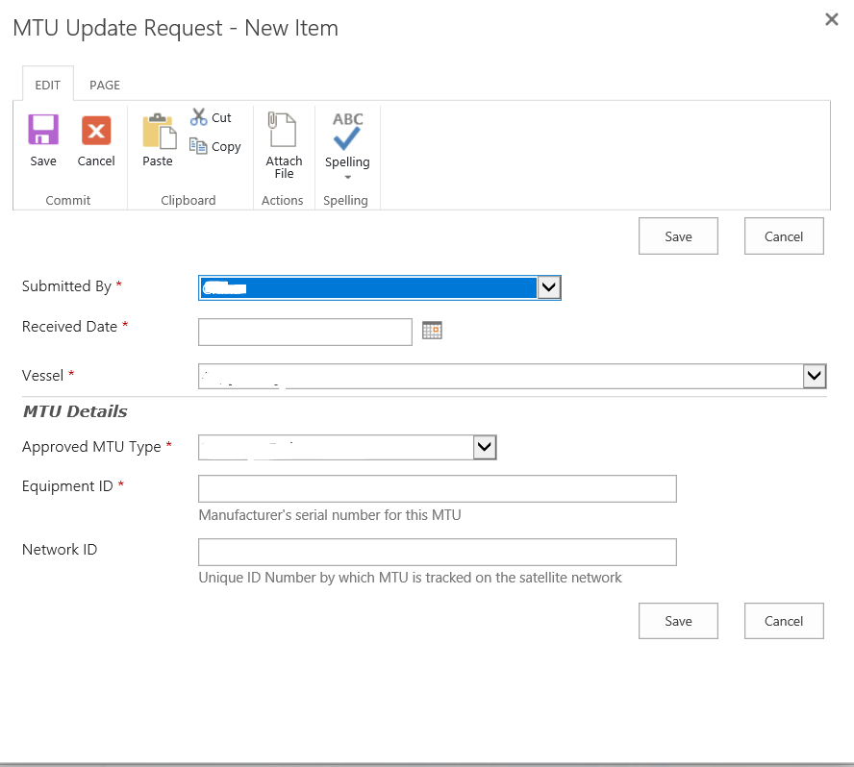
Figure 1
- Secretariat to follow activation procedure that is specific to the gateway for the MTU/ALC (see below). The following details must be provided for all activation requests:
1. Vessel Name
2. Reg No
3. IRCS
4. Vessel Type
5. Flag
6. Approved MTU Type
7. Equipment ID
8. Network ID
- If activation was successful, Secretariat to advise CCM, via email that the vessel has been activated to report. The Secretariat to complete internal procedure so that MTU update request form is completed to show “MTU Update Request Completed OK”. This provides advice to Trackwell VMS system that the vessel MTU details have been confirmed and are activated to report to WCPFC VMS.
- If activation was not successful, the Secretariat to request the CCM official to check the vessel’s MTU/ALC, rectify any anomalies with the MTU/ALC or VTAF data and inform the WCPFC Secretariat of when the vessel is ready for activation.
- On receipt of the advice by the CCM that the MTU/ALC is ready for a second activation attempt, the Secretariat to activate the vessel on the system again.
- If the MTU/ALC activation fails on the second attempt, the Secretariat to notify the CCM and draw to the CCM’s attention that vessel position reports shall be provided by the vessel on a manual basis, as required by the Commission VMS SSPs.
Vessel activation procedure for specific gateways:
WCPFC VMS has gateways for the following services:
- Argos
- Faria Watchdog
- Halios – CLS MTUs using the Iridium service
- Inmarsat BGAN – for iFleetONE MTUs
- Inmarsat C
- Iridium – for insight X2 EMTU (Nautic Alert)
- Iridium (mini LEO) - for BB3 & BB5 MTUs (SASCO)
- Iridium SBD – for iTrac II (MetOcean Telematics) and RomTrax Wifi (Rom Communications)
- SkyMate
- Skywave – currently operational for Chinese Taipei vessels using IDP-690, and for Australia vessels for IDP 6100 and 690 units.
ARGOS
Argos MTUs installed post WCPFC14 decision are no longer accepted for activation. Therefore, if a CCM contact requests activation of an Argos MTU, the Secretariat to draw to the CCM’s attention to the WCPFC14 decision and that vessel position reports shall be provided by the vessel on a manual basis, as required by the Commission VMS SSPs, until a suitable ALC may be installed and activated.
FARIA WATCHDOG:
Faria MTUs and the vessel’s details are to be sent to SpeedCast (support.mss.apac@speedcast.com) with a request to provide Faria 4-digit unique MTU Id made on activation. The outcome will be advised by the Secretariat to the CCM contact⁵.
HALIOS
List of vessels with Halios MTU/ALCs to be activated should be sent by the Secretariat to CLS-OCEANIA (hspencer@groupcls.com). CLS-OCEANIA will then advise the Secretariat whether activation is successful or not. MTU reporting status may also be verified through the CLS portal application - https://mydata.cls.fr/iwp/Main.do.

INMARSAT C
For Inmarsat C MTUs, activation is done at the Secretariat using a web application developed by SpeedCast (see Figure 2, below).
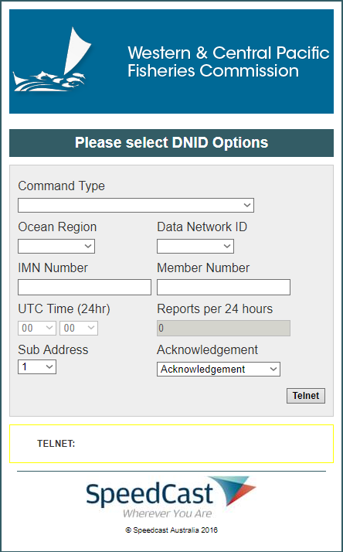
If activation was not successful then the Secretariat to advise CCM Official of why the activation was unsuccessful, which may include:
- Unknown mobile number
- Mobile logged out
- Mobile is not in the Ocean Region
- DNID sent to vessel, but vessel did not send acknowledgement to Commission VMS;
- Program sent to vessel but vessel did not send acknowledgement to Commission VMS; or
- Start Command sent to vessel but vessel did not send acknowledgement to Commission VMS.

Figure 2
Inmarsat BGAN
Activation request for iFleetONE MTUs are sent to Addvalue (weehong.ng@addvalue.com.sg). Addvalue will then advise the Secretariat if activation is successful or not.
IRIDIUM
Activation request for insight X2 EMTU is to be sent to Nautic Alert via email: nfvelado@nauticalert.com. Nautic Alert will then advise the Secretariat if activation is successful or not.
IRIDIUM (mini LEO)
Activation request for Sasco BB3 & BB5 MTUs are to be sent to SASCO email: chuck@sasco-inc.com. SASCO will then advise the Secretariat if activation is successful or not.
IRIDIUM SBD
This is a gateway service for iTrac II and RomTrax Wifi MTUs.
Activation of iTrac II MTU are to be sent by the Secretariat to MetOcean Telematics (service@metocean.com). MetOcean Telematics will then advise the Secretariat if activation is successful or not.
Activation RomTrax Wifi are to be sent by the Secretariat to Rom Communications (michael@romcomm.net). Rom Communications will then advise the Secretariat if activation is successful or not.

SKYMATE
For skymate MTUs, the vessel’s details as above are to be sent by the Secretariat to Skymate (williamricaurte@navcast.com). Skymate will then advise the Secretariat if activation is successful or not.
SKYWAVE
For vessels flagged to Chinese Taipei and equipped with IDP-690 MTUs the current process between the Secretariat and ORBCOMM is as follows:. Chinese Taipei will activate the MTU on submission of the VTAF for IDP-690. If an MTU activation required, an email request will be sent to Deep Sea Fisheries Division (hsiangyi@ms1.fa.gov.tw). The Secretariat is following up with TrackWell whether the current gateway setup can accept IDP-690 position reports from other ORBCOMM Solution Providers. Updates are expected prior to TCC17.
Australia has finalized steps with the Secretariat and its service provider to facilitate the Secretariat to receive position reports from vessels equipped with IDP-690 and IDP-6100 MTUs. Australia will provide an update to CCMs prior to TCC17 to outline the steps taken to achieve facilitate reporting.

4.4 VMS Reporting Status Tool (VRST)

Access to the VRST is granted to WCPFC website user accounts by assigning one of the following two roles:
- VMS Viewer - provides read-only access to the VRST.
- VMS Editor – provides VMS Viewer access plus it allows the user to update the reporting status of vessels not reporting.

The roles can be assigned by a CCM Party Administrator, or upon CCM request, the Secretariat can assist in managing user accounts on behalf of a CCM. More information on managing roles can be found in the Party Administrator Guide on the WCPFC knowledgebase - https://wcpfc.freshdesk.com/

The VRST provides the authorized CCM contact a daily snapshot of whether each CCM vessel on the Record of Fishing Vessels is meeting its Commission VMS requirements. The VRST is updated each day at 1am UTC. There are currently four parts to the VRST (see Figure 3 below):

- Information

The “Information” tab of the VRST provides explanatory information about the VRST.

- All Vessels

The "All Vessels" tab of the VRST is in response to the WCPFC12 task and provides the latest WCPFC VMS reporting status for every vessel on the Record of Fishing Vessels (RFV).

- CCM Vessels

The "CCM Vessels" tab of the VRST lists only RFV vessels flagged to the CCM, viewable only by that CCM’s authorized contact.

The CCM Vessels tab provides CCMs with a daily snapshot of whether each of their vessels on the RFV is meeting its Commission VMS requirements. If a vessel is not on the FFA Good Standing List, the VRST provides an indication of whether WCPFC has completed the necessary steps to activate the vessels MTU to report to the Commission VMS, and if so the VRST provides a generic current vessel status (e.g., “OK” or “STOP”) for each of their vessels and a daily VMS-reporting status (how many position reports are transmitted by each vessel each day for the past 14 days).

For vessels that are not on FFA Good Standing List, the VRST will display the following status
to the vessels based on reporting and CCMs advice.

- ‘ACTR’ – VTAF info received and in the process of activation by the Secretariat.
- ‘In Port’ – based on advice from CMMs that the vessel is in port and MTU is powered down.
- ‘OK’ – the vessel’s MTU is reporting correctly to WCPFC VMS. No action required.
- ‘Outside the WCPFC Convention Area’ – based on advice from flag CCM, the vessel is operating outside of the Convention area and is not reporting to WCPFC VMS.
- ‘STOP’ – The vessel has stopped reporting. Secretariat staff to work with Flag CCM to resolve the non-reporting issue.

- Non-Reporting Vessels

The “Non-Reporting Vessels” tab of the VRST is a subset of the CCM Vessels tab list providing a list of vessels from which the expected VMS data is not being received.

For each vessel that is not reporting to the WCPFC VMS, authorized CCM users are able to update the status to ‘In Port’ or ‘Outside the Convention Area’ and the date the status took effect. When VMS data is received by the WCPFC VMS, the status will be automatically reset to ‘OK’.


Figure 3

4.5 Manual Reporting
Since 1 March 2013, the Commission has agreed to regular extensions of amendments to the SSPs related to the reporting timeframes for manual reporting in the event of ALC malfunction. A standard reporting format for these manual reports has been previously agreed as is required by the WCPFC Standards Specifications and procedures (SSPs) for the fishing vessel monitoring system (VMS) of the Western and Central Pacific Fisheries Commission (WCPFC) – December 2016 (or its update).
CCM vessels that fail to report to the Commission VMS must commence manual reporting not later than the time specified in the SSPs (generally not later than 30 days from the date the VRST shows that the MTU stopped reporting positions) unless the CCM contact has provided an appropriate and accurate update of the MTU status (either via the VRST directly, or by email to the Secretariat VMS staff).

Manual reports should be sent to email: VMSManualReports@wcpfc.int
The Secretariat is following up with TrackWell on manual reports upload via an email parser to the TrackWell system. Updates are expected prior to TCC17.
The first manual report received from a vessel will be recorded in the WCPFC Intranet – VMS Manual Report (see Figure 4 below). This record will remain open until the vessel resumes normal VMS reporting.

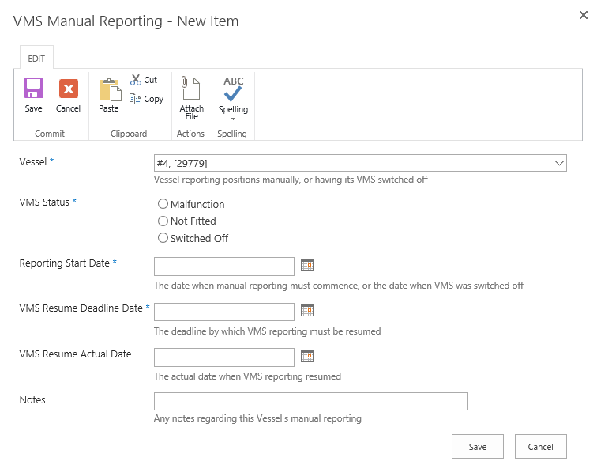
Figure 4

All manual position reports should then be entered in the VMS Manual Reporting database (Figure 5).

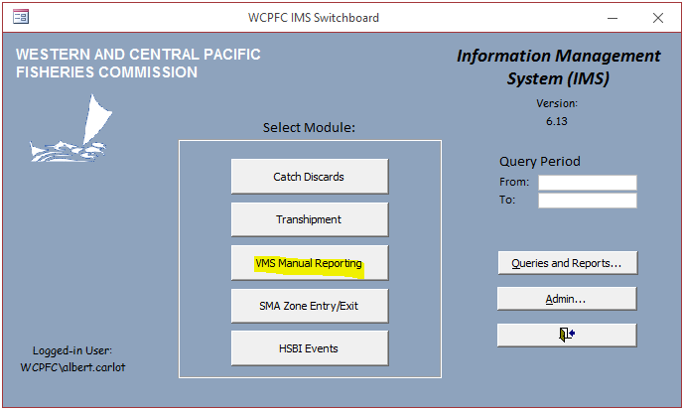
Figure 5

The vessel may recommence fishing on the high seas only when the MTU/ALC has been confirmed as operational by the WCPFC Secretariat following the flag CCM informing the Secretariat that the vessel’s automatic reporting complies with the regulations established in the Commission VMS Standards, Specifications and Procedures (SSPs).

4.6 Routine Reports from the Secretariat on VMS reporting anomalies and WCPFC VMS
As was explained in Section 4.4, the VRST tool, which is accessible by authorized CCM users, provides CCMs a daily snapshot of whether each of their vessels on the RFV is meeting Commission VMS requirements.
The following reports are provided to TCC annually:
- Annual Report on the Commission VMS;
- Review of integrity of the Secretariat’s VMS data
- Annual Report on the administration of the data rules and procedures.
Ad hoc reports may be generated on request and following necessary approvals in accordance with the data rules and administrative procedures.

4.7 Secretariat processes to identify and follow-up on VMS reporting issues
The Secretariat will routinely check on the VMS reporting status of vessels when there is a change to their listing on FFA Good Standing List and take appropriate action:
- If a vessel that has its MTU activated to report directly to WCPFC VMS is subsequently listed on the FFA Good Standing List, WCPFC Secretariat VMS staff will take necessary steps to deactivate the MTU and update WCPFC records to show that the vessel is expected to be reporting to WCPFC VMS through the FFA VMS.
- If a vessel that was on the FFA Good Standing List is de-listed, VMS staff will take necessary steps activate the most recent VTAF received for direct reporting.
- Flag CCMs may receive relevant updates through the VRST about whether their vessel is on the FFA Good Standing List and if a MTU is in the process of activation by the Secretariat (refer to Section 4.4).
For vessels not on the FFA Good Standing List, the Secretariat routinely checks the following issues:
- That a vessel is not showing as ‘STOP’ in VRST, when:
- a high seas transhipment notification is received by the Secretariat,
- a notification is received that a vessel has been inspected through the High Seas Boarding and Inspection Scheme, and
- Upon request by an authorized CCM contact.

- For all vessels that have a vessel status ‘STOP’ in the VRST, a workflow process will document actions taken by the VMS staff to resolve non reporting (refer to Figure 6 below).
- Flag CCMs may receive relevant updates through the VRST about whether their vessel is on the FFA Good Standing List, if a MTU is in the process of activation by the Secretariat, if a vessel is In Port or outside the Convention Area, and if the vessel is reporting normally or has stopped reporting to the Commission VMS. (refer to Section 4.4).

The following procedures are to be followed by the Secretariat when a VMS non-reporting is identified:
- Create a record in RFV MTU workflow that the vessel has stopped reporting and proceed with the process getting the MTU to resume reporting.
- Check with the flag CCM to confirm that the MTU is switched on and reporting to the CCM’s VMS. If so:
  - Confirm with the flag CCM that the VTAF info is accurate;
  - For Inmarsat C MTUs, a re-download of DNID and polling will be required;
  - For other MTU types, the Secretariat will contact the MCSP to verify the MTU’s status, and VMS staff to follow-up with Trackwell or MCSP where appropriate, to ensure the data is being received by the WCPFC VMS.
- If the flag CCM indicates that the MTU has been replaced, remind the CCM contact of their responsibility to provide VTAF info for the new MTU, and proceed with normal activation process (refer to Section 4.3 above).
- Failure of the MTU to properly report requires the flag CCM require the vessel to provide manual reports as per manual reporting requirements (refer Section 4.5 above).

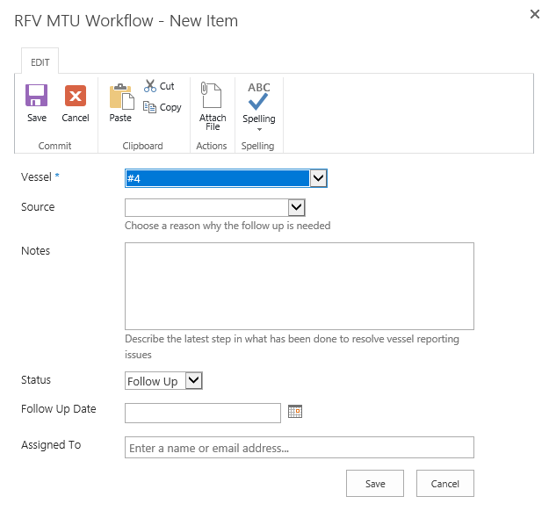
Figure 6

4.8 Proposals for Inclusion of Additional ALC makes and models on the Approved MLC/ALC List
Commission VMS SSPs require that the Secretariat will assess proposals for inclusion of additional ALC makes and models on this list from both CCMs and equipment manufacturers. VMS SSPs 2.7 states “The Secretariat shall include the ALC/MTU make or model being proposed on this list, if no CCM objects in writing within 30 days of the Secretariat circulating notice of its intent to all CCMs, and, if in the Secretariat’s assessment, the ALC/MTU make or model meets the minimum standards for the Commission VMS as set out in Annex 1 of CMM 2014-02 (or its successor measure), the WCPFC SSPs, as relevant, by determining that the ALC/MTU make and model has the ability to successfully report to the Commission VMS, and by using the methodology established by the FFA with expenses for type approval processing.”

The Secretariat is to assess proposals for the inclusion of additional MTU/ALC units and their communication / satellite service provider / gateway, against the new MTU/ALC type approval checklist (appended in Annex B). The following procedures are to be followed by the Secretariat when a proposal from MTU manufacturers, CCMs and service providers is received seeking the inclusion of additional ALC makes and models on the Approved MTU/ALC List:
- Application received with sufficient supporting technical documentation.
- Secretariat checks application information and verifies it against minimum standards in Annex 1 of the CMM 2014-02 (or its successor).
- Submit request for testing to TrackWell. TrackWell will liaise with the MTU applicant to test the gateway created is able to receive error-free position reports as per Annex 1 of CMM 2014-02 (or its successor).
- Trackwell will provide completion test report to the Secretariat for final assessment.
- As part of the assessment, the Secretariat VMS staff shall detail how each step on the checklist was or was not satisfied for each unit proposed for listing.

Where the Secretariat concludes in its assessment that a proposed ALC/MTU make or model does meet these requirements, the Secretariat will propose that the Commission approve a new ALC/MTU make or model. The Secretariat shall provide CCMs details on how each step on the checklist was satisfied for each unit, along with any other documentation provided by the flag CCM or vendor, to better inform CCMs’ consideration. The timeframes in the VMS SSPs for circulation of the notice will be applied.

Where the Secretariat concludes in its assessment that a proposed ALC/MTU make or model does not meet these requirements, or if a CCM objects in writing to the Secretariat's proposal to approve a new ALC/MTU make or model, the Secretariat shall make recommendations in the annual report regarding the proposed ALC/MTU make or model for the TCC’s consideration. The Secretariat shall provide CCMs with details on how each step on the checklist was satisfied for each unit, along with any other documentation provided by the flag CCM or vendor, to better inform CCMs’ consideration.

4.9 Removal of ALC/MTU from the Approved ALC/MTU List
The Secretariat will recommend to TCC as needed, the removal of units currently on the list of approved ALC/MTU makes and models that no longer meet the minimum standards set out in Annex 1 of CMM 2014-02 (or successor measure), or that do not have the ability to successfully report to the Commission VMS. As part of the assessment, the Secretariat VMS staff shall detail how each step on the checklist in Annex 2 was or was not satisfied for each unit proposed for removal from the Approved ALC/MTU List.

4.10 Commission VMS Helpdesk Support
The Secretariat is committed to developing online self-service support options via the WCPFC support knowledgebase (https://wcpfc.freshdesk.com/) and VMS help topics are in the process of being developed.

Email support for the Commission VMS can be sent to VMS.helpdesk@wcpfc.int

Annex A

Annex B
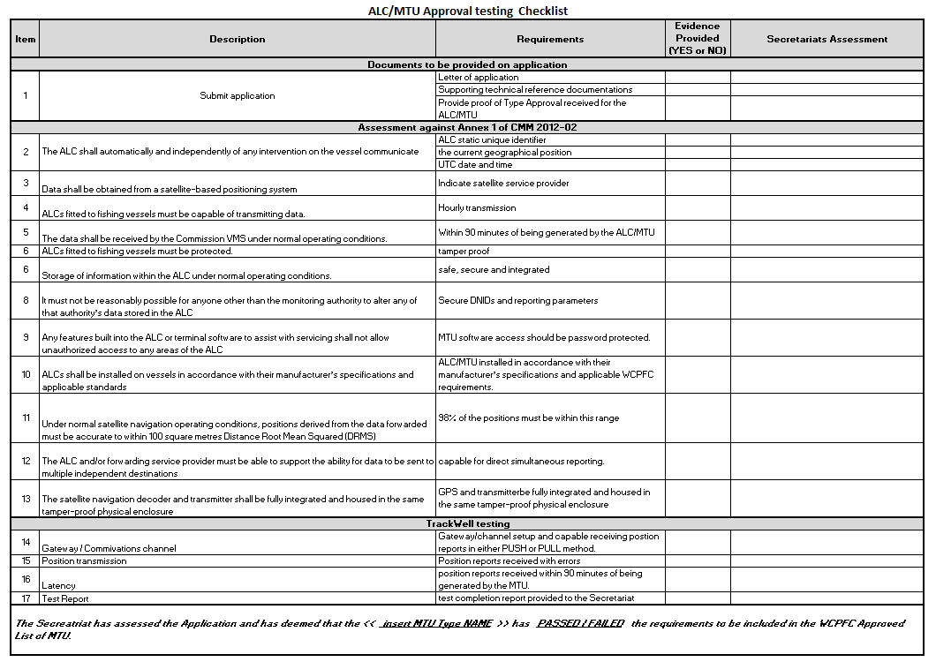

based on available data and information
and the flow chart at https://www.wcpfc.int./ToBeCompletedByTheSecretariat
Ibid
The success of their vessels’ ALC activations will also be evident in the VRST to CCMs ⁵ This activation confirmation process between the Secretariat and CCM will be followed for all approved MTU types shown in this section; the MTU status will also be evident to the CCM contact via the VRST

