

The Commission for the Conservation and Management of
Highly Migratory Fish Stocks in the Western and Central Pacific Ocean

Scientific Committee

Oceanic Whitetip Shark (Carcharhinus longimanus)

Stock Status AND Management Advice

Contents
SC21 2025 (STOCK ASSESSMENT PHASE II CONDUCTED) 2
SC20 2024 (STOCK ASSESSMENT PHASE I CONDUCTED) 11
SC16, 2020 – SC19, 2023 (NO STOCK ASSESSMENTS) 12
SC15 2019 (STOCK ASSESSMENT CONDUCTED) 12
SC9, 2013 – SC14, 2018 (NO STOCK ASSESSMENTS) 18
Useful References 19

SC21 2025 (STOCK ASSESSMENT PHASE II CONDUCTED)

Oceanic whitetip shark (Carcharhinus longimanus) stock assessment (Project 124)

- SC21 noted the extensive efforts undertaken to provide the dual-model stock assessment and appreciated the thoroughness of the assessment approach. While the Stock Synthesis (SS3) integrated age-structured model and Dynamic Surplus Production Model (DSPM) provide different structural assumptions for addressing data conflicts and uncertainties, SC21 noted that the multi-model ensemble approach strengthened conclusions about stock status compared to single-model approaches used previously.

- SC21 recommended that stock status and management advice be based upon the Bayesian ensemble across SS3 models, given that it both more appropriately captures the age-structured dynamics and has satisfactory model diagnostics. Additionally, the Bayesian approach provides a comprehensive and principled framework for characterizing uncertainty in stock status and recent fishing mortality.

Provision of scientific information to the Commission

  - Stock assessment and trends

- This assessment represents the third for oceanic whitetip shark (Carcharhinus longimanus; OCS) in the Western and Central Pacific Ocean. The assessment employed a dual-model approach to address persistent data conflicts and structural uncertainties. The primary assessment utilized an integrated, age-structured population model in Stock Synthesis (SS3), building on the 2019 assessment framework, using a single region model (Figure OCS-01, Table OCS-01). A parallel dynamic surplus production model (DSPM) served as a structural sensitivity analysis, relying on catch and CPUE data while avoiding potentially problematic length-composition data. The assessment incorporated updated data inputs, largely based on observer data, from 1995 through 2023.

- The assessment identified multiple sources of uncertainty, and, in particular, emphasized the issue surrounding data quality following non-retention measures (Table OCS-02). Conflicts between CPUE indices and length-composition data, and life history parameter uncertainty, both identified in the 2019 stock assessment, remained present. Uncertainties in the level of survival from current discarding practices were considered to inform alternative estimates of recent fishing mortality. Potential non-representativeness of length data was addressed by fitting the DSPM and including model runs with alternative weighting for length compositions in the Bayesian model ensemble.

- Historical catch reconstruction suggested markedly lower and less variable early catch estimates compared to the previous assessment. This discrepancy was largely due to the treatment of likely mis-reported hooks-between-float numbers in early assessment years (late 1990s and early 2000s). Longline fisheries were identified as the primary source of catch and historical fishing mortality (Figure OCS-02). Significant reductions in catches were predicted over the past decade, following the implementation of the non-retention measure for OCS (CMM-2011-04).

- Standardized CPUE indices showed a steep historic decline, with a slow recent increase since the implementation of CMM-2011-04 (Figure OCS-03). These trends in CPUE created a persistent conflict with length-composition data; the latter did not show any trends over time.

- The diagnostic model showed a reasonable fit to CPUE and length compositions, despite the low weight assigned to the length compositions (Figure OCS-04). Recent CPUE increases could not be fitted without some residual trends, suggesting that recent CPUE increases exceed expectations under the current model configuration. SC21 noted that future shark assessments should explore time-blocks or alternative methods to more explicitly account for changes in the fishery post-CMM-2011-04. The model showed little retrospective pattern in recent depletion or fishing mortality estimates, with retrospective patterns mainly concerning estimates of initial depletion.

- A full Bayesian ensemble across key uncertainties was used to characterise uncertainty in stock status and fishing mortality levels. Growth and associated natural mortality priors were key determinants of stock status estimates in the ensemble, while recent discard mortality was a major determinant for recent fishing mortality estimates.

- SC21 noted that biomass and recruitment declined substantially during the late 1990s from a starting point that was estimated to be near 20% of equilibrium unfished levels (SB₀) to levels around 4% of equilibrium unfished biomass between 2013-2015 (Figure OCS-05). Recent biomass was estimated at approximately 6% of unfished biomass in 2022-2023, following a substantial decline in fishing mortality. The stock, therefore, remains in a severely depleted state, with indications that declines have been halted and slow rebuilding is taking place.

- SC21 noted that the 2025 assessment showed a high level of consistency with the previous stock assessment (Tremblay-Boyer et al. 2019) as well as with projections performed from the 2019 stock assessment (Bigelow et al. 2022), while incorporating improved methodologies and data. The dual-model approach strengthened conclusions about stock status compared to single-model approaches used previously.

Table OCS-01. Assessment structure, including key ﬁsheries and catch proportions.
Species | Oceanic whitetip shark (Carcharhinus longimanus)
Stock area | Western and Central Pacific Ocean; Single area
Assessment model | Dual approach: Stock Synthesis (SS3) and Dynamic Surplus Production Model (DSPM)
Data period | 1995 through 2023
Primary fisheries | Longline bycatch (major source of mortality), purse seine (minor)
Key data | Catch predictions, discard condition (mortality) estimates, standardized CPUE, and length compositions

Table OCS-02. Summary of main sources of uncertainty in the assessment, with a degree of conﬁdence assigned to each aspect of the assessment and potential source of uncertainty.
Source | Type | Rationale | Uncertainty | Impact | Confidence
Data | CPUE | Standardized longline CPUE index | Steep decline and recent recovery conflicts with length data; recent CPUE may be biased by cutting free of sharks | Potential bias in recent abundance trends | Medium
Data | Catch | Reconstructed historical catches using refined HBF methods | Early period uncertainty, zero-HBF treatment. HBF may not reflect depth of hook in some cases. Uncertainty in the proportion of discard survival and historic overall catch | Population scale estimates may be impacted | Medium
Data | Length composition | Observer length measurements | Data quality degraded by non-retention policy | Conflicts with CPUE trends | Low
Model | Stock Synthesis | Integrated age-structured model | Length data probably not representative of abundance trends | Primary model for inference | High
Model | DSPM | Surplus production model | Alternative structural assumption | Provides robustness check | Medium
Spatial assumptions | Single stock | WCPO treated as single unit | Stock structure unknown | May affect assessment validity | Low
Key parameter | Natural mortality (M) | Literature- derived priors | Conflicting information in data | Affects productivity | Medium
Key parameter | Growth | Fixed, from Literature | Not estimable from data | Structural uncertainty | Medium
Structural | CMM-2011-04 effects | Non-retention conservation measure | Data quality | Potential under-estimated recent CPUE | Low
Estimation | Bayesian inference | MCMC estimation | Parameter uncertainty | Principled estimation of uncertainty | High

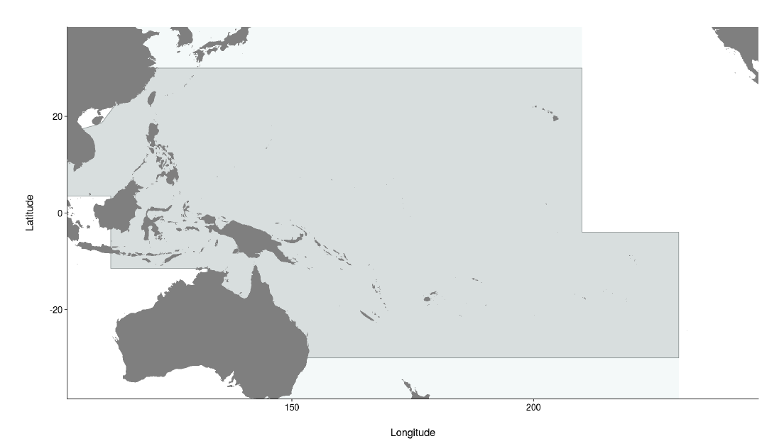

Figure OCS-01. Western and Central Pacific Fisheries Commission Convention Area (light grey), including the stock assessment area for oceanic whitetip shark (dark grey), bounded by the 30◦ N and 30◦S parallels.

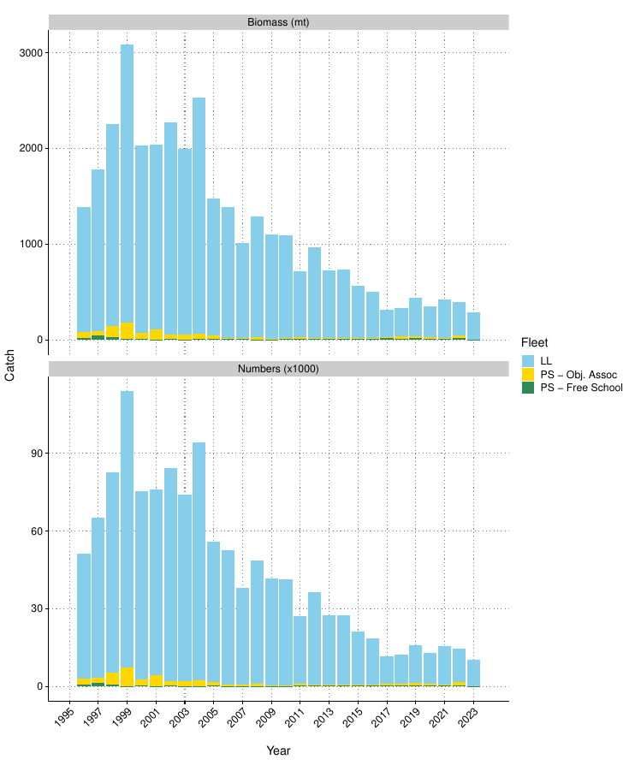
Figure OCS-02. Estimated mortality by fleet in biomass and numbers.

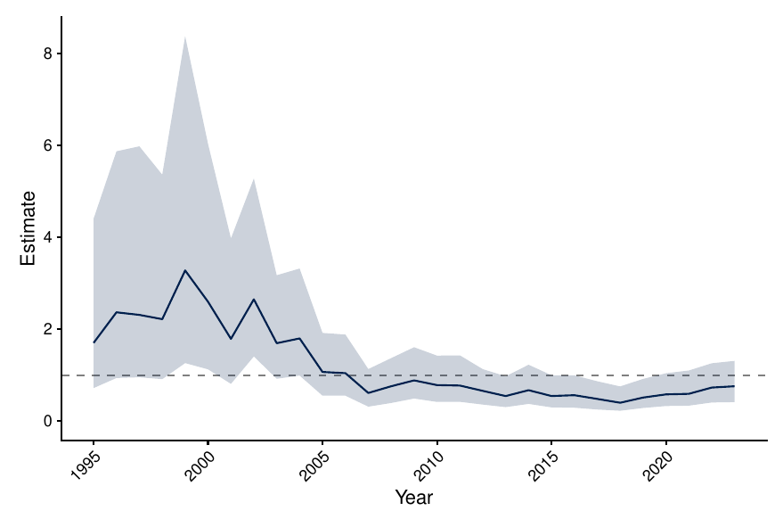

Figure OCS-03. Longline CPUE index using long-running observer indices. Shown is the posterior median and 95% credible interval for the year effect, standardised for regional trends and environmental variables.

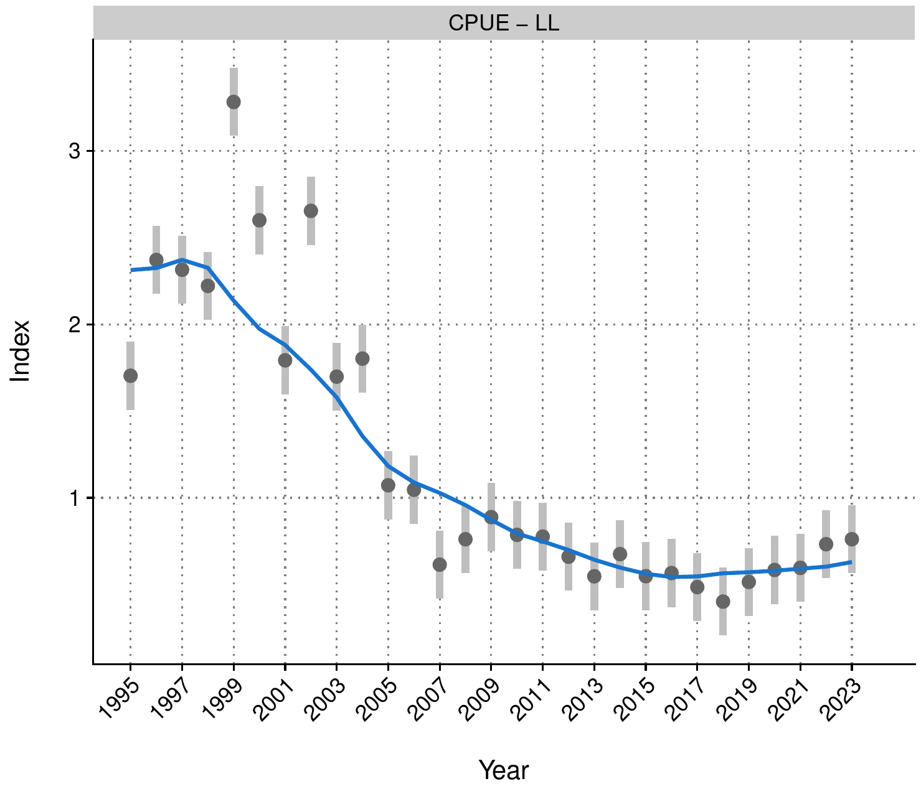
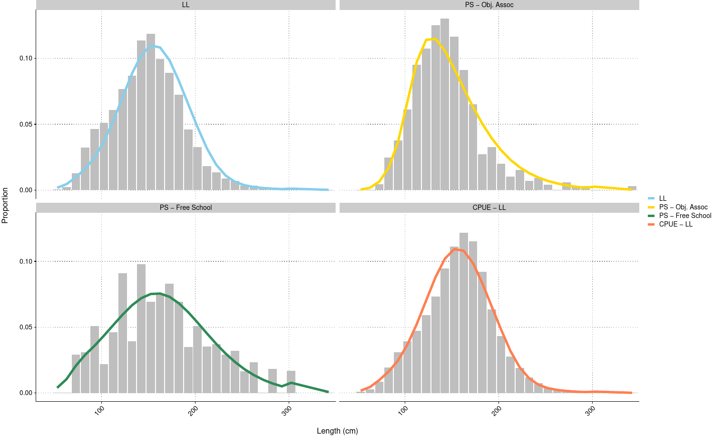
Figure OCS-04. Fits to CPUE and length composition data for the diagnostic model for OCS in 2025.

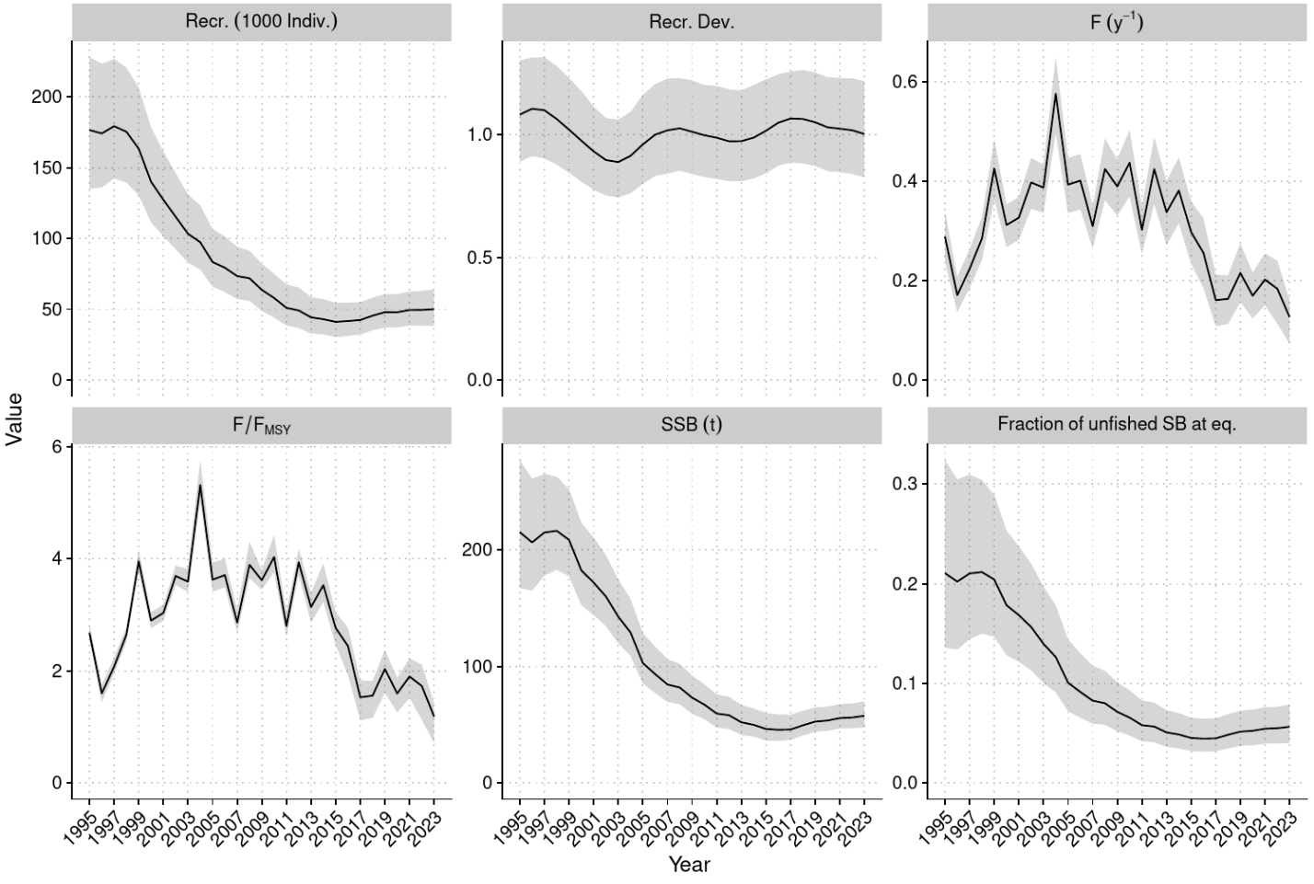
Figure OCS-05. Estimated annual average recruitment (top left), recruitment deviations (top middle), fishing mortality (F; top right), fishing mortality relative to FMSY (bottom left), spawning biomass (bottom middle), and spawning biomass depletion (bottom right) across the model ensemble.

  - Stock status

- SC21 noted that there are no agreed reference points for sharks in the WCPFC. The 2025 model suggested that stock status has been improving since 2015. Recent fishing mortality was estimated to be below suggested biological reference points for sharks with high probability (F_{recent}/F_{crash} = 0.54 [95% credible interval 0.37-0.74]; Figure OCS-06, Table OCS-03).

- SC21 noted that the 2025 assessment for oceanic whitetip shark concluded that the stock was overfished at 6% of estimated unfished equilibrium biomass, and as likely as not to be subject to overfishing (F_{recent}/F_{MSY} = 1.07 [0.73 – 1.39]; P[F>F_{MSY}] = 0.57).

- SC21 noted that the multi-model ensemble indicated recent fishing mortality rates are below suggested limit reference points (F_{lim} and F_{crash},, WCPFC-SC15-2019/MI-IP-04), and current estimated fishing pressure is unlikely to preclude stock rebuilding.

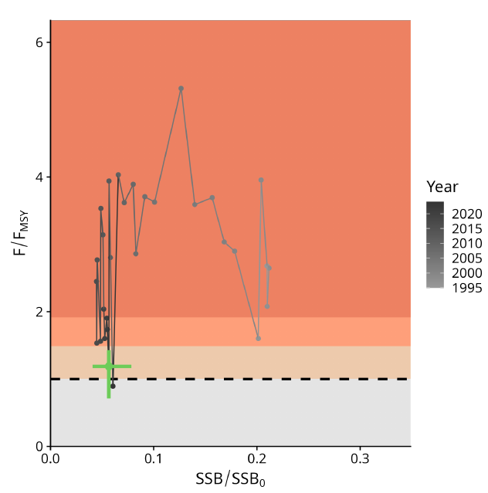

Figure OCS-06. Majuro plot summarising the results for each of the models, including uncertainty arising from estimation, structural, and intrinsic uncertainties (variability and process error). Note that the SSB axis has been truncated to better depict the results.

  - Management advice

- SC21 noted that the 2025 oceanic whitetip assessment concluded that while oceanic whitetip shark remains severely depleted at approximately 6% of unfished biomass (Table OCS-03), recent signs of recovery indicate conservation measures are likely providing some positive effects.

- SC21 noted that the largest reductions in mortality appear to have come from changes in longline fishing practices, suggesting gear-based mitigation measures have been effective. However, given the subtle nature of estimated recovery and persistent uncertainties, continued monitoring is essential.

- SC21 noted that the assessment provides high confidence that recent fishing mortality is below levels that would preclude rebuilding, with F/F_{crash} ratios well below 1. It is as likely as not that recent fishing mortality has exceeded F_{MSY.}

- SC21 additionally recommended continuing multi-model assessments for shark species, where possible, to address persistent concerns with data quality and structural assumptions.

- SC21 noted the need for improved observer data collection to inform monitoring of shark abundance trends and shark post-release survival. SC21 also noted this would be expected to inform the review of implementation of CMM 2024-05 paragraphs 21 and 22.

- SC21 recommended that the IWG-ROP assess and identify specific data gaps for enhancements needed in order to improve the accuracy and consistency of shark species identification and reporting, noting lower reporting rates of oceanic whitetip sharks by observers relative to logbooks in some regions and diminishing levels of length records since the implementation of CMM 2011-04.

- Given persistent uncertainties about stock structure and life-history parameters, SC21 recommended that tagging, genetic, and life-history studies be conducted to improve the biological baseline for future stock assessments of the oceanic whitetip shark.

Table OCS-03. Stock status summary table
Summary
Year: 2023 | Fishing mortality | Likely (>60%) to be below tentative limits
 | Recommendation | Stock is increasing slowly, and F is declining at the current catch; maintain conservation measures to minimize fishing mortality. There is a high level of confidence that recent fishing mortality is below levels that would preclude stock rebuilding.
Reference points |  | Estimate [5%--95%] |  | Comment
Fishing Mortality | F_{MSY} | 0.11 [0.09 – 0.13] |  | (not agreed)
Fishing Mortality | F_{Lim} | 0.16 [0.14 – 0.18] |  | (not agreed)
Fishing Mortality | F_{Crash} | 0.21 [0.18 – 0.24] |  | (not agreed)
Recent (2023) estimates |  |  |  | Recent trend/projection
Biomass | SB_{recent} | 12 630 [7 670 – 19 350] |  | SB_{recent} increasing
Depletion | SB_{recent}/SB₀ | 0.06 [0.04 – 0.08]
Fishing mortality | F_{recent} | 0.12 [0.07 – 0.16] |  | F_{recent} declining
Status |  |  | Likelihood
Fishing mortality | F_{recent}/F_{MSY} | 1.07 [0.73 – 1.39] | As likely as not (40%-60%) to be above F_{MSY}
Fishing mortality | F_{recent}/F_{lim} | 0.71 [0.49 – 0.93] | Likely (>60%) to be below F_{lim}
Fishing mortality | F_{recent}/F_{crash} | 0.54 [0.37 – 0.74] | Very likely (>90%) to be below F_{crash}

SC20 2024 (STOCK ASSESSMENT PHASE I CONDUCTED)

Oceanic whitetip shark (Carcharhinus longimanus) stock assessment

- SC20 noted that there are likely to be sufficient data and a sufficiently consistent signal in the different datasets, especially from longline, to conduct a stock assessment. SC20 recommended that a fully integrated assessment be attempted for phase II of this project.

- SC20 recommended a dual-track approach where a fully integrated model (e.g., Stock Synthesis) and a dynamic surplus production model are developed concurrently.

- If the agreed assessment approaches are unable to provide reliable stock status information or if the SC wants to gain a better understanding of the utility of risk assessment methods, SC20 recommended exploring a spatial risk assessment as part of the assessment development process. It is intended that this would be a separate project funded in 2026 if required.

SC16, 2020 – SC19, 2023 (NO STOCK ASSESSMENTS)

- Stock status and trends

- SC16 to SC19 noted that no stock assessments were conducted for oceanic whitetip shark in 2020 to 2023. Therefore, the stock status descriptions from SC15 are still current for oceanic whitetip shark.

- Management advice and implications

- SC16 to SC19 noted that no management advice has been provided since SC15 for oceanic whitetip shark. Therefore, previous advice should be maintained, pending a new assessment or other new information. For further information on the management advice and implications from SC15, please see below.

SC15 2019 (STOCK ASSESSMENT CONDUCTED)

- Stock status and trends

- The median values of relative recent (2013-2015) spawning biomass (SB_{recent}/SB_{F=0}, SB_{recent}/SB_{MSY}) and relative recent fishing mortality (F_{recent}/F_{MSY}) over the structural uncertainty grid were used to measure the central tendency of stock status. The span of the recent time period was determined to only include years following the adoption of CMM-2011-04. The values of the upper 90th and lower 10th percentiles of the empirical distributions of relative spawning biomass and relative fishing mortality from the uncertainty grid were used to characterize the probable range of stock status.

- Descriptions of the updated structural sensitivity grid used to characterize uncertainty in the assessment are provided in Table OCS-01. Historical catch data used for the diagnostic case is presented in Figure OCS-01. Estimated annual average total biomass, recruitment and spawning biomass are shown in Figure OCS-02, and fishing mortality in Figure OCS-03. The time series of depletion in spawning biomass over all runs in the structural uncertainty grid is shown in Figure OCS-04. Kobe and Majuro plots summarizing the results for each of the models in the structural uncertainty grid retained for management advice are represented in Figures OCS-05 and OCS-06. Table OCS-02 provides a summary of reference points used to determine stock status over the 648 models in the structural uncertainty grid using the grid weights agreed upon by SC and outlined in Table OCS-01.

- SC15 noted that the median level of spawning biomass depletion from the uncertainty grid was SB_{recent}/SB₀ ₌ 0.04 with a probable range of 0.03 to 0.05 (80% probability interval). While no limit reference point has been adopted, the depletion in spawning biomass is very high. The median level of recent spawning biomass relative to that leading to MSY was SB_{recent}/SB_{MSY} = 0.09 (range: 0.05–0.17).

- SC15 noted that the recent relative fishing mortality was very high and the grid median F_{recent}/F_{MSY} was 3.94, with a range of 2.67 to 5.89 (80% probability interval), and that there were no model runs in the grid where F_{recent}/F_{MSY} was below 1.

- The key conclusions are that overfishing is occurring and the stock is in an overfished state relative to MSY and depletion-based reference points (noting that depletion-based reference points have only been adopted for tunas) (Tables OCS-1 and OCS-2). This conclusion is robust to uncertainties in key model assumptions (Figure OCS-5).

- SC noted that the inclusion of discard mortality (DM) scenarios in the historical catches was an improvement to the assessment and was necessary to account for the potential impacts of the no-retention measure (CMM-2011-04) for oceanic whitetip sharks.

- SC noted that stock status improved relative to F-based reference points in the period since CMM 2011-04 became active, which covers the last 4 years of the assessment’s time-span (2013–2016). Notably, F/F_{MSY} is predicted to have declined by more than half from 6.12 to 2.67 (n=432, unweighted grid median) (Figure OCS-2), for the last year of the assessment when the impact of CMM 2011-04 on survival is accounted for under 25% and 43.75% discard mortality scenarios (Figure OCS-6 and OCS-7). Relative fishing mortalities under two alternative reference points that have not been adopted by the WCPFC, specifically F /F_{lim,AS} (the fishing mortality resulting in 0.5 of SB_{MSY}) and F/F_{crash,AS} (the fishing mortality resulting in population extinction when sustained over the long-term, follow similar trends. Under the survival scenarios above, median SB/SB_{MSY} is predicted to have increased slightly from 2013 to 2016 (8.6% to 9.2%).

- SC15 noted that there was some inconsistency between observed and estimated CPUEs for 2013-2016 in the diagnostic case, which is probably caused by the assumptions about the stock recruitment relationship in this stock assessment. Whether or not this inconsistency is present in all models across the included uncertainty grid remains unknown.

- Management advice and implications

- Despite the data limitations going into the assessment and the wide range of uncertainties considered, all of the feasible grid model runs indicate that the WCPO oceanic whitetip shark stock continues to be overfished and overfishing is occurring relative to commonly used depletion and MSY-based reference points.

- SC15 noted that while the assessment estimates that overfishing is still occurring (F_{recent}/F_{MSY} was 3.94) the stock assessment also estimates a slight recovery in stock biomass in recent years (2013-2016). It remains unclear whether the stock status will continue to improve or perhaps decline in the future. To help clarify this issue SC15 recommends that stock projections based on the assessment are undertaken and presented to SC16.

- SC15 noted that there now appear to be few if any major fisheries targeting oceanic whitetip. The greatest impact on the stock is attributed to bycatch from the longline fisheries, with lesser impact from purse seining.

- Noting that there are existing CMMs directed at oceanic whitetip, SC15 recommended that further efforts to mitigate catch and improve handling and release practices are required to further reduce fishing mortality and improve stock status.

- SC15 noted that the assessment would be improved with better data collection for longline fisheries, such as improved observer coverage, as these fisheries are the major component of fishing mortality and would provide additional information on interaction rates, mitigation options and the fate and condition at release.

- SC15 recommends that, as a minimum, CCM’s meet the observer coverage specified in CMM 2018-05.

- SC15 noted the need for improved estimates of age, growth and fecundity, as well as new length-length conversion factors that would allow for an improved assessment and the inclusion of a greater number of observed lengths.

- SC15 noted that following the implementation of CMM 2011-04 and CMM 2014-05, the amount of scientific information available per year on oceanic whitetip sharks and other sharks species covered by a retention ban and the ban on shark lines or wire traces (e.g., bycatch estimates, length measurement, species and sex identification, and biological samples) has declined. SC15 also noted that the decline in information available for the oceanic whitetip shark assessment resulted in higher uncertainty in stock status, especially in more recent years since the introduction of these CMMs. This will also affect the capacity of SC to undertake future assessments if this decline in available information persists. SC15 recommends that WCPFC16 gives more consideration to the data needs for estimating reliable CPUE and other inputs into assessments when management measures are put in place, as these measures may have unintended consequences on continued availability and reliability of data. SC15 also recommended that WCPFC16 also take these considerations into account when reviewing the relevant sharks CMMs.

- Noting that no limit reference points have been adopted for oceanic whitetip sharks, as well as other WCPO shark species, SC15 recommends that WCPFC16 consider identifying appropriate limit reference points for WCPO sharks.

Table OCS-01. Description of the axes for the structural uncertainty grid, and assigned weight by level in the final resampling of stock status metrics. Settings used under the diagnostic case are highlighted with a star.
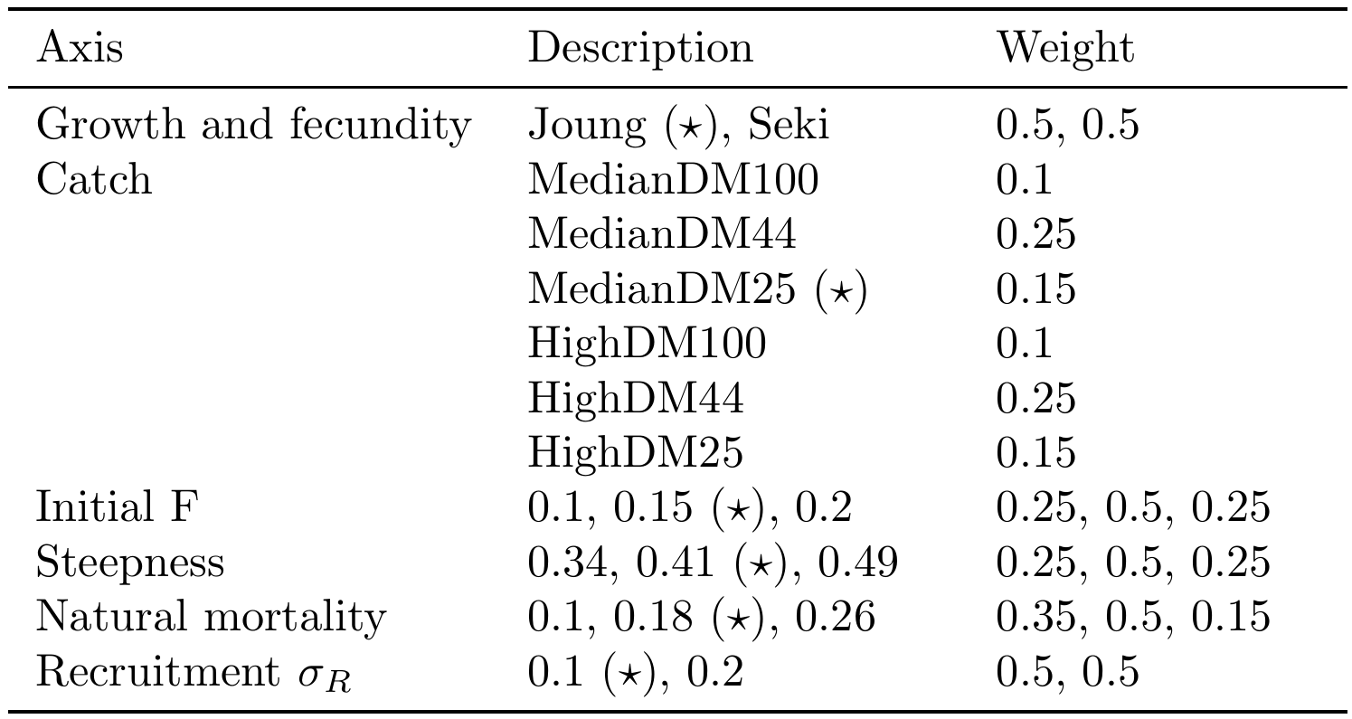

Table OCS-02. Summary of reference points using SC15 adopted weights by axes over the 648 models in the structural uncertainty grid.
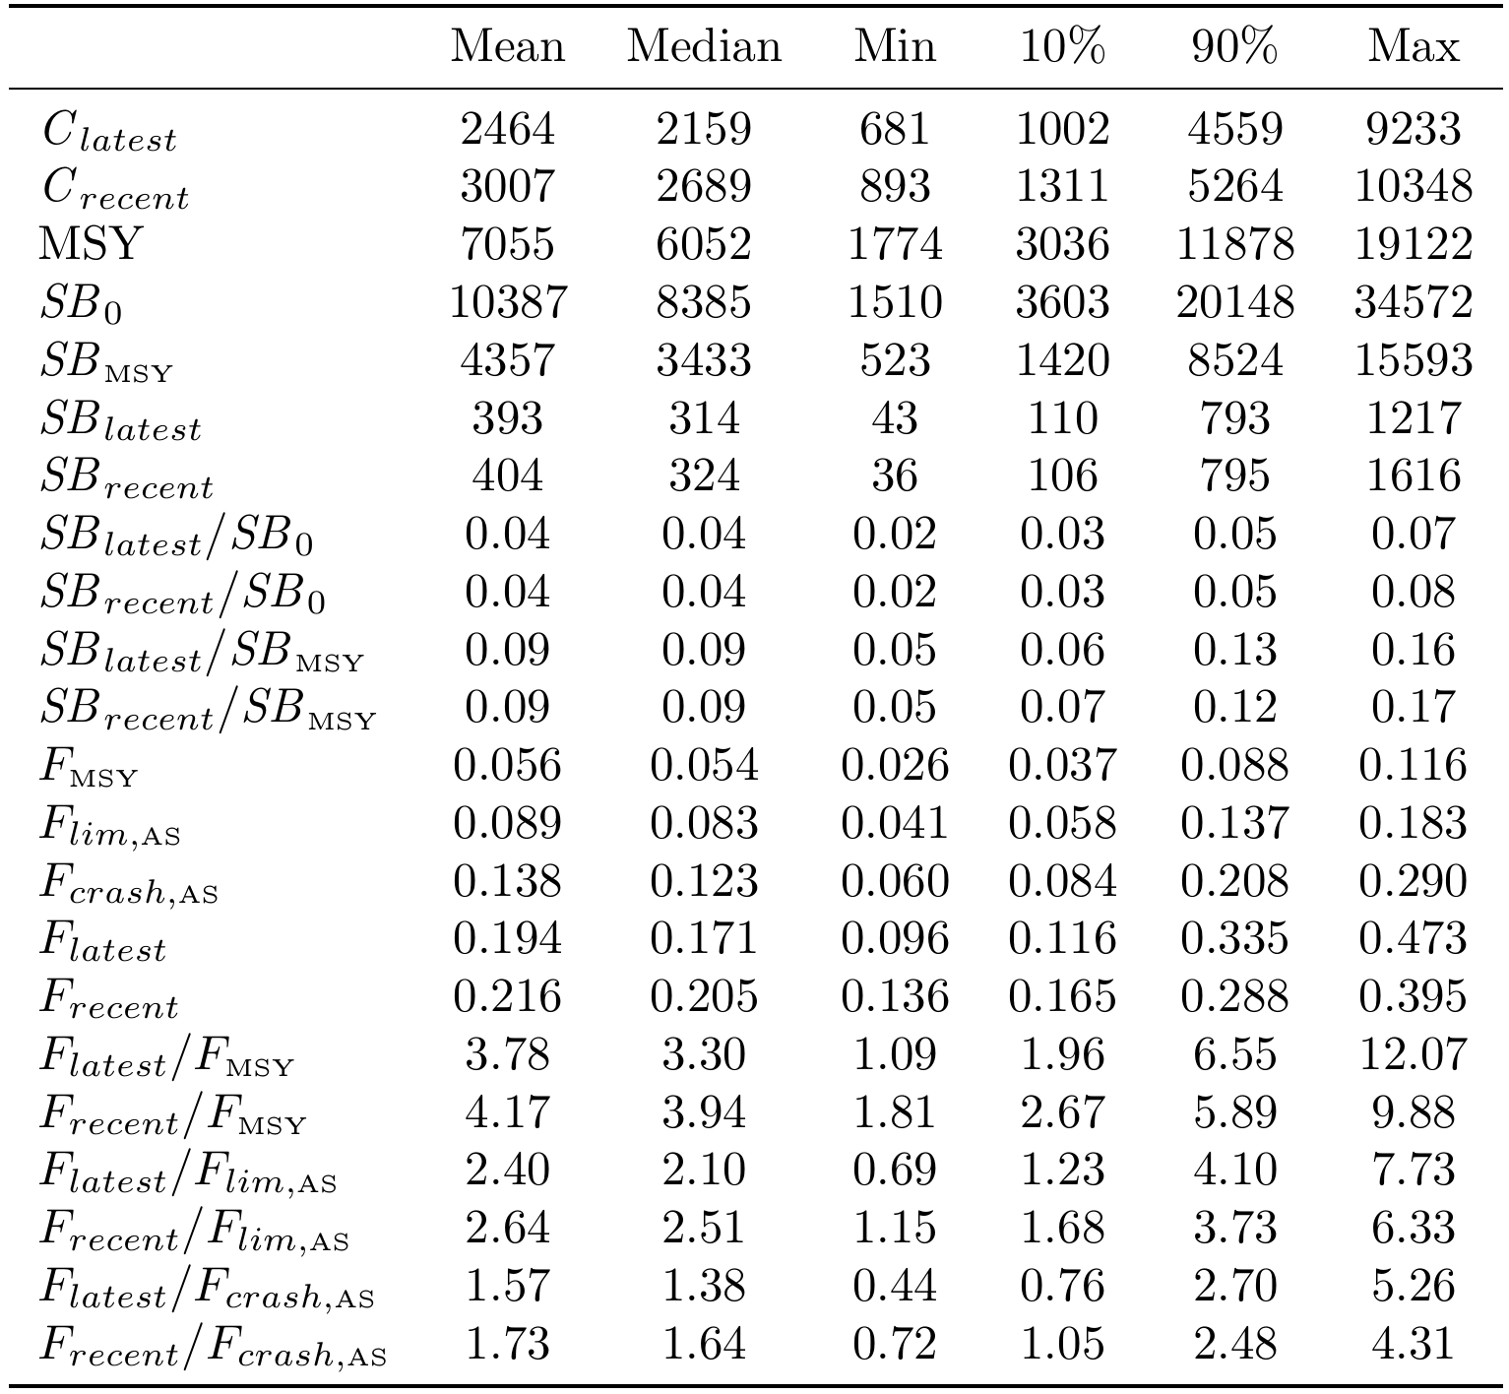

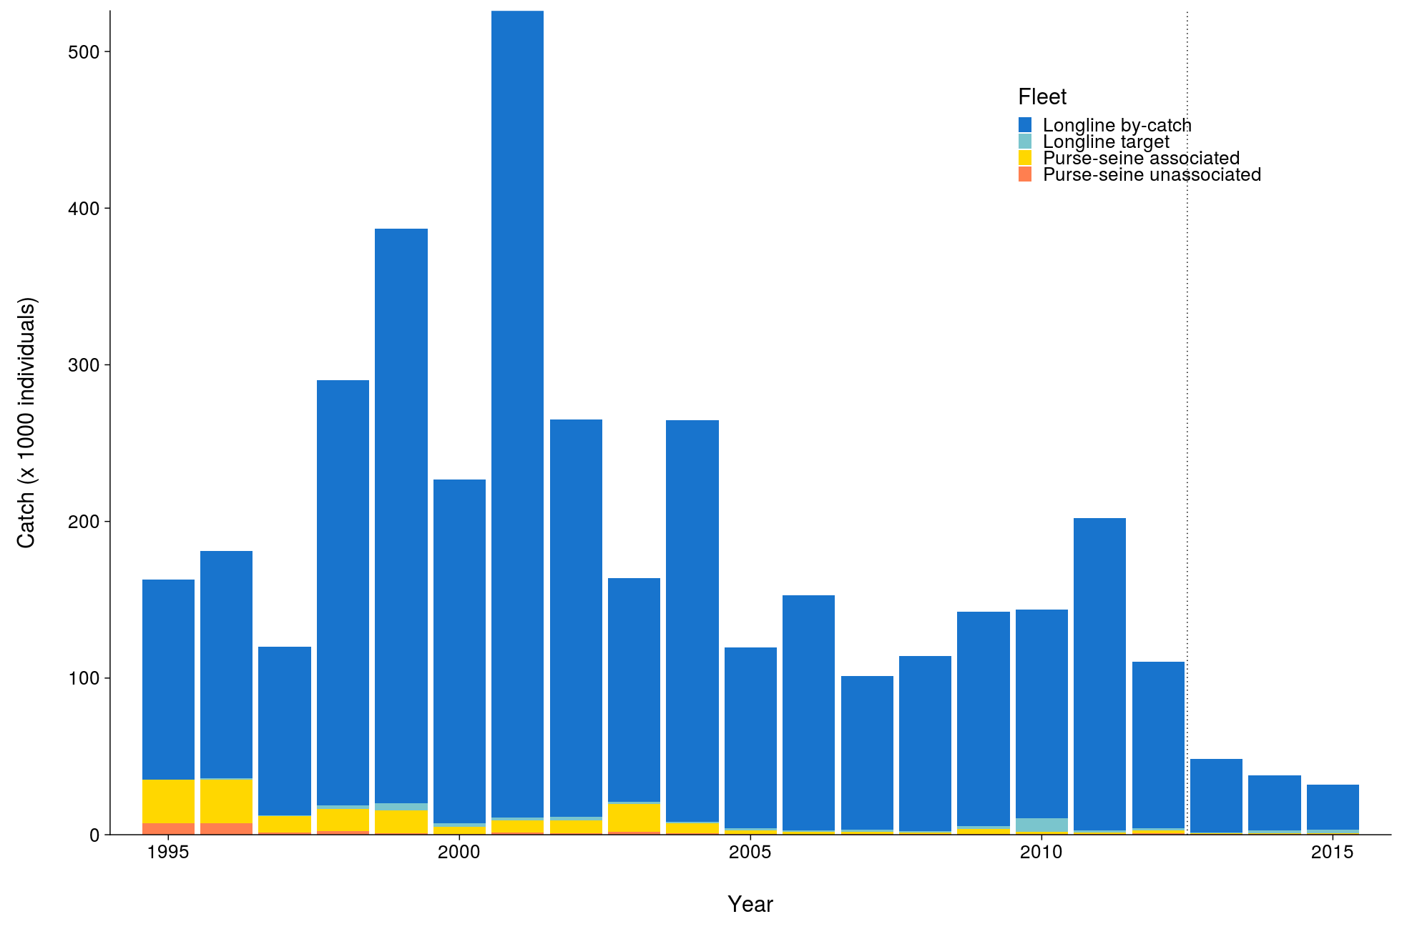 | 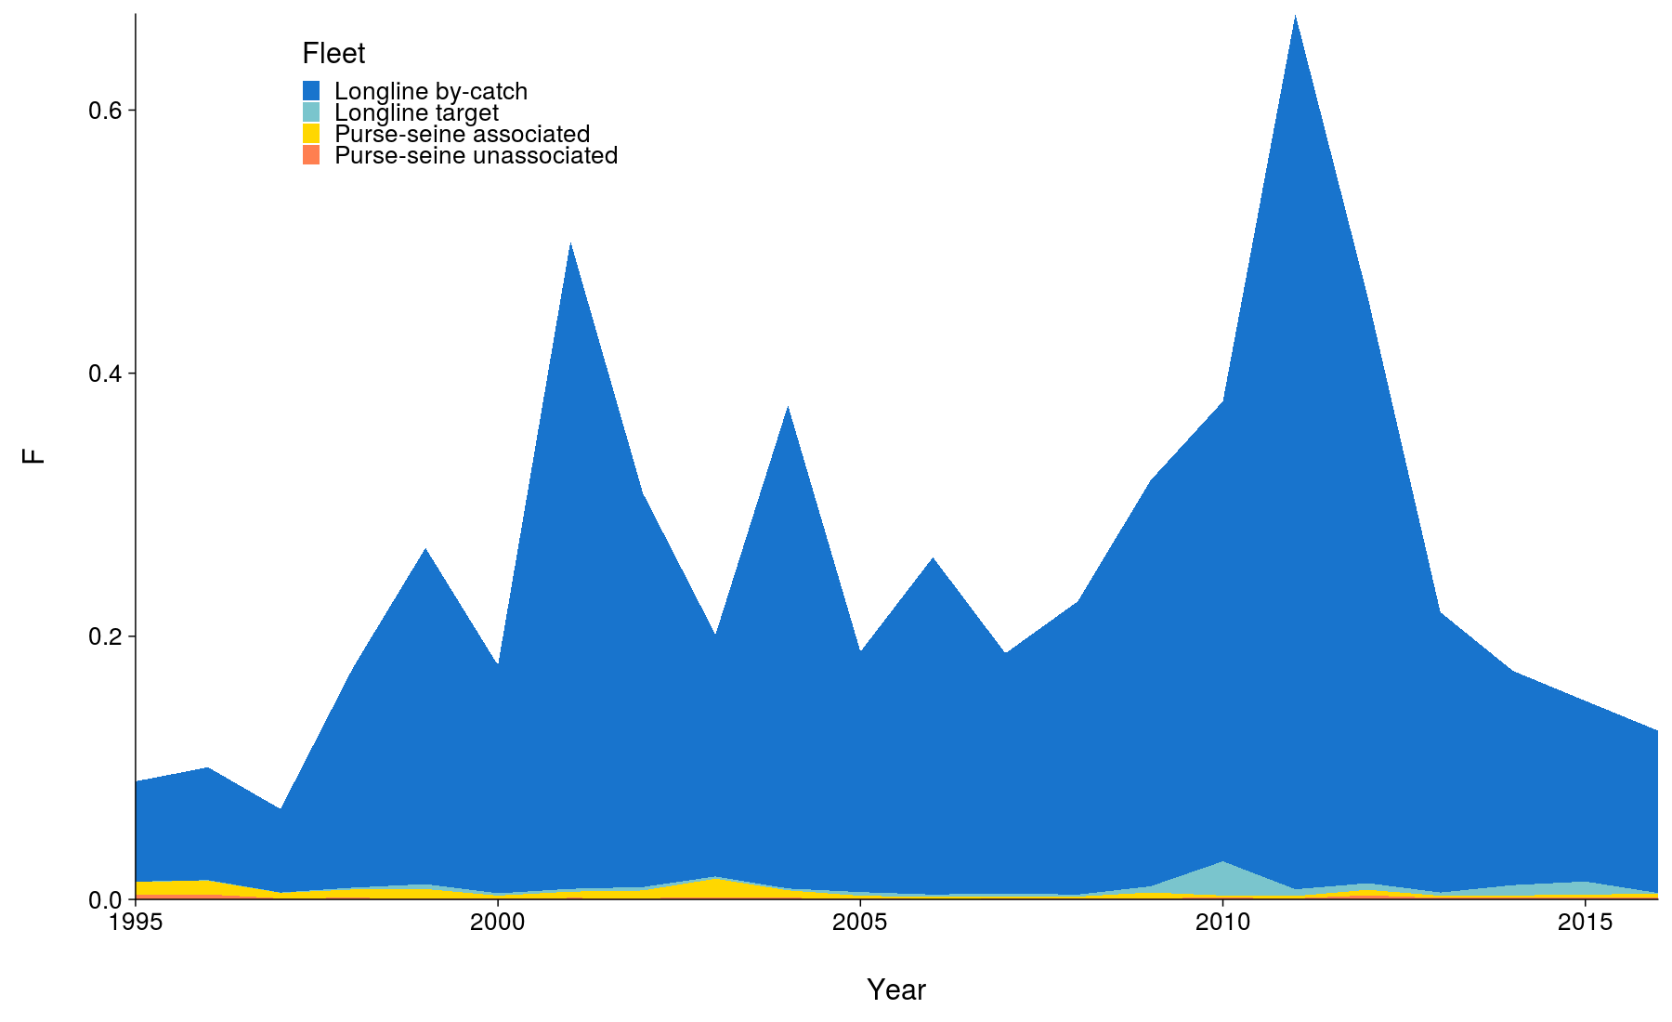
Figure OCS-01. Total reconstructed catches by fleet over time used for the diagnostic case. | Figure OCS-02. Cumulative fishing mortality by fleet estimated for the diagnostic case over the time-span of the assessment (1995-2016).
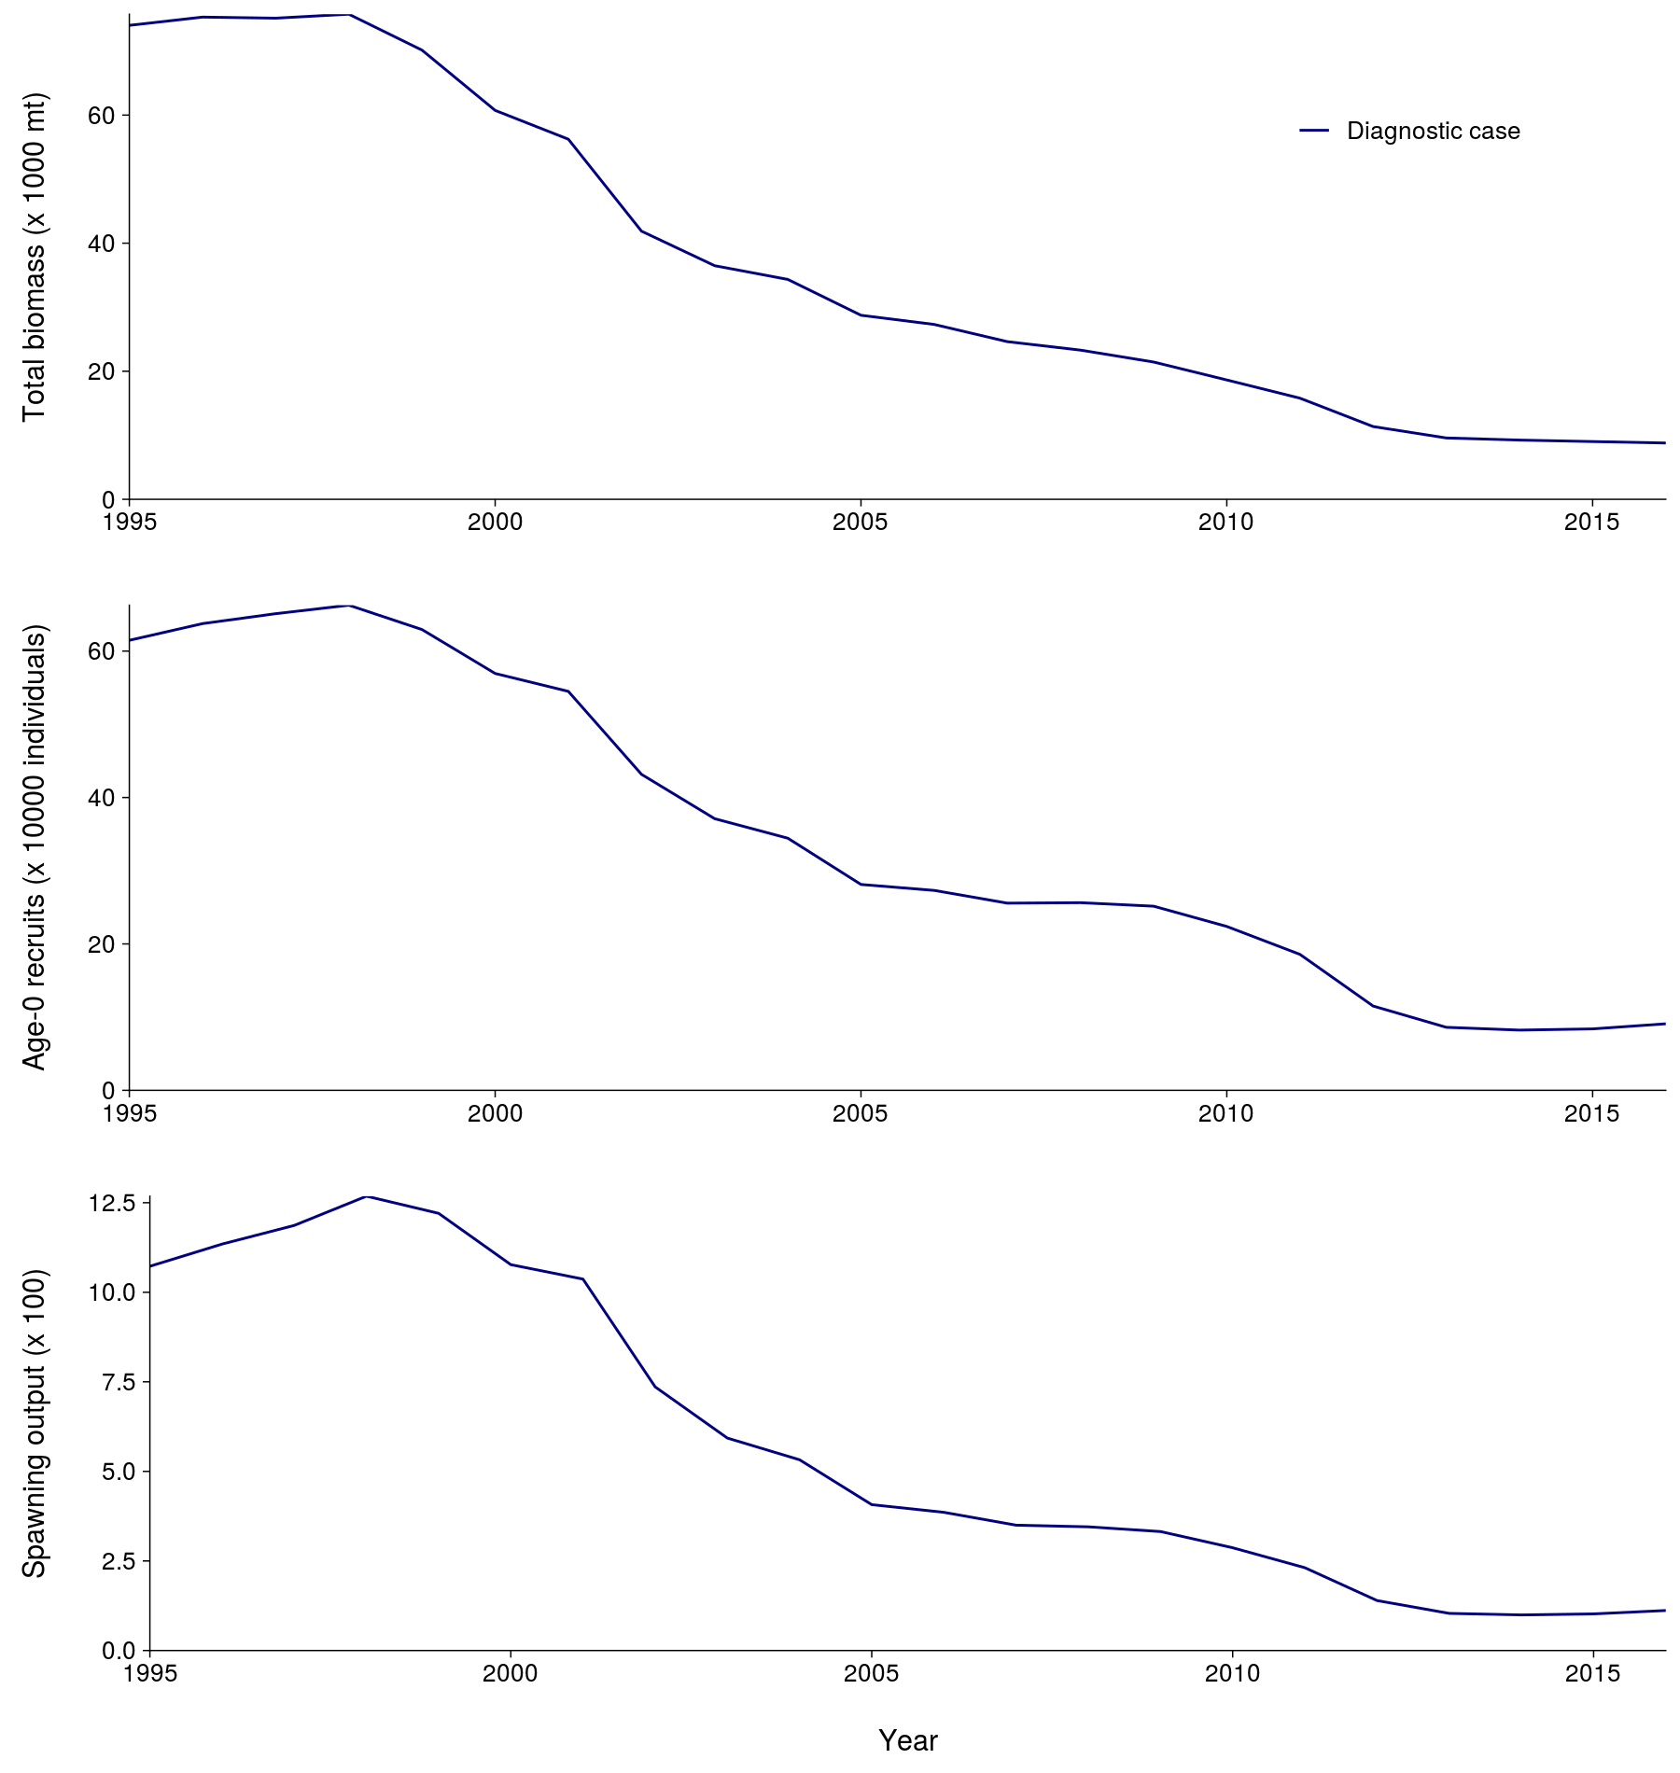 | 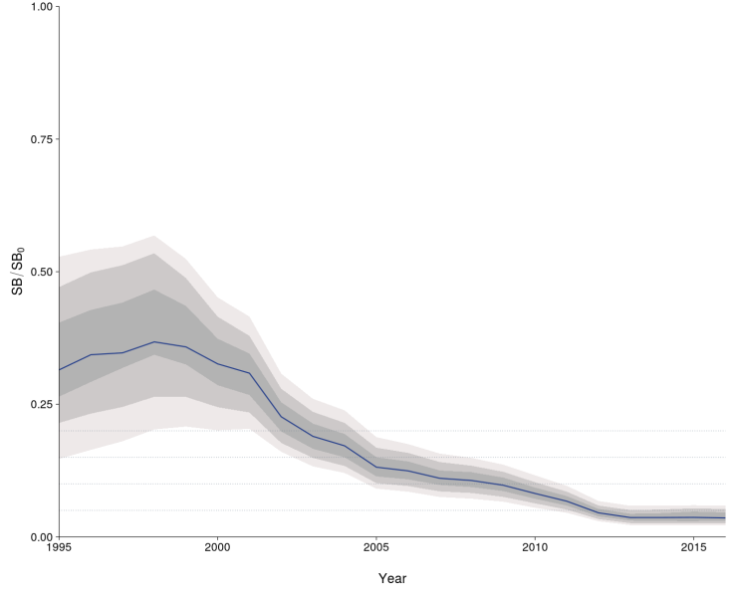
Figure OCS-03. Total biomass, recruitment and spawning biomass for the diagnostic case over the time-span of the assessment (1995-2016). | Figure OCS-04: Median estimates of depletion in spawning biomass over all (weighted) grid runs, with 2.5th -97.5th, 10th-90th and 25th -75th quantile intervals. Horizontal grey lines are placed at intervals of 5% in the lower part of the graph to aid visualization.

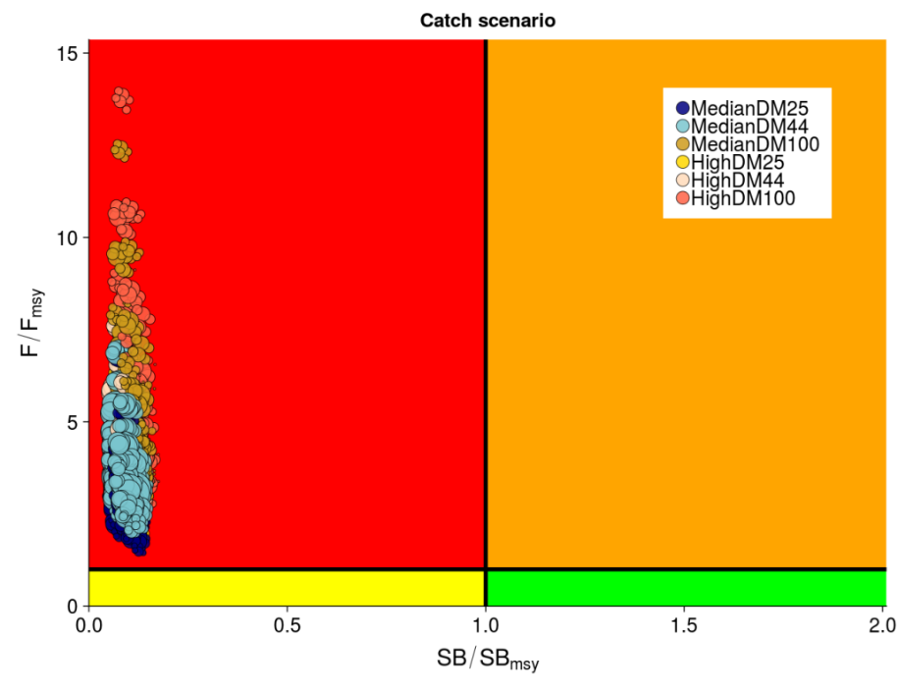
Figure OCS-05: Kobe plot summarizing recent status (2013-2015) for each of the (weighted) models in the structural uncertainty grid, based on SB/SB_{MSY} and F/F_{MSY}. The stock is considered to be overfished when SB/SB_{MSY} > 1 and undergoing overfishing when F/F_{MSY} > 1. The points are coloured according to the catch scenario that was used as input to the individual grid run. The size of the circle relates to the weight of that particular model run.

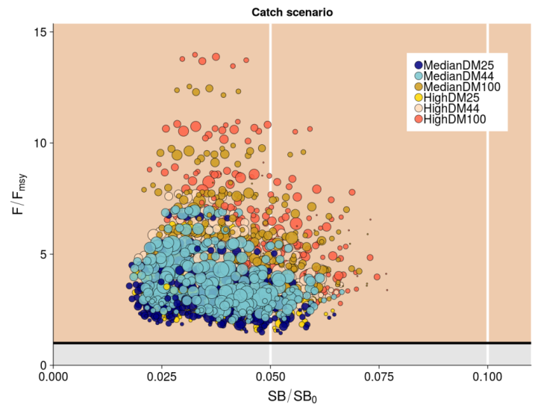 | 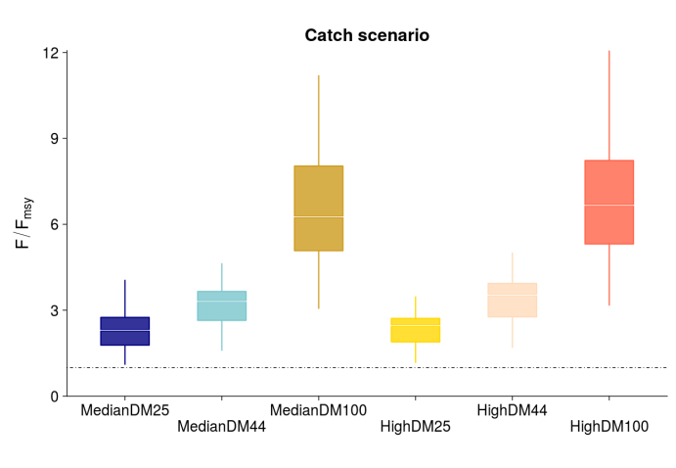
Figure OCS-06: Panel plot summarizing recent stock status (2013-2015) for each of the weighted models in the structural uncertainty grid for SB/SB₀ and F/F_{MSY}, noting no limit or target reference points have been adopted for oceanic whitetip shark. The stock is considered to be undergoing overfishing when F/F_{MSY} > 1 (beige zone). The SB/SB₀ axis was scaled to span the range of depletion values. Guidelines were added in white at 0.5SB/SB₀ and 0.1SB/SB₀. The points are coloured according to the catch scenario that was used as input to the individual grid run. The size of the circle relates to the weight of that particular model run. | Figure OCS-07: Median (white bar) and inter-quartile bounds (box) for F/F_{MSY} in the final year of the assessment (2016) under the 6 catch scenarios used in the structural uncertainty axis. The catch scenarios included baseline and high levels of catches with 3 scenarios of discard mortality (25%, 43.75% and 100%). The whiskers extend to 1.5 times the interquartile range.

SC9, 2013 – SC14, 2018 (NO STOCK ASSESSMENTS)

- Stock status and trends

- SC14 noted that no stock assessments were conducted for oceanic whitetip shark in 2018. Therefore, the stock status descriptions from SC8 are still current for oceanic whitetip shark. Updated information on catches was not compiled for and reviewed by SC14.

- Management advice and implications

- SC14 noted that no management advice has been provided since SC8 for oceanic whitetip shark. Therefore, previous advice should be maintained, pending a new assessment or other new information. For further information on the management advice and implications from SC8, please see below.

Useful References

SC21-SA-WP-08 Stock Assessment of Oceanic Whitetip Shark in the Western and Central Pacific Ocean 2025 (Rev.01). Philipp Neubauer and Kath Large https://meetings.wcpfc.int/node/26650

SC20-SA-WP-11 Analyzing Potential Inputs to the 2025 Stock Assessment of Western and Central Pacific Oceanic Whitetip Shark (Carcharhinus longimanus) (Project 124) - Rev.02. T. Hill-Moana, P. Neubauer, K. Large, and S. Brouwer. https://meetings.wcpfc.int/node/23124

SC15-SA-WP-06 Stock Assessment of Oceanic Whitetip Shark in the Western and Central Pacific Ocean. https://www.wcpfc.int/node/42932

SC15-SA-WP-13 Alternative Assessment Methods for Oceanic Whitetip Shark. https://www.wcpfc.int/node/43050

SC15-SA-IP-17 Historical catch reconstruction and CPUE standardization for the stock assessment of oceanic whitetip shark in the Western and Central Paciﬁc Ocean. https://www.wcpfc.int/node/43122

WCPFC-SC8-SA-WP-06 Stock Assessment of Oceanic Whitetip Sharks in the Western and Central Pacific Ocean Rev 1 (3 August 2012). https://www.wcpfc.int/node/3235

