

The Commission for the Conservation and Management of
Highly Migratory Fish Stocks in the Western and Central Pacific Ocean

Scientific Committee

Southwest Pacific Striped Marlin (Kajikia audax)

Stock Status and Management Advice

Contents
SC21 2025 (STOCK ASSESSMENT CONDUCTED) 2
SC20 2024 (STOCK ASSESSMENT CONDUCTED) 4
SC16, 2020 – SC19, 2023 (NO STOCK ASSESSMENTS) 5
SC15 2019 (STOCK ASSESSMENT CONDUCTED) 5
SC9, 2013 – SC14, 2018 (NO STOCK ASSESSMENTS) 10
Useful References 12
Previous Assessments 12

SC21 2025 (STOCK ASSESSMENT CONDUCTED)

Southwest Pacific striped marlin (Kajikia audax) stock assessment

- SC21 thanked the SSP and the collaborative contribution (as supported by SC20) from the NOAA Pacific Islands Fisheries Science Center, for their thorough work conducted on the revision of the Southwest Pacific striped marlin stock assessment and considerable efforts to improve the assessment, particularly by providing multiple model frameworks to consider, and working with CCMs to address the concerns raised about the assessment at SC20. Individual working papers were presented for both assessment approaches. SC21 noted that the model outcomes presented were reasonably consistent with previous stock assessment results and with each other. However, there were remaining issues with the integrated assessment (moved from Multifan-CL to Stock Synthesis 3) that could not be resolved in the time available. The alternative Bayesian Surplus Production Model (BPSM) was proposed as a simpler, more robust model for management advice that more appropriately characterized the assessment uncertainty.

- SC21 recommended that stock status and management advice be based upon the Bayesian surplus production model (BSPM) results as the most parsimonious and robust assessment presented for the SW Pacific MLS stock. As such, the summary text, figures, and tables below are based on the BSPM.

Provision of scientific information to the Commission

- Stock assessment and trends

- The revision of the 2024 Southwest Pacific Ocean striped marlin stock assessment employed a multi-model approach in an effort to provide a robust basis for the provision of management advice on stock status. During the revision work, issues with the age-structured integrated assessment, using Stock Synthesis 3, that could not be satisfactorily resolved led to a strategic shift to a data-moderate Bayesian surplus production model (BSPM). For the BSPM, the Fletcher-Schaefer production model framework was implemented in Stan using a state-space formulation where population depletion evolves according to surplus production and fishing mortality dynamics linked to effort data. This approach condenses biological and fishery assumptions, which provides a robust framework for estimating stock status and efficiently exploring uncertainties in productivity and scale. The model assumes a single, well-mixed stock (Figure MLS-01) with no population age structure and fished by a single aggregate fishery (Table MLS-01).

- The assessment incorporated multiple sources of uncertainty through both model structure and parameter estimation approaches (Table MLS-02). Key uncertainties included substantial uncertainty in absolute population scale, biological parameter uncertainty in growth, maturity, natural mortality, and steepness that contributed to broad priors for maximum intrinsic rate of increase, and population scale. The model ensemble explicitly incorporated uncertainty in population trend by considering the distant water fishing nation (DWFN) and the New Zealand recreational sportfish index. Alternative priors for the shape parameter, which informs the location of MSY, were also considered in the ensemble.

- Annual catches are provided from 1952 to 2022 (Figure MLS-02). The annual catch series showed initially low removals in 1952-1953, followed by a high but potentially legitimate peak of ~80,000 individuals in 1954, then generally stable catches of between 20,000 and 40,000 individuals with a slight decline since 2000.

- The standardized DWFN CPUE index (1988-2022) and New Zealand recreational index (Figure MLS-03) were the only indices with sufficient length and contrast to inform population-scale estimates, both exhibiting declining trends that constrain population size. The DWFN index showed high variability with a general decline most pronounced after 2000, though stabilizing somewhat before showing slight recent increases. The New Zealand index showed a more continual decline from the mid-1990s, though observation error was larger in the terminal years. The shorter observer indices were largely flat from 2000 to 2022. The Australian longline index was also short and showed an initial decline before being largely stable with a larger observation in the terminal year.

- The ensemble estimated total population trajectories (Figure MLS-04) showing a pronounced decline from unfished conditions during the 1950s-1960s, relatively stable population levels around from the 1970s through early 2000s, and recovery since approximately 2015. Fishing mortality (F) estimates (Figure MLS-04) generally increased through the model period until the early 2000s, followed by generally declining trends in recent decades consistent with population recovery patterns. The models demonstrated evidence of a well-determined production function through successful model-free hindcast validation, where models fitted to progressively truncated datasets successfully predicted future population dynamics based solely on estimated production parameters and catch data. Model validation through retrospective analysis showed acceptable bias within recommended ranges, and all models showed good convergence according to conventional Bayesian diagnostics.

- Total depletion (D), defined as the static depletion of total numbers relative to the initial total unfished numbers, largely followed the same patterns as the total population trajectory (Figure MLS-04). Uncertainty in total depletion was large and asymmetrical, with more uncertainty to the high side. This is driven by the large uncertainty in population scale. The lower bound of uncertainty was constrained by requiring a large enough population to support the 70-year catch history. However, the existing data do not support a large population but rather indicate a small, highly productive stock capable of sustaining observed catch levels, which is a conclusion consistent with the Stock Synthesis assessment and previous assessments of this stock. Though population scale estimates were driven by different productivity assumptions, larger catches or a flatter CPUE index would all support a larger population.

- As noted, this BSPM approach showed similar results to the Stock Synthesis integrated model but provided greater confidence in the results by identifying a well-determined production function and more appropriately integrating over uncertainty in population scale and productivity. Previous integrated assessments encountered challenges fitting size composition data, conflicts between data sources, and difficulties in determining a stock production function. Key strengths of the BSPM included explicit parameter uncertainty incorporation through simulation-based priors, prior pushforward analysis ensuring biological realism, comprehensive sensitivity analysis, and a well-determined production function.

Table MLS-01. Stock assessment model structure for the 2025 Southwest Pacific striped marlin assessment.
 | Number | Description
Spatial structure | 1 | Assumes single, well-mixed stock
Age structure | 1 | Assumes a single age class
Fishery structure | 1 | Assumes a single fishery with knife-edge asymptotic selectivity

Table MLS-02 Key sources of uncertainty considered in the 2025 Southwest Pacific striped marlin stock assessment.
Rationale | Uncertainty | Impact | Confidence
Data
CPUE | Best available long-term indices (DWFN & New Zealand recreational) | Changes in the fleet composition and or fishing location in the DWFN index can be interpreted by the model as population-level changes. For the New Zealand index, if the stock distribution has shifted, this may impact representativeness | Medium
Catch | Situationally targeted species, so catch reporting may be inconsistent | Reported catches are highly influential on the estimated population scale | Medium
Model
Parsimonious and robust model | Over-simplifies population and spatial dynamics | Unknown | Medium
Static models | The value of key parameters is constant | Changes in the fleet composition would influence the age structure of the population and lead to time-varying population dynamics. | Low
Spatial Assumptions
Little tagging data to understand the structure | Unclear | Potentially important, not quantified, impact unknown | Low
Key Parameter uncertainty
Productivity ($R_{MAX}$) | Uncertainty in key biological processes | Wide prior contributes to high uncertainty within model runs | High
Population scale (log(K) & $q_{eff}$) | Scale prior dependent on the maximum observed catch being representative of MSY | Broad prior contributes to high uncertainty within model runs | High
Shape n | Alternative priors used to capture the shape of the production function | Uncertainty in where MSY occurs as a fraction of the unfished condition | Medium
Structural Uncertainty
Fixed $σ_{C}$ = 0.2 | Choice of $σ_{C}$ and observation model impacts estimated removals | Removal estimates may not exactly match observations | Medium
Estimation Uncertainty
Full Bayesian estimation integrating uncertainty over key parameters | Estimated | Basis for model ensemble | High
Other sources of uncertainty
Genetic sampling of catch in the North Pacific indicates the presence of SWPO fish | Not considered | Actual population removals may be under-counted, impacting scale and stock status | Low

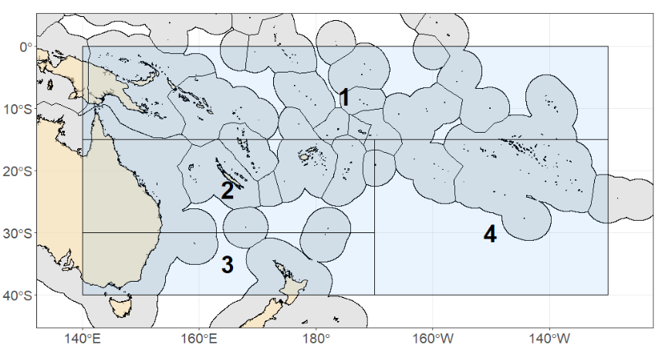
Figure MLS-01 Assessment model spatial domain, noting that no sub-fleets or regions were used.

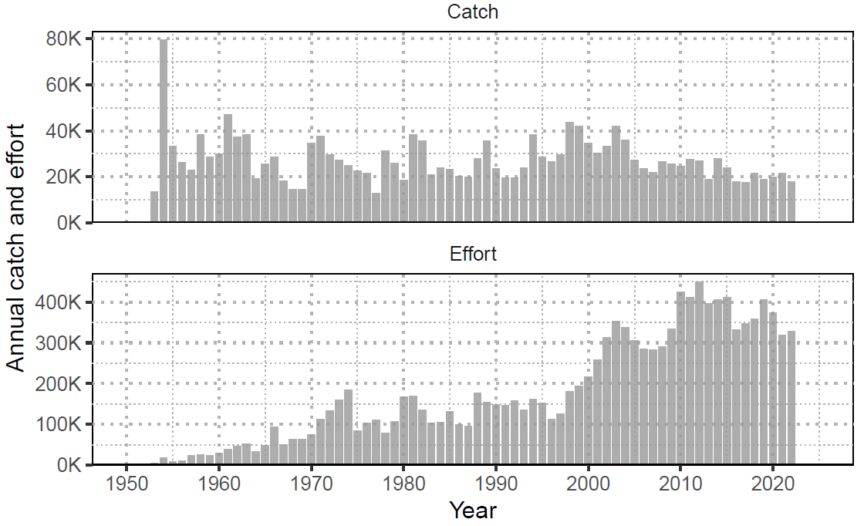
Figure MLS-02 Annual catch (numbers; individuals) of striped marlin and nominal longline effort (hooks fished; thousands) in the Southwest Pacific Ocean (1952-2022).
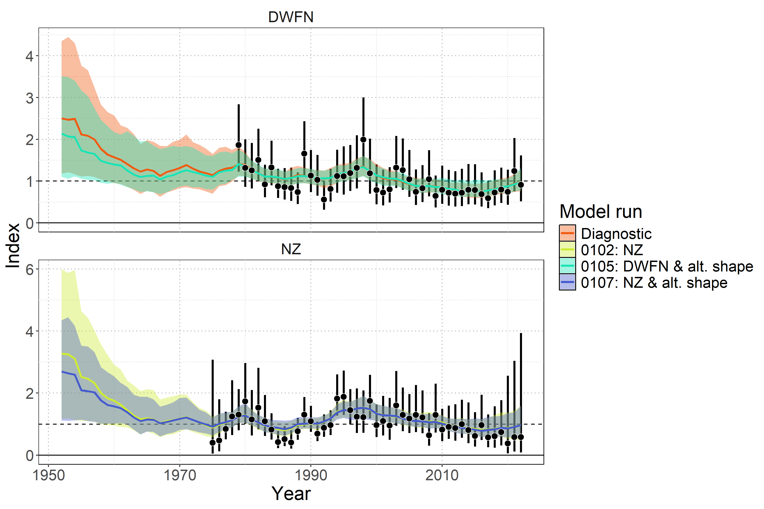
Figure MLS-03 Model fit to standardized index data showing observations (black points with 95% error bars) and model predictions (colored lines and shaded ribbons representing 95% credible intervals). The diagnostic model ( 0100 ) is shown in orange.

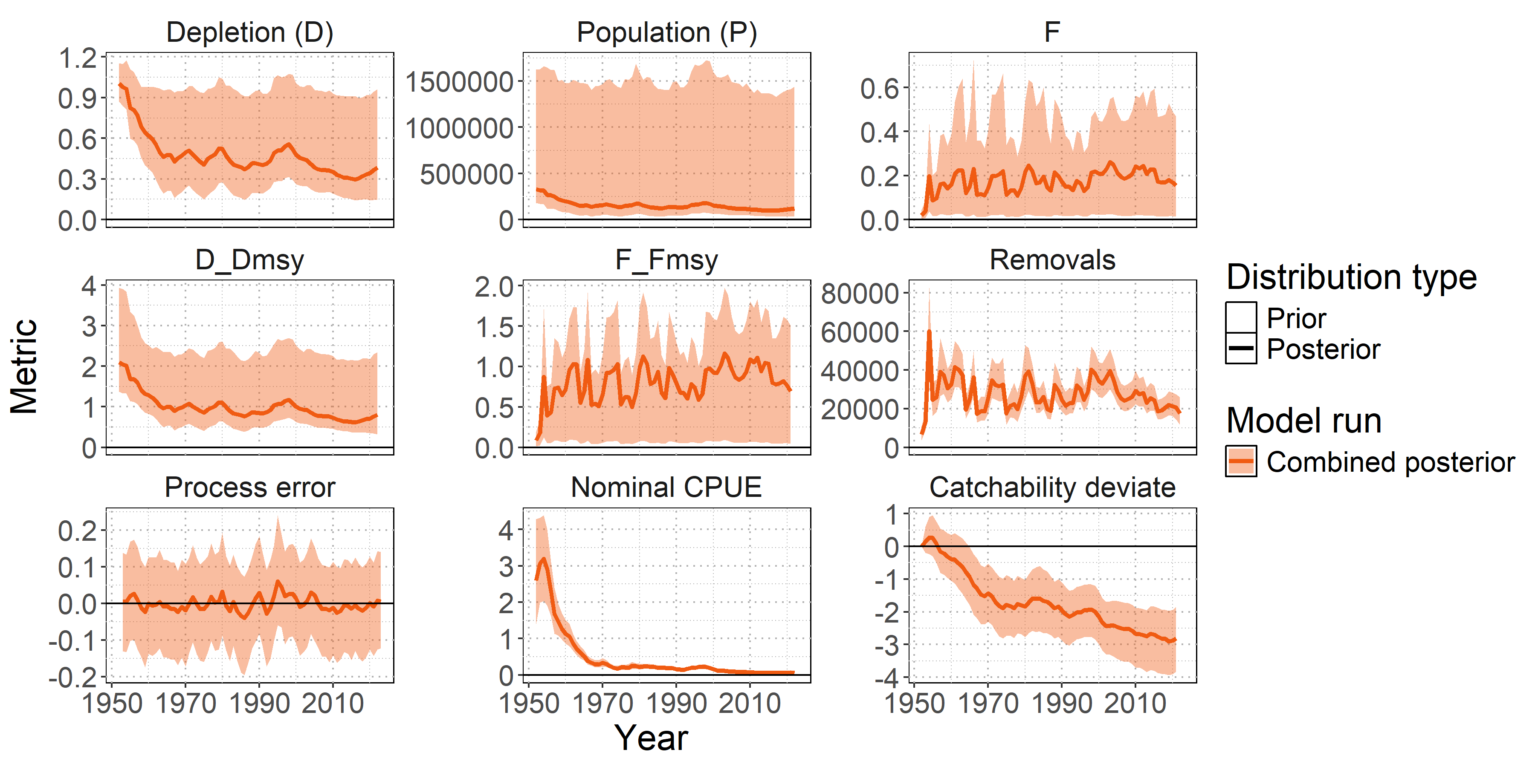
Figure MLS-04 Posterior time series distributions for key derived quantities over time (line = median, shading = 95% credible interval): depletion (D), absolute population size in numbers (P), fishing mortality (F), stock status relative to MSY reference points ($D/D_{MSY}$ , $F/F_{MSY}$ ), total removals in numbers, process error, nominal CPUE (numbers caught per 1000 hooks), and catchability deviates. The model ensemble is shown in orange.

- Stock status

- SWPO striped marlin lacks formal, agreed-upon reference points, so stock status (Table MLS-03) was summarized using MSY-based reference points and total depletion relative to the generalized limit reference point of 20% total depletion from the unfished state ($D/D_{0.2,F=0}$).

- Median recent fishing mortality was below F_{MSY} (F_{recent}/F_{MSY} = 0.77 with a 95% range of 0.05-1.51 and a 22.9% probability of F_{recent} exceeding F_{MSY}. Figure MLS-06) indicating the stock was unlikely to be subject to overfishing.

- Median recent stock abundance was below D_{MSY} (D_{recent}/D_{MSY} = 0.77 with a 95% range of 0.33-2.3 and a 74% probability that the stock abundance was below D_{MSY}. Figure MLS-06) indicating the stock was likely to be overfished. The depletion value at which MSY occurs is 0.48 (the 95% credible interval is 0.26-0.7).

- The stock is very unlikely to be below 20% of the unfished state (Figure MLS-05). The probability of the stock being below D_{0.2,F=0} is 9.2% for the recent period, with a median ratio of 1.84 (95% CI: 0.73 – 4.7295). Noting that this depletion is relative to the 20% total depletion from the equilibrium unfished population level and is not equivalent to the conventional SB/SB_{20%,F=0}.

- SC21 recommended that future work investigate the estimated long-term decline in catchability and evaluate the assumption of stationary productivity, in order to reduce uncertainty and improve confidence in future stock assessments. In addition, it encouraged using the prior information and results from the BSP approach to improve the Stock Synthesis model and to continue using both models in parallel to improve understanding of the status of the SWPO MLS stock.

Table MLS-03. Estimates of management quantities (stock status as depletion D_{recent} relative to MSY), and fishing mortality (F) relative to indicators (F_{MSY}). P(>RP) refers to the probability that the metric (status, fishing mortality) is above the respective indicator.
Summary
Year of assessment: 2025 | Depletion ($D_{recent}$) | Likely (74%) to be below $D_{MSY}$ |  | The stock is overfished
Last year of data: 2022 | Fishing mortality ($F_{recent}$) | Unlikely (23%) to be above $F_{MSY}$ |  | Overfishing is not occurring
 | Projection | $F$ about as likely as not (33-66%) to decline further by 2027 |  | The stock is unlikely (<33%) to be undergoing overfishing in the near term under recent average catch levels.
 |  | $D$ likely (>66%) to increase further by 2027 |  | The stock is about as likely as not (33-66%) to be overfished in the near term under recent average catch levels.
Reference points | Metric | Median [2.5%-97.5% CI] | Likelihood | Recent trend / projection
Depletion | $$D_{MSY}$$ | 0.48 [0.26 – 0.7]
Abundance | $$P_{MSY}$$ | 155,183 n [63,037 – 808,861]
Abundance | $$0.2×log\left(K\right)$$ | 65,041 n [36,198 – 327,844]
Catch | MSY | 29,962 n [25,828 – 184,069]
Fishing mortality | $$F_{MSY}$$ | 0.23 [0.08 – 0.69]
Estimates | Metric | Median [2.5%-97.5% CI] | Likelihood | Recent trend / projection
Depletion | $$D_{latest}$$ | 0.38 [0.14 – 0.96] |  | Increasing
Depletion | $$D_{recent}$$ | 0.37 [0.15 – 0.94] |  | Increasing
Abundance | $$P_{latest}$$ | 121,943 n [34,067 – 1,479,253] |  | Increasing
Abundance | $$P_{recent}$$ | 117,967 n [34,199 – 1,442,511] |  | Increasing
Catch | $$C_{latest}$$ | 17,488 n [11,545 – 25,988] |  | Stable, decreasing
Catch | $$C_{recent}$$ | 20,570 n [13,357 – 28,058] |  | Stable, decreasing
Fishing mortality | $$F_{latest}$$ | 0.15 [0.01 – 0.47] |  | Decreasing
Fishing mortality | $$F_{recent}$$ | 0.17 [0.01 – 0.49] |  | Decreasing
Status | Metric | Median [2.5%-97.5% CI] | Likelihood | Recent trend / projection
Depletion | $$D_{latest}/D_{MSY}$$ | 0.81 [0.32 – 2.36] | Likely (>66%) to be below $D_{MSY}$
Depletion | $$D_{recent}/D_{MSY}$$ | 0.77 [0.33 – 2.3] | Likely (>66%) to be below $D_{MSY}$
Fishing mortality | $$F_{latest}/F_{MSY}$$ | 0.69 [0.05 – 1.51] | Unlikely (<33%) to be above $F_{MSY}$
Fishing mortality | $$F_{recent}/F_{MSY}$$ | 0.77 [0.05 – 1.51] | Unlikely (<33%) to be above $F_{MSY}$
Projections | Metric | Median [2.5%-97.5% CI] | Likelihood | Recent trend / projection
Depletion | $$D_{proj}^{2027}/D_{MSY}$$ | 1.1 [0.13 – 2.47] | About as Likely as Not (33-66%) to be below $D_{MSY}$ | $D_{proj}$ increasing
Fishing mortality | $$F_{proj}^{2027}/F_{MSY}$$ | 0.6 [0.04 – 19.3] | Unlikely (<33%) to be above $F_{MSY}$ | $F_{proj}$ decreasing

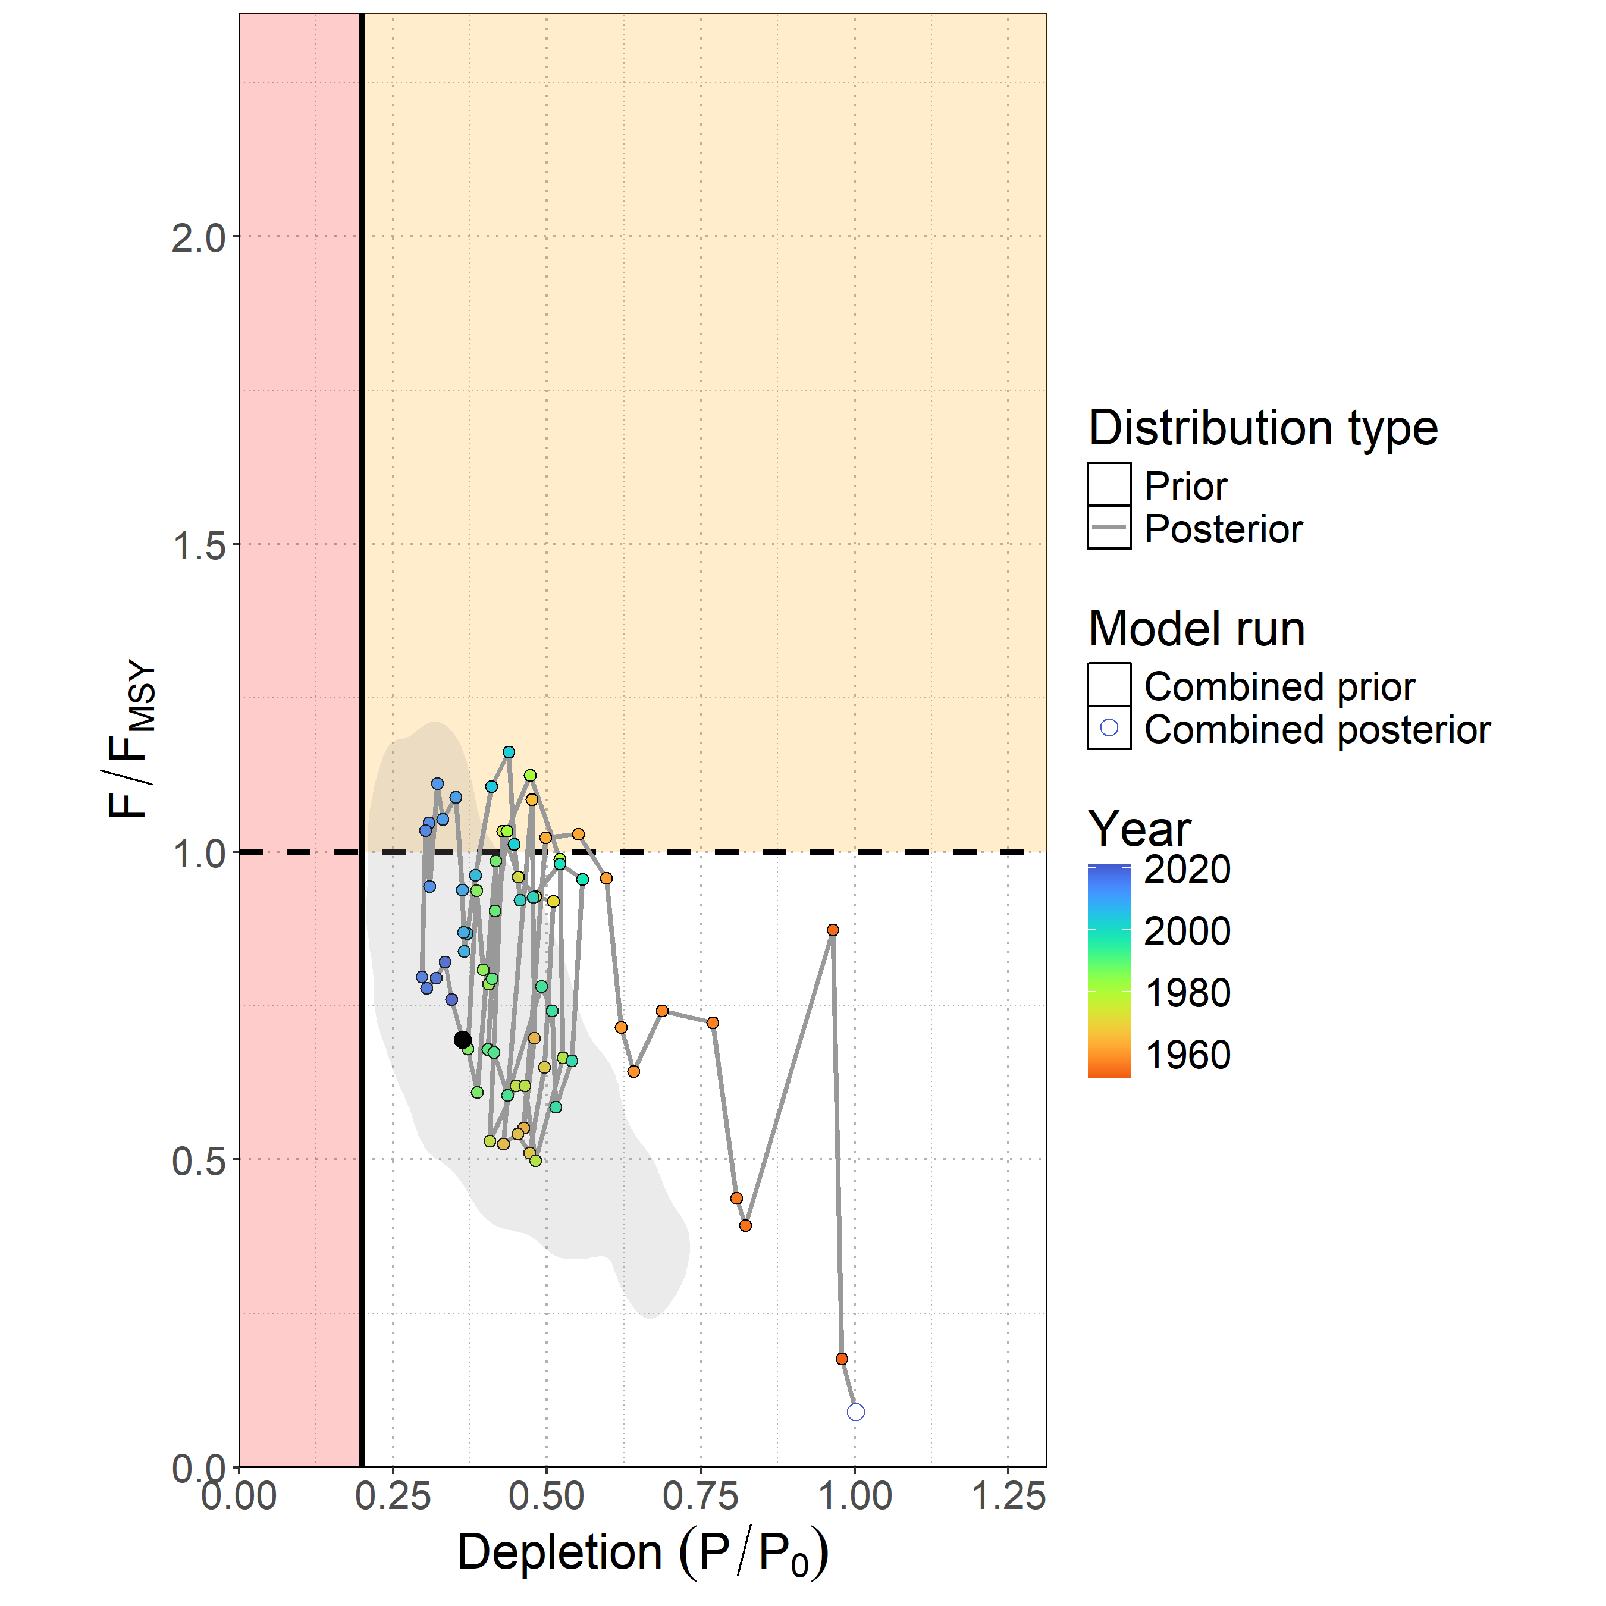
Figure MLS-05. Majuro plot showing the median posterior estimate of the latest stock depletion ($D_{latest} = P_{latest}/P_{0}$) and fishing mortality relative to MSY ($F_{latest}/F_{MSY}$ ). Points represent model estimates colored by year (blue ∼ 2020, green ∼ 1985, orange ∼ 1950), with a connecting line showing the trajectory over time. The gray shaded contour is the bi-variate 95% credible distribution around the terminal year estimate $D_{2022}$ and $F_{2021}/F_{MSY}$.
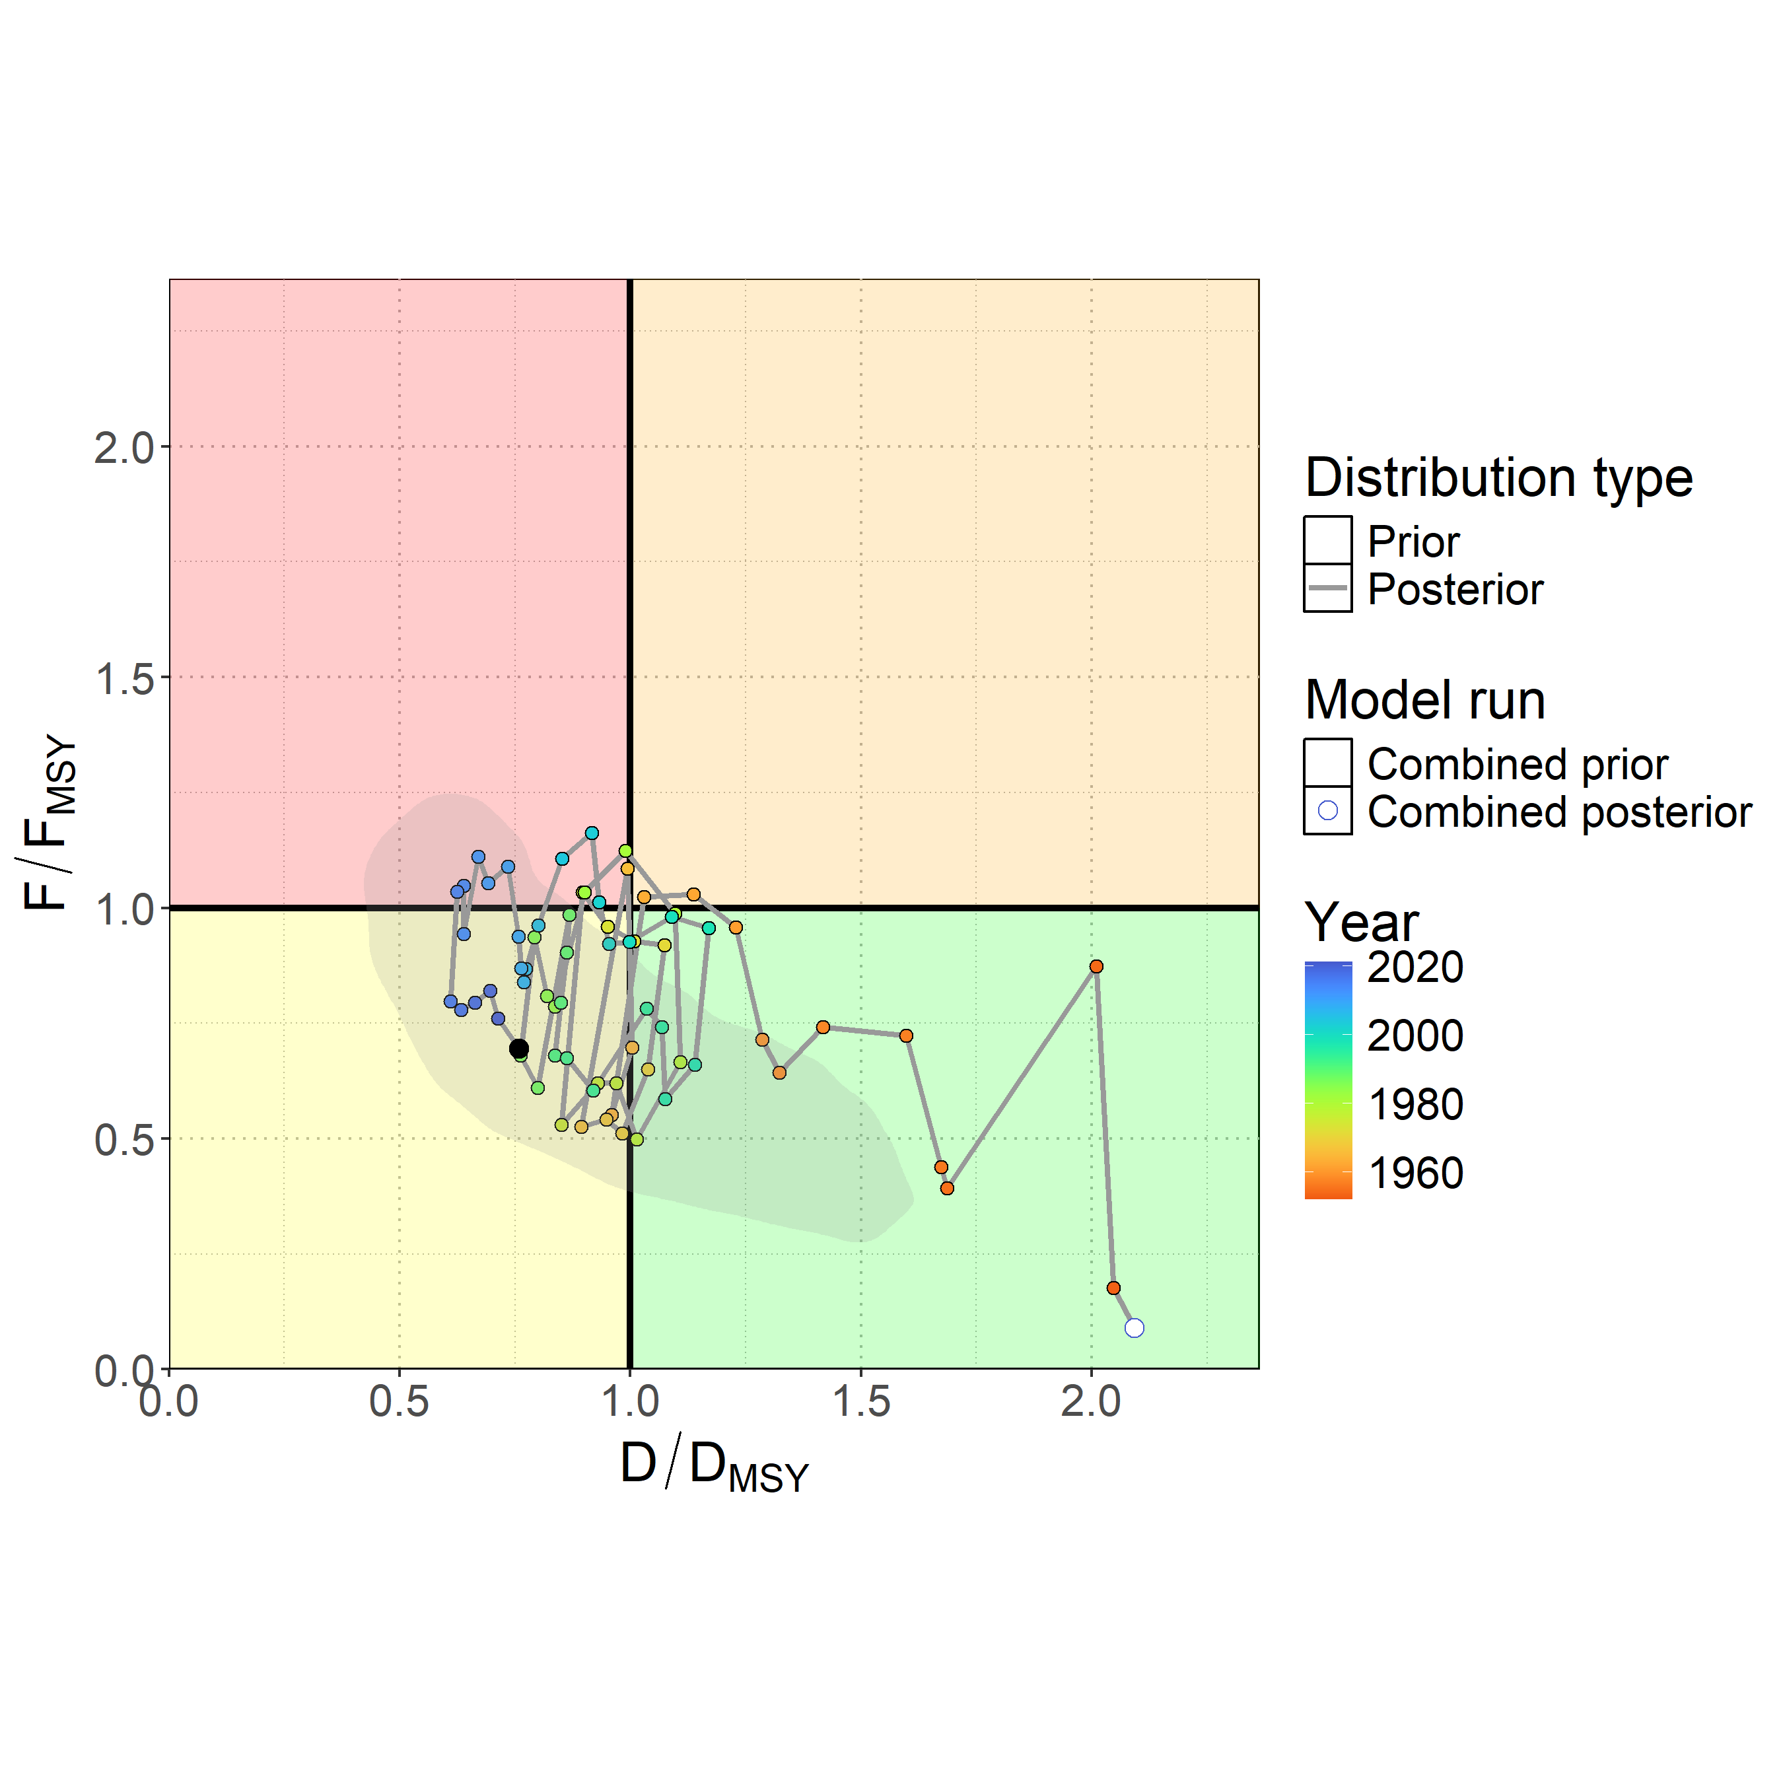
Figure MLS-06. Kobe plot showing the median posterior estimate of the latest stock depletion relative to depletion at MSY ($D_{latest}/D_{MSY}$ ) and fishing mortality relative to MSY ($F_{latest}/F_{MSY}$ ). Points represent model estimates colored by year (blue ∼ 2020, green ∼ 1985, orange ∼ 1950), with a connecting line showing the trajectory over time. The gray shaded contour is the bi-variate 95% credible distribution around the terminal year estimate $D_{2022}/D_{MSY}$ and $F_{2021}/F_{MSY}$ .

- Management advice

- Ten-year stochastic projections (Figure MLS-07), assuming recent average catch levels (2018-2022), indicated continued population recovery through 2032, with a median $D/D_{MSY}$ projected to reach 1.32 by 2032 and only a 26% chance of remaining overfished. Projections to 2025 showed a median $D/D_{MSY}$ of 0.99 with only a 51% chance of being overfished, improving to less than 50% probability by 2026. Fishing mortality was projected to continue declining through the projection period, with a median $F/F_{MSY}$ reaching 0.49 by 2032 and only a 15% chance of overfishing occurring. While continued recovery was expected under status quo catch scenarios, the substantial uncertainty in model inputs was carried forward into projections, and, for example, there remained a very unlikely risk (5%) of the stock declining to less than 5% depletion under recent average catch levels by 2032. This risk would be expected to increase if catches rose above recent average levels.

- SC21 noted that under projections using recent average catch, the stock had a 55% probability of recovering to greater than MSY levels by 2026 (Table MLS-04), and recommended not increasing catch above recent average levels.

- SC21 also agreed that the projections requested in SC20 were likely not necessary based upon the results provided (Agenda item 5.3).

- SC21 noted that the current BSPM may not reflect population dynamics associated with the changing population age structure, and encouraged the SSP to include non-stationary population processes in model parameters to improve understanding of the population dynamics in future assessments.

Table MLS-04. Table of the probability of Southwest Pacific striped marlin reaching D_{MSY} from status quo projections.
Year | Probability
2023 | 38%
2024 | 44%
2025 | 49%
2026 | 55%
2027 | 59%
2028 | 62%
2029 | 66%
2030 | 69%
2031 | 71%
2032 | 74%

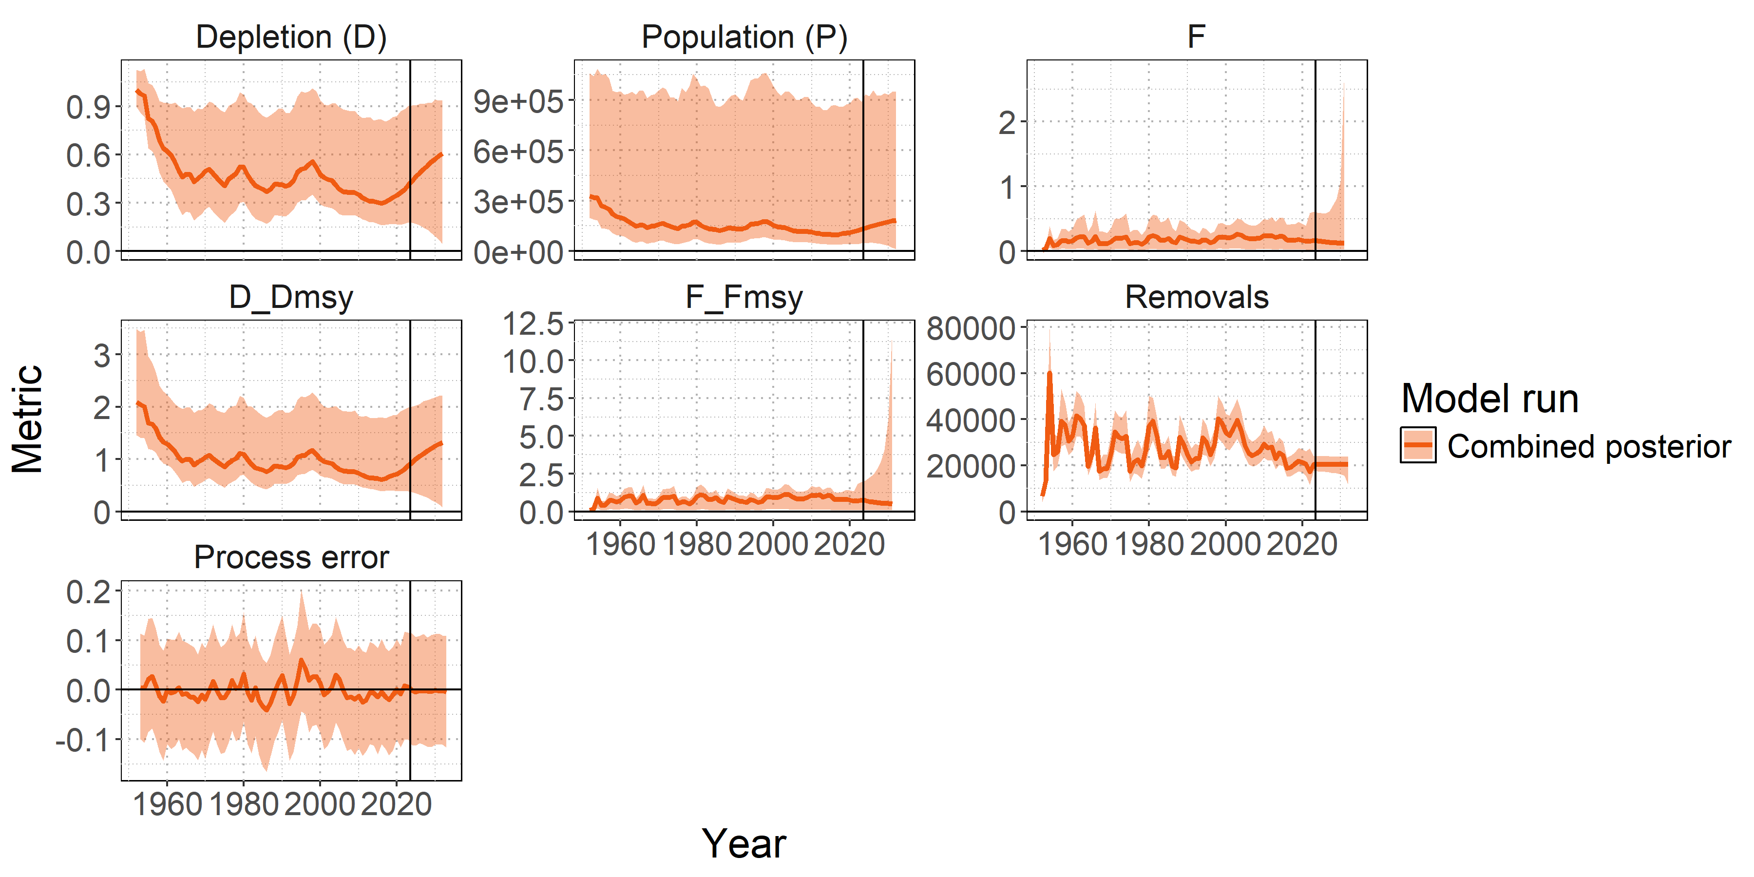
Figure MLS-07. Posterior time series distributions for key derived quantities over time during the forecast period 2023-2032 (line = median, shading = 90% credible interval): depletion (D), absolute population size in numbers (P), fishing mortality (F), stock status relative to MSY reference points ($D/D_{MSY}$ , $F/F_{MSY}$), total removals in numbers, and process error. The model ensemble is shown in orange. A 90% credible interval is shown to restrict the y-axis of the fishing mortality F panel, which shows high values of F in the projection period, as a very small percentage of populations are estimated to go to zero under recent average catch levels.

SC20 2024 (STOCK ASSESSMENT CONDUCTED)

- SC20 thanked the SSP for conducting the stock assessment of the Southwest Pacific striped marlin (SC20-SA-WP-03) and acknowledged their transparency in outlining the issues of serious concern from the SC with the technical aspects of the assessment.

- Noting the above, SC20 recommended that further work, including resolving the conflict between the size composition data and the CPUE indices, should be undertaken as part of a revision to the assessment for consideration at SC21.

- SC20 acknowledged that further work on the assessment will place unplanned additional burden on the assessment team and welcomed the offer from the United States to provide in-kind support to SSP to moderate the impacts to other key SC21 deliverables.

- SC20 encouraged the collection of additional age-at-length data for striped marlin across the southwest Pacific Ocean from 2025-2028, as outlined in the Billfish Research Plan. Additional age-at-length data are needed to further improve growth estimates through the internal estimation of growth within the stock assessment, as recommended by the WCPFC yellowfin assessment peer review.

Provision of scientific information to the Commission
- SC20 reiterated the most recent stock status advice from SC15 that “the stock is likely overfished, and close to undergoing overfishing according to MSY-based reference points.”

- SC20 recommended that a revised assessment be presented at SC21 which includes presentation of the projection scenarios.

- SC20 recommended the WCPFC21 request a tractable set of projections, including, but not limited to the four scenarios proposed below:

- Status quo scenario: Projection based on recent catch levels;
- Recovery scenario 1: Catch levels that result to a median depletion of 20% within 10 years;
- Recovery scenario 2 Catch levels that result to a median depletion of 30% within 10 years; and
- Non-retention/live release scenario: Catch levels that reflect the likely outcomes under a management measure requiring the release of live animals or non-retention of all animals.

SC16, 2020 – SC19, 2023 (NO STOCK ASSESSMENTS)

- Stock Status

      - SC19 noted that no stock assessments were conducted for southwest Pacific striped marlin in 2023. Therefore, the stock status descriptions from SC15 are still current for southwest Pacific striped marlin.

- Management Advice

      - SC19 noted that the previous management advice from SC15 should be maintained, pending a new assessment or other new information. For further information on the management advice and implications from SC15, please see below.

SC15 2019 (STOCK ASSESSMENT CONDUCTED)

- Stock status and trends

- The description of the updated structural sensitivity grid used to characterize uncertainty in the assessment is provided in Table SMLS-01. The spatial structure used in the assessment model is shown in Figure SMLS-01, with sub-regions used to define fisheries shown. Catch trend data is presented in Figure SMLS-02. Estimated annual average recruitment, spawning biomass, and total biomass from the diagnostic case are shown in Figure SMLS-03. Fishing mortality and depletion estimated from the diagnostic case are shown in Figures SMLS-04 and SMLS-05, respectively. The median and 80 percent quantile trajectories of the fishing depletion for models in the structural uncertainty across the grid axes in Table SMLS-01 are shown in Figure SMLS-6.

- The Majuro plot summarizing the results for each of the models in the structural uncertainty grid retained for management advice are represented in Figure SMLS-07. Figure SMLS-08 presents the Kobe plot summarizing the results for each of the models in the structural uncertainty grid retained for management advice.

- SC15 noted that the median of recent spawning biomass depletion relative to the unfished condition was (SB_{recent}/SB_{F=0}) = 0.198, with a probable range of 0.093 to 0.464 (80% probable range), and there was a roughly 50.33% probability (151 out of 300 models) that the recent spawning biomass depletion relative to the unfished condition was below the LRP adopted for tunas (SB_{recent}/SB_{F=0} = 0.2). The median estimate (0.198) is below that estimated from the previous (2012) assessment (SB₂₀₀₆₋₂₀₀₉/SB_{F=0} = 0.34) (see SC8-SA-WP-05), noting the differences in the use of the grid in the two assessments and different model assumptions. In the current assessment the feasible grid consisted of 300 models (186 model runs removed from 486 grid models).

- SC15 noted that the median of recent spawning biomass relative to the spawning biomass at MSY was (SB_{recent}/SB_{MSY}) = 0.737 with a probable range of 0.334 to 1.635 (80% probable range), and there was a roughly 68.66% probability (206 out of 300 models) that the recent spawning biomass depletion was below the spawning biomass at MSY. The median estimate (0.737) is below that estimated from the previous (2012) assessment (SB_{current}/SB_{MSY} = 0.87) (see SC8-SA-WP-05), noting the differences between the two assessments.

- SC15 noted that the median of relative recent fishing mortality was (F_{recent}/F_{MSY} = 0.911) with an 80% probability interval of 0.313 to 1.891, and there was a roughly 44.3% probability (133 out of 300 models) that the recent fishing mortality was above F_{MSY}. The median estimate (0.911) is above that estimated from the previous assessment (F_{current}/F_{MSY} = 0.81) (see SC8-SA-WP-05), noting the differences in the use of the grid in the two assessments.

Table SMLS-01. Description of the structural sensitivity grid used to characterize uncertainty in the assessment. The star denotes the level assumed in the diagnostic case.
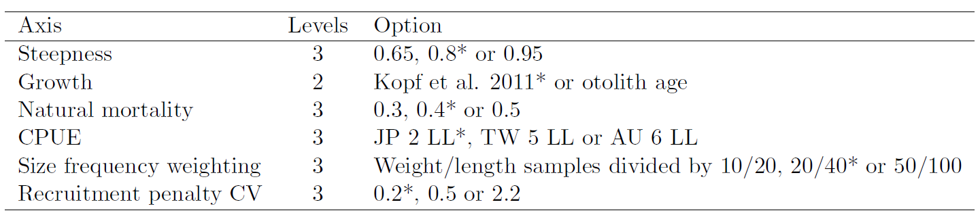

Table SMLS-02. Summary reference points over the models in the structural uncertainty grid.
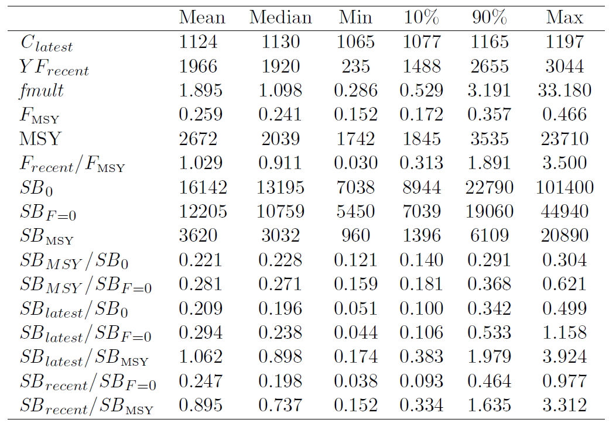

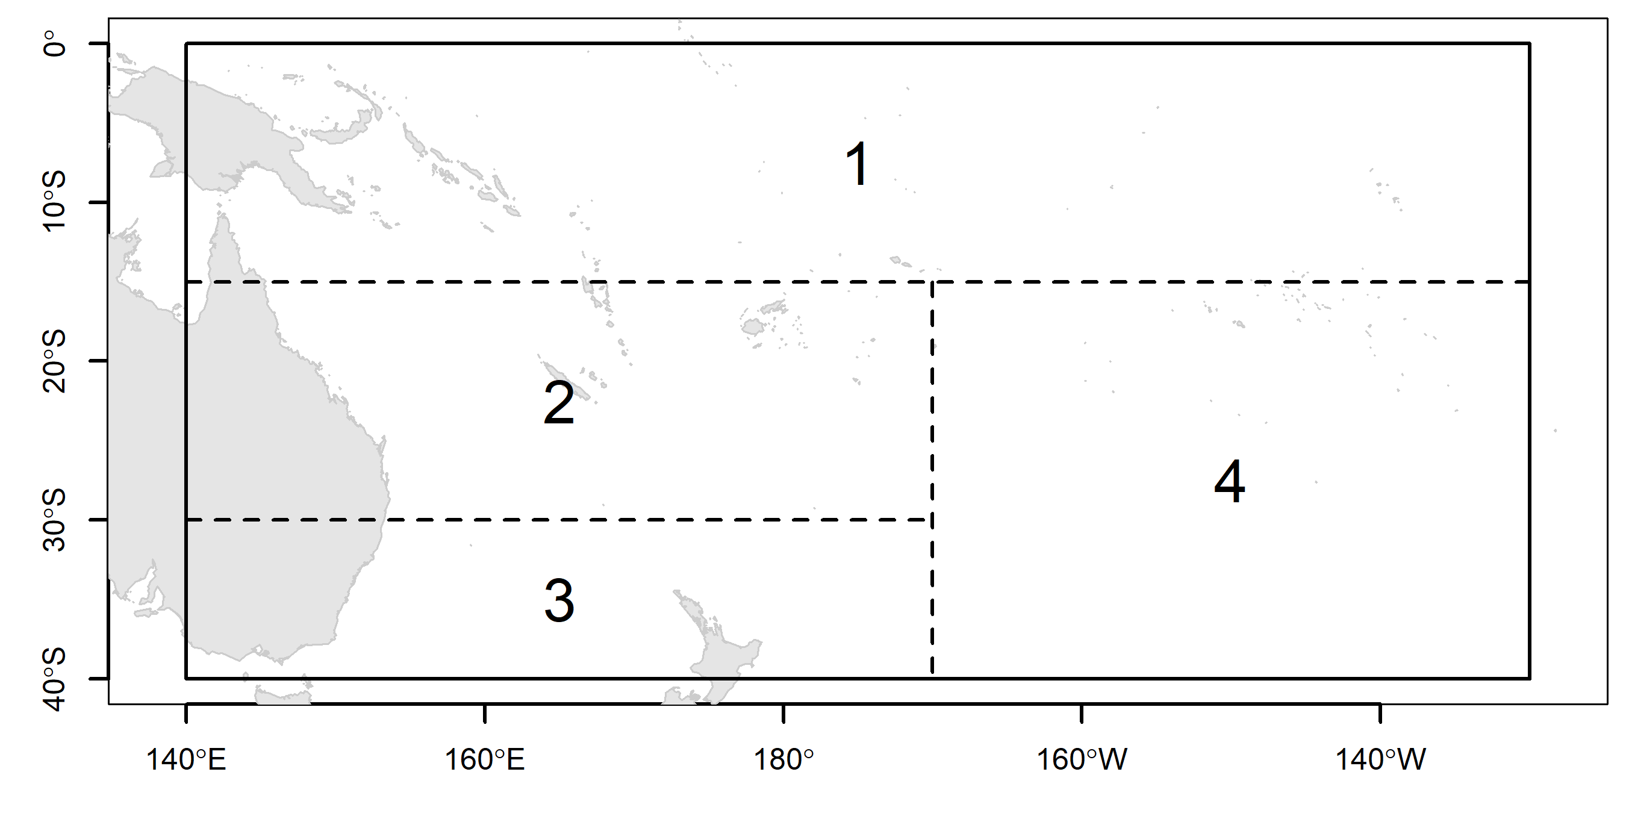 | 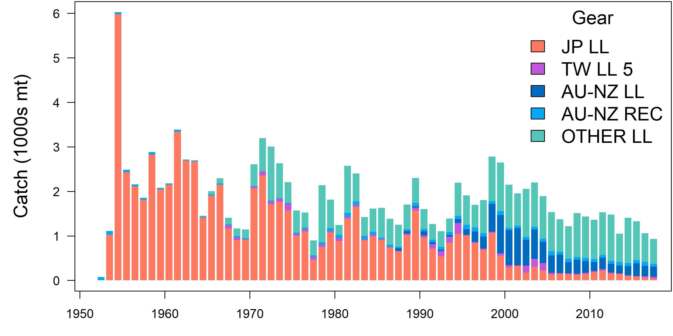
Figure SMLS-01. Single region spatial structure used in the 2019 stock assessment. | Figure SMLS-02. Time series of total annual catch (1000s mt) by fishery group over the full assessment period.
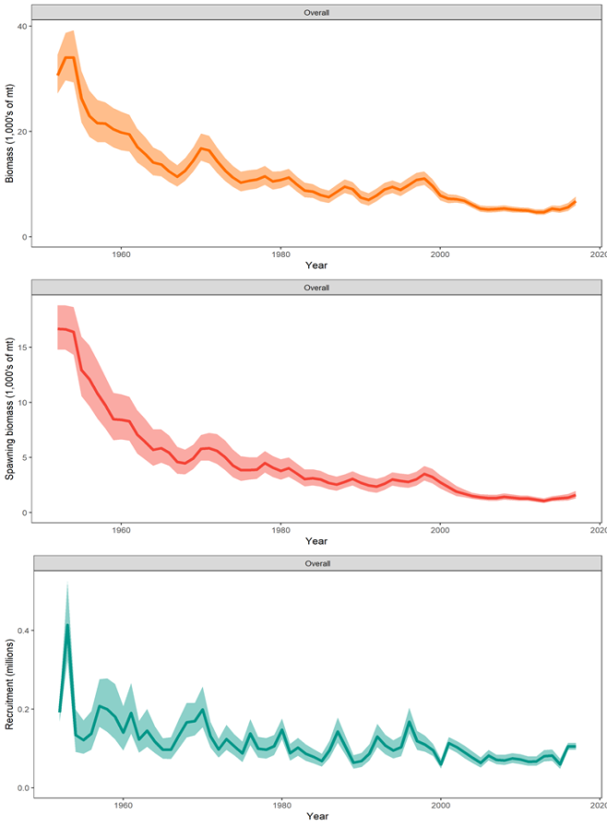 | Figure SMLS-03. Estimated annual average total biomass, spawning biomass, and recruitment for the diagnostic model. Shaded region gives ± 2 standard deviations (i.e., 95% CI).

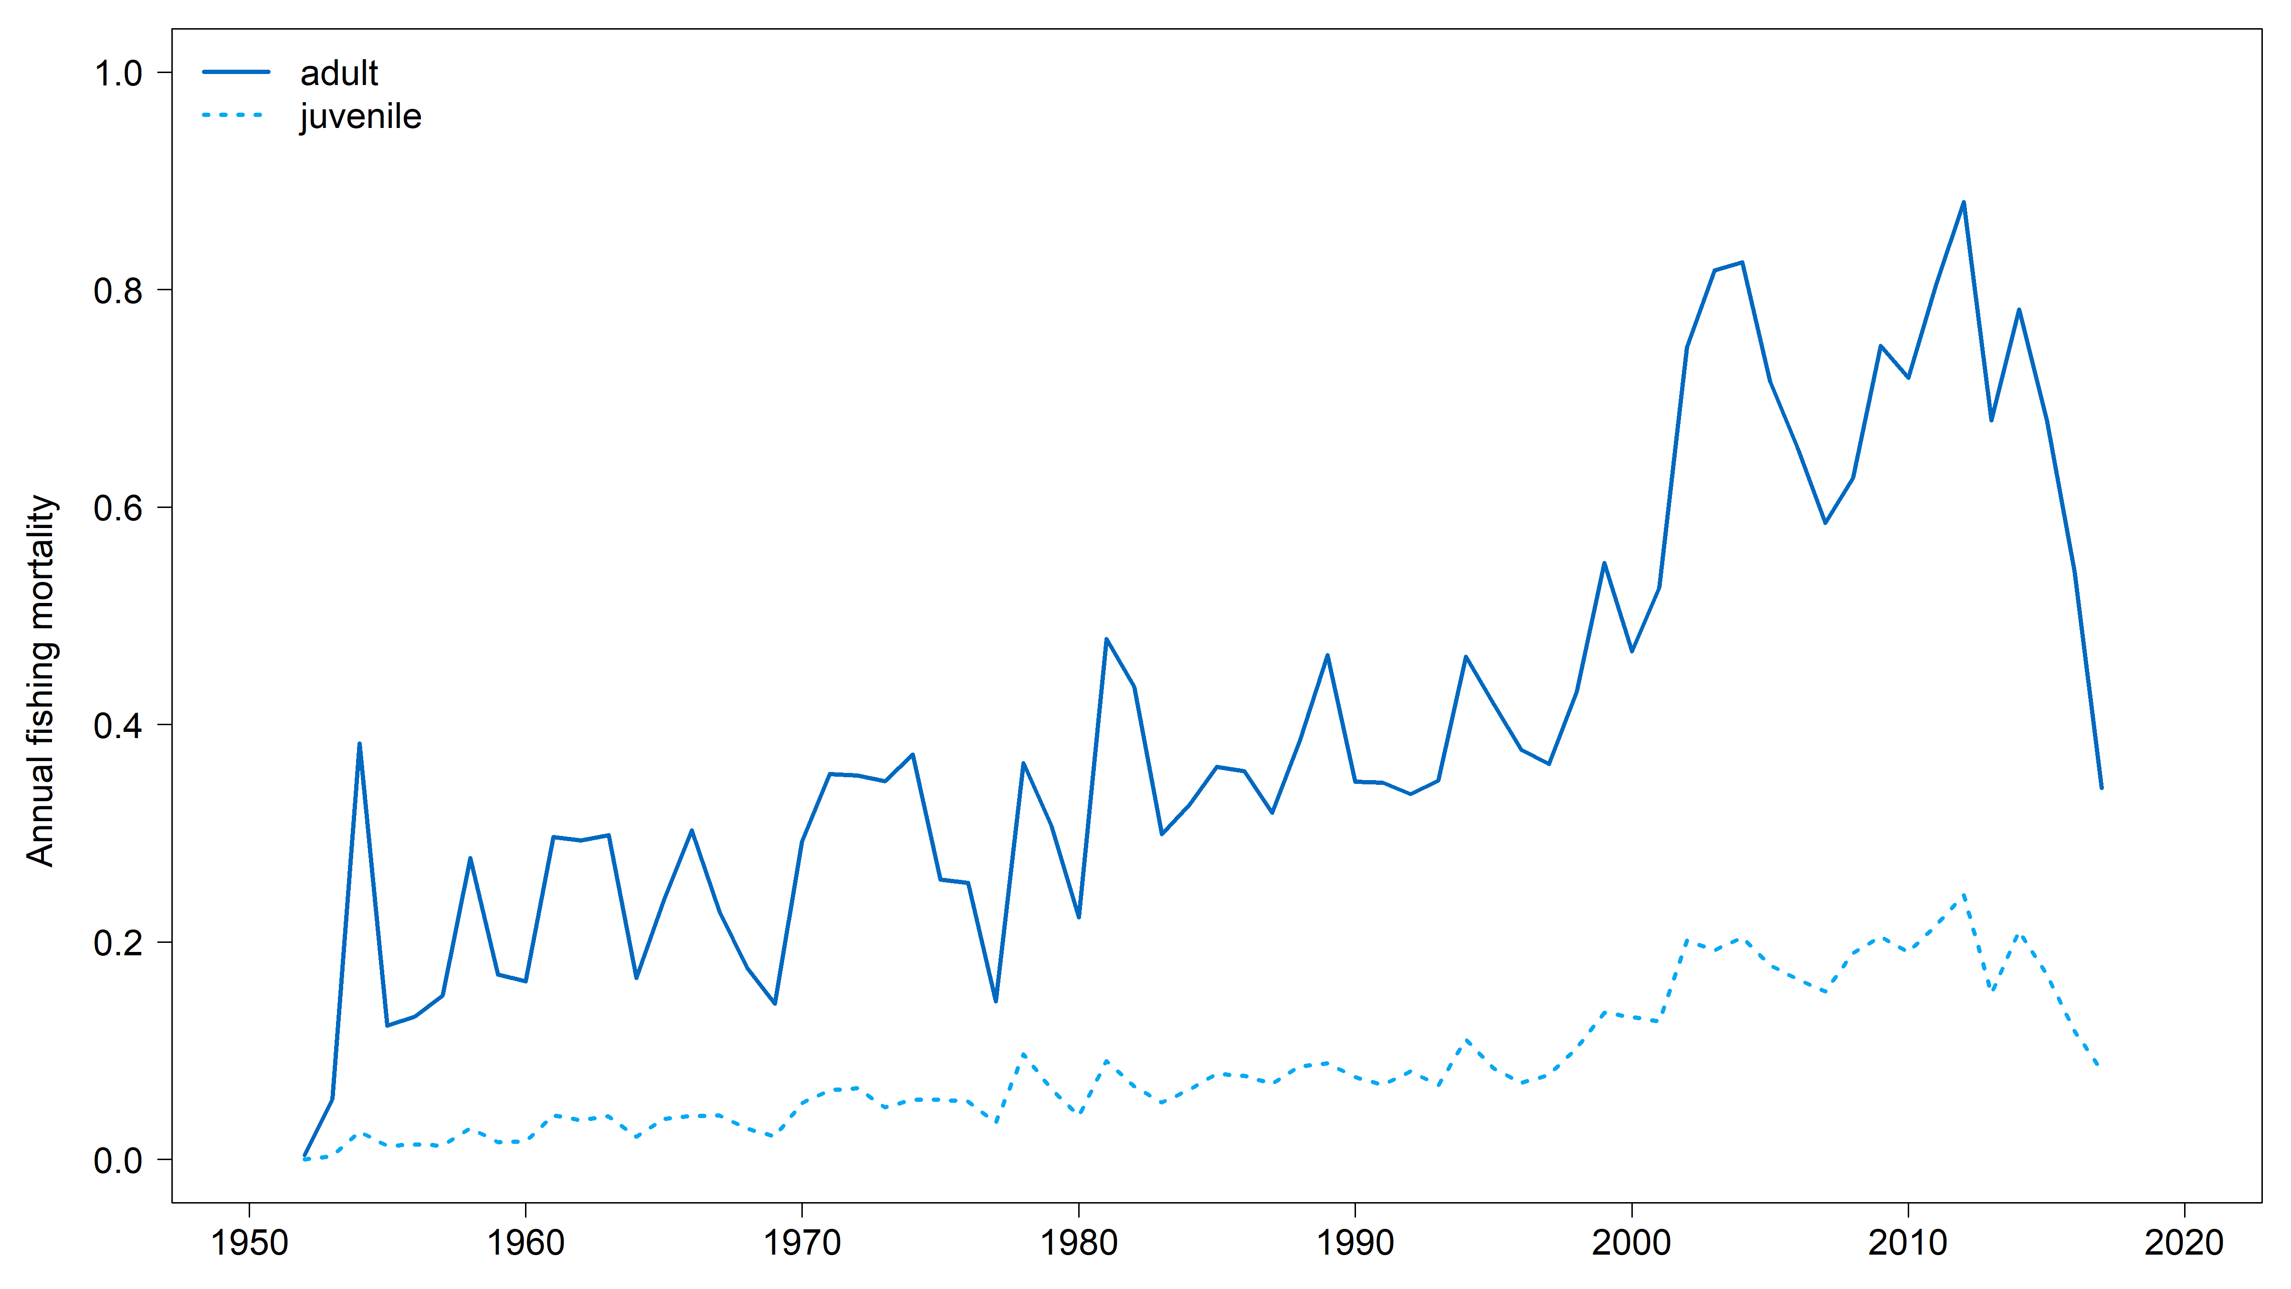 | 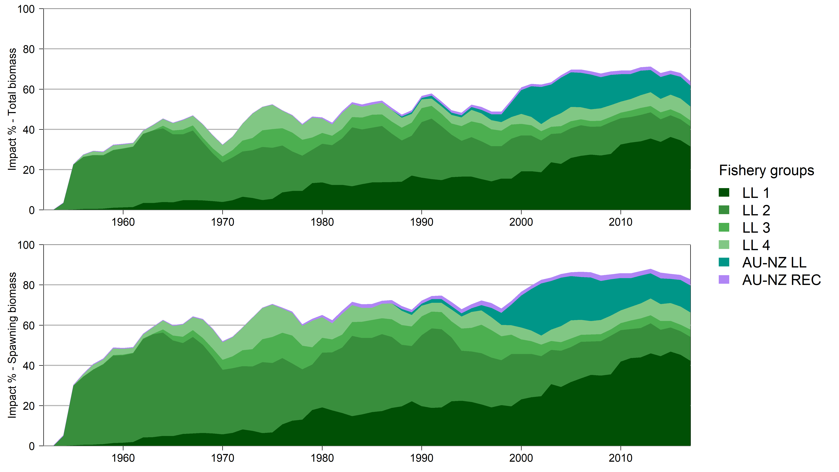
Figure SMLS-04. Estimated annual average juvenile and adult fishing mortality for the diagnostic model. | Figure SMLS-05. Estimates in reduction in spawning biomass and total biomass due to fishery impact for the diagnostic case model.

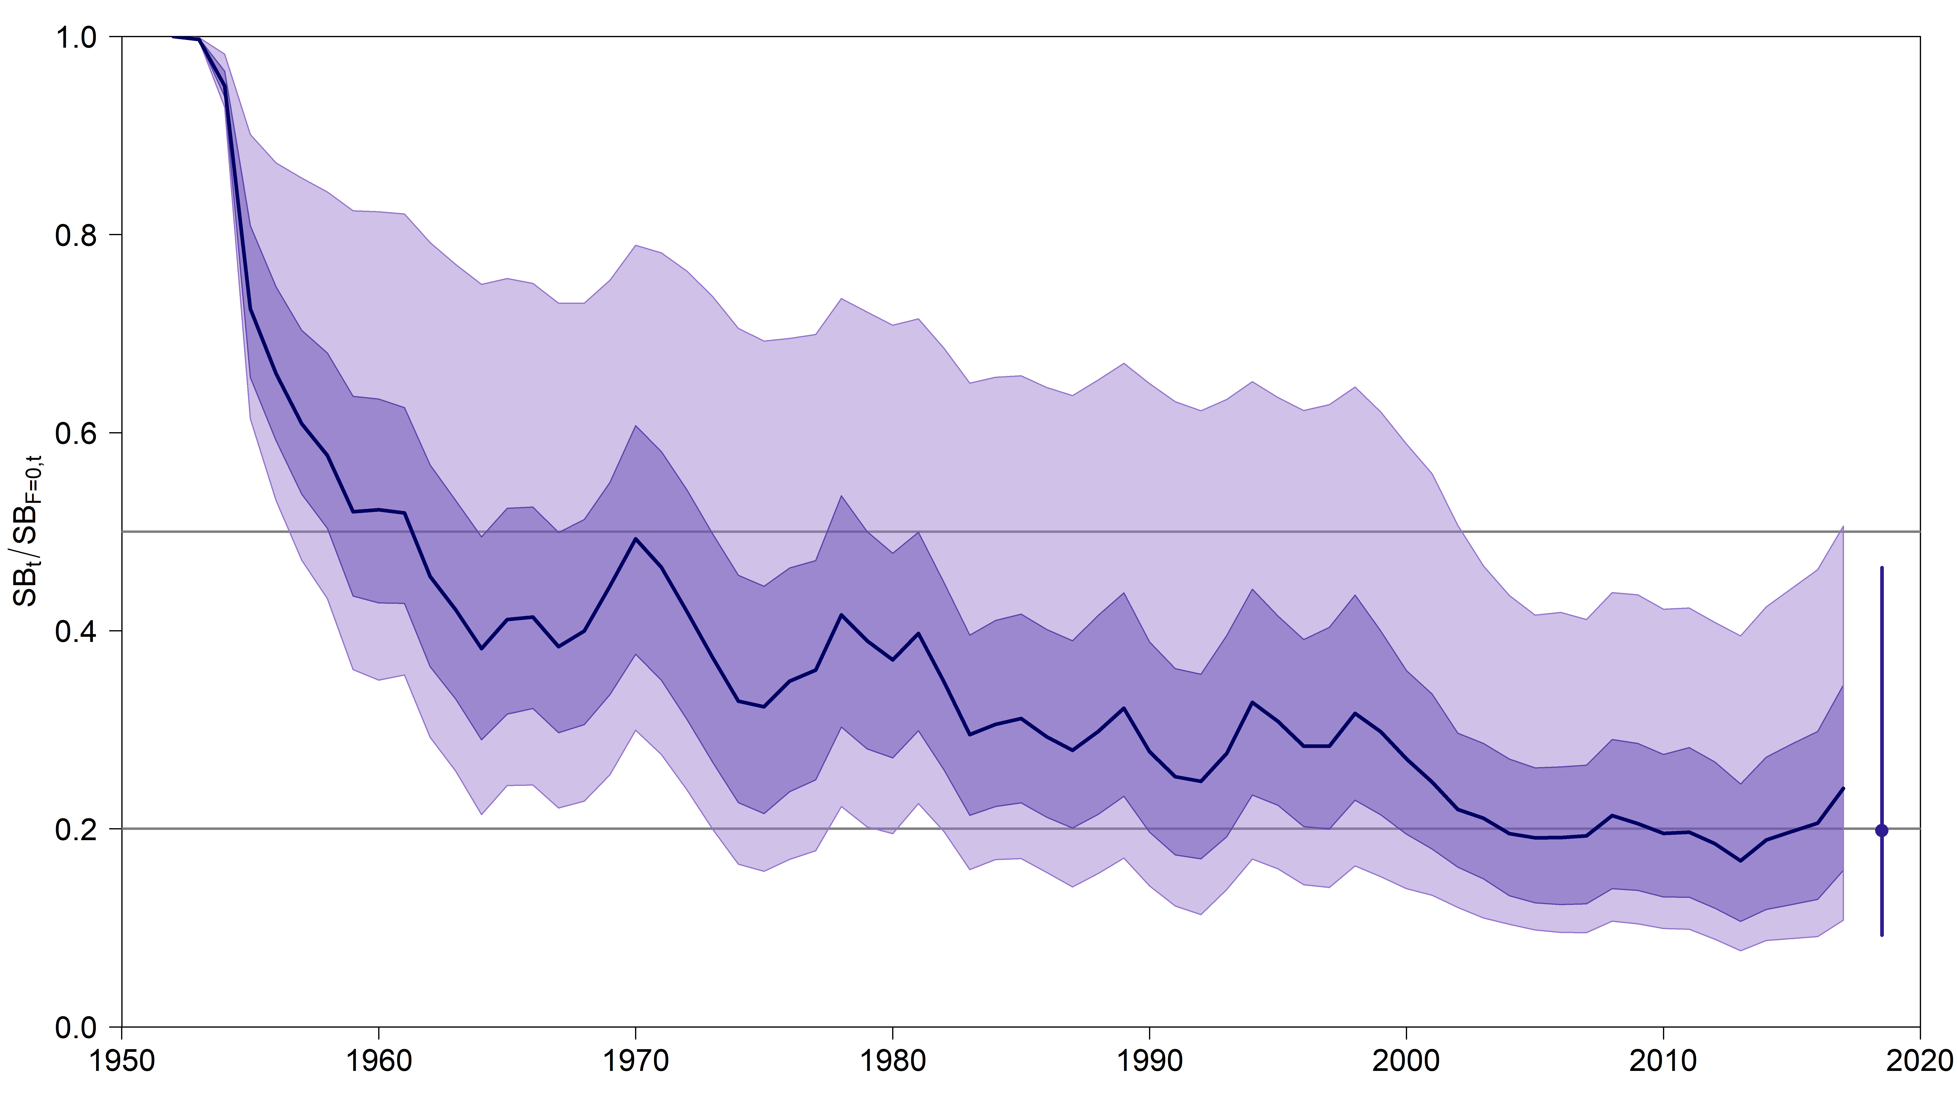 | 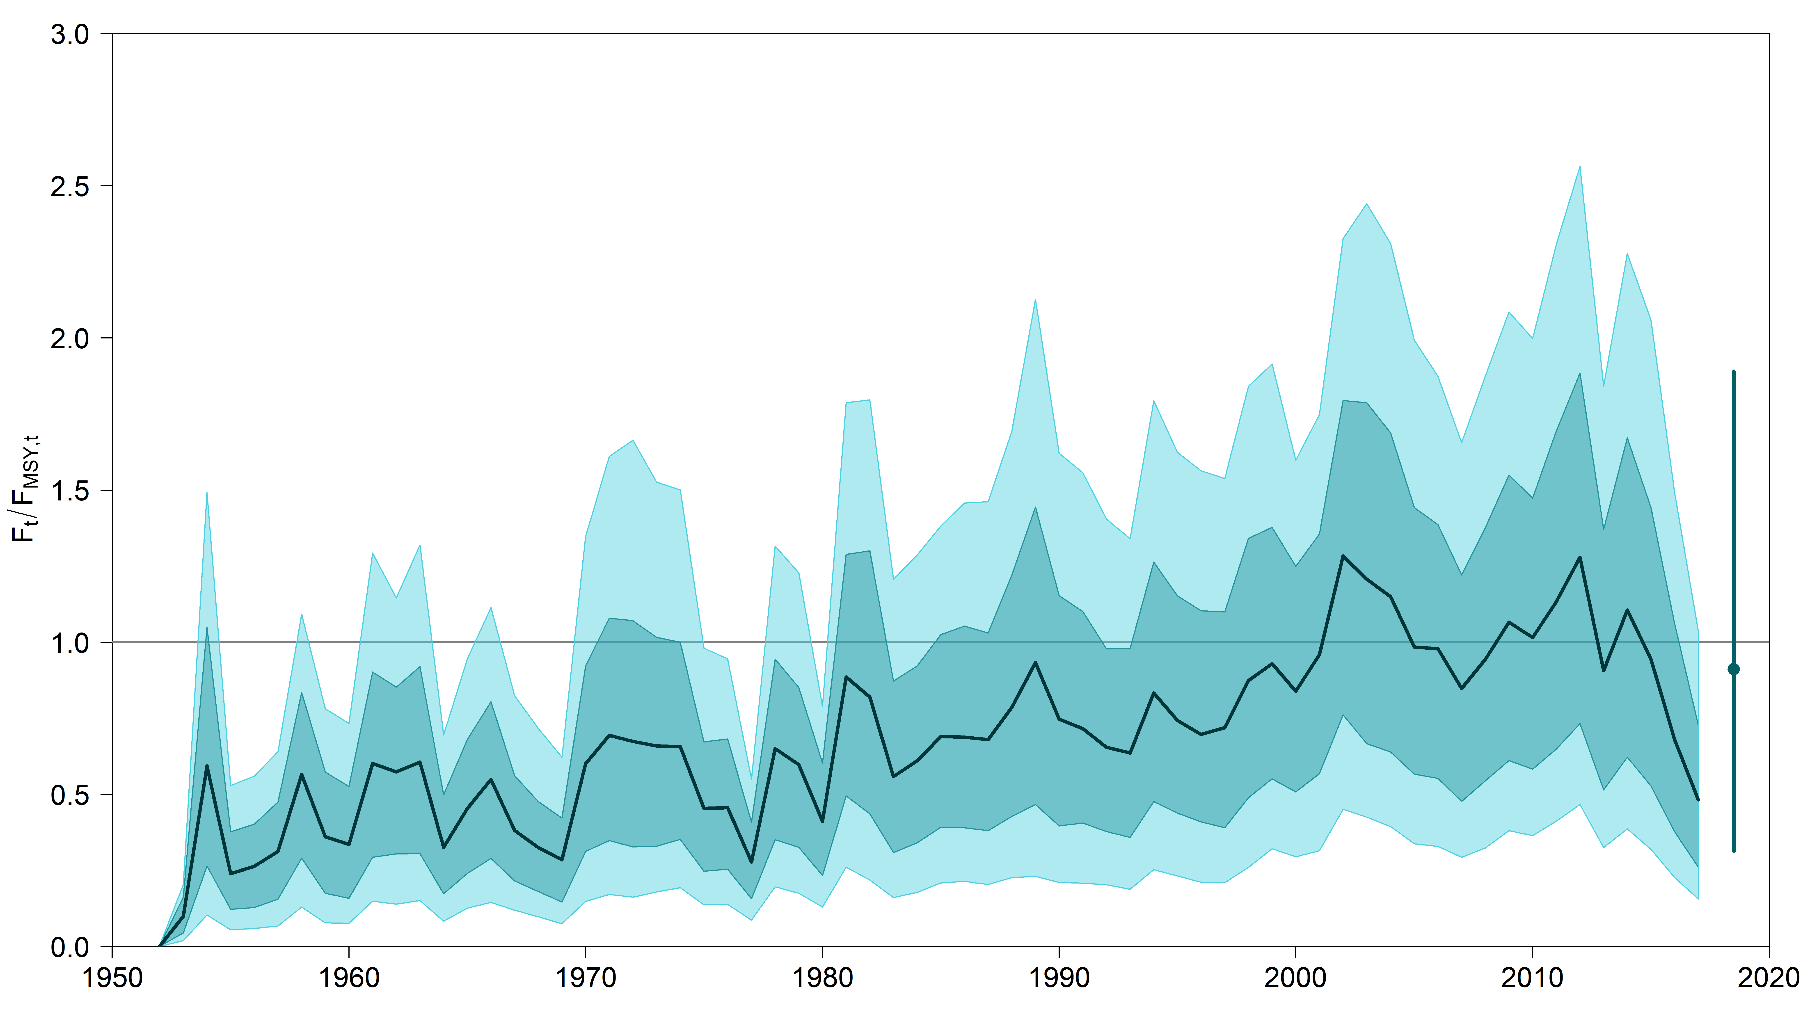
Figure SMLS-06. Plot showing the trajectories of spawning biomass depletion for the model runs included in the structural uncertainty grid described in Table SMLS-01. Gray horizontal lines indicate 50% and 20% levels of depletion. On the right of the depletion is the median point estimate of the recent level reference point with the bar indicating the 80th percentile. | Figure SMLS-06bis. Plot showing the trajectories of fishing mortality for the model runs included in the structural uncertainty grid described in Table SMLS-01. Gray horizontal lines indicate F_{MSY}. On the right of the depletion is the median point estimate of the recent level reference point with the bar indicating the 80th percentile.
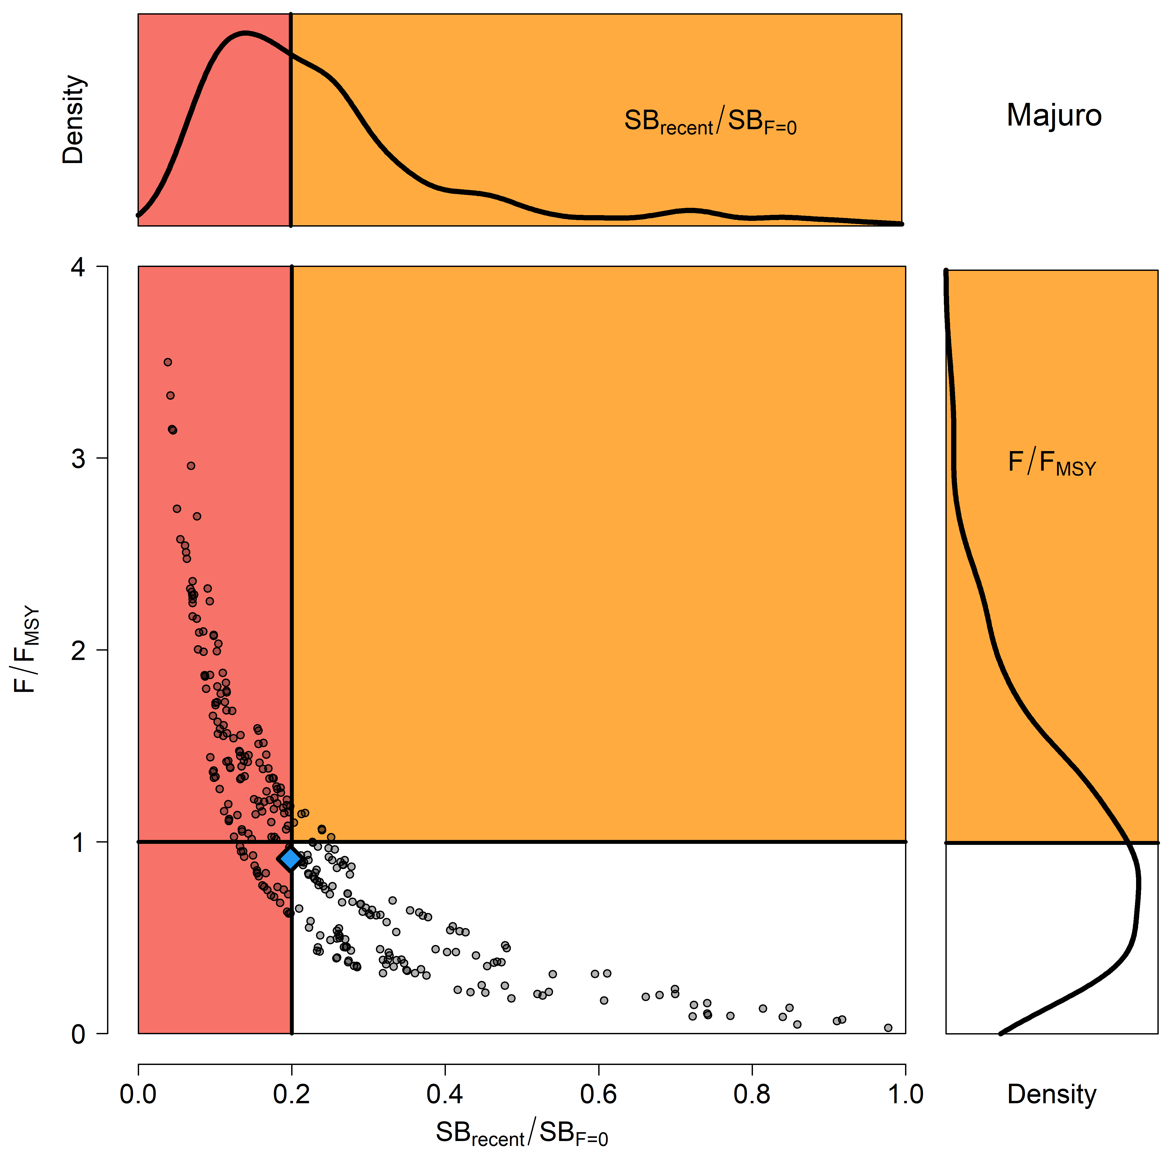 | 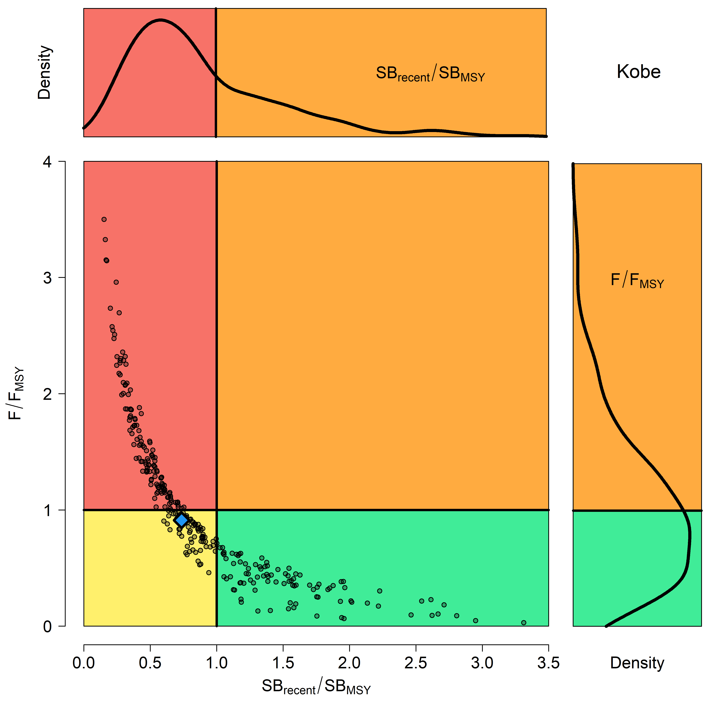
Figure SMLS-07. Majuro plot for the recent spawning biomass (2014 – 2017) summarizing the results for each of the models in the structural uncertainty grid. The plots represent estimates of stock status in terms of spawning biomass depletion and fishing mortality, and marginal distributions of each are presented. The blue square is the median of the grid. | Figure SMLS-08. Kobe plot for the recent spawning biomass (2014 – 2017) summarizing the results for each of the models in the structural uncertainty grid. The plots represent estimates of stock status in terms of spawning biomass relative to the spawning biomass that produces MSY and fishing mortality, and marginal distributions of each are presented. The blue square is the median of the grid.

- Management Advice and implications

- SC15 noted that there are no agreed limit reference points for the WCPO billfish. However, SC15 also noted that based on the adopted uncertainty grid, the southwest Pacific striped marlin assessment results indicate that the stock is likely overfished, and close to undergoing overfishing according to MSY-based reference points. SC15 recommends that WCPFC16 identify an appropriate limit reference point for this stock. Key management quantities can be found in Table SMLS-02. The recent spawning biomass depletion relative to the unfished condition was close to the LRP adopted for tunas (SB_{recent}/SB_{F=0} = 0.2).

- SC15 noted that recent catches are approximately half the MSY, and that recent fishing mortality is slightly less than the fishing mortality that would result in MSY.

- SC15 recommended SC16 use stochastic stock projections, including the expansion of the geographic scope of CMM2006-04 by assuming average fishing effort during 2000-2004 by CCMs and zero fishing mortality in assessment region 1, to evaluate the potential long-term performance of the CMM.

- SC15 recommended that WCPFC16 consider measures to reduce the overall catch of this stock, including through the expansion of the geographical scope of CMM2006-04, in order to cover the distribution range of the stock.

- Research recommendations

- The following research activities were recommended by SC15 in order to progress the assessment of Southwestern Pacific striped marlin.
- Improved estimates of life history parameters including growth, maturity, and natural mortality. Verify the aging method used to derive the growth relationship in order to inform meta analyses for M and steepness specific to SWPO striped marlin. Additionally, efforts should be made to increase sampling of smaller individuals.
- Better estimates of striped marlin movement (>180 days) are needed to characterize mixing rates across model region in order to develop spatially explicit model structure and improve upon “areas as fleets” approach.
- Improved estimates of conversion factors (such as weight-to-length and length-to-length) are needed, together with improved length-at-age estimates to better inform the data inputs used in the stock assessment.
- Conduct sensitivities analyses with respect to the uncertainties in conversion factors used in the stock assessment and assess whether this should be included as an axis in the structural uncertainty grid.
- Develop better estimates of historical catch (1950-1960) to resolve the potential issue of misidentification caused by merging the billfishes datasets.

SC9, 2013 – SC14, 2018 (NO STOCK ASSESSMENTS)

- Stock Status

      - SC14 noted that no stock assessments were conducted for southwest Pacific striped marlin in 2018. Therefore, the stock status descriptions from SC8 are still current for southwest Pacific striped marlin. Updated information on catches was compiled but not reviewed by SC14.

- Management Advice

      - SC14 noted that no management advice has been provided since SC8 for southwest Pacific striped marlin. Therefore, previous advice should be maintained, pending a new assessment or other new information. For further information on the management advice and implications from SC8, please see below.

Useful References

SC21-SA-WP-06 Revised 2024 stock assessment of striped marlin in the southwestern Pacific Ocean: Part 1- integrated assessment in Stock Synthesis (Rev.03). C. Castillo-Jord´an, N. Ducharme-Barth, P. Hamer, J. Day, N. Davies, T. Peatman, K. Kim https://meetings.wcpfc.int/node/26682

SC21-SA-WP-07 2025 Stock Assessment of Striped Marlin in the Southwest Pacific Ocean: Part II – Bayesian Surplus Production Model (Rev.01). N. Ducharme-Barth, C. Castillo-Jordán, F. Carvalho, P. Hamer https://meetings.wcpfc.int/node/26683

SC20-SA-WP-03 Stock Assessment of Striped Marlin in the Southwest Pacific Ocean: 2024 (Rev.02).
C. Castillo-Jordan, J. Day, T. Teears, N. Davies, J. Hampton, S. McKechnie, A. Magnusson, T. Peatman, T. Vidal, P. Williams, and P. Hamer https://meetings.wcpfc.int/node/23120

SC15-SA-WP-07 Stock assessment of SW Pacific striped marlin in the WCPO. https://www.wcpfc.int/node/42933

SC15-SA-IP-07 Background analyses for the 2019 stock assessment of SW Pacific striped marlin. https://www.wcpfc.int/node/42944

SC15-SA-IP-16 Characterisation of New Zealand striped marlin fisheries. https://www.wcpfc.int/node/2851

SC15-SA-IP-18 Preliminary ageing of striped marlin in the southwest Pacific using otoliths. https://www.wcpfc.int/node/43330

SC9-SA-WP-07 Distribution of longline catches for southwest Pacific striped marlin.
https://www.wcpfc.int/node/3704

SC8-SA-WP-05 Stock Assessment of Striped Marlin (Kajikia audax) in the Southwest Pacific Ocean. https://www.wcpfc.int/node/3234

SC2-SA-WP-06 Stock assessment of striped marlin (Tetrapturus audax) in the southwest Pacific Ocean. https://wcpfc.int/meetings/2nd-regular-session

