

The Commission for the Conservation and Management of
Highly Migratory Fish Stocks in the Western and Central Pacific Ocean

Scientific Committee

South Pacific Swordfish (Xiphias gladius)

Stock Status AND Management Advice

Contents
SC21-2025 (STOCK ASSESSMENT CONDUCTED) 3
SC18-2022 to SC20-2024 (NO STOCK ASSESSMENT WAS CONDUCTED) 3
SC17-2021 (STOCK ASSESSMENT CONDUCTED) 4
SC16-2020 (NO STOCK ASSESSMENT) 11
SC15-2019 (NO STOCK ASSESSMENT) 11
SC14-2018 (NO STOCK ASSESSMENT) 12
SC13-2017 (Stock Assessment Conducted) 12
Useful References 20
Previous Assessments 20

SC21-2025 (STOCK ASSESSMENT CONDUCTED)

Southwest Pacific swordfish (Xiphias gladius) stock assessment

- SC21 thanked the SSP for their thorough work conducted on the Southwest Pacific swordfish stock assessment and for the considerable efforts to improve the assessment, particularly by transitioning to a Stock Synthesis model, implementing a two-sex model, including conditional-age-at-length data, and using length-based selectivity.

SC21 accepted this assessment for management advice and expressed overall confidence in the assessment, noting the model still shows some lack of fit to the CPUE index, and diagnostics still suggest some model mis-specification. The need for increased collection of conditional age-at-length data, improving limitations of the size composition data, a better understanding of potential boundary effects on the assessment, further work on CPUE indices, and further refining the stock assessment model structure were noted.

Provision of scientific information to the Commission

- Stock assessment and trends

The 2025 stock assessment of the southwest Pacific Ocean swordfish adopts a two-region spatial structure with three subregions within each region (Figure SWO-01). The model assumes a fixed quarterly movement between these two regions and a single reproductive stock, with 19 extraction fisheries (Table SWO-01), each operating in one of 6 sub-regions.

The major structural uncertainties considered include incorporating: two alternative CPUE indices for region 2; three fixed values for steepness; two options for the proportion of recruitment in each region; three movement rate options between the two regions; five data weighting options for the length and weight composition data; and two options for natural mortality (Table SWO-02). These axes of structural uncertainty were incorporated into the estimates of reference point values listed in Table SWO-03.

The annual catches show a generally moderate increase through to the late 1990s, when there was a notable increase to a peak in annual catches in 2007, followed by a general decrease in catches through to 2023. However, recent catches remain twice as large as the catches during the early 1990s (Figure SWO-02).

Catches in the WCPFC-CA south of the equator but north of 20ºS, and therefore not managed by CMM 2009-03, have accounted for 42% of the catch in the most recent period (2021-2024; Figure SWO-03).

Both the Australian CPUE index (Figure SWO-04a) and the New Zealand CPUE index (Figure SWO-4b) peak in the 2010s, but with no obvious longer-term trends that would indicate a general increase or decrease in the population size. The CPUE indices start much later (1998 for the Australian index and 2004 for the New Zealand index) than the catch series (1953).

The estimated absolute recruitment and recruitment deviations (Figure SWO-05) suggest some autocorrelation, and they appear to be partly driven by the pattern in the CPUE indices. The estimated time series of spawning biomass by region (Figure SWO-06) also reflects the pattern seen in the CPUE, but with a declining trend since the late 1990s, to match the increase in catches in this period. Fishing mortality started to increase in the late 1990s (Figures SWO-07) and has been relatively stable, fluctuating around a higher historical average mortality level, since around 2005.

The model convergence is very good, as seen from the jitter analysis. However, likelihood profiles indicate some conflict in the data. The retrospective analysis indicates sensitivity to recent data, and the ASPM indicates that the population scale is not well determined by the CPUE.

The spawning biomass trajectory is relatively stable into the mid-1990s (Figure SWO-08), followed by a period of decline and then a period of some recovery, from 2008-2015, followed by a further decline. The spawning biomass relative to SB_{MSY}, the default WCPFC reference point, shows a similar pattern (Figure SWO-09).

The 2025 stock assessment results are generally similar to the previous assessment, indicating that the stock is unlikely to be experiencing overfishing or to be overfished, albeit with tighter uncertainty bounds, which are likely to be underestimated due to the simplified model structure and the limited range of options explored in the uncertainty grid.

Table SWO-01. Definition of fisheries by model regions (1, 2), fleet areas (N, C, S), and flags. Extraction fisheries: 1-19 and CPUE indices: 20-21), and indication of whether catch data is in tonnes (t) or numbers of fish (nos).
Fishery | Catch
01.DW.1N | nos
02.DW.1C | nos
03.DW.1S | nos
04.AU.1N | nos
05.AU.1C | nos
06.AU.1S | nos
07.EU.1C | t
08.PICT.1N | nos
09.PICT.1C | nos
10.DW.2N | nos
11.DW.2C | nos
12.DW.2S | nos
13.NZ.2C | nos
14.NZ.2S | nos
15.EU.2N | t
16.EU.2C | t
17.EU.2S | t
18.PICT.2N | nos
19.PICT.2C | nos
Index fisheries
20.AU.IDX.1 | nos
21.NZ.IDX.2 | nos

Table SWO-02. Key sources of uncertainty in the 2025 Southwest Pacific swordfish stock assessment.
TYPE | RATIONALE | UNCERTAINTY | IMPACT | CONFIDENCE
DATA
CPUE | Best available standardised indices, incorporating operational data,  multiple indices. | Not a spatio-temporal index, limited spatial range for index fisheries compared to fishery range, mostly bycatch fisheries | May not be representative of the full stock | Medium
Catch | Best available information | Good certainty, mandatory catch reporting | Minor | High
Length | Representative sampling | Considerable uncertainty in some data sources.  Conversion factors, patchy sampling, and likely selective sampling issues. | May have temporal variation, but due to filtering and data weighting, the impact of unreliable data will be low. | Medium
Weight | Representative sampling | Conversion factors have some uncertainty. Weight sampling programs have high coverage from some fisheries, but restricted spatial coverage. | Medium | High (but spatial coverage is low)
Age | Representative sampling | Very limited temporal and spatial sampling of age composition data. | Influences estimated growth | Low
MODEL
Stock Synthesis | Widely used platform | Low, well-tested | Single model framework used for inference | High
SPATIAL ASSUMPTIONS
2 regions | Based on the movement of satellite tags | High uncertainty in spatial structure, only one spatial structure considered. | Potentially important, but uncertainty not quantified, impact unknown | Low
KEY PARAMETER UNCERTAINTY
M | Estimable | Estimated and fixed (in grid) | Influential in the grid | Medium
Steepness | Not estimable in the current model | Grid (0.7, 0.8, 0.9) | Influential in the grid | High
Growth | Estimable | Estimated variance of length-at-age fixed | Not included in the grid | Medium
Recruitment proportion | Not estimable in the current model | Grid (1:3, 1:4) | Some influence on the grid | Medium
Movement | External estimates | Grid (halving each of the 2 movement rates successively) | Limited influence on the grid | Low
STRUCTURAL UNCERTAINTIES
CPUE options | PICT observer index in region 2 | Limited time series | Potentially important | Medium
Estimation uncertainty
Hessian | Variance-covariance estimates | Calculated | Important | High
Other source of uncertainty
Climate | Possible recruitment impacts | Not considered | Changes to productivity parameters | Low
Stock structure |  | Not considered | Unknown | Low
Spatial variation in growth |  | Not considered | Unknown | Low

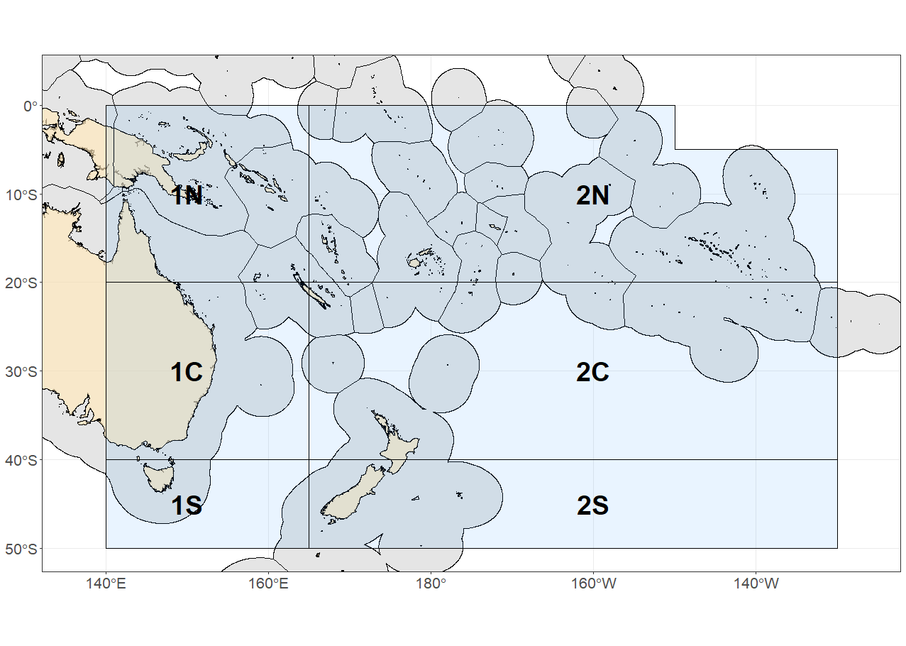
Figure SWO-01. The geographical area covered by the stock assessment and the boundaries of the two model regions (1, 2) and six subregions (N, C, S) used for the 2025 southwest Pacific swordfish assessment.

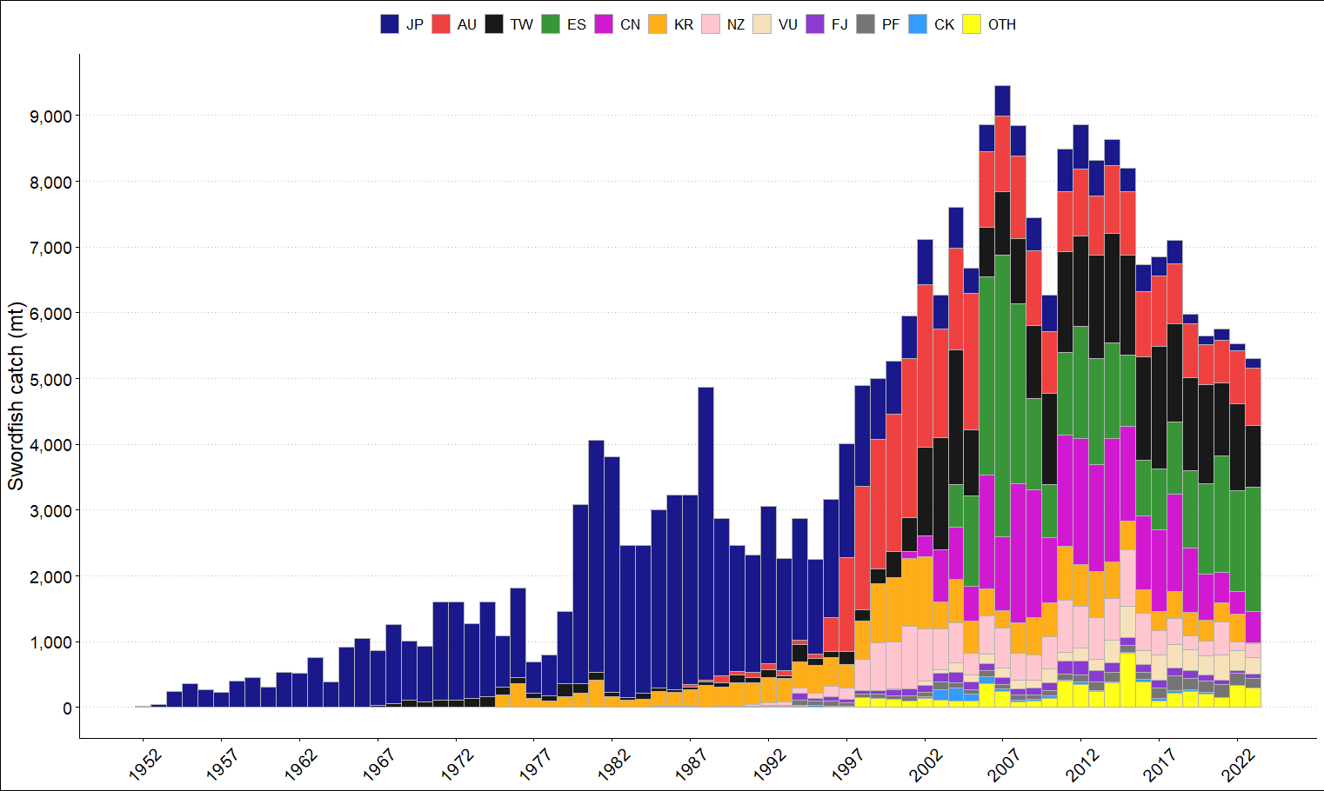
Figure SWO-02. Annual catches of southwest Pacific swordfish by flag in the area covered by the assessment.

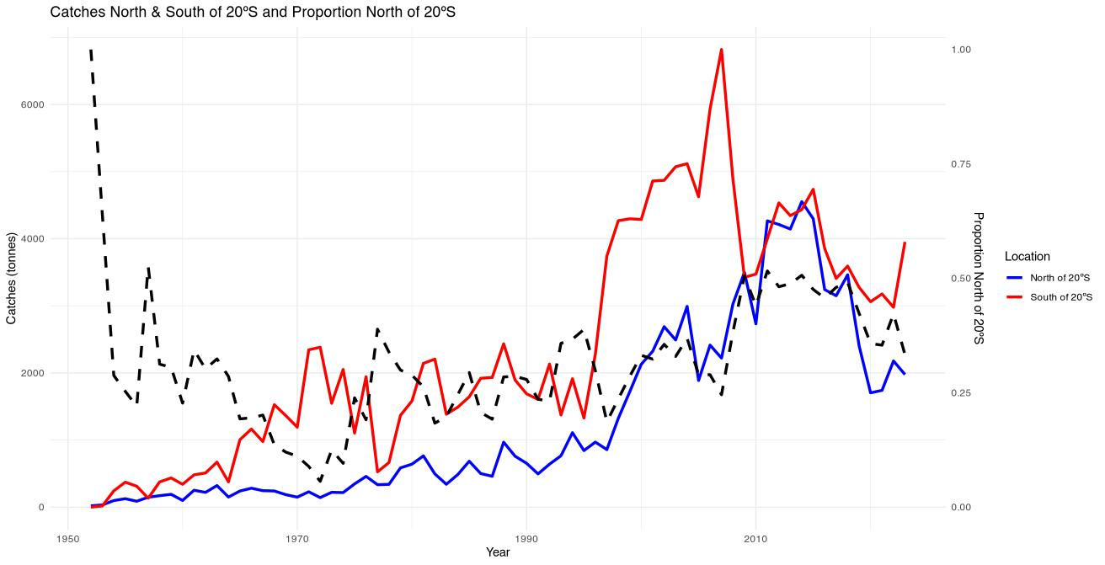
Figure SWO-03. Plot of the total Southwest Pacific swordfish catch (primary axis) south of 20S (red line), between the equator and 20S (blue line), and proportion of catch between the equator and 20S (dashed black line, secondary axis) by year in the WCPFC-CA.

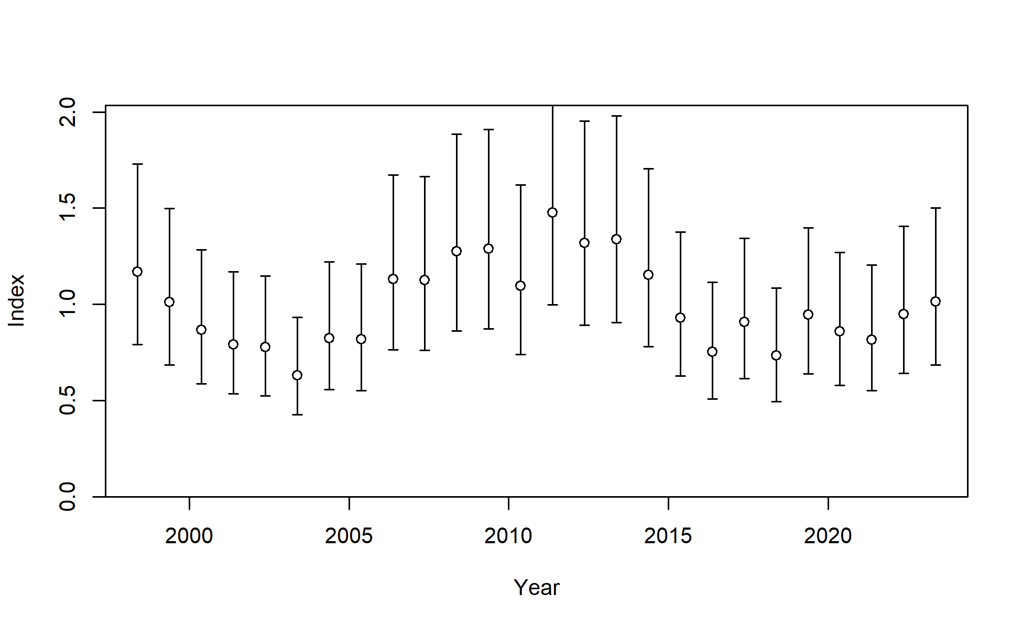

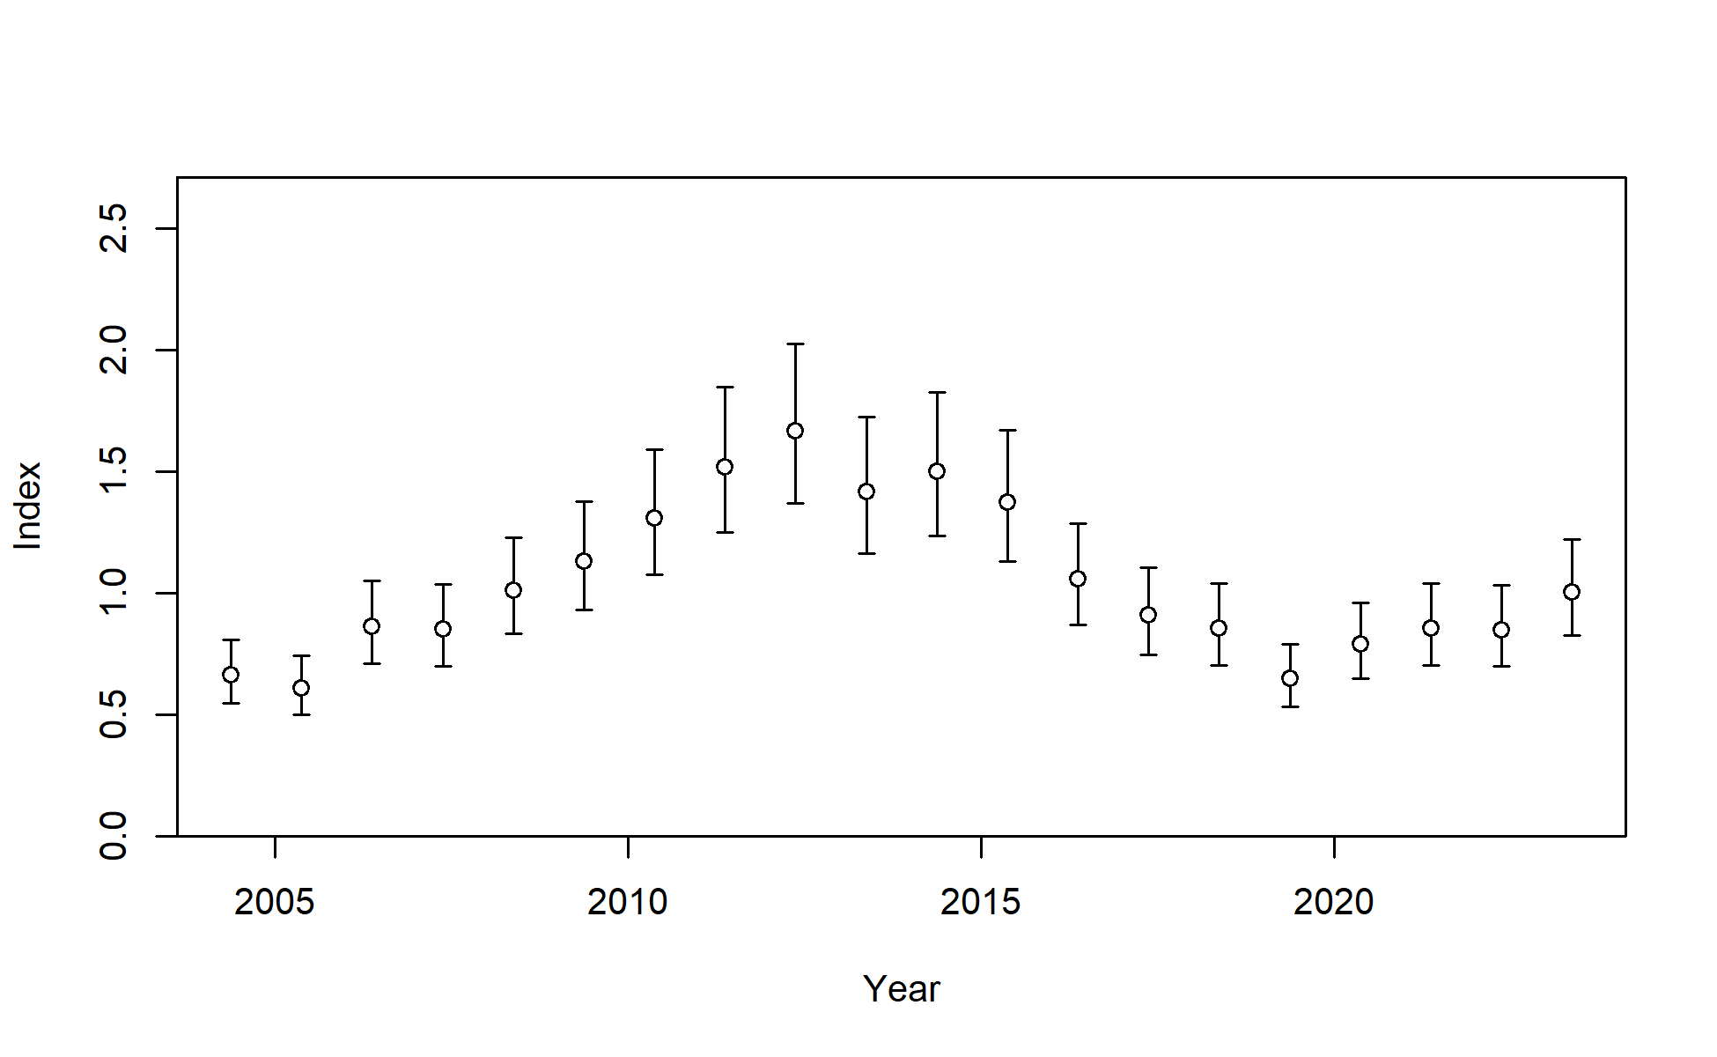
Figure SWO-04. Standardised CPUE with initial input 95% confidence interval (CI) for (top) the Australian longline CPUE index fishery in region 1 and (bottom) the New Zealand longline CPUE index fishery in region 2. Additional variance was estimated within the model, which effectively reduced these confidence intervals for the AU index and increased them for the NZ index.
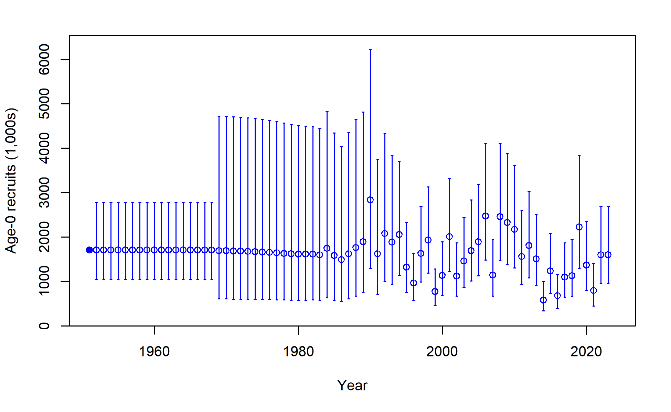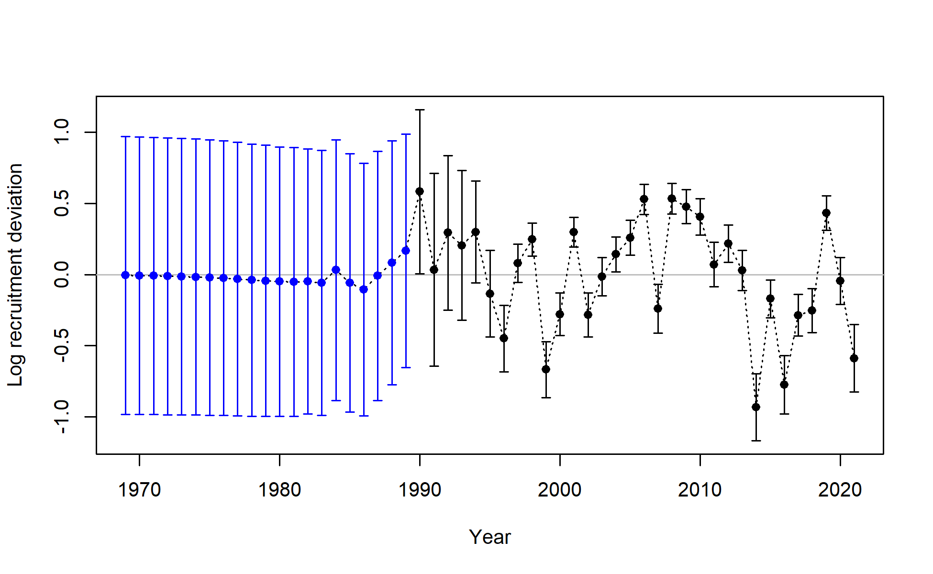
Figure SWO-05. Annual time series of estimated absolute annual recruitment in numbers (top) and annual time series of estimated log annual recruitment deviations (bottom), including estimation uncertainty with 95% confidence interval for the diagnostic model.
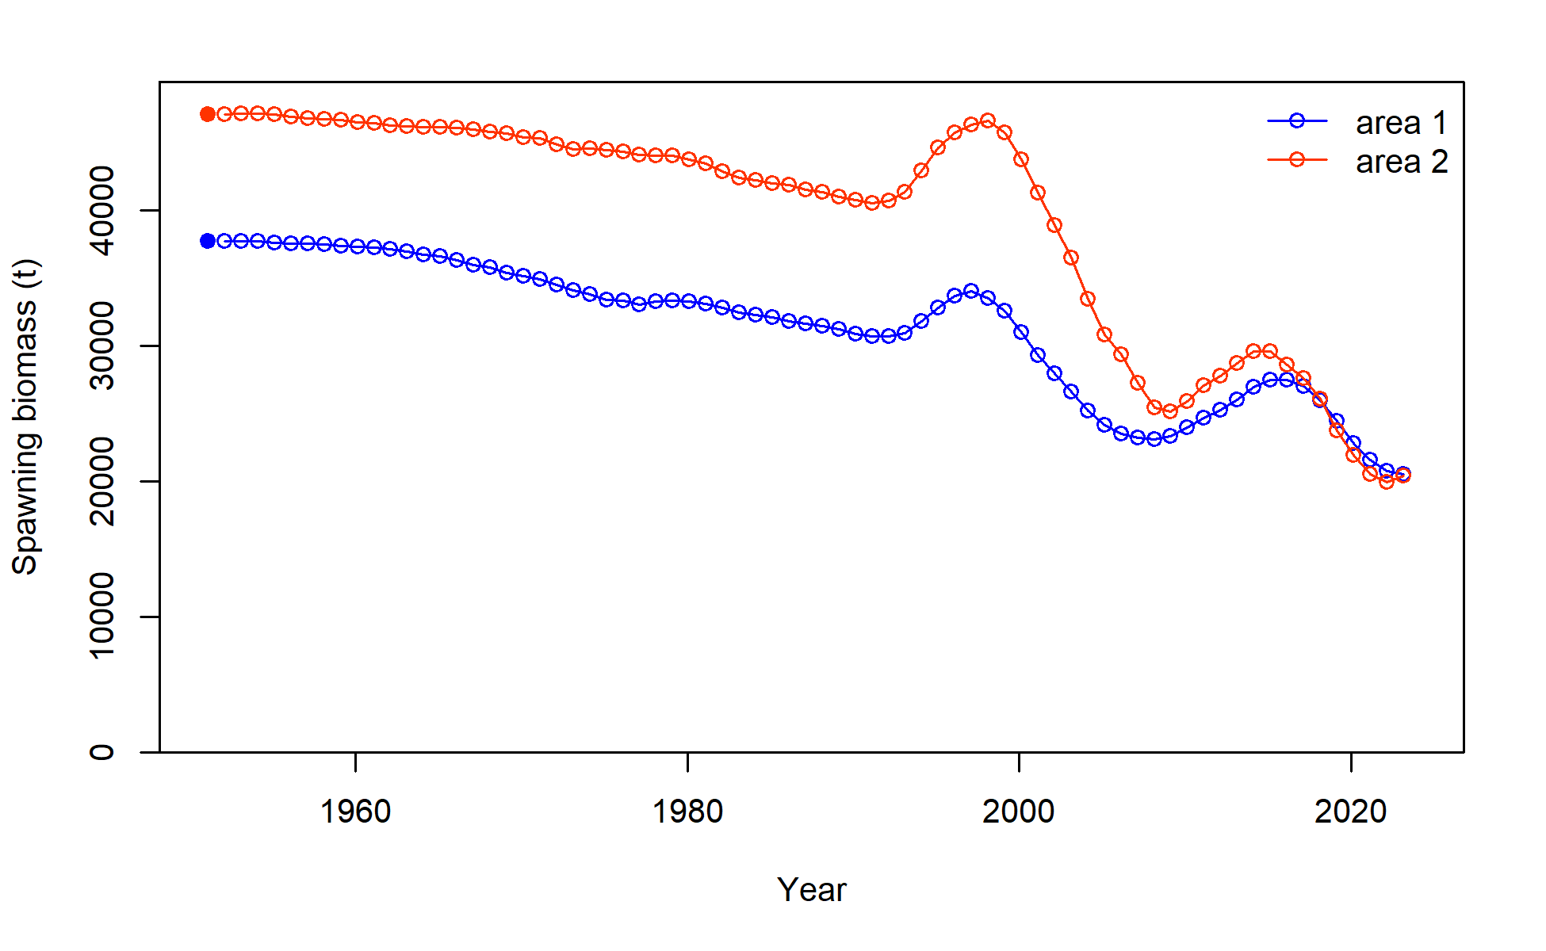
Figure SWO-06. Time series of estimated annual female spawning biomass (without estimation uncertainty) by region for the diagnostic model.
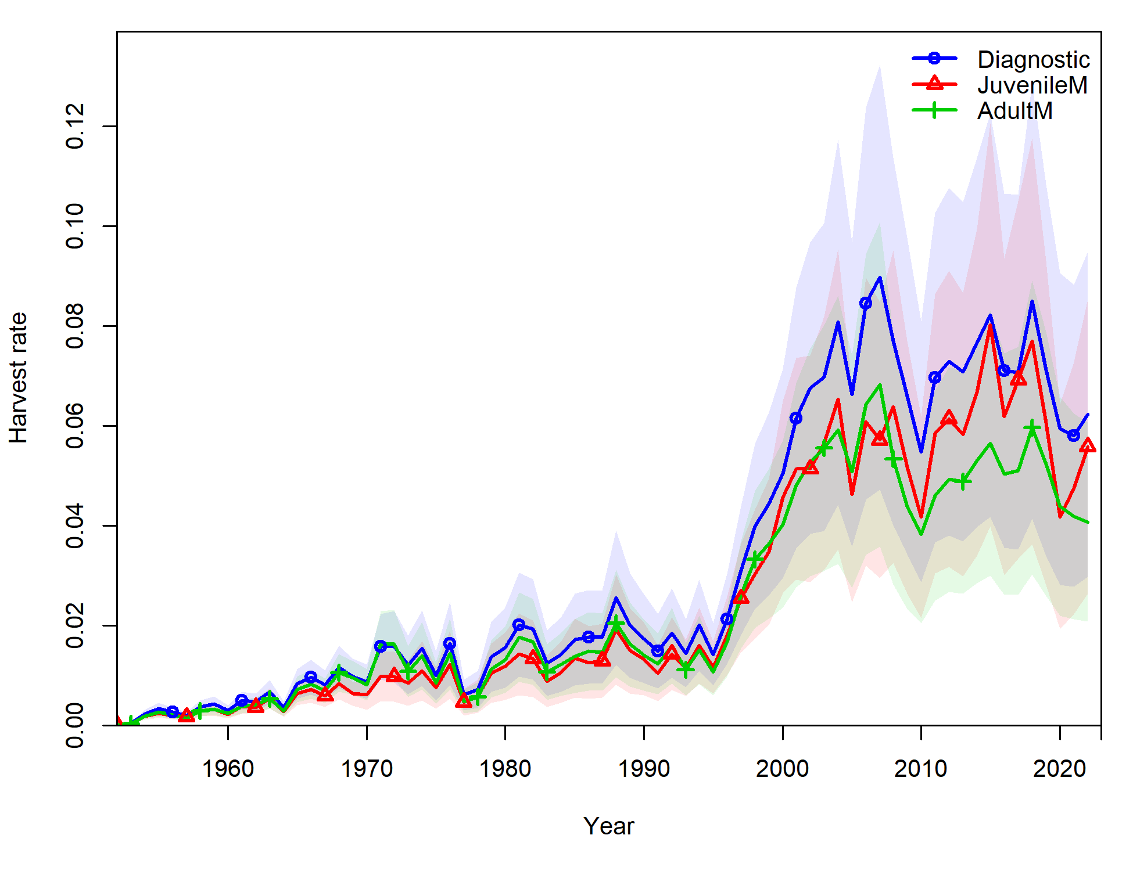
Figure SWO-07. Time series of annual estimated mean fishing mortality for age range 3-12 years for the diagnostic model (blue); for juvenile SWPO swordfish (age 1-3, red); and for adult SWPO swordfish (age 8-15, green).

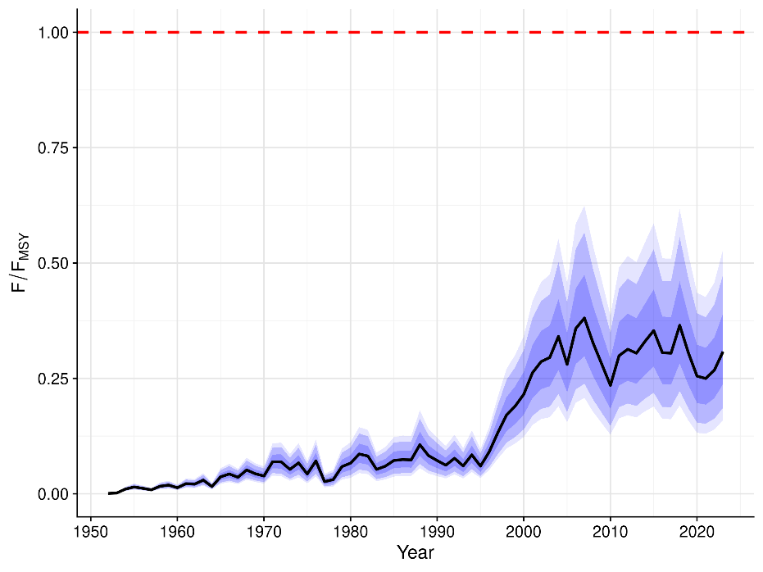

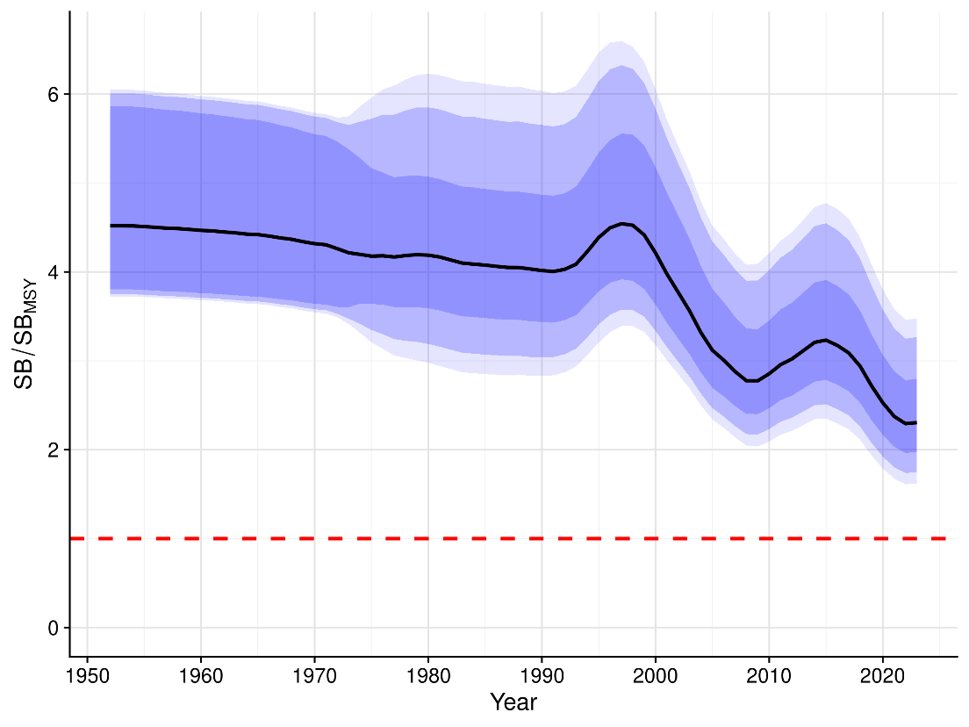
Figure SWO-08. Annual estimated F/F_{MSY} (top) and annual SB/SB_{MSY} (bottom) from the uncertainty grid. The black line indicates the median of all trajectories, along with 50%, 80% and 90% quantile ranges.

- Stock status

There are no agreed reference points for Southwest Pacific swordfish. Stock status is therefore assessed in relation to the default WCPFC SB/SB_{MSY} and F/F_{MSY} reference points, with information also provided for the depletion relative to the 20%SB_{F=0} LRP that is applied to key tunas. The 2025 stock assessment indicates that the stock status is positive with respect to the MSY-based reference points, and although the stock biomass trend and depletion decline, the last few years of the model indicate some stability in female spawning biomass.

Median recent fishing mortality was below F_{MSY} (F_{recent}/F_{MSY} is 0.28 with 80% quantile range from 0.18 – 0.38, and the probability of F_{recent}/F_{MSY} > 1 is < 1%, Tables SWO-03 and SWO-04). Median recent female spawning biomass was well above SB_{MSY} (SB_{recent}/SB_{MSY} biomass reference point is 2.33 with 80% quantile range 1.88 – 3.34, and the probability of SB_{recent}/SB_{MSY} < 1 is < 1%, Table SWO-03 and SWO-4). Median recent spawning biomass was also well above the 20%SB_{F=0} LRP applied to tunas (SB_{recent}/SB_{F=0} = 0.50 with 80% quantile range 0.46-0.58, without estimation uncertainty, Tables SWO-03 and Table SWO-04). Depletion with respect to unfished female biomass (SB_{recent}/SB_{F=0}) is 0.50 with an 80% quantile range of 0.46 – 0.58 (Tables SWO-03 and SWO-04), without estimation uncertainty.

Based upon these results, the stock is exceptionally unlikely to be experiencing overfishing (< 1% probability) and to be overfished (< 1% probability) relative to MSY-based reference points (Figures SWO-09 – SWO-12).

Table SWO-03. Summary of reference points over the uncertainty grid, along with results incorporating estimation uncertainty. Note that these values do not include estimation uncertainty, unless otherwise indicated.
Metric | Mean | Median | Min | 10%ile | 90%ile | Max
C latest | 5922 | 5926 | 5758 | 5846 | 5994 | 6071
SBlatest | 47080 | 43738 | 26110 | 35742 | 62301 | 96686
SBrecent | 48523 | 44994 | 27255 | 36729 | 64013 | 99654
TBlatest | 118832 | 110466 | 65944 | 91676 | 155510 | 234896
TBrecent | 118023 | 109628 | 65577 | 90625 | 154507 | 234147
Flatest | 0.06 | 0.06 | 0.03 | 0.04 | 0.07 | 0.10
Frecent | 0.06 | 0.06 | 0.03 | 0.04 | 0.07 | 0.10
SBMSY | 20039 | 19502 | 11521 | 13580 | 26557 | 38811
MSY | 12078 | 11560 | 8189 | 9708 | 15339 | 22310
FMSY | 0.21 | 0.20 | 0.15 | 0.16 | 0.27 | 0.27
Frecent/FMSY | 0.28 | 0.28 | 0.11 | 0.18 | 0.38 | 0.53
Flatest/FMSY | 0.28 | 0.27 | 0.11 | 0.18 | 0.38 | 0.53
SBrecent/SBMSY | 2.48 | 2.33 | 1.54 | 1.88 | 3.34 | 4.10
SBlatest/SBMSY | 2.41 | 2.27 | 1.47 | 1.82 | 3.24 | 3.98
SBrecent/SBF =0 | 0.52 | 0.50 | 0.37 | 0.46 | 0.58 | 0.67
SBlatest/SBF =0 | 0.50 | 0.49 | 0.36 | 0.45 | 0.57 | 0.65
Including estimation uncertainty
 | Mean | Median | Min | 10%ile | 90%ile | Max
Frecent/FMSY | 0.28 | 0.27 | 0.00 | 0.16 | 0.41 | 0.93
SBrecent/SBMSY | 2.48 | 2.37 | 0.48 | 1.80 | 3.37 | 5.37

Table SWO-04. Estimates of management quantities (stock status as abundance SB_{recent} relative to SB_{MSY}, and unfished spawning biomass (SB_{F=0}), and recent fishing mortality (F_{recent}/F_{MSY}). P(>RP) refers to the probability that the metric (status, fishing mortality) is above the respective indicator.
Year: 2025  (final data year = 2023) | Spawning Potential | Exceptionally unlikely (<1%) to be below SB_{MSY} |  | Stock is not overfished
Year: 2025  (final data year = 2023) | Fishing mortality | Exceptionally unlikely (<1%) to be above fishing mortality upper limit of F_{MSY} |  | Overfishing is not occurring
Year: 2025  (final data year = 2023) | Projections | Not conducted |  | Not conducted
Year: 2025  (final data year = 2023) | Recommendation | The stock has a generally declining female spawning biomass since the late 1990s, with some periodic oscillations, but with a steadier and a gentler decline in $\frac{{SB}_{recent}}{{SB}_{F=0}}$, with a generally stable fishing mortality since 2004. No action required to reach target biomass.
Reference points |  | Median [10%--90%] | Comment
Ratio of ${SB}_{recent}$ to ${SB}_{MSY}$ | $$\frac{{SB}_{recent}}{{SB}_{MSY}}$$ | 2.33 [1.88-3.34] | Spawning biomass is well above SB_{MSY}, the default WCPFC limit reference point (LRP) for billfish stocks
Ratio of $F_{recent}$ to $F_{MSY}$ | $$\frac{F_{recent}}{F_{MSY}}$$ | 0.28 [0.18 – 0.38] | Fishing mortality is well below the default F_{MSY} WCPFC LRP for fishing mortality.
Recent estimates |  |  | Recent trend / projection
Fishing mortality | $$F_{recent}$$ | 0.06 [0.04 – 0.07] | $F_{recent}$ shows a stable trend, with short-term variation over the last 15 years, and a slight increase over the last 3 years of the assessment, which is most likely variability rather than indicative of any recent trend.
SB relative to SB to produce MSY | $$\frac{{SB}_{recent}}{{SB}_{MSY}}$$ | 2.33 [1.88-3.34] | The spawning biomass relative to biomass at MSY has a trend of becoming more depleted, especially since the 1990s, but with some signs or stability in the very recent years.
SB depletion relative to SB without fishing (w/o estimation uncertainty) | $$\frac{{SB}_{recent}}{{SB}_{F=0}}$$ | 0.50 [0.46 – 0.58] | The spawning biomass relative to unfished spawning biomass has a trend of becoming more depleted, especially since the 1990s, but with some signs of stability in the very recent years.
Status |  |  | Likelihood
SB depletion | $$\frac{{SB}_{recent}}{{SB}_{MSY}}$$ | 0.50 [0.46 – 0.58] | <1% probability < SB_{MSY} (Exceptionally unlikely)
Fishing mortality | $$\frac{F_{recent}}{F_{MSY}}$$ | 0.28 [0.18 – 0.38] | <1% probability > $F_{MSY}$ (Exceptionally unlikely)

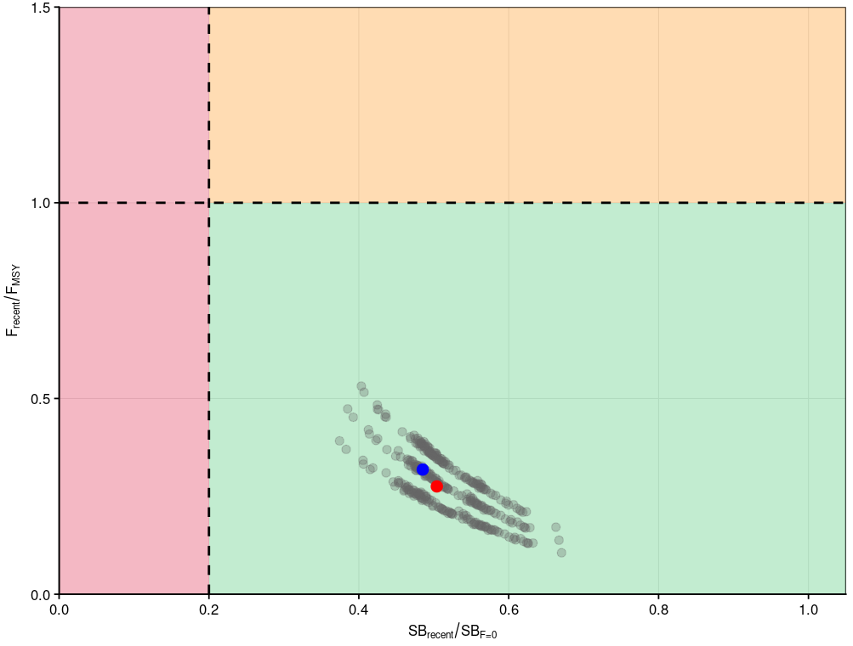
Figure SWO-09. Majuro plot summarising the results for the uncertainty grid (without estimation error) for the relevant recent periods, 2020–2023 for SB_{recent}/SB_{F=0} and 2019–2022 for F_{recent}/F_{MSY,} respectively. The red dot indicates the median, and the blue dot the diagnostic model.
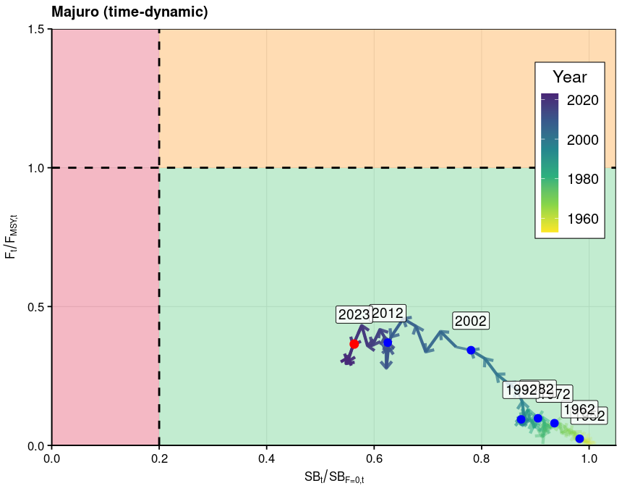
Figure SWO-10. Time dynamic Majuro plot from the diagnostic model for SWPO swordfish for the period 1952 to 2023 (red dot).

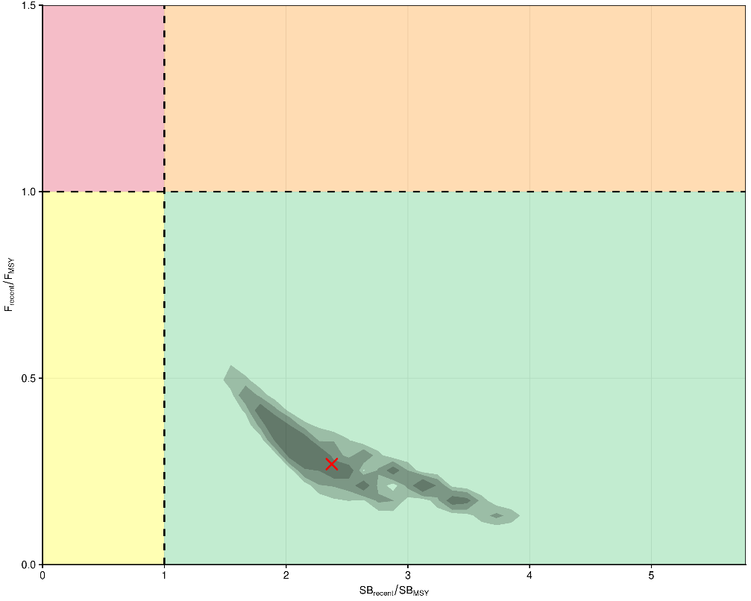
Figure SWO-11. Kobe plot for the relevant recent periods, 2020–2023 for SB_{recent}/SB_{MSY} and 2019–2022 for F_{recent}/F_{MSY,} respectively, using contour plots to summarise the full uncertainty grid, including structural and estimation uncertainty, with 50%, 80% and 90% quantile ranges. The red cross shows the median.

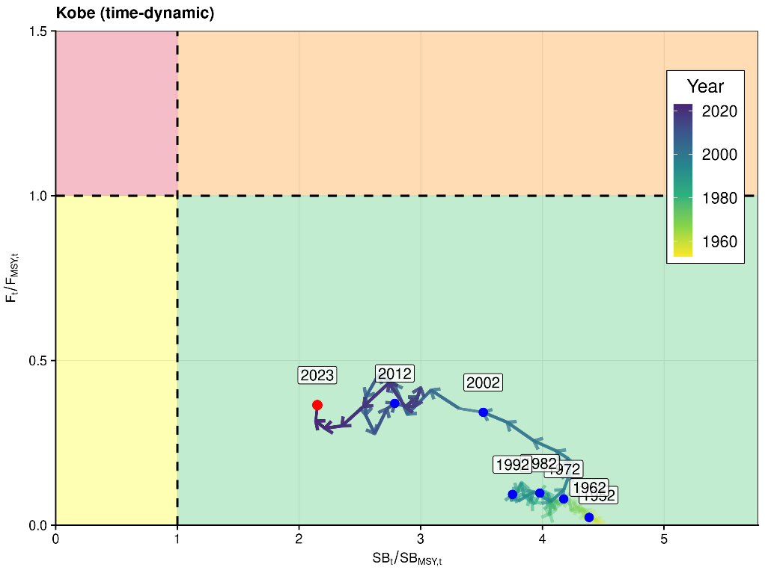
Figure SWO-12. Time dynamic Kobe plot from the diagnostic model for SWPO swordfish for the period 1952 to 2023 (red dot).

- Management advice

SC21 advised that it is exceptionally unlikely that Southwest Pacific swordfish is overfished and subject to overfishing. SC21 noted that the estimated spawning biomass relative to unfished levels has continued to decline over the last decade, despite a brief recovery in 2015. This declining trend highlights the ongoing need for management. To this end, SC21 noted the Commission’s intention to develop a management strategy evaluation framework for Southwest Pacific swordfish and to design and evaluate a candidate management procedure (see SC21-GN-WP-04 Project P21X03). SC21 agreed to use this year’s stock assessment model as a starting point for developing an operating model reference set to evaluate the candidate management procedures, noting that better addressing the issue of model mis-specification is necessary to improve the reliability of the operating model reference set.

SC21 noted that due to challenges and associated time constraints in fitting the stock assessment model, no projections were provided to the SC and recommended that projections be included in future assessment reports.

- Research recommendations

SC21 noted the challenges in developing this model. The persistent conflict between size composition and CPUE signals, the retrospective patterns, and the divergence in CPUE trends across fleets may not solely reflect data limitations, but could also stem from structural assumptions within the model that are difficult to validate or adjust. SC21 recommended several research avenues to help improve the next assessment, including:
- additional conditional age-at-length data;
- exploring the use of close-kin mark recapture;
- the further exploration of a simplified modeling approach; and
- SC21 also recommended moving data-moderate billfish assessments like Southwest Pacific swordfish and striped marlin to a two-year approach, similar to the shark assessments.

SC18-2022 to SC20-2024 (NO STOCK ASSESSMENT WAS CONDUCTED)

  - Stock Status and trends

- SC18 to SC20 noted that no stock assessments were conducted for south Pacific swordfish in 2022 to 2024. Therefore, the stock status descriptions from SC17 are still current for south Pacific swordfish. For further information on the stock status and trends from SC17, please see https://meetings.wcpfc.int/node/12553.

- Management Advice and implications

- SC18 to SC20 noted that no management advice has been provided since SC17 for south Pacific swordfish. Therefore, previous advice should be maintained, pending a new assessment or other new information. For further information on the management advice and implications from SC17, please see https://meetings.wcpfc.int/node/12553.

SC17-2021 (STOCK ASSESSMENT CONDUCTED)

- SC17 accepted SC17-SA-WP-04 (Stock assessment of Southwest Pacific swordfish), providing the best available scientific information for the purpose of stock assessment determination.

- Stock status and trends

- The median values of relative latest (2019) spawning potential depletion (SB_{latest}/ SB_{F=0}), spawning potential relative to MSY (SB_{latest}/ SB_{MSY}) and relative recent (2015-2018) fishing mortality (F_{recent}/F_{MSY}) over the 25-model ensemble (Table SWO-03) were used to define Southwest Pacific swordfish stock status. The values of the upper 90th and lower 10th percentiles of the empirical distributions of relative spawning potential depletion, spawning potential relative to MSY and relative fishing mortality from the uncertainty ensemble (that included both structure and estimation uncertainty) were used to characterize the probable range of stock status.
A description of the model ensemble used to characterize uncertainty in the assessment is illustrated in Tables SWO-01 and SWO-02. Table SWO-03 shows reference points for Southwest Pacific swordfish, including the median values of relative ‘latest’ (2019) spawning biomass depletion (SB_{latest}/SB_{F=0}), spawning potential relative to spawning potential at MSY (SB_{latest}/SB_{MSY}), and relative recent (2015-2018) fishing mortality (F_{recent}/F_{MSY}) over the final 25-model ensemble used to define stock status. These values present a more holistic view of uncertainty, accounting for both model (structural) and estimation (statistical) uncertainty.

The spatial structure used in the 2021 stock assessment is shown in Figure SWO-01. Time series of total annual catch by fishing gear over the full assessment period and by regions is shown in Figure SWO-02. Estimated annual average recruitment, spawning potential, and total biomass by model region for the diagnostic case model are shown in Figure SWO-03. Estimated trends in fishing mortality rates by age and region from the diagnostic model are shown in Figure SWO-04. Time-dynamic median and percentiles of depletion (SB_{t}/SB_{t,F=0}) for the 25 models are shown in Figure SWO-05. Majuro and Kobe plots summarizing the results for each of the 25 models in the ensemble are shown in Figures SWO-06 and SWO-07, respectively.

Estimated stock status was most impacted by the uncertainties in movement and natural mortality. Low natural mortality and higher rates of movement from Region 1 into Region 2 resulted in more pessimistic stock status.

SC17 noted that the stock is estimated to have gradually declined from the 1950s to the mid-1990s before rapidly declining to an overall low point near 2010. Current stock status is estimated to be at a similar level as the overall low with a declining trend in the terminal 4 years of the model.

SC17 noted that latest spawning potential depletion levels estimated by this assessment (SB_{latest}/SB_{F=0}) indicated a median of 0.39 (10th and 90th percentiles 0.18 - 0.79).

SC17 noted that there was 13% risk that the latest (2019) spawning potential was lower than 20% SB/SB_{F=0} when considering structural + estimation uncertainty. Omitting the estimation uncertainty as was done in the previous assessment, although this is known to exist, would have resulted in an 8% risk.

SC17 noted that the stock is estimated to have spawning potential above the MSY level (SB_{latest}/SB_{MSY} median 2.95; 10th and 90th percentiles 0.99 – 6.78) and SB_{recent}/SB_{MSY} has a median value of 3.61, 10th and 90th percentiles 1.23–7.39.

SC17 noted that there was 10% risk that SB_{latest}/SB_{MSY} < 1 when considering model and estimation uncertainty. Using only model-based uncertainty would have resulted in an 4% risk.

SC17 noted that fishing mortality is predicted to have increased gradually across the assessment region through the mid-1990s. Fishing mortality is estimated to have sharply increased in the early-2000s and appears to have stabilized at high levels in the last decade.

SC17 noted that the median of relative recent fishing mortality for Southwest Pacific swordfish F_{recent}/F_{MSY} is 0.47 and 10th and 90th percentiles are 0.25 – 1.29.

SC17 noted that there was 20% risk that F/F_{MSY} > 1 when considering structural + estimation uncertainty. Omitting the estimation uncertainty, as was done in the previous assessment, although this is known to exit, would not have changed the level of risk.

Table SWO-01. Summary of fixed assumptions made in the final model ensemble. The minimum, maximum, median and 10th and 90th percentiles are given for the ensemble parameters.
 | Mean | Median | Min | 10 | 90 | Max
$$σ_{Age}$$ | 29.51 | 28.50 | 25.76 | 26.13 | 34.10 | 40.66
$$σ_{Length}$$ | 0.39 | 0.37 | 0.18 | 0.24 | 0.60 | 0.85
Steepness | 0.89 | 0.90 | 0.71 | 0.85 | 0.94 | 0.98
$$α_{LW}$$ | 0.0000130 | 0.0000131 | 0.0000117 | 0.0000121 | 0.0000139 | 0.0000154
$$β_{LW}$$ | 3.00 | 3.00 | 2.97 | 2.98 | 3.01 | 3.02
k | 0.20 | 0.19 | 0.16 | 0.17 | 0.22 | 0.26
$$L_{∞}$$ | 241.13 | 242.02 | 228.62 | 235.17 | 248.09 | 250.59
$$t_{0}$$ | -2.07 | -2.12 | -2.60 | -2.39 | -1.74 | -1.15
Average M | 0.27 | 0.27 | 0.11 | 0.17 | 0.35 | 0.39
$L_{50}$ Female maturity | 179.85 | 179.90 | 176.78 | 177.81 | 181.62 | 182.55
$$Region 1→ 2$$ | 0.036 | 0.036 | 0.008 | 0.011 | 0.065 | 0.096
$$Region 2→ 1$$ | 0.017 | 0.015 | 0.002 | 0.006 | 0.034 | 0.044
LF scalar | 33.04 | 32.00 | 20.00 | 22.00 | 46.60 | 49.00
WF scalar | 30.24 | 30.00 | 11.24 | 13.40 | 45.20 | 47.76
Recruitment CV | 0.52 | 0.50 | 0.29 | 0.29 | 0.71 | 0.71
AU index CV | 0.46 | 0.37 | 0.11 | 0.13 | 0.78 | 0.80
NZ index CV | 0.43 | 0.42 | 0.11 | 0.19 | 0.71 | 0.78

Table SWO-02. Percentage of models remaining across the ensemble (Aggregate) and for each factorial level following each post-hoc filtration step.
 | Aggregate | DWFN - EU | DWFN - JP | DWFN - TW | DWFN - None | BH CV -0.7 | BH CV - 0.5 | BH CV - 0.3 | t₀ prior - Uninformative | t₀ prior- Informative |  | M prior - VB |  | M prior - max Age
1 | 40% | 32% | 46% | 40% | 41% | 44% | 36% | 39% | 33% | 46% | 40% |  | 40%
2 | 29% | 31% | 18% | 25% | 41% | 30% | 26% | 30% | 24% | 33% | 30% |  | 28%
3 | 28% | 31% | 18% | 24% | 41% | 30% | 26% | 30% | 24% | 32% | 30% |  | 27%
4 | 27% | 31% | 18% | 21% | 40% | 29% | 25% | 28% | 23% | 31% | 29% |  | 26%
5 | 14% | 20% | 5% | 5% | 27% | 16% | 14% | 13% | 18% | 11% | 15% |  | 14%
6 | 11% | 18% | 3% | 4% | 18% | 11% | 11% | 10% | 18% | 4% | 11% |  | 10%
7 | 7% | 13% | 2% | 2% | 9% | 9% | 4% | 7% | 12% | 1% | 6% |  | 7%

Table SWO-03. Summary of reference points (measures of central tendency, min, max and relevant percentiles, 10th and 90th) including model and estimation uncertainty from the 25 models in the final ensemble. Models were equally weighted in the ensemble. The quantity of SB_{recent}/SB_{F=0} was not available from the current MFCL version due to the inclusion of both model and statistical uncertainty.
 | Mean | Median | Min | 10 | 90 | Max
C_{latest} | 7,772 | 7,723 | 7,364 | 7,524 | 8,259 | 8,453
Y F_{recent} | 6,558 | 6,608 | 3,351 | 4,964 | 8,106 | 9,347
MSY | 9,922 | 9,543 | 3,869 | 5,470 | 14,738 | 22,278
F_{recent}/F_{MSY} | 0.67 | 0.47 | 0.16 | 0.25 | 1.29 | 2.34
SB₀ | 83,853 | 69,390 | 16,491 | 31,472 | 145,944 | 334,518
SB_{latest} | 38,287 | 31,517 | 10,588 | 16,096 | 69,370 | 125,681
SB_{recent} | 41,916 | 38,106 | 14,975 | 18,956 | 68,550 | 99,304
SB_{MSY} | 12,507 | 11,480 | 2,427 | 5,212 | 21,722 | 29,297
SB_{latest}/SB_{MSY} | 3.7 | 2.95 | 0.44 | 0.99 | 6.78 | 18
SB_{recent}/SB_{MSY} | 4.1 | 3.61 | 0.64 | 1.23 | 7.39 | 16
SB_{latest}/SB₀ | 0.59 | 0.46 | 0.1 | 0.2 | 1.09 | 2.49
SB_{latest}/SB_{F=0} | 0.45 | 0.39 | 0.08 | 0.18 | 0.79 | 1.42

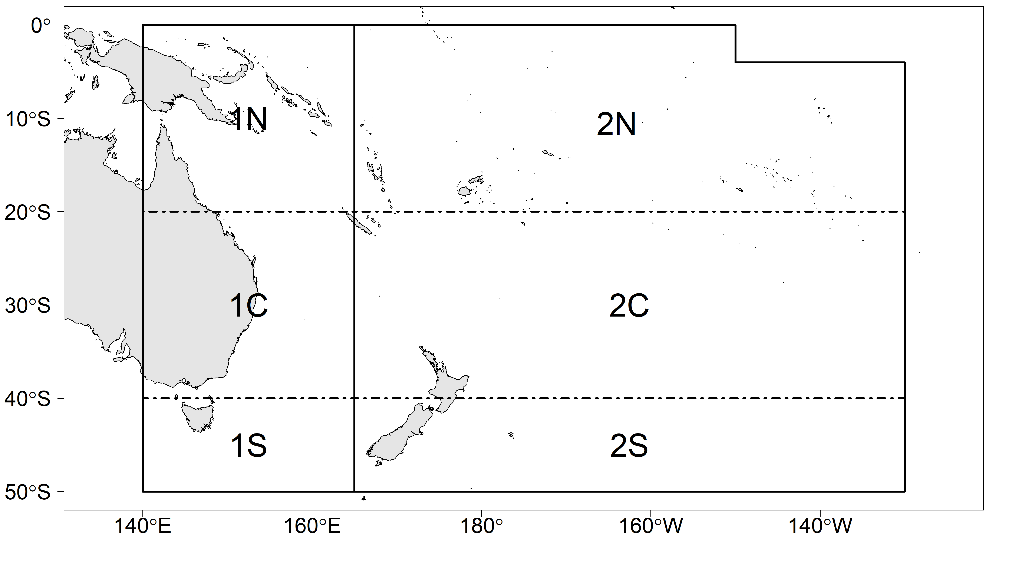
Figure SWO-01. Spatial structure for the 2021 Southwest Pacific swordfish stock assessment. Sub-regions used to differentiate fisheries are shown with the dotted lines.

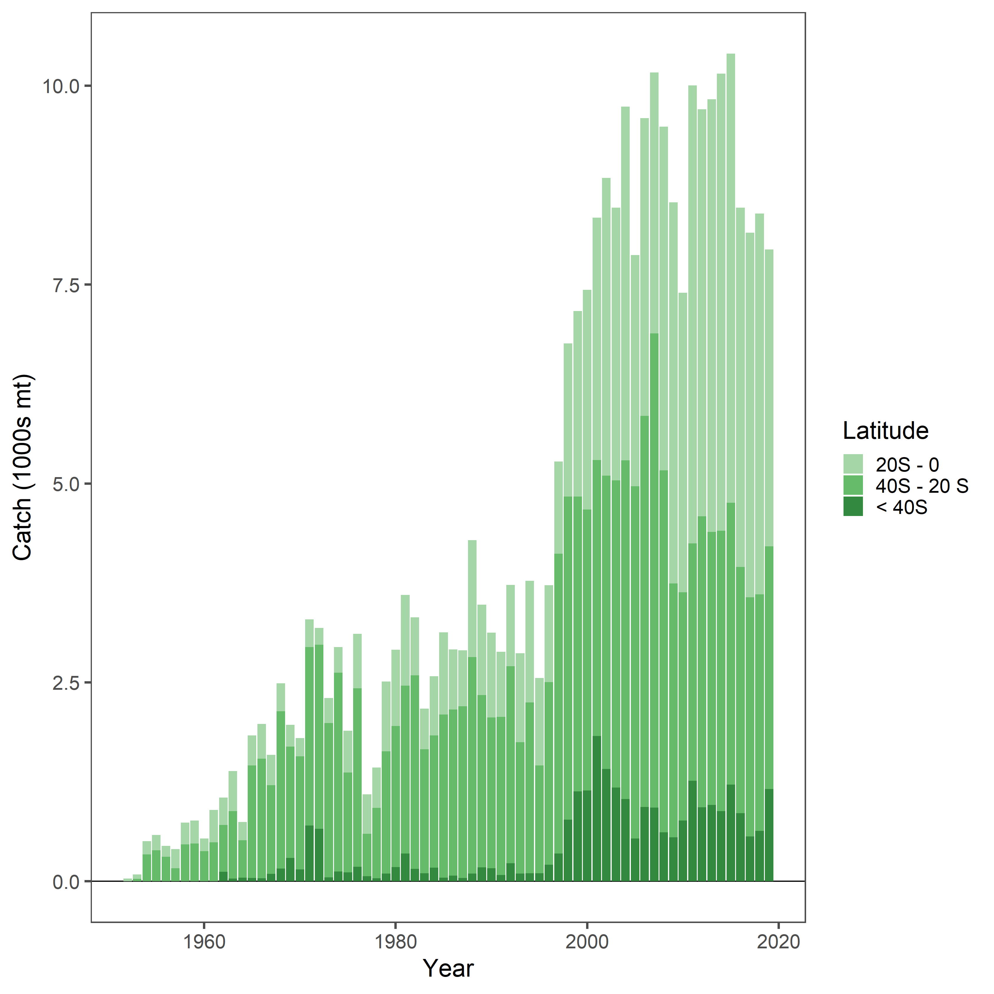
Figure SWO-02. Annual catch (mt) where the colors indicate latitudinal location of the catch.
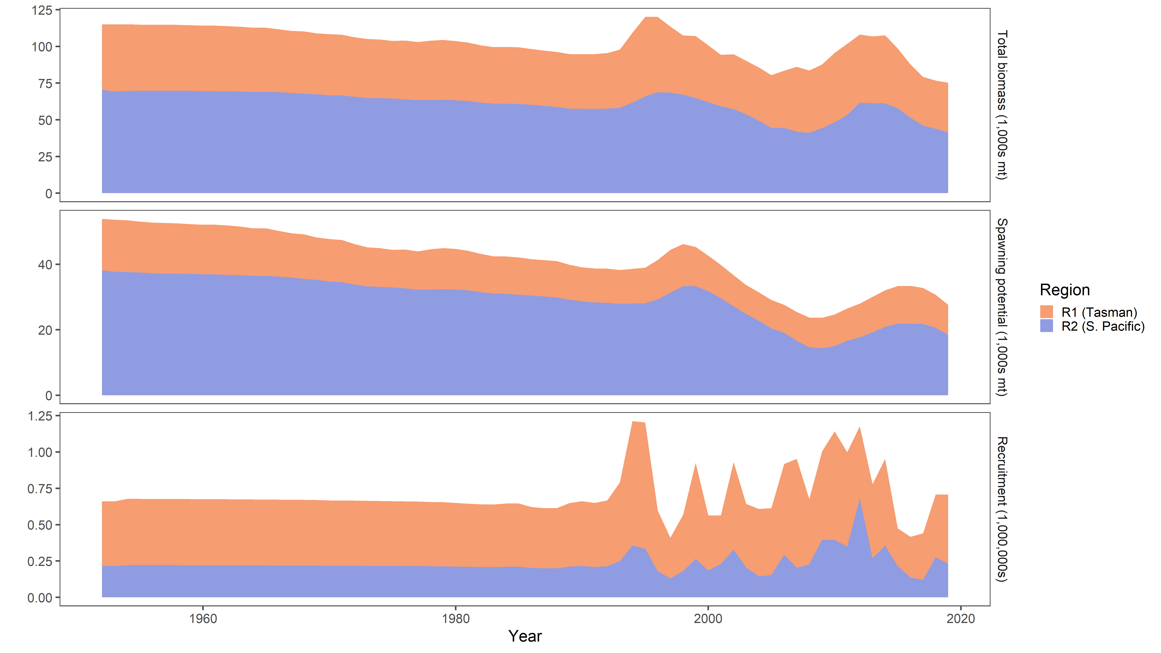
Figure SWO-03. Estimated total biomass (top panel), spawning potential (middle panel), and recruitment (lower panel) for the diagnostic case model. Color indicates the model region: Region 1 (orange) and Region 2 (blue).

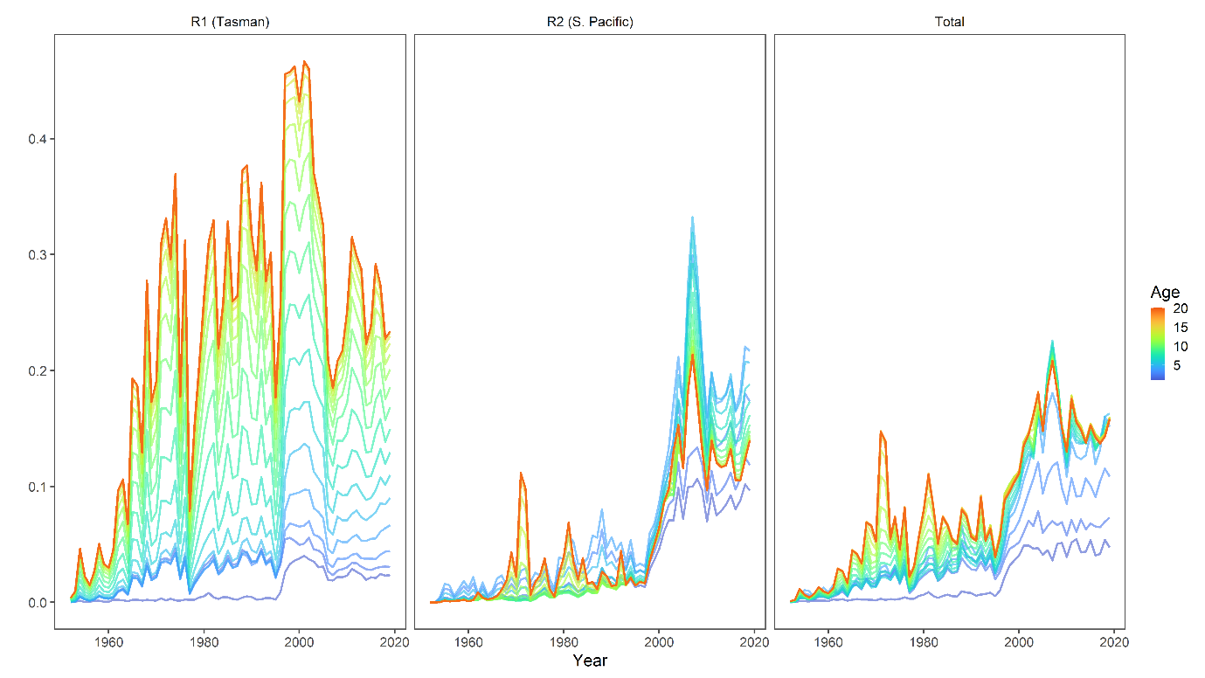
Figure SWO-04. Annual fishing mortality by age (color) and region (panel: Region 1 - left, Region 2 - center, and total - right).
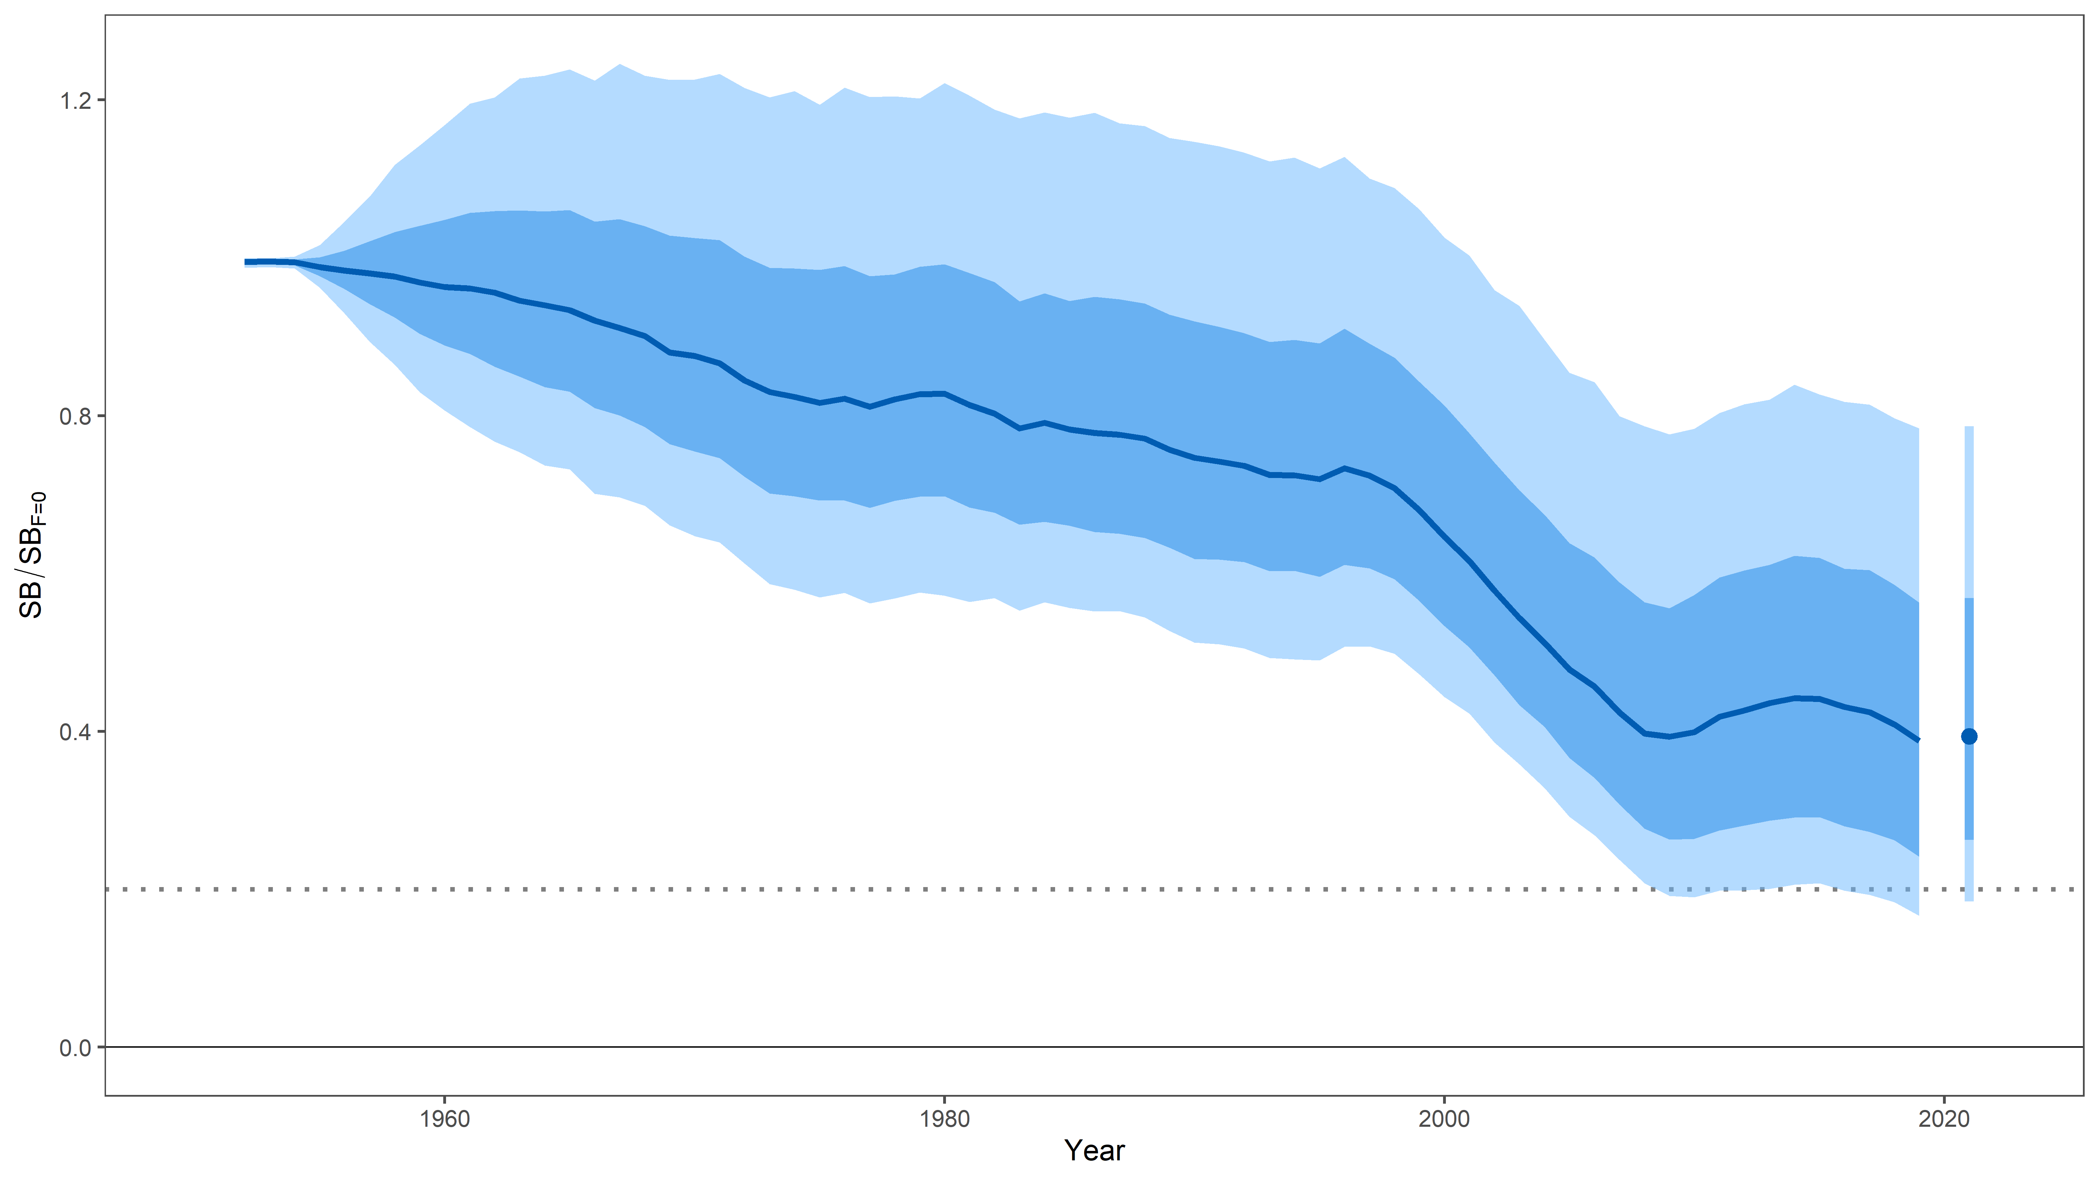
Figure SWO-05. Uncertainty in depletion where uncertainty is characterized as structural + estimation uncertainty. The median is showed by the dark line, the 25th-75th percentiles shown by the dark band, and the 10th-90th percentiles by the light band. The median and percentiles for total SB_{latest}/SB_{F=0} are shown to the right of the Figure. For reference, the WCPFC tropical tuna LRP 20%SB_{F=0} is shown with the dotted line.

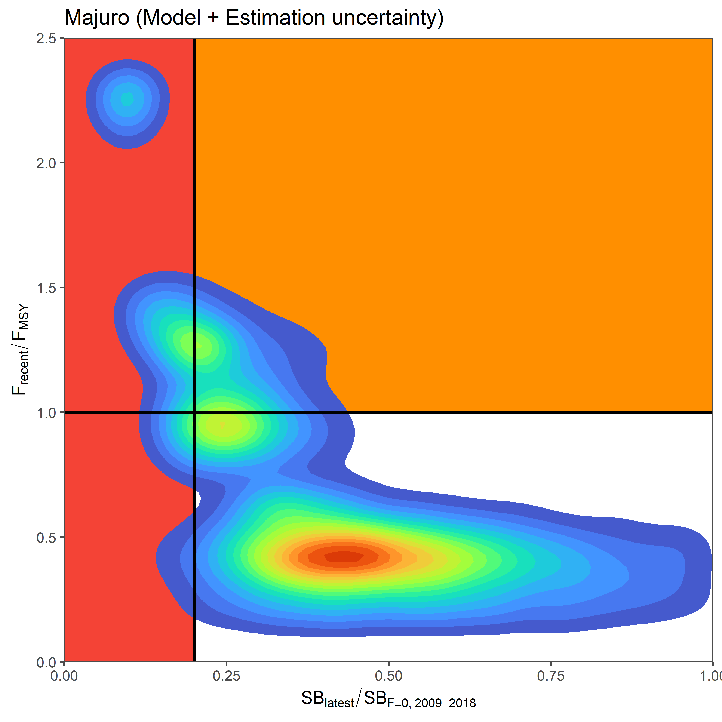 | 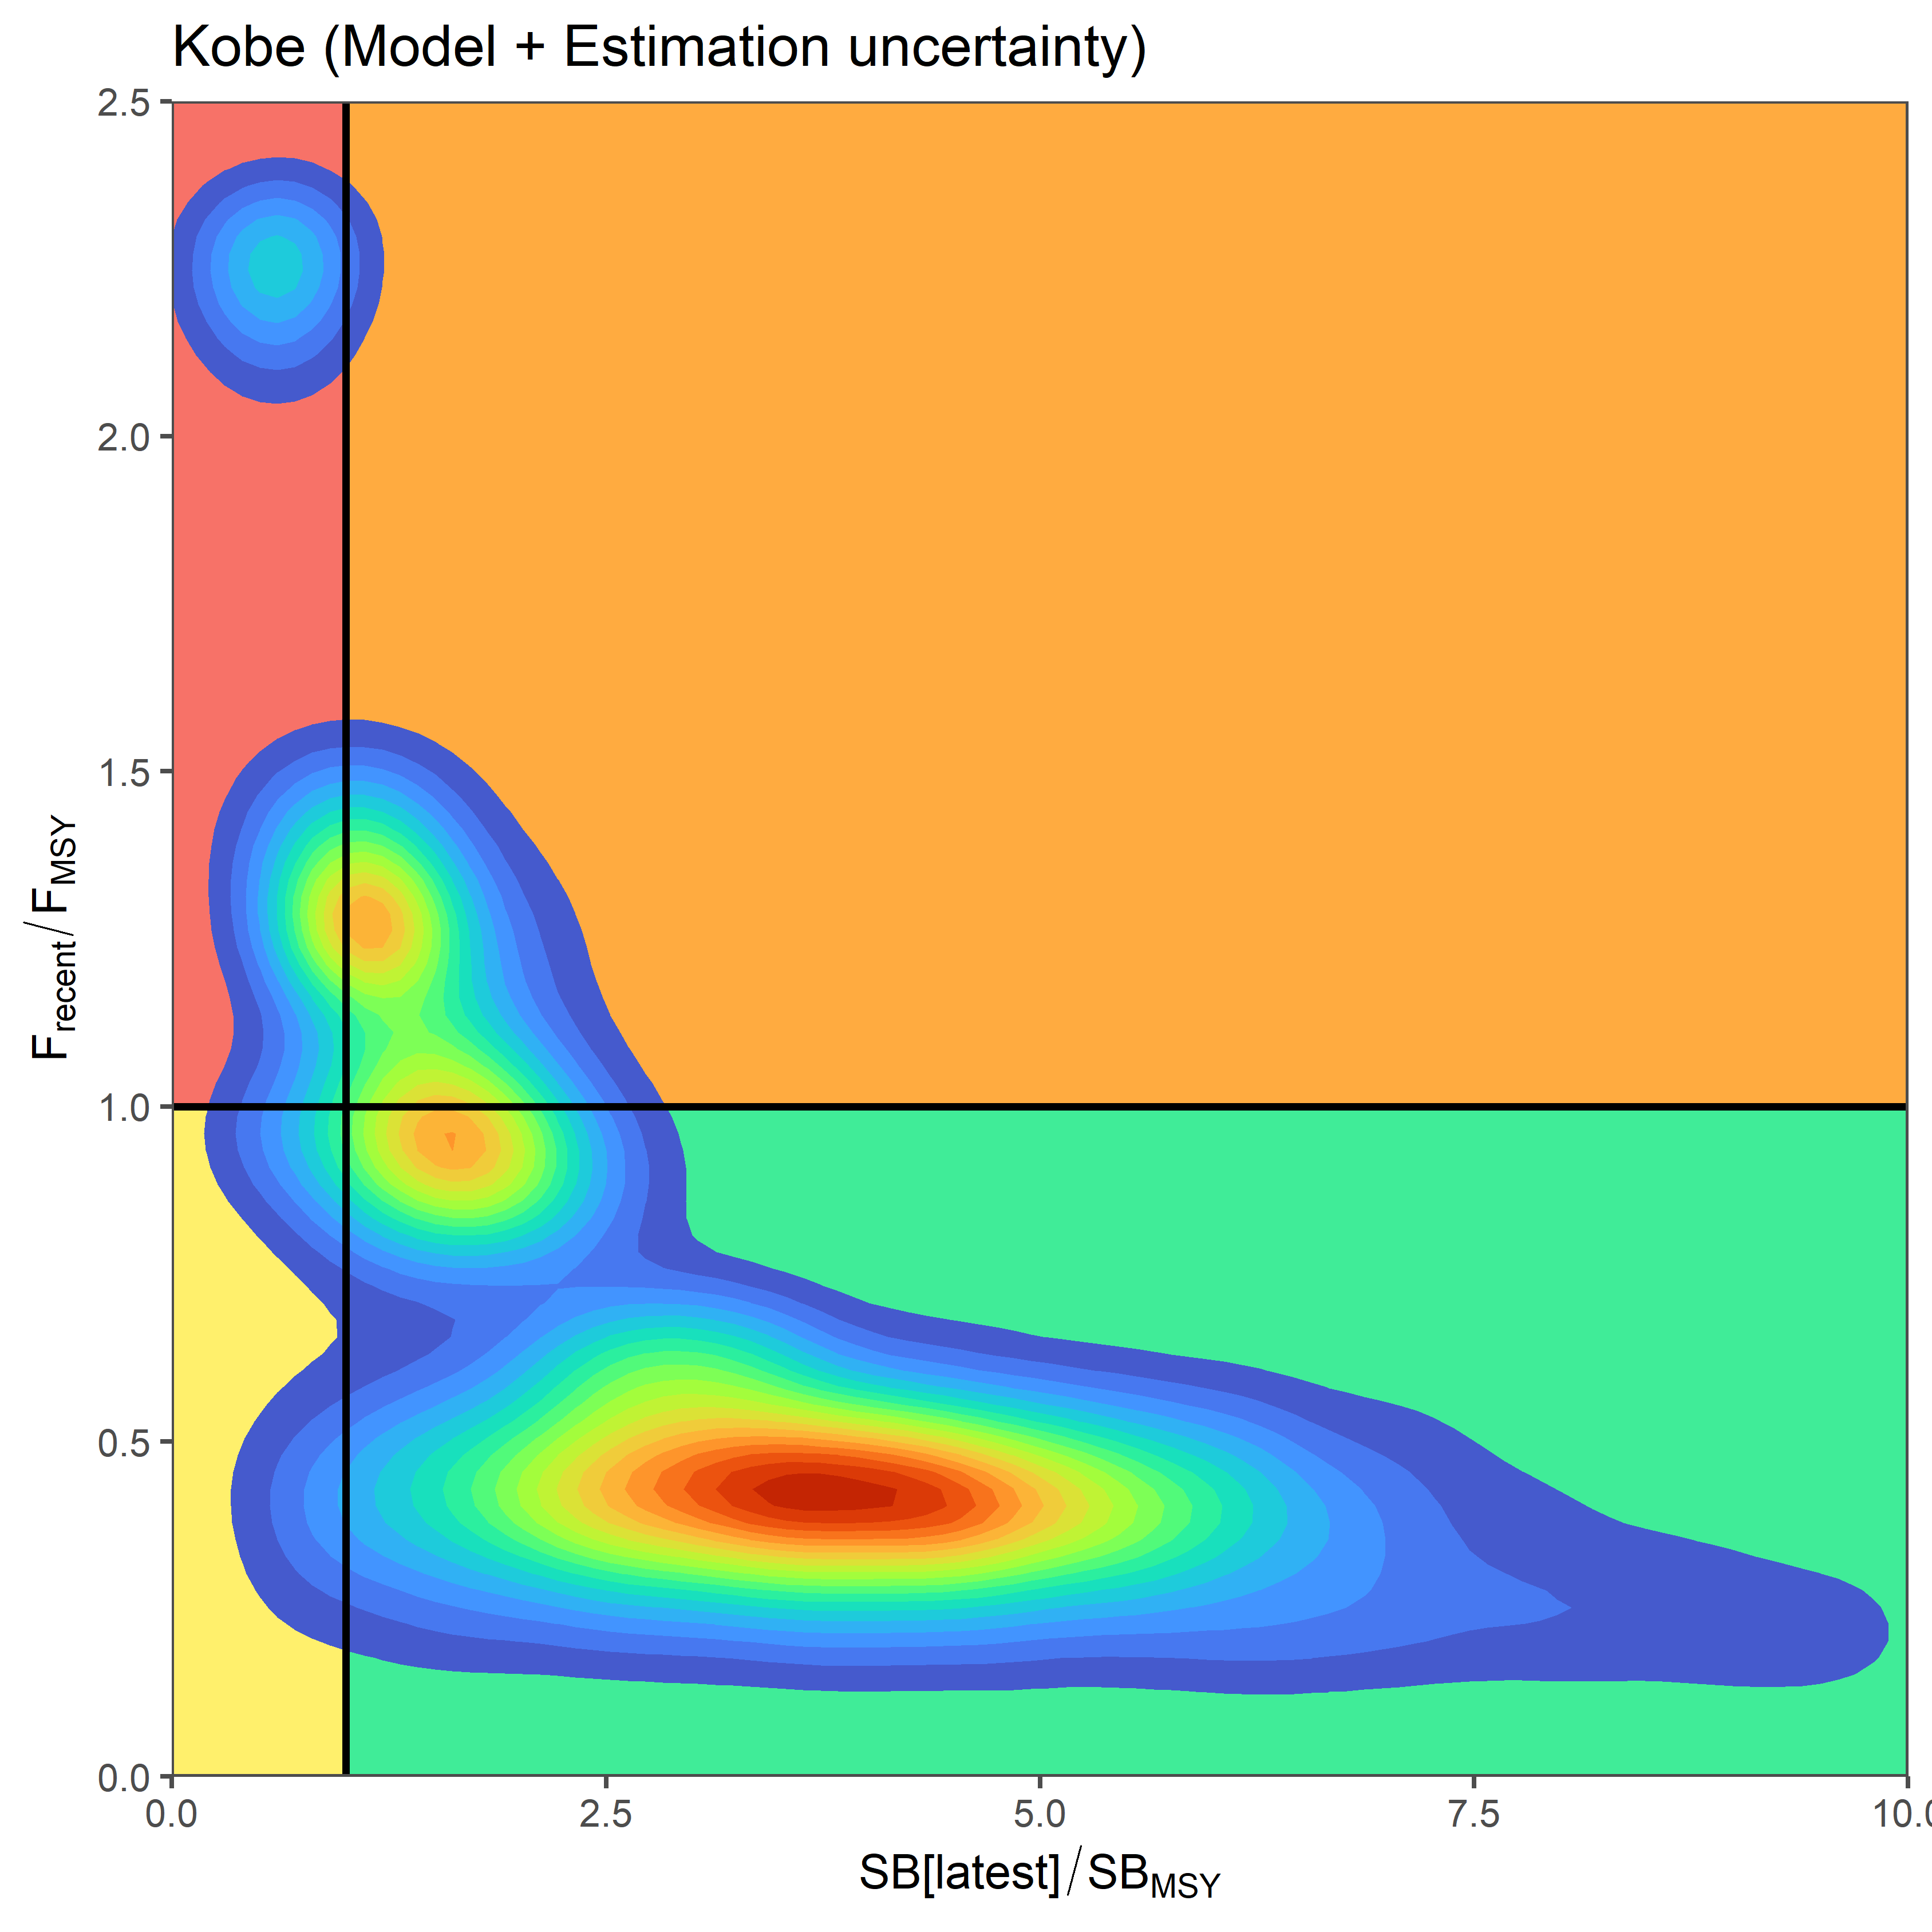
Figure SWO-06. Uncertainty in terminal stock status, based on the 12,500 bootstrap samples characterizing the structural + estimation uncertainty. Warmer colors indicate a greater density of samples, while cooler colors show the fringe of the distribution. | Figure SWO-07. Uncertainty in terminal stock status, based on the 12,500 bootstrap samples characterizing the structural + estimation uncertainty. Warmer colors indicate a greater density of samples, while cooler colors show the fringe of the distribution.

- Management advice and implications

Annual catch estimates for Southwest Pacific swordfish peaked at 11,128 mt in 2012 (SC17-ST-IP-01). Catch by longline vessels in 2020 was 5,373 mt compared to 5,812 mt in 2019, a decline of 7.6%.

SC17 supported the new model ensemble approach for developing management advice for this stock, noting that this approach, including the process for review of priors and decisions on post-hoc filtering rules, would continue to be refined and improved in future. SC17 also noted this new approach may result in significant changes in the level of uncertainty assumed so far. This may have implications in the perception of risks, particularly when applied to species with adopted LRPs.

The outcomes of the assessment are on average more optimistic in relation to the 2017 assessment, but the estimated uncertainty has increased. Noting that a LRP for Southwest Pacific swordfish has not yet been adopted by WCPFC, SC17 noted that the median latest Southwest Pacific swordfish spawning biomass is above both SB_{MSY} and the LRP 20%SB_{F=0} applied to tunas, and recent fishing mortality is below F_{MSY}. The stock is likely not experiencing overfishing (80% probability F<F_{MSY} and 20% probability F>F_{MSY}) and is likely not in an overfished condition (13% probability that SB_{latest}/SB_{MSY} < 1 and a 10% probability that SB_{latest}/SB_{F=0}<0.2).

SC17 noted that the levels of fishing mortality and depletion in the diagnostic case differ between the two model regions, with fishing mortality higher in Region 1 but spawning biomass depletion greater (more depleted) in Region 2. SC17 noted that over the past two decades, the majority of catch has been taken by a combination of swordfish targeting fleets (in the area south of 20°S; 42% of catches) and fleets taking swordfish as a bycatch on the high seas (in particular in the eastern stock area north of 20°S; 34% of catches).

While SC17 advocated for the adoption of the new ensemble approach, it is nevertheless important that the Commission understand the implications of the new approach and that additional work is required to refine this approach.

SC17 noted the significant unresolved uncertainties in the assessment relating to the reliability of CPUE indices, longitudinal movements, spatial connectivity and absolute population size. These uncertainties, combined with the need to further refine and review the new ensemble approach, suggest additional caution may be appropriate when interpreting the current assessment outcomes to guide management decisions. SC17 recommended that research priorities for this stock include directed longitudinal tagging of swordfish and a feasibility study on the utility of Close Kin Mark Recapture (CKMR).

SC17 noted the current measure (CMM 2009-03) for this stock does not contain provisions to limit total fishing mortality on the stock and emphasized the continued importance of WCPFC to develop a revised and strengthened CMM that will ensure the ongoing future sustainability of the Southwest Pacific swordfish. SC17 noted that the suite of catch projections requested by WCPFC16, which are to be undertaken by the SSP post-SC17 and prior to WCPFC18, are intended to test the future likely state of the stock under a range of potential future catch or effort scenarios. This information will inform the revision of the future measure.

SC17 recommended that a number of additional projection runs be explored alongside the WCPFC16 requested projections to be presented for consideration at WCPFC18:
- No change to recent catch and effort levels.
- 10% and 20%reduction in total swordfish catch.

SC17 noted that the current CMM does not cover catches north of 20°S. SC17 recommends that the Commission take note of the swordfish projections in framing any future CMM.

- Future research recommendations

Contingent on the collection of comprehensive sex-specific catch and size composition data, SC17 recommended to continue progress on developing a sex-disaggregated model to better account for the significant differences in life history between male and female swordfish. Implementation of a sex-disaggregated model applied to comprehensive sex-specific data could reduce bias in the model results. The Scientific Services Provider however did note that lack of sex specific size composition data was a major limitation to a sex disaggregate approach that would need to be improved.

The SPC investigated the application of a length-weight relationship bias correction factor during SC17. The analysis concluded that applying the bias-correction factor would not qualitatively change the management advice in this instance as it resulted in a 2-3% reduction in the risks to both the SW swordfish stock undergoing overfishing and being overfished. The Co-Convener advocated not to change the assessment runs for SC17 and to consider the correction for the next assessment.

The following three key research needs were identified in undertaking the assessment that should be investigated either internally or through directed research.
- Directed longitudinal tagging of swordfish to reduce the uncertainty in movement rates, and a feasibility study to explore applying CKMR techniques to Southwest Pacific swordfish are the two most critical research items.
- Development of a statistically robust sampling plan for the collection of fisheries dependent biological samples (by sex), including but not limited to age, catch, size frequency data, and genetic samples.
- In order to improve quality of abundance indices there is a need to expand minimum reporting requirements for longline operational characteristics to include: a priori target species, light stick use, bait type, setting time (or fraction of night-time soak), and gear settings that influence fishing depth (e.g., hooks between floats, branch line length, float line length, and/or line setting speed).

SC16-2020 (NO STOCK ASSESSMENT)

There was no stock assessment for south Pacific swordfish in 2020. This was not discussed at SC17 due to its streamlined agenda and discussion were conducted virtually due to the impacts of COVID-19 pandemic. Therefore, the stock status descriptions and management advice from SC13 are still current for south Pacific swordfish.

SC15-2019 (NO STOCK ASSESSMENT)

  - Stock Status and trends

- SC15 noted that no stock assessments were conducted for south Pacific swordfish in 2019. Therefore, the stock status descriptions from SC13 are still current for south Pacific swordfish. For further information on the stock status and trends from SC13, please see https://www.wcpfc.int/node/29904. Updated information on catches was not compiled for and reviewed by SC15.

- Management Advice and implications

- SC15 noted that no management advice has been provided since SC13 for south Pacific swordfish. Therefore, previous advice should be maintained, pending a new assessment or other new information. For further information on the management advice and implications from SC13, please see https://www.wcpfc.int/node/29904

SC14-2018 (NO STOCK ASSESSMENT)

- Stock status and trends

- SC14 noted that no stock assessments were conducted for south Pacific swordfish in 2018. Therefore, the stock status descriptions from SC13 are still current for south Pacific swordfish. Updated information on catches was compiled but not reviewed by SC14.

b. Management advice and implications

- SC14 noted that no management advice has been provided since SC13 for south Pacific swordfish. Therefore, previous advice should be maintained, pending a new assessment or other new information. For further information on the management advice and implications from SC13, please see https://www.wcpfc.int/node/29904

SC13-2017 (Stock Assessment Conducted)

- SC13 endorsed the 2017 SWO stock assessment as the best and most up to date scientific information available for this species.

- SC13 also endorsed the use of the SWO assessment model uncertainty grid to characterize stock status and management advice and implications.

- Stock status and trends

- The median values of relative recent (2012-2015) spawning biomass (SB_{recent}/SB_{MSY}) and relative recent fishing mortality (F_{recent}/F_{MSY}) over the uncertainty grid were used to measure the central tendency of stock status. The values of the upper 90th and lower 10th percentiles of the empirical distributions of relative spawning biomass and relative fishing mortality from the uncertainty grid were used to characterize the probable range of stock status.

- Description of the updated structural sensitivity grid used to characterize uncertainty in the assessment is provided in Table SWO-1. Time trends in estimated catch, recruitment, biomass, fishing mortality and depletion are shown in Figures SWO-1 – 5. Figures SWO-6 and SWO-7 show Majuro plot summarising the results for each of the models in the structural uncertainty grid retained for management advice. Kobe plots are shown in Figures SWO-8 and SWO-9. Figure SWO-10 provides estimated time-series (or “dynamic”) Majuro and Kobe plots from the SW Pacific swordfish ‘diagnostic case’ model run. Figure SWO-11 shows Estimates of reduction in spawning potential due to fishing by region, and over all regions (lower left panel), attributed to various fishery groups (distant water ‘north’, ‘central’ and ‘south’, corresponding to the model regions, and a combined domestic fleet) for the diagnostic case model. Summary of reference points over all 72 individual models in the structural uncertainty grid are shown in Table SWO-2.

Table SWO-1: Description of the structural sensitivity grid used to characterize uncertainty in the assessment
Axis | Levels | Option
Steepness | 3 | 0.65, 0.80, 0.95
Diffusion rate | 3 | 0, 0.11, 0.25
Size frequency weighting | 2 | Sample size divided by 20,40
Natural mortality vectors | 4 | M1,M2,M3, M4

 | 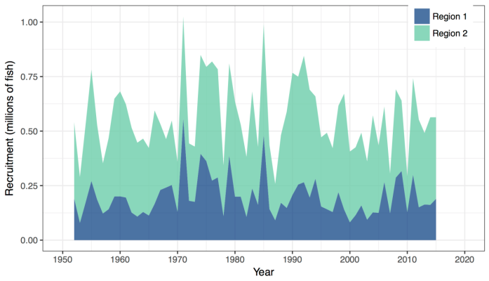
Figure SWO-1. Total swordfish catches in weight grouped by major longline-method fisheries in the model regions, 1952–2011. (DW1 - distant water fleet region 1; AUS – Australian region 1; Other1 - Other fisheries region 1; DW2 - distant water fleet region 2; NZ2 - New Zealand region 2; EU2 – EU (Spanish) region 2; Other2 - other fisheries region 2) | Figure SWO2. Estimated annual average recruitment by model region for the diagnostic case model, showing the relative sizes among regions.
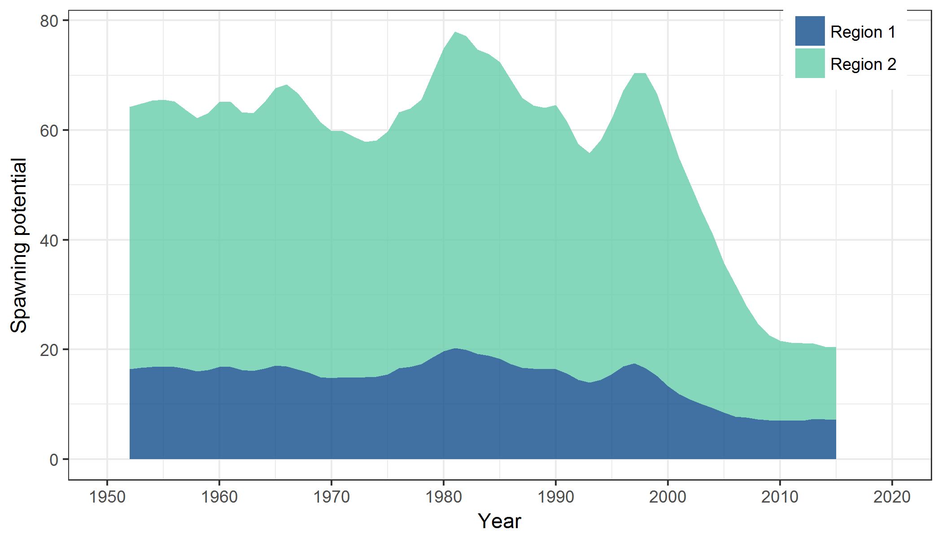 | 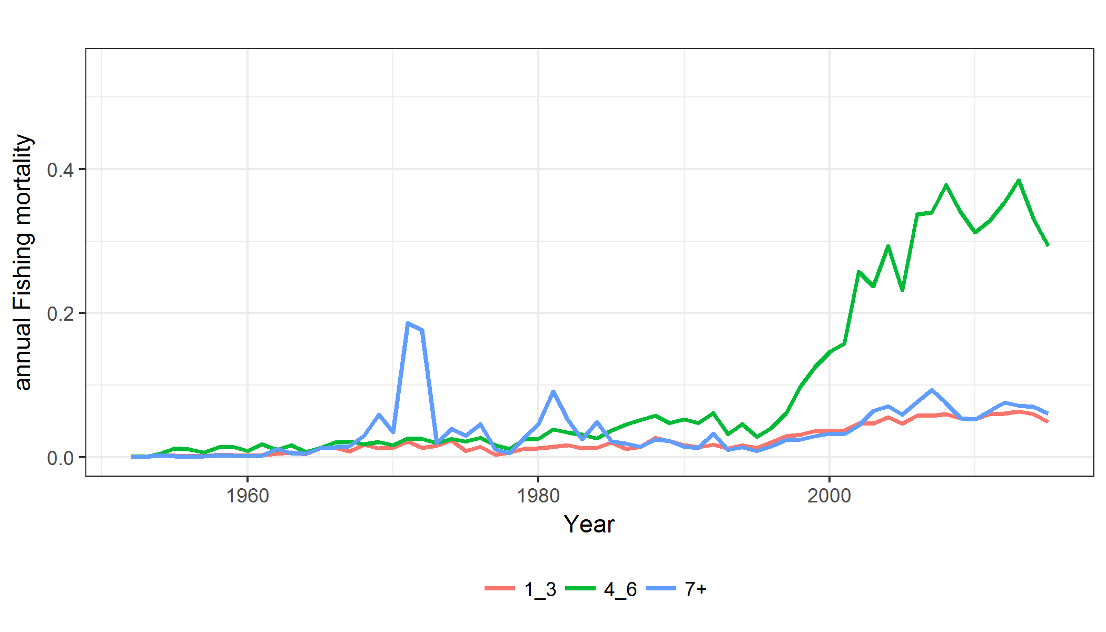
Figure SWO3. Estimated annual average spawning potential by model region for the diagnostic case model, showing the relative sizes among regions. | Figure SWO-4. Estimated annual average juvenile (age classes 1-3), maturing adult (4-6) and adult (7+) fishing mortality for the diagnostic case model.

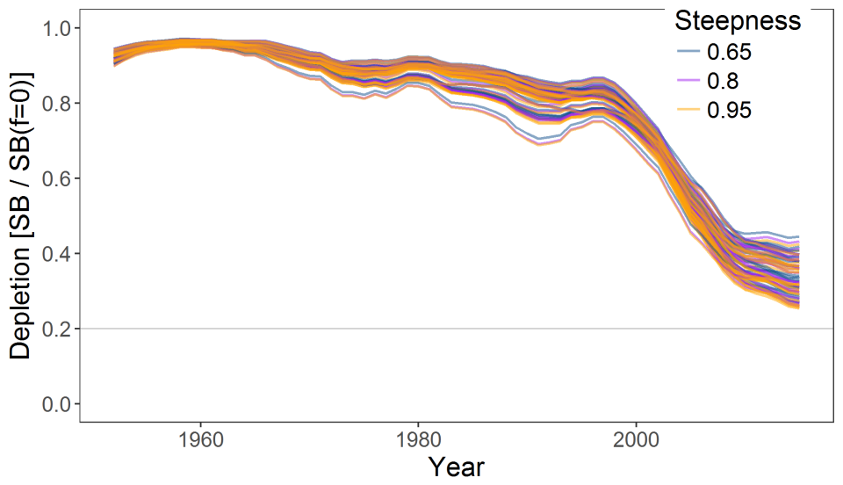
Figure SWO-5. Plot showing the trajectories of fishing depletion (of spawning potential) for the 72 model runs retained for the structural uncertainty grid used for management advice. The colours depict the models in the grid with three levels of steepness (0.65, 0.8 and 0.95).

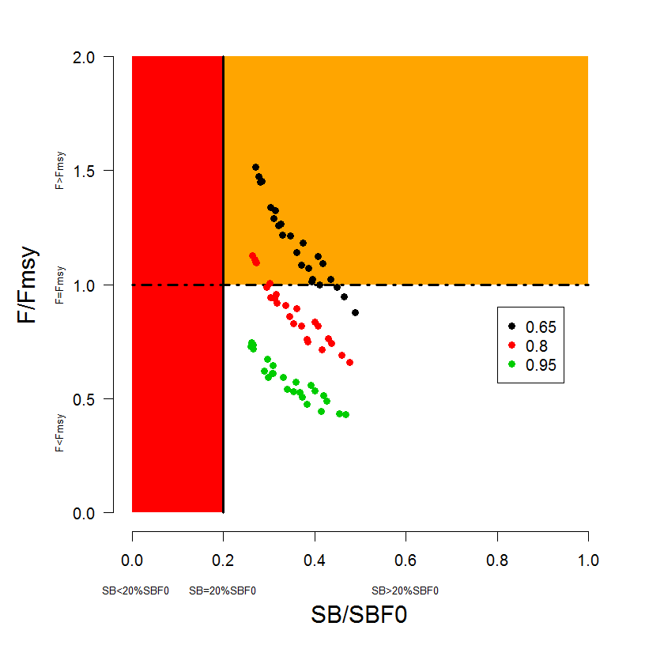 | 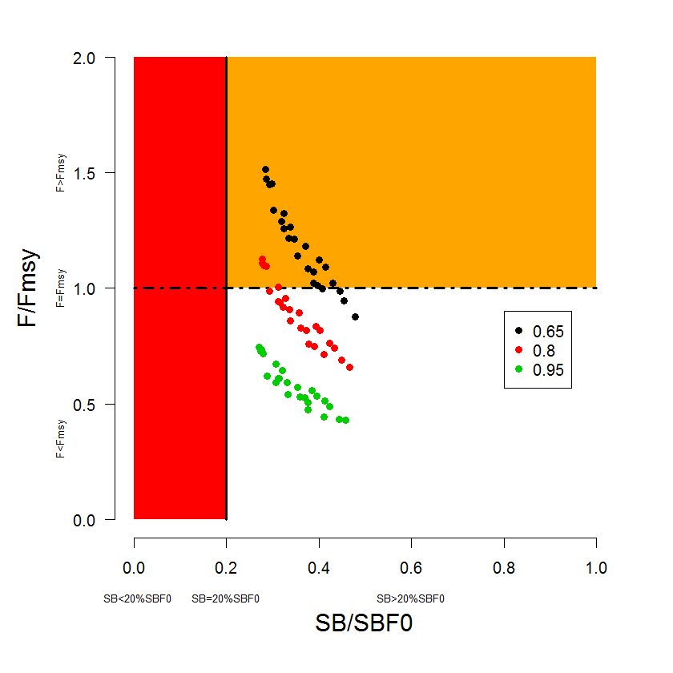
Figure SWO-6. Majuro plot summarising the results for each of the models in the structural uncertainty grid retained for management advice. The plots represent estimates of stock status in terms of spawning potential depletion and fishing mortality. The red zone represents spawning potential levels lower than the agreed limit reference point which is marked with the solid black line. The orange region is for fishing mortality greater than F_{MSY} (F_{MSY} is marked with the black dashed line). The points represent SB_{latest} /SB_{F=0}, and the colours depict the models in the grid with three levels of steepness (0.65, 0.8 and 0.95). | Figure SWO-7. Majuro plot summarising the results for each of the models in the structural uncertainty grid retained for management advice. The plots represent estimates of stock status in terms of spawning potential depletion and fishing mortality. The red zone represents spawning potential levels lower than the agreed limit reference point which is marked with the solid black line. The orange region is for fishing mortality greater than F_{MSY} (F_{MSY} is marked with the black dashed line). The points represent SB_{recent}/SB_{F=0}, and the colours depict the models in the grid with three levels of steepness (0.65, 0.8 and 0.95). Note, SB_{recent} is defined as the mean of SB over 2012-2015.
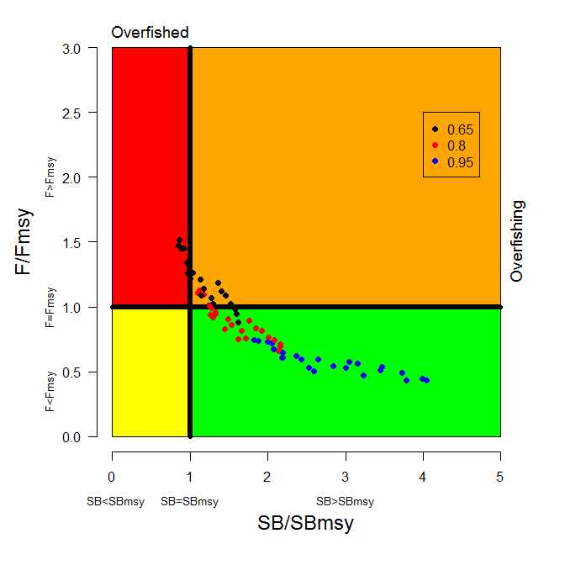 | 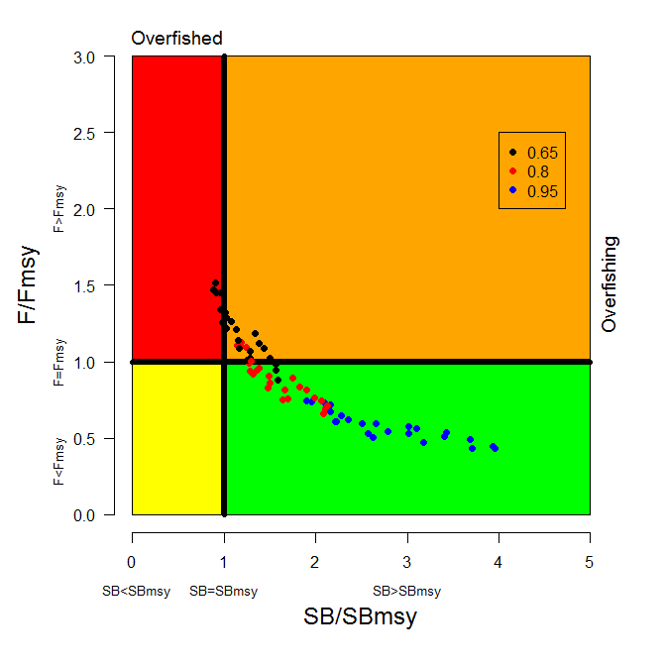
Figure SWO-8. Kobe plot summarising the results for each of the models in the structural uncertainty grid, where the x-axis represents SB_{latest} /SB_{MSY}. The colours depict the models in the grid with three levels of steepness (0.65, 0.8 and 0.95). | Figure SWO-9. Kobe plot summarising the results for each of the models in the structural uncertainty grid. The colours depict the models in the grid with three levels of steepness (0.65, 0.8 and 0.95). As in Figure SWO7, SB_{recent} was used instead of SB_{latest}.
Figure SWO-10. Estimated time-series (or “dynamic”) Majuro and Kobe plots from the SW Pacific swordfish ‘diagnostic case’ model run.

Figure SWO-11. Estimates of reduction in spawning potential due to fishing by region, and over all regions (lower left panel), attributed to various fishery groups (distant water ‘north’, ‘central’ and ‘south’, corresponding to the model regions, and a combined domestic fleet) for the diagnostic case model.

Table SWO-2. Summary of reference points over the 72 models in the structural uncertainty grid for management advice. Note that SB_{recent}/SB_{F=0} is calculated where SB_{recent} is the mean SB over 2012-2015 instead of 2011-2014 (used in the stock assessment report), at the request of the Scientific Committee.
 | Mean | Median | Min | 10% | 90% | Max
C_{latest} | 9,884 | 9,884 | 9,318 | 9,343 | 10,157 | 10,287
MSY | 8,172 | 7,913 | 5,905 | 6,396 | 10,150 | 11,360
Y_{Frecent} | 7,628 | 7,775 | 4,998 | 6,062 | 8,948 | 9,684
f_{mult} | 1.27 | 1.15 | 0.66 | 0.79 | 1.89 | 2.32
F_{MSY} | 0.16 | 0.14 | 0.10 | 0.10 | 0.22 | 0.23
F_{recent}/F_{MSY} | 0.88 | 0.87 | 0.43 | 0.53 | 1.26 | 1.51
SB_{MSY} | 17,314 | 17,740 | 7,278 | 8,943 | 26,661 | 30,460
SB₀ | 84,173 | 84,075 | 57,070 | 71,199 | 98,039 | 111,000
SB_{MSY}/SB₀ | 0.20 | 0.21 | 0.11 | 0.12 | 0.28 | 0.28
SB_{F=0} | 78,619 | 78,301 | 61,996 | 64,342 | 92,120 | 100,691
SB_{MSY}/SB_{F=0} | 0.22 | 0.23 | 0.10 | 0.12 | 0.32 | 0.33
SB_{latest} /SB₀ | 0.33 | 0.32 | 0.24 | 0.25 | 0.44 | 0.46
SB_{latest} /SB_{F=0} | 0.35 | 0.35 | 0.26 | 0.27 | 0.44 | 0.49
SB_{latest} /SB_{MSY} | 1.85 | 1.61 | 0.85 | 0.99 | 3.14 | 4.05
SB_{recent}/SB_{F=0} | 0.36 | 0.35 | 0.27 | 0.29 | 0.43 | 0.48
SB_{recent}/SB_{MSY} | 1.86 | 1.58 | 0.88 | 1.02 | 3.10 | 3.96

- SC13 noted that the central tendency of relative recent spawning biomass was median (SB_{recent}/SB_{F=0}) = 0.35 with a probable range of 0.29 to 0.43 (80% probability interval). The median estimate (0.35) is below that estimated from the 2014 assessment grid((SB_{current}/SB_{F=0}) = 0.49, see SC9-SA-WP-05), noting the differences in grid uncertainty axes used in that assessment, due to the inclusion of two representations of growth and maturity. SC13 also noted that in the previous assessment this central tendency was not considered for the provision of management advice given the uncertainties in growth assumptions. The median estimate for SB_{recent}/SB_{MSY} is 1.23, which is below that estimated from the 2014 assessment grid ((SB_{current}/SB_{MSY}) = 2.07, see SC9-SA-WP-05).

- SC13 noted that the central tendency of relative recent fishing mortality was median (F_{recent}/F_{MSY}) = 0.86 with an 80% probability interval of 0.51 to 1.23. While this suggested that there was likely a buffer between recent fishing mortality and F_{MSY}, it also showed that there was some probability that recent fishing mortality was above F_{MSY}.

- SC13 also noted that there was a roughly 32% probability (23 out of 72 models) that the recent fishing mortality was above F_{MSY} with Prob((F_{recent}/F_{MSY})>1) = 0.32. The median estimate (0.86) is above that estimated from the 2014 assessment grid (F_{current}/F_{MSY} = 0.74, see SC9-SA-WP-05).

- Fishing mortality rate increased notably from the mid-1990s in both model regions, on maturing swordfish aged 4-6 fish in particular.

- Across all models in the uncertainty grid the spawning biomass declines steeply between the late 1990s and 2010 but since then the rate of decline has been less. Those declines are found in both model regions, but are higher in the eastern Region 2 (equator to 50°S, 165°E to 130°W).

- SC13 noted that in comparison with the bigeye and yellowfin assessments, evidence for an increase in recent recruitment for southwest Pacific swordfish was not found in either the CPUE time series or estimates of recruitment. SC13 noted that the longline only nature of the fishery catching mainly larger, older swordfish, is not strongly informative with regards to recruitment dynamics.

- Management advice and implications

- Based on the uncertainty grid adopted by SC13, the south west Pacific swordfish spawning biomass is likely above the 20%SB_{F=0}, biomass LRP adopted for tunas and the SB_{MSY} level (noting that the Commission has yet to adopted an LRP for south Pacific swordfish) and it is highly likely that the stock is not in an overfished condition (0% probability). Recent F is likely below F_{MSY}, and it appears that the stock is not experiencing overfishing (32% probability of overfishing).

- SC13 noted that there has been an increase in fishing mortality notably from the mid-1990s, and that the biomass relative to unfished levels is estimated to have declined rapidly during the period late-1990s to 2010 followed by a more gradual but continued decline after 2010, across the uncertainty grid. It was noted the fishing mortality was likely below F_{MSY}.

- Consistent with its previous advice (from SC9), SC13 recommends that the Commission consider developing appropriate management measures for the area north of 20°S to the equator which is not covered by CMM 2009-03, noting that:
- recent catches between the equator and 20°S continue to represent the largest component of the catch in Region 2 (equator to 50°S, 165°E to 130°W) and represent half the total catches from the stock, and,
- catches in that area contribute substantially to fishing mortality and spawning biomass depletion levels in eastern Region 2 that are substantially higher than in the western region (Region 1).

- Further, SC13 recommends that current restrictions on catches south of 20°S also be maintained.

Useful References

SC21-SA-WP-05 Stock assessment of Southwest Pacific swordfish (Rev.03). J. Day, C. Castillo-Jord´an, S. McKechnie, A. Magnusson, K. Kim, T. Teears, N. Davies, J. Hampton, T. Peatman, T. Vidal, P. Hamer (SPC-OFP) https://meetings.wcpfc.int/node/26681

Refer to the SC21 website for more information

Previous Assessments

SC17-SA-WP-04 Stock assessment of Southwest Pacific swordfish. N. Ducharme-Barth, C. Castillo-Jordan, J. Hampton, P. Williams, G. Pilling, P.Hamer (SPC-OFP)
https://meetings.wcpfc.int/node/12553

SC13-SA-WP-13 Stock assessment of swordfish in the SW Pacific. Takeuchi Y, G. Pilling and J. Hampton. (SPC-OFP)
https://www.wcpfc.int/node/29526

SC9-SA-WP-05 Stock assessment of swordfish (Xiphias gladius) in the southwest Pacific Ocean. https://wcpfc.int/node/3683

SC4-SA-WP-06 Multifan-CL Stock Assessment of Southern Western-Central Pacific Swordfish 1952-2007. https://wcpfc.int/node/1223

SC2-SA-WP-07 SW Pacific Swordfish Stock Status Summary from multiple assessment models. https://wcpfc.int/node/1752

SC1-SA-WP-07 Southwest Pacific swordfish assessment: 2005-6 objectives and preliminary results. https://wcpfc.int/node/1891

