

The Commission for the Conservation and Management of
Highly Migratory Fish Stocks in the Western and Central Pacific Ocean

Scientific Committee

Skipjack Tuna (Katsuwonus pelamis)

Stock Status and Management Advice

Contents
SC21 2025 (STOCK ASSESSMENT CONDUCTED) 3
SC20 2024 (FISHERY INDICATORS UPDATED) 13
SC19 2023 (FISHERY INDICATORS UPDATED) 13
SC18 2022 (STOCK ASSESSMENT CONDUCTED) 14
SC17 2021 (FISHERY INDICATORS UPDATED) 29
SC16 2020 (FISHERY INDICATORS UPDATED) 29
SC15 2019 (STOCK ASSESSMENT CONDUCTED) 29
SC14 2018 (FISHERY INDICATORS UPDATED) 35
SC13 2017 (FISHERY INDICATORS UPDATED) 36
SC12 2016 (STOCK ASSESSMENT CONDUCTED) 37
Useful References 42
Previous Assessments 42

SC21 2025 (STOCK ASSESSMENT CONDUCTED)

WCPO skipjack tuna (Katsuwonus pelamis) stock assessment

- SC21 thanked the SSP for their thorough work conducted on the skipjack tuna stock assessment and for the considerable efforts to improve the assessment.

- SC21 accepted the 2025 skipjack assessment results based on the best available science, noting that conflicts among data sources and issues with model fit highlight the need for improvements to the modelling approach.

- SC21 agreed that management advice should be based on the management procedure already in place (CMM2022-01) under the skipjack monitoring strategy.

- SC21 recognised the need for a regular peer review system for the WCPFC stock assessment, acknowledging the importance of conducting periodic, in-depth, independent reviews of stock assessments as an example of good global fisheries management practice, and recommended that this be considered at SC22.

Provision of scientific information to the Commission

    - Stock assessment and trends

- The 2025 stock assessment of skipjack adopts an eight-region spatial structure (Figure SKJ-01) similar to the structure adopted in previous skipjack assessments. The model estimates quarterly movement between the regions and assumes regionally varying recruitment, with 32 extraction fisheries (Table SKJ-01, SKJ-02).

- The major structural uncertainties considered include drawing steepness from a beta distribution with mode 0.85, drawing growth coefficient k from a uniform distribution (range 0.2–0.4), drawing effort creep trajectories from a prior distribution, and applying various tag mixing scenarios based on dissimilarity of tagged and untagged populations (using the K statistic metric). These structural uncertainties were incorporated into the estimations of reference point values listed in Table SKJ-02.

- Skipjack tuna comprises the largest component of the tuna fisheries throughout the WCPO and is caught using a wide variety of fishing gears. The annual catches show a general increase until 2009, with higher variability since that time (Figure SKJ-02).

- The Japanese pole-and-line CPUE indices indicated relatively stable trends (Figure SKJ-03a). However, with the application of effort creep, each index shows a slight decline in relative abundance over time. Similarly, the purse seine CPUE indices (Figure SKJ-03b) indicated an overall decline in relative abundance. The region 8 purse seine CPUE index indicated high uncertainty in some time-steps due to very low sample sizes.

- The estimated recruitment aggregated across all regions (Figure SKJ-04a) shows high inter-annual variation throughout the 1970s and 1980s and reduced variability thereafter. Mean recruitment declines during the 1970s and 1980s, increases from 1990 until the mid-2000s, and remains stable thereafter. The trends of the regional recruitment time series (Figure SKJ-04b) vary strongly and suggest substantial changes in regional recruitment distribution through time.

- The 2025 diagnostic model predicted that spawning potential (Figure SKJ-05a, b) declined steadily but with strong seasonality throughout the time series for regions 1–4. Regions 3 and 4 showed a slow increase in the last five years. However, regions 5–8 indicated less monotonic trends. Region 5 indicated the highest overall biomass with an initial decline until the 1980s, a stable trend until the early 2000s when biomass rose sharply, followed by a steady decline until the early 2020s. Region 6 indicated an overall slight declining trend with periodically sharp increases through the early 2000s and then less variability thereafter. Regions 7 and 8 demonstrated similar patterns with seasonality and a slow decline until approximately 1990 when spawning potential dropped sharply, recovered slightly in the mid-1990s, and then slowly increased with variability until the terminal year. The aggregated spawning potential (over all regions) indicated an initial increase in the early 1970s and a steady decline to a minimum in the early 1990s, after which spawning potential increased and then stabilized until the terminal year.

- Average fishing mortality rates for juvenile and adult age classes (Figure SKJ-06) indicated variability spatially as well as temporally. Overall, juveniles and adults showed similar trends, except for region 7 and all regions combined, where juveniles indicated less severe increases in fishing mortality. Regions 1–4 demonstrated relatively stable trends over time in fishing mortality but with periods of high variability, and regions 3 and 4 indicated fishing mortality to be much lower in scale compared to other regions. Juveniles in region 1 experienced higher fishing mortality than adults. Regions 5–8 and the combined regions indicated overall increasing trends in fishing mortality, with regions 6 and 7 being much higher in scale than region 8 and all regions combined (except for juveniles in region 7), with differing periods of high variability. Regions 5, 6, and 7 had the highest fishing mortality, and region 4 had the lowest. Region 5 shows a very strong increase in fishing mortality from around 2000.

- Estimates of F/F_{MSY} indicate a steady increase over time with a sharp decline in the early 2020s, followed by an increase in the terminal year (Figure SKJ-07). All estimates (and confidence intervals) were below 0.4 over the time series.

- The 2025 diagnostic model predicted that spawning depletion SB_{recent}/SB_{F =0} (Figure SKJ-08) had a similar pattern to the spawning potential with overall declines (i.e., increased stock depletion) in regions 1–4 and high seasonality. However, there were stronger increases in spawning depletion (i.e., less depleted status) in the last 5-10 years of the model. Region 5 indicated less seasonality with high uncertainty in the 1980s and an overall decline with periods of stability from 1990 through 2010 and an increase in the early 2020s. Region 6 showed an overall decline, but with high variability. Region 7 indicated strong declines until around 2000, followed by a relatively stable period until around 2010, and then an increasing trend (i.e., increased stock depletion) until the end of the model period. Region 8 indicated a similar trend to region 6, with overall declining stock status with periods of temporary recovery. The aggregated spawning depletion (over all regions) estimates suggested a steady decline in stock status until approximately the early 2020s, when stock status increased until the terminal year, when it then decreased slightly. Uncertainty in regions 1-3 was higher compared to regions 4-8, with region 5 indicating higher uncertainty between the 1980s and 2000. Overall, the uncertainty was moderate throughout the time series.

- The model convergence is better than that obtained in the 2022 assessment, as seen from the convergence criteria. However, jitter analyses still indicate the presence of multiple local minima. Likelihood profiles indicate some conflict in the data regarding population scaling. Specifically, the length data indicate a better likelihood at higher biomass, whereas the CPUE and tagging data indicate a better likelihood at lower biomass.

- This assessment is a substantial improvement over the previous assessment in 2022. In contrast to previous assessments, recruitment is estimated to have been more variable and above average but declining slightly prior to 1990. Recruitment increased from 1990 to around 2005, after which there has been no particular trend. There is some evidence of high recruitment in recent years. The lack of a persistently increasing trend in recruitment that was estimated in previous assessments appears due to the exclusion of the SSAP tagging data and some early size data, and the incorporation of effort creep in the pole-and-line CPUE indices.

Table SKJ-01. Definition of fisheries by gear, model region, flags, fishery type (extraction or CPUE indices), and proportion of total catch (Prop. Catch).
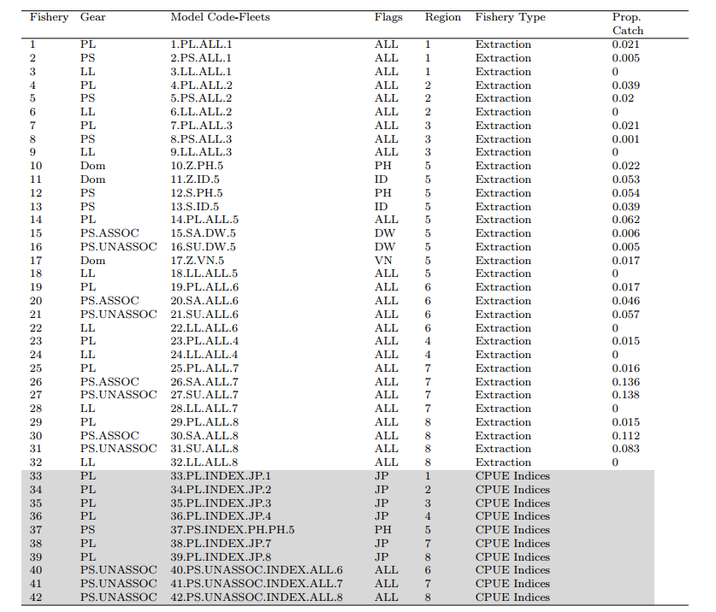

Table SKJ-02. Summary of stock assessment configuration and key sources of uncertainty in the WCPO skipjack tuna stock assessment by the MFCL.
TYPE | RATIONALE | UNCERTAINTY | IMPACT | CONFIDENCE
DATA
CPUE | Best available standardised indices, incorporating operational data,  multiple indices. | Potential hyperstability in PS CPUE indices | Abundance estimates could be biased from 2010-2024 | High
Catch | Best available information | ID catches may be biased high or low | Sensitivity indicated low impact | High
Size | Representative sampling | Good certainty, mandatory length reporting | Selectivity may vary temporally | Medium
Tag
MODEL
MFCL | Commonly used platform for the WCPO tuna stocks | Robust platform for modeling length and tagging data | Low impact | High
SPATIAL ASSUMPTIONS
8 regions | Based on regional processes informed by size and tagging data | Low uncertainty; informed by the literature | Low impact | High
KEY PARAMETER UNCERTAINTY
Growth coefficient k | Not estimable | Uniform distribution (0.2-0.4) | Influential on MSY-based reference points | High
Steepness | Not estimable | Beta distribution (mode of 0.85) | Influential on MSY-based reference points | High
STRUCTURAL UNCERTAINTIES
Mixing period K statistic | External estimates | K statistic (0.1, 0.2, 0.3) | Highly influential in the ensemble | Medium
Effort creep | External estimates | Effort creep trajectories randomly sampled from prior | Low influence | High
Estimation uncertainty
Estimation uncertainty | Monte-Carlo model ensemble | Estimated | Estimation uncertainty | High
Other source of uncertainty
Data conflict | Likelihood profile indicates length conflicts with CPUE and tag data | Conflict in the scaling of biomass | Not considered | Low

Table SKJ-03. WCPO Skipjack stock status summary table.
Skipjack
Year: 2025 | Spawning Potential | Exceptionally unlikely (<1%) to be below the LRP |  | Stock is not overfished
Year: 2025 | Fishing mortality | Exceptionally unlikely (<1%) to be above F_{MSY} |  | Overfishing is not occurring
Year: 2025 | Projection | The stock is on average at 98% of the recalibrated interim TRP (iTRP) as defined in CMM 2022-01 |  | Depletion is in the range expected through the MSE testing of the adopted interim skipjack MP (CMM 2022-01)
Year: 2025 | Recommendation | The stock has had stable spawning potential, spawning potential depletion (SB/SB_{F=0}), and fishing mortality since around 2010. The stock status and fishing mortality are well above the LRPs for depletion and fishing mortality, respectively.
Reference points/MP |  | Estimate  [10%--90%] | Comment
iTRP (interim Target Reference Point) | iTRP recalibrated based on 2025 stock assessment | 0.52 [0.47 – 0.64] | The calculation method for the iTRP is described in CMM 2022-01. The iTRP depletion value requires recalibration for each new stock assessment. Stock status is reported below as the ratio of the SB_{recent}/SB_{F=0} of the new stock assessment to the corresponding recalibrated iTRP value.
iTRP (interim Target Reference Point) | iTRP | 0.98 [0.94 – 1.01] | The iTRP is recalibrated for each assessment according to the definition in CMM 2022-01 – Reference Points.  The ratio presented here is the ratio of the SB_{recent}/SB_{F=0} from the current stock assessment to the recalibrated iTRP value.
Depletion | LRP (0.2SB_{F=0}) | 0.51 [0.45 – 0.63] | LRP based on SB_{recent}/SB_{F=0} is the adopted LRP for tuna stocks by the WCPFC.
Fishing Mortality | F_{MSY} | 0.28 [0.25 – 0.32] | F_{MSY} is the upper-level limit reference point for fishing mortality used by WCPFC for tuna stocks.
Recent estimates |  |  | Recent trend/projection
SB depletion (w/ estimation uncertainty) | SB_{recent}/SB_{F=0} | 0.51 [0.45 – 0.63]
Fishing mortality | F_{recent} | 0.10 [0.07 – 0.12]
SB depletion (w/o estimation uncertainty) | SB_{recent}/SB_{F=0} | 0.51 [0.45 – 0.63]
Status |  |  | Likelihood
Ratio of SB depletion:iTRP | SB_{recent}/SB_{F=0}：iTRP | 0.98 [0.94 – 1.01] | Within the range expected through the MSE testing of the adopted interim skipjack MP
SB depletion (w/ estimation uncertainty) | SB_{recent}/SB_{F=0} | 0.51 [0.45 – 0.63] | <1% probability < 0.2 (LRP)
SB depletion with respect SB_{MSY} (w/estimation uncertainty) | SB_{recent}/SB_{MSY} | 3.90 [2.95 – 5.61] | <1% probability < SB_{MSY}
Fishing mortality | F_{recent}/F_{MSY} | 0.35 [0.24 – 0.45] | <1% probability > F_{MSY}

Table SKJ-04. Summary of reference points over the model ensemble, along with results incorporating estimation uncertainty. Note that these values do not include estimation uncertainty, unless otherwise indicated.
 | Mean | Median | Min | 10% | 90% | Max
F_{MSY} | 0.28 | 0.28 | 0.22 | 0.25 | 0.32 | 0.37
F_{mult} | 3.01 | 2.85 | 1.88 | 2.25 | 4.12 | 5.42
F_{recent}/F_{MSY} | 0.35 | 0.35 | 0.18 | 0.24 | 0.44 | 0.53
MSY | 2,506,046 | 2,374,800 | 1,819,600 | 2,090,400 | 3,200,800 | 4,204,000
SB_{latest} | 3,715,913 | 3,365,822 | 2,320,595 | 2,747,472 | 5,231,863 | 5,801,571
SB_{recent} | 3,681,316 | 3,248,438 | 2,337,134 | 2,641,802 | 5,337,579 | 6,023,691
SB_{F=0} | 6,844,279 | 6,466,725 | 5,102,043 | 5,753,337 | 8,444,739 | 9,440,668
SB_{latest}/SB_{F=0} | 0.54 | 0.53 | 0.42 | 0.46 | 0.62 | 0.82
SB_{latest}/SB_{MSY} | 4.17 | 3.91 | 2.24 | 3.07 | 5.62 | 8.92
SB_{MSY} | 924,241 | 893,900 | 399,400 | 624,900 | 1,232,000 | 1,908,000
SB_{MSY}/SB_{F=0} | 0.13 | 0.14 | 0.07 | 0.10 | 0.16 | 0.20
SB_{recent}/SB_{F=0} | 0.53 | 0.51 | 0.40 | 0.45 | 0.63 | 0.68
SB_{recent}/SB_{MSY} | 4.11 | 3.91 | 2.14 | 2.98 | 5.60 | 8.92
Y_{Frecent} | 440,394 | 438,000 | 362,400 | 398,500 | 486,800 | 562,600
20%SB_{F=0} | 1,368,856 | 1,293,345 | 1,020,409 | 1,150,667 | 1,688,948 | 1,888,134
SB_{recent}/SB_{F=0}:iTRP | 0.98 | 0.98 | 0.83 | 0.94 | 1.01 | 1.05
Including estimation uncertainty
F_{recent}/F_{MSY} | 0.35 | 0.35 | 0.16 | 0.24 | 0.45 | 0.59
SB_{recent}/SB_{F=0} | 0.53 | 0.51 | 0.37 | 0.45 | 0.63 | 0.74
SB_{recent}/SB_{MSY} | 4.11 | 3.90 | 1.92 | 2.95 | 5.61 | 10.73

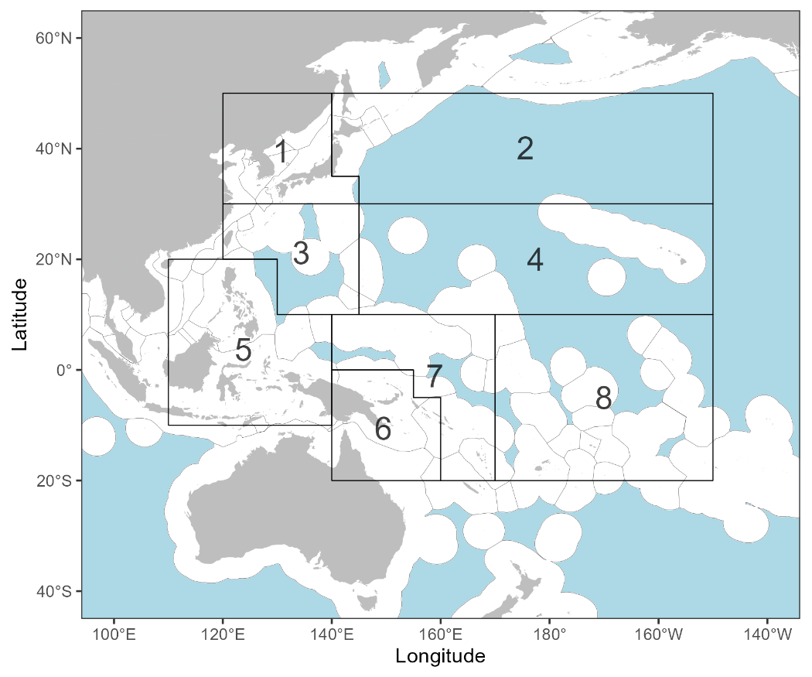
Figure SKJ-01. The geographical area covered by the stock assessment and the boundaries of the eight model regions used for the 2025 skipjack assessment.

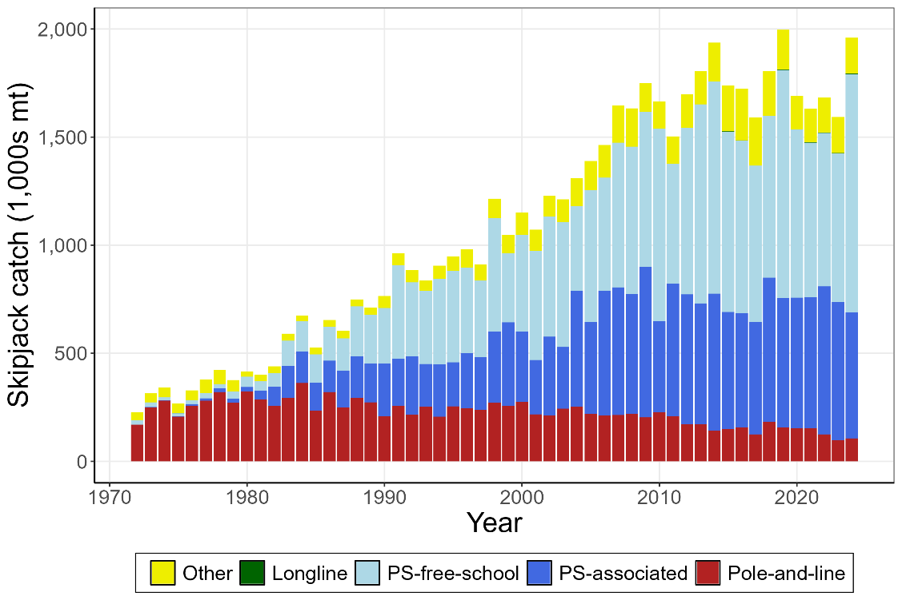
Figure SKJ-02. Time series of total annual catch (1000’s mt) by fishing gear over the full assessment period.
(a)
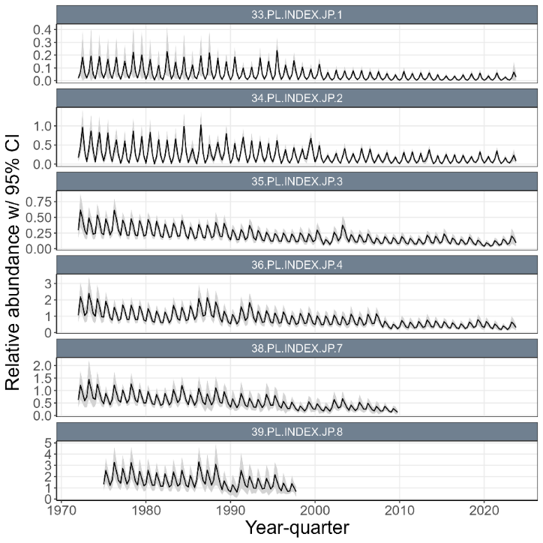
(b)
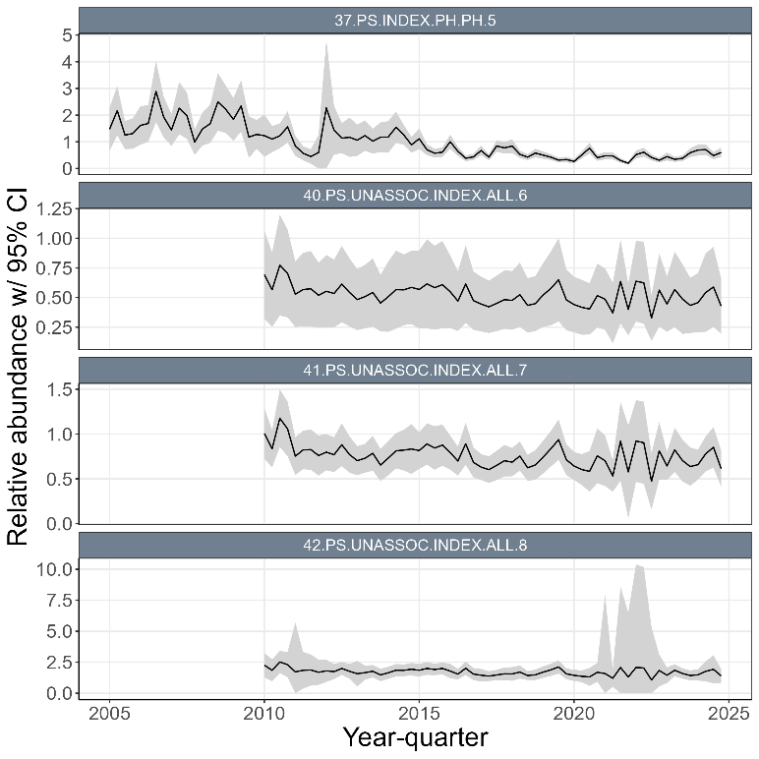
Figure SKJ-03. (a) Time series of standardized CPUE with 95% confidence intervals (CI) for the Japanese pole-and-line with effort creep adjustment and confidence intervals derived from bi-regionally grouped models (i.e., region 1 with 2, region 3 with 4, and region 7 with 8). (b) Time series of standardized CPUE with 95% confidence intervals (CI) for the ‘unassociated’ purse seine CPUE indices in regions 6, 7, and 8, and the Philippines purse seine index in region 5. Fishery labels indicate fishery number, gear type, flags, and region, respectively.

(a)
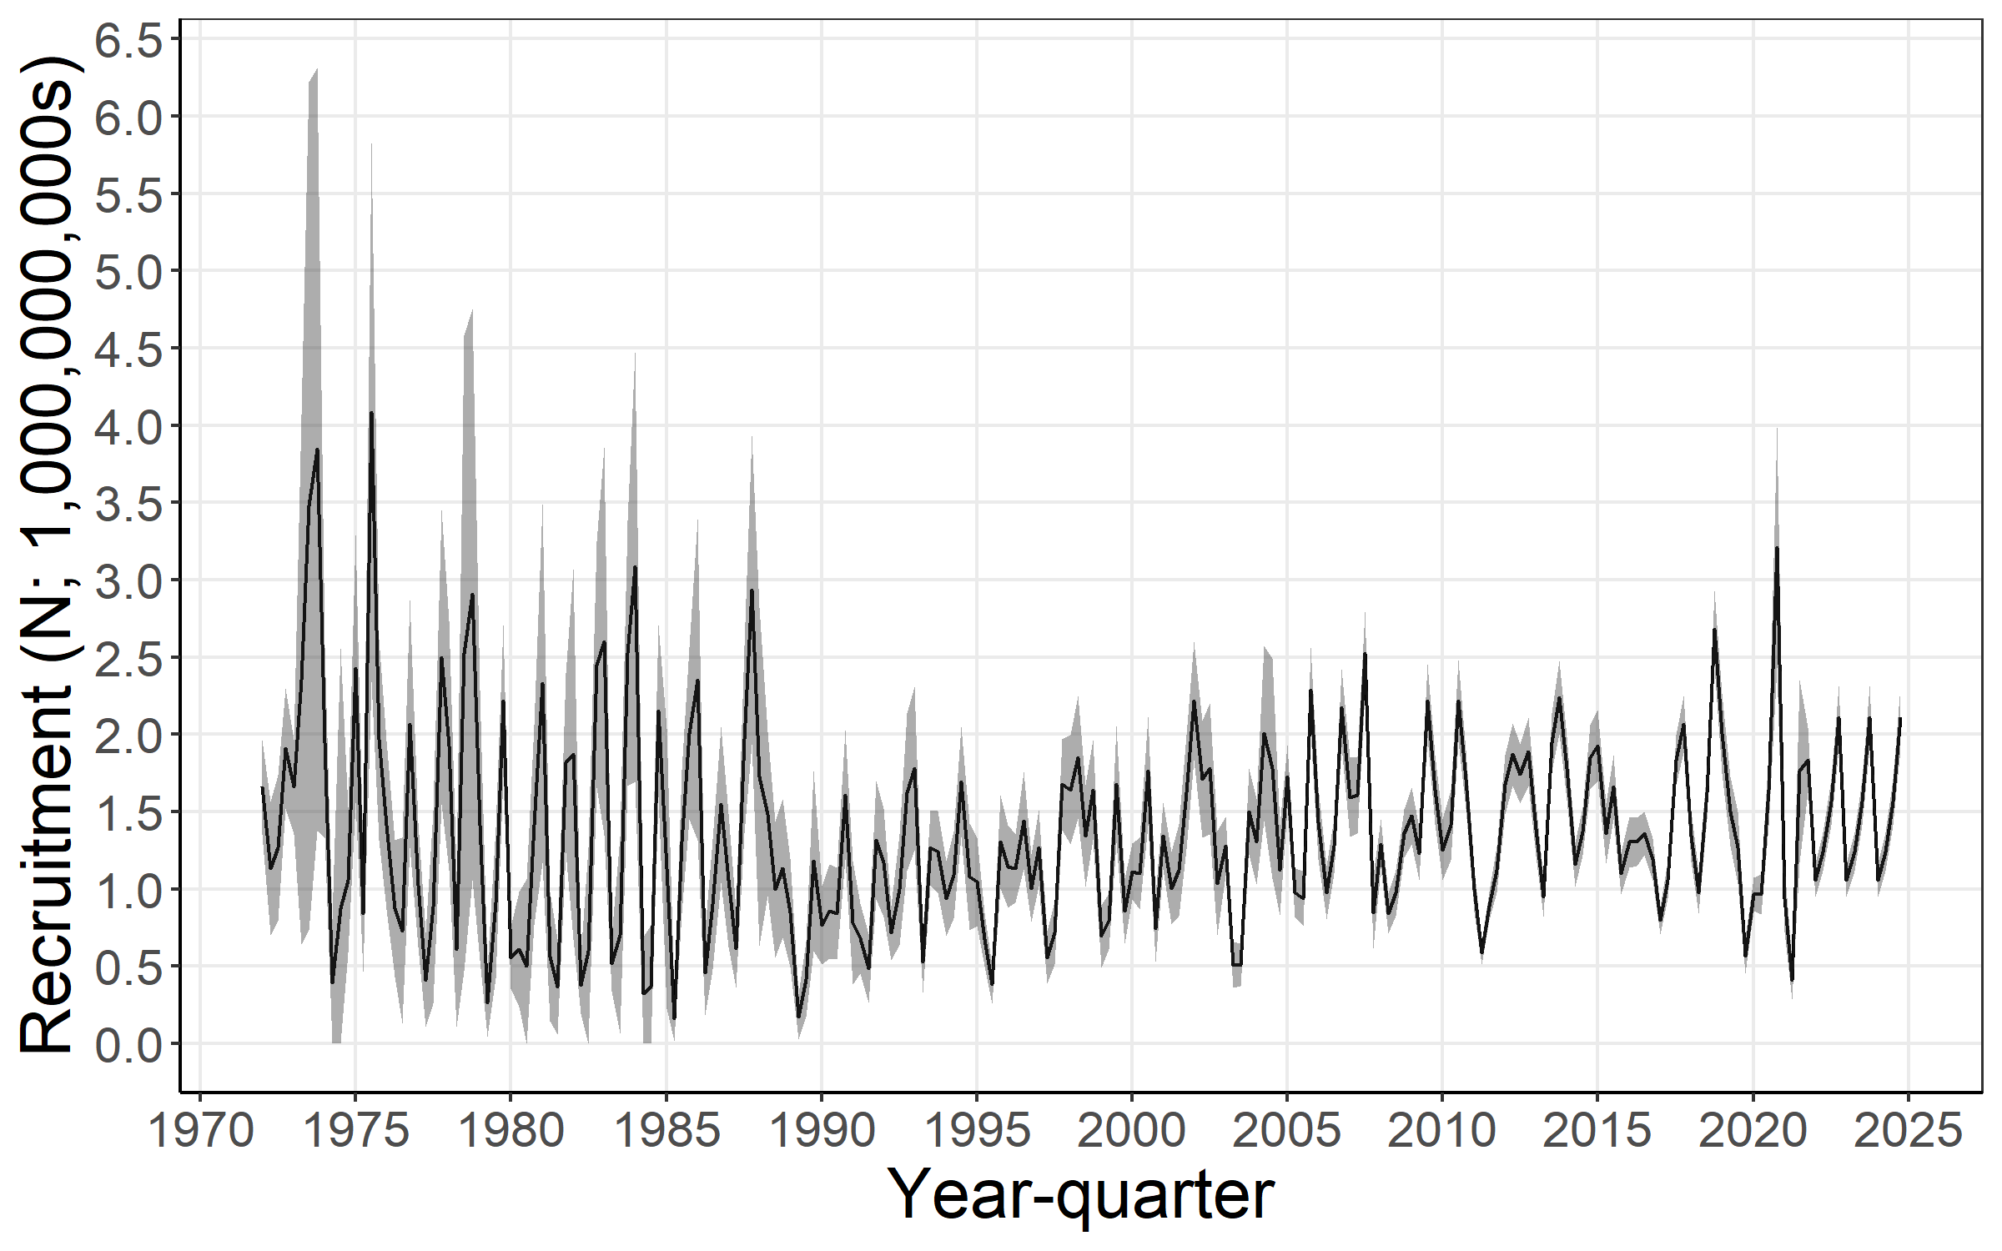
(b)
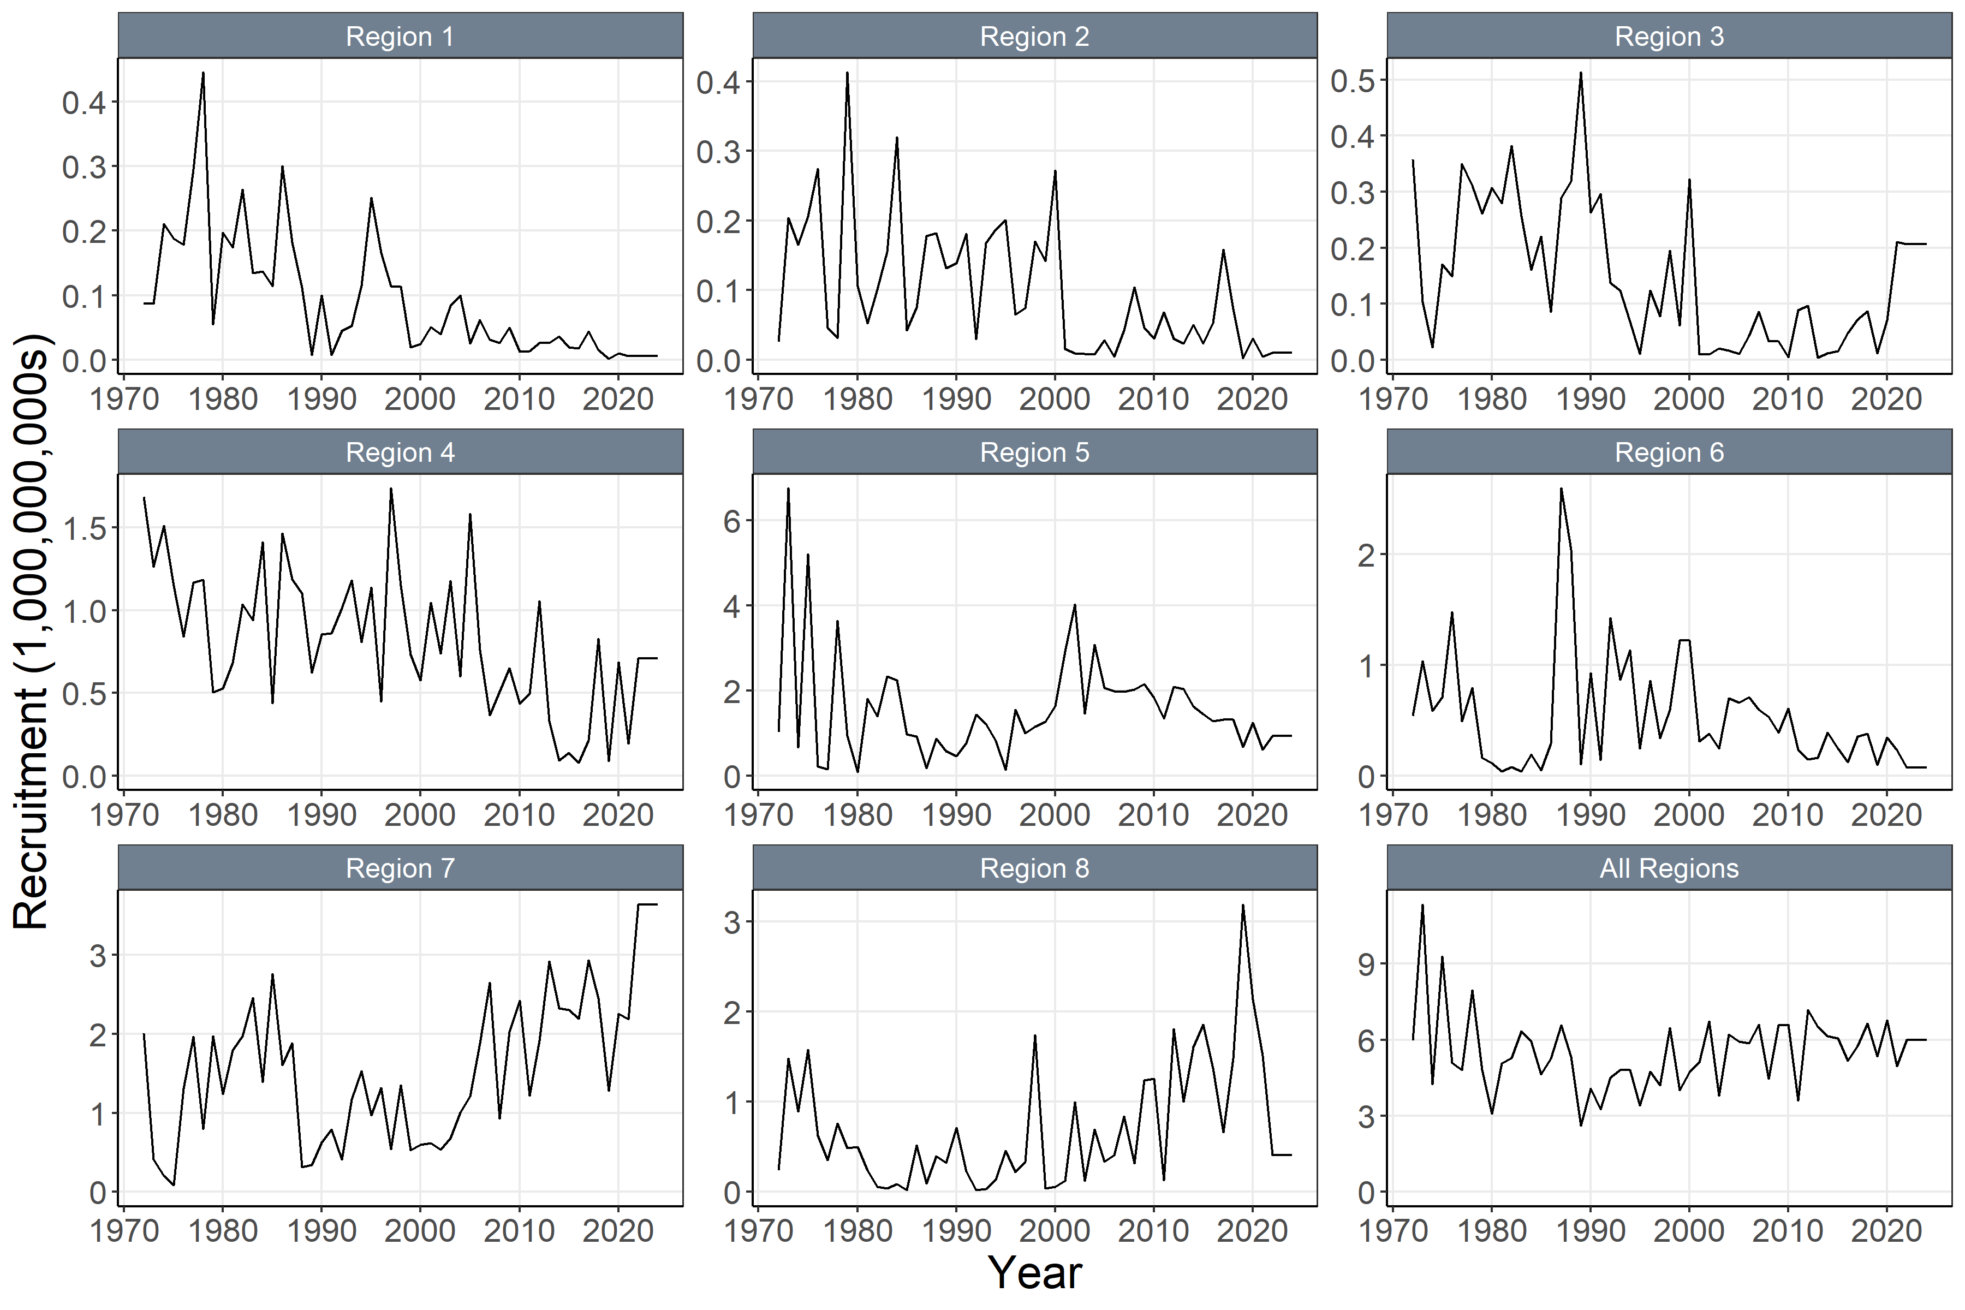
Figure SKJ-04. (a) Annual time series of estimated quarterly recruitment (including estimation error) summed across regions with 95% confidence interval for the diagnostic model. (b) Annual time series of estimated annual recruitment (without estimation error) among regions for the diagnostic model.

(a)
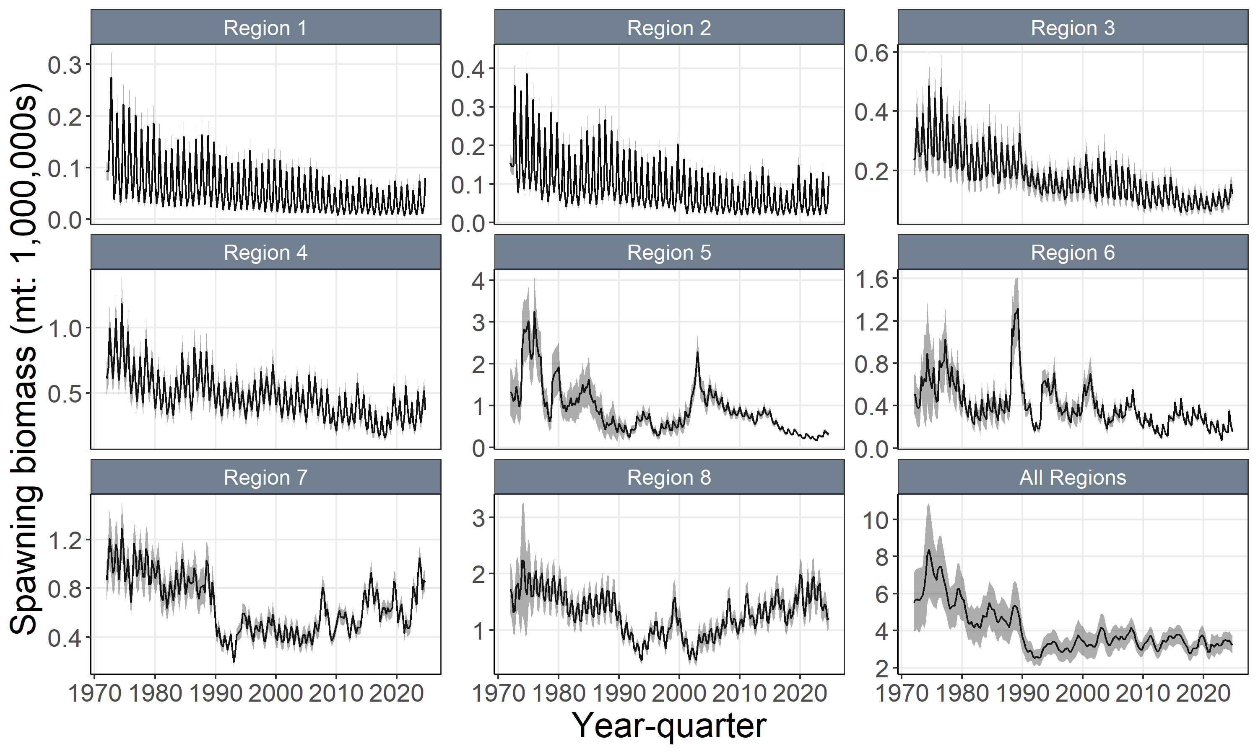
(b)
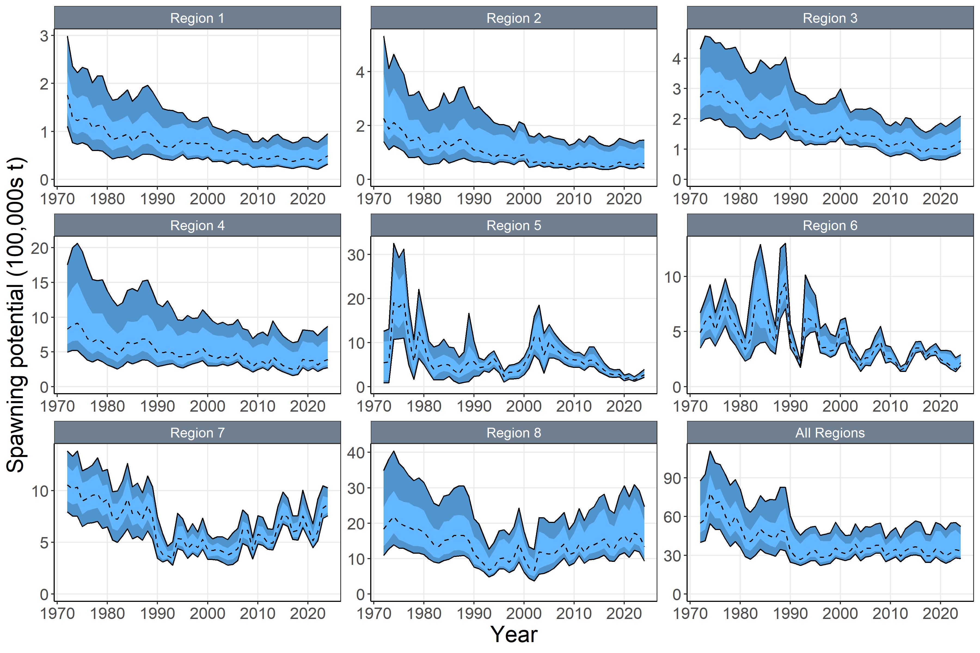
Figure SKJ-05. (a) Time series of estimated quarterly spawning potential by region with 95% confidence interval for the diagnostic model, including estimation error. (b) Time series of annual estimated 90% (dark blue) and 75% (light blue) quantiles of spawning potential by region from the model ensemble. The dashed line indicates the median. Estimation uncertainty is not included in b).

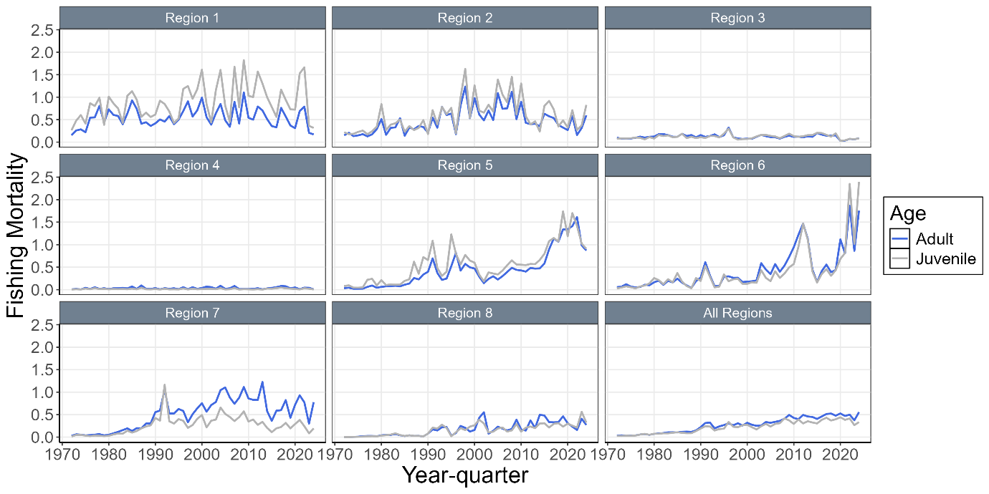
Figure SKJ-06. Time series of annual estimated fishing mortality (F) for adults and juveniles by regions for the diagnostic model.

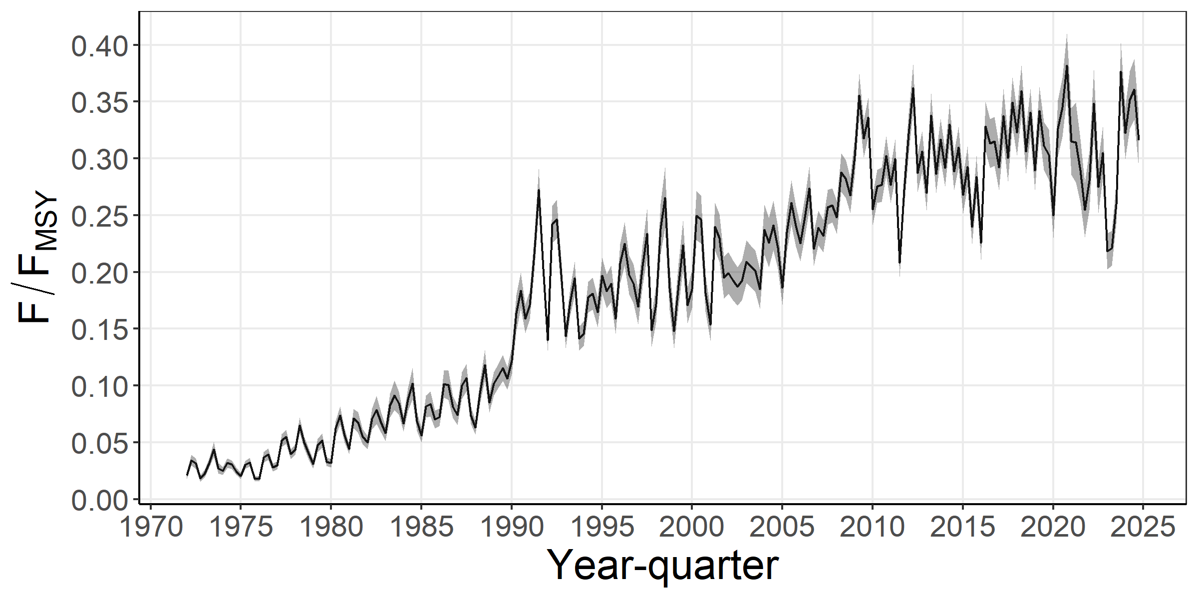
Figure SKJ-07. Time series of estimated F/F_{MSY} with 95% estimation error for the diagnostic model.

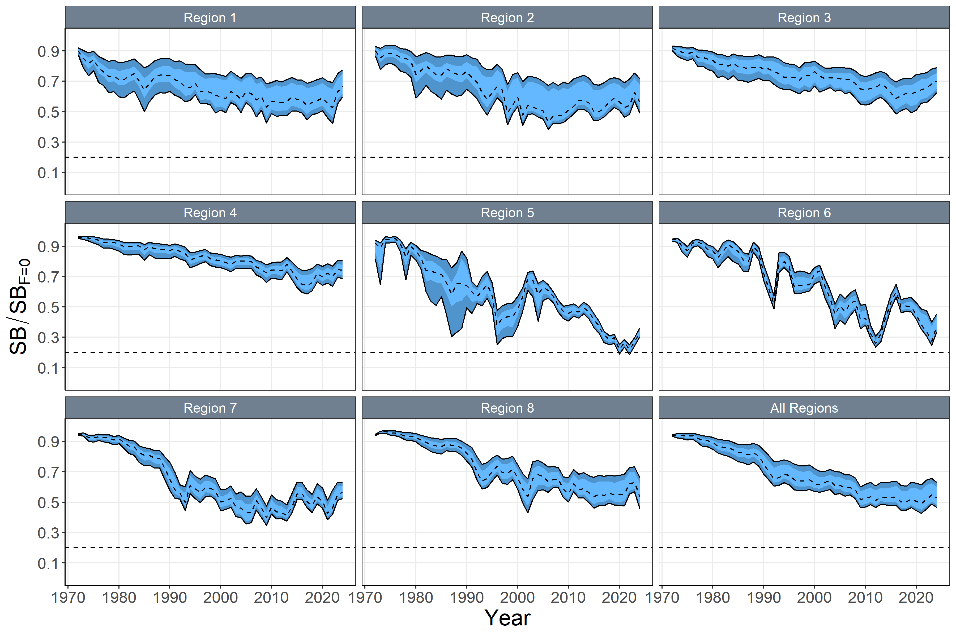
Figure SKJ-08. Time series of annual estimated 90% (dark blue) and 75% (light blue) quantiles of SB/SB_{F=0} by region from the model ensemble. The dashed line within the interval indicates the median. Estimation uncertainty not included.

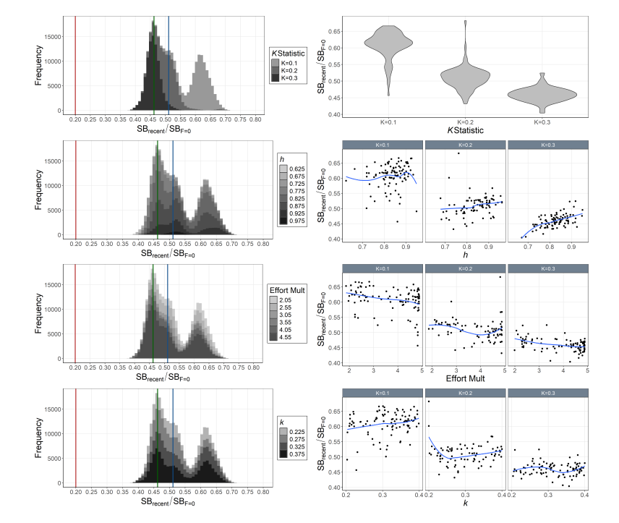

Figure SKJ-09. Histograms of Monte-Carlo estimated model uncertainty for SB_{recent}/SB_{F=0} by mixing period (K statistic, top-left), h (2nd-left), effort multiplier (Effort Mult; 3rd-left), and growth coefficient k (bottom left) with mode (green line), median (blue line), and SB_{recent}/SB_{F=0} = 0.2 (red line). Also includes estimated SB_{recent}/SB_{F=0} by mixing period (K statistic; top-right), h (2nd-right), effort multiplier (Effort Mult; 3rd-right), and growth coefficient k (bottom-right) for each model in the ensemble with a loess smoother.

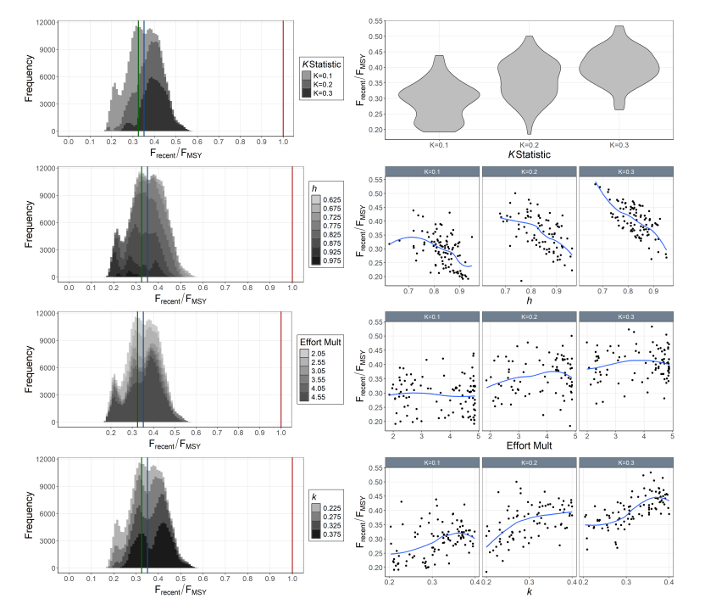

Figure SKJ-10. Histograms of Monte-Carlo estimated model uncertainty for F_{recent}/F_{MSY} by mixing period (K statistic, top-left), h (2nd-left), effort multiplier (Effort Mult; 3rd-left), and growth coefficient k (bottom left) with mode (green line), median (blue line), and F_{recent}/F_{MSY} = 1.0 (red line). Also includes estimated F_{recent}/F_{MSY} by mixing period (K statistic; top-right), h (2nd-right), effort multiplier (Effort Mult; 3rd-right), and growth coefficient k (bottom-right) for each model in the ensemble with a loess smoother.

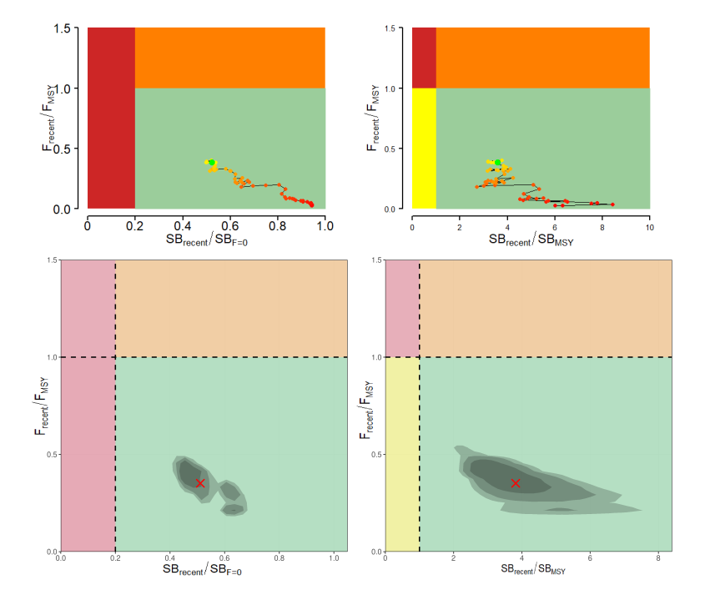

Figure SKJ-11. Majuro plots (left) and Kobe plots (right) summarizing the results for the dynamic MSY analysis (top; 4-year window moving back in time) and the Monte-Carlo random draws from the model ensemble (i.e., including estimation uncertainty) for the recent period (2021–2024; right). Colors for dynamic MSY go from red to green over time. The shading of model ensemble results indicates the 50th, 80th, and 90th highest density regions. The red X in the model ensemble represents the median.

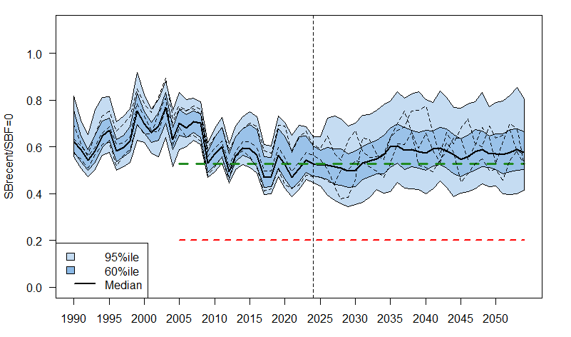
Figure SKJ-12. WCPO skipjack tuna SB depletion from the uncertainty grid of assessment model runs for the period 1990 to 2024 (the vertical line at 2024 represents the last year of data used in the assessment), and stochastic projection results for the period 2025 to 2054 assuming catch and effort levels in 2024 continued into the future. Prior to 2025, the data represent the 60th and 95th percentiles of the uncertainty grid from the assessment models and the median. During the projection period (2025-2054), levels of recruitment variability estimated over the period used to estimate the stock-recruitment relationship (1984-2020) are assumed to continue in the future. The dashed lines indicate three example trajectories (chosen randomly out of 8,100) from the model grid. The red dashed line represents the WCPFC agreed limit reference point (0.20). The green dashed line represents the recalibrated skipjack TRP level.

    - Stock status

- Estimation uncertainty was incorporated by applying a Monte-Carlo model ensemble approach. Estimates of SB_{recent}/SB_{F=0} (Figure SKJ-09) and F_{recent}/F_{MSY} (Figure SKJ-10) indicated that tag mixing period assumptions (i.e., dissimilarity K statistic) had the largest impact on estimates of stock status.

- The models from the ensemble indicated the probability that SB_{recent}/SB_{F =0} < 0.2 (LRP) was 0 (Table SKJ-03), the probability that F_{recent}/F_{MSY} >1 was 0. The dynamic Majuro and Kobe plots indicated that for all time periods, the SB_{recent}/SB_{F=0} was > 0.2, SB_{recent}/SB_{MSY} was > 1, and the F_{recent}/F_{MSY} was < 1 (Figure SKJ-11). Similarly, all models in the ensemble for the recent period (2021–2024) indicated that the SB_{recent}/SB_{F=0} was > 0.2, SB_{recent}/SB_{MSY} was > 1, and the F_{recent}/F_{MSY} was < 1. As in the previous stock assessment, results indicate that the skipjack stock in the WCPO is not overfished, and overfishing is not occurring.

- The projected stock depletion levels under recent conditions are presented in Figure SKJ-12. The year 2024 represents the first year of application of the skipjack interim management procedure (CMM 2022-01). The stock is on average at 98% of the recalibrated TRP (0.94 – 1.01). This is within the range expected through the MSE testing of the adopted interim skipjack MP (see MSE shiny at https://ofp-sam.shinyapps.io/PIMPLE_WCPFC19/; performance indicator: ‘SB/SB_{F=0} relative to target’).

    - Management advice

- While acknowledging that ongoing improvements to the modelling are still needed, SC21 accepted the 2025 skipjack stock assessment results and considered that they, in general, support the continued application of the skipjack management procedure (MP). The entire monitoring strategy for the skipjack MP can be found in Agenda item 5.1.1.2 of the Management Issues theme.

    - Research recommendations

- SC21 identified a range of areas for improvement and suggested the following items for consideration in the development of the next stock assessment:
- Potential effort creep in PS CPUE.
- Data conflicts that affect assessment outcomes, and approaches to resolving them.
- Impact of tagging data on population scale
- Tag diagnostics: Models that fit to tagging data require diagnostic plots that indicate a) the degree of mixing for the tags included in the model, b) the likelihood profile on the SSB scale by tagging program, and c) tag mixing scenarios.
- Tag reporting rate priors
- Tag mixing period: more appropriately modelling the tagging data externally using the approach being developed in collaboration with DTU to develop external abundance indices for the tagging data.
- Meta population structure: improve understanding of linkages between East Asian waters and the WCPFC area, and East-West linkages across the Pacific.
- Growth and age structure research: conduct research to explore the epigenetic approach.

SC20 2024 (FISHERY INDICATORS UPDATED)

Refer to SC20-SA-WP-07, “A compendium of fisheries indicators for target tuna stocks in the WCPFC Convention Area” providing empirical information on recent patterns in skipjack fisheries.

SC19 2023 (FISHERY INDICATORS UPDATED)

Indicator analysis

Refer to SC19-SA-WP-06, “A compendium of fisheries indicators for target tuna stocks in the WCPFC Convention Area” providing empirical information on recent patterns in skipjack fisheries.

Update of skipjack tuna stock assessment information

SC19 reviewed SPC’s follow-up work on the 2022 skipjack tuna diagnostic assessment and commended the SSP for improving the model, including achieving a positive definite Hessian. SC19 noted that while the technical issues identified by SC18 were addressed and the updates had negligible impact on overall stock status or management advice, some biological and selectivity parameters—such as growth, mortality-at-age, and selectivity-at-age—changed between the 2022 and 2023 versions, warranting further investigation.

SC19 highlighted the value of conducting follow-up work between assessment cycles to resolve issues early and strengthen future stock assessments, noting that such work depends on available staff resources and should be prioritised through the TARP process. SC19 also identified priority areas for continued improvement, including better fits to length data, estimation of tag reporting rates, exploring alternative spatial structures, addressing unrealistic recruitment estimates, and using jittering diagnostics to test model stability.

SC18 2022 (STOCK ASSESSMENT CONDUCTED)

a. Status and trends

- SC18 noted that the total catch in 2021 was 1,547,945t, a 10% decrease from 2020 and a 14% decrease from the 2016-2020 average. Purse seine catch in 2021 (1,254,022t) was a 11% decrease from 2020 and a 13% decrease from the 2016-2020 average. Pole and line catch (97,908t) was a 39% decrease from 2020 and a 37% decrease from the 2016-2020 average catch. Catch by other gears totalled 192,182t and was a 25% increase from 2020 and 5% decrease from the average catch in 2016-2020.

- SC18 adopted the 2022 assessment and a structural uncertainty grid was used to develop management advice which included axes for tag mixing (three options), growth (two options) and steepness (three options), resulting in 18 models (Table SKJ-01). All models within the grid were equally weighted. The assessment grid of models estimated that the overall median recent spawning depletion (SB_{recent}/SB_{F=0}) is 0.51 (80th percentile 0.43-0.64), which is close to the interim target reference point (TRP) of 0.50 (CMM 2021-01). No grid models were below the limit reference point (LRP) of 0.20 SB_{F=0}. The median of F_{recent}/F_{MSY} was 0.32 (80th percentile 0.18-0.45) (Table SKJ-02). The 2022 stock assessment of skipjack tuna for the WCPO, indicated that according to WCPFC reference points the stock is not overfished, nor undergoing overfishing.

- Catches of skipjack tuna in the WCPO have increased from approximately 250,000 metric tonnes in the late 1970s to a peak catch of approximately 2,000,000 metric tonnes in 2019; catches have dropped from 2019 to 2021 (Figure SKJ-02). Catches are dominated by purse seine fisheries in equatorial regions 6, 7, and 8, and purse seine and other gears in region 5 (Figure SKJ-03). Catches are dominated by pole-and-line in the northern regions 1–4 and continue to be low compared to those in the equatorial regions (Figures SKJ-03 and SKJ-04). The spawning potential and total biomass, while showing variability over time, do not show sustained long-term declining trends (Figures SKJ-05 and SKJ-08). In contrast, the trajectory of spawning potential depletion (SB/SB_{F=0}) shows a long-term trend towards a more depleted status (Figure SKJ-09). The spawning potential depletion trajectory was largely driven by the model estimates of increased levels of unfished spawning potential over time which are in turn driven by the model estimates of increasing recruitment over time (Figure SKJ-05). The model estimated increased recruitment over time to account for the increased catches in the face of a relatively stable biomass that is partly informed by several long-term stable CPUE indices of abundance (i.e., pole-and-line fishery indices) within the assessment. However, it is noted that spawning potential, recruitment and total biomass are estimated to have declined since around 2010 (Figure SKJ-05).

- Fishing mortality continues to increase over time for the adult and juvenile components of the stock, with fishing mortality being consistently higher for adults (Figure SKJ-06).

- Fishery impact analyses show that the purse seine fisheries continue to dominate the impact in the equatorial regions 6, 7, and 8, with similar impacts by the ‘associated’ and ‘unassociated’ components, except for region 8 where ‘associated’ fishing appears to have more impact (Figure SKJ-07). Fishery impacts in region 5 are dominated by purse seine and other gears, and in regions 1-4, by pole-and-line, but with increasing impact of purse seine over time (Figure SKJ-07).

- The influences of the structural uncertainty grid axes on key management quantities are shown in Figure SKJ-10. Tag mixing assumptions that applied longer tag mixing periods, and the externally estimated growth curve, resulted in more optimistic estimates of spawning potential depletion and spawning potential and lower fishing mortality.

- Majuro and Kobe plots summarising stock status for the 18 models in the structural uncertainty grid are included for the ‘latest’ (2021, Figure SKJ-11) and ‘recent’ periods (2018-2021, Figure SKJ-12). These plots show that the stock status estimates across the 18 models are all within the zones indicating that the stock is not overfished nor undergoing overfishing.

- The assessment provided a range of diagnostic analyses derived from the diagnostic model that indicated conflict between tag and CPUE data and instability in the convergence minima. Despite this, the model showed low retrospective bias and the important spawning potential depletion management quantities were robust to the differences in model convergence. However, as noted by several CCMs, data conflicts and the instability in model convergence minima require follow-up work and should be improved.

Table SKJ-01. Structural uncertainty grid for the 2022 WCPO skipjack tuna stock assessment. Bold values indicate settings for the diagnostic case.
Axis  Tag mixing | Levels 3 | Option 1 | Option 2 | Option 3
Axis  Tag mixing | Levels 3 | T1, D=0.1 (longer period) | T2, D=0.2 (intermediate) | T3, D=0.3 (shorter)
Growth | 2 | G1, Internally estimated | G2, Externally estimated
 |  | (Dirichlet-multinomial) | (otolith and tagging data)
Steepness | 3 | 0.65 | 0.8 | 0.95

Table SKJ-02. Summary of reference points over the 18 individual models in the structural uncertainty grid.
 | Mean | Median | Min | 10%ile | 90%ile | Max | Diagnostic model
C_{latest} | 1530209 | 1530208 | 1530207 | 1530207 | 1530212 | 1530212 | 1530207
F_{MSY} | 0.23 | 0.23 | 0.18 | 0.19 | 0.27 | 0.28 | 0.24
fmult | 3.61 | 3.18 | 1.88 | 2.22 | 5.54 | 8.08 | 2.86
F_{recent}/F_{MSY} | 0.32 | 0.32 | 0.12 | 0.18 | 0.45 | 0.53 | 0.35
MSY | 2933489 | 2648400 | 2046000 | 2167840 | 4777200 | 4868000 | 2416000
SB₀ | 7958888 | 7204500 | 5317000 | 5611000 | 12842000 | 14390000 | 5686000
SBF=0 | 8073171 | 7616930 | 5953338 | 6156944 | 12310363 | 12744728 | 6147339
SB_{latest}/SB₀ | 0.48 | 0.48 | 0.37 | 0.41 | 0.56 | 0.60 | 0.48
SB_{latest}/SB_{F=0} | 0.47 | 0.46 | 0.35 | 0.38 | 0.60 | 0.61 | 0.44
SB_{latest}/SB_{MSY} | 2.82 | 2.68 | 1.65 | 1.95 | 3.81 | 4.62 | 2.54
SB_{MSY} | 1419366 | 1335000 | 806300 | 870530 | 1984600 | 2925000 | 1073000
SB_{MSY}/SB₀ | 0.18 | 0.18 | 0.13 | 0.13 | 0.22 | 0.22 | 0.19
SB_{MSY}/SB_{F=0} | 0.17 | 0.17 | 0.11 | 0.13 | 0.22 | 0.23 | 0.17
SB_{recent}/SB_{F=0} | 0.52 | 0.51 | 0.41 | 0.43 | 0.64 | 0.66 | 0.50
SB_{recent}/SB_{MSY} | 3.12 | 2.98 | 1.92 | 2.20 | 4.22 | 4.97 | 2.88
Y_{Frecent} | 1896888 | 1892400 | 1621600 | 1683880 | 2116000 | 2282800 | 1762400
(SB_{recent}/SB_{F=0})/(SB₂₀₁₂/SB_{F=0}) | 0.84 | 0.85 | 0.82 | 0.82 | 0.86 | 0.87 | 0.85

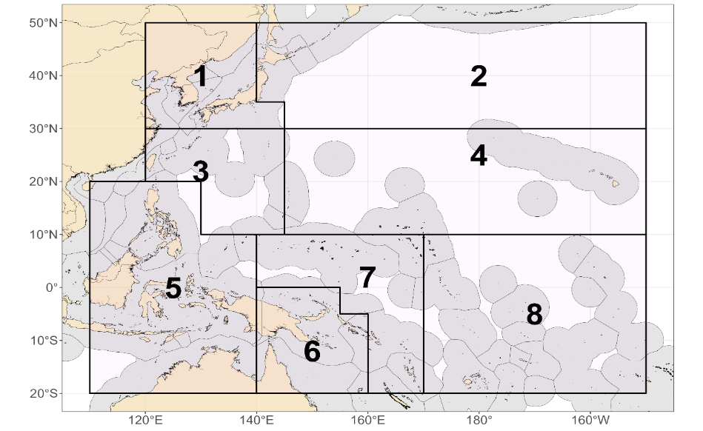
Figure SKJ-01. The geographical area covered by the stock assessment and the boundaries of the eight
model regions used for 2022 WCPO skipjack assessment.

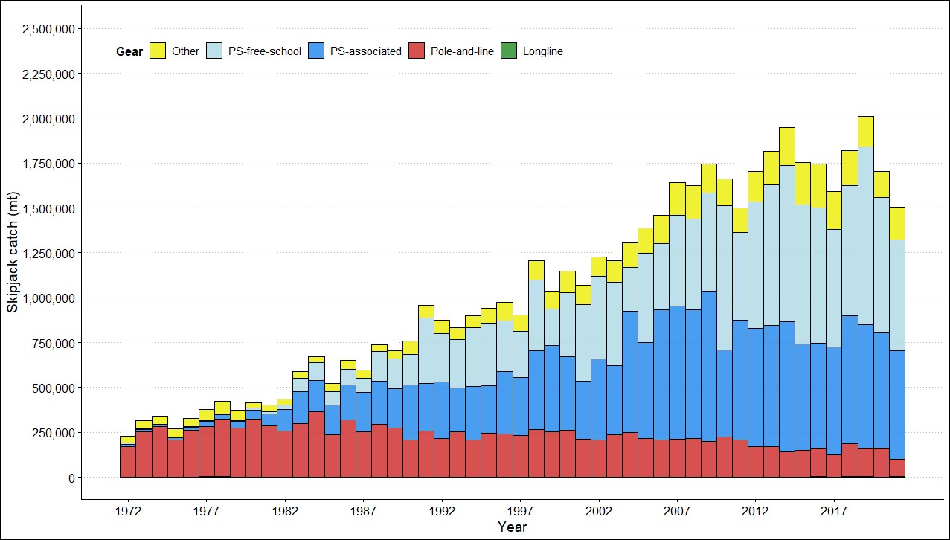
Figure SKJ-02. Annual catches of skipjack by gear type in the WCPO area covered by the assessment.
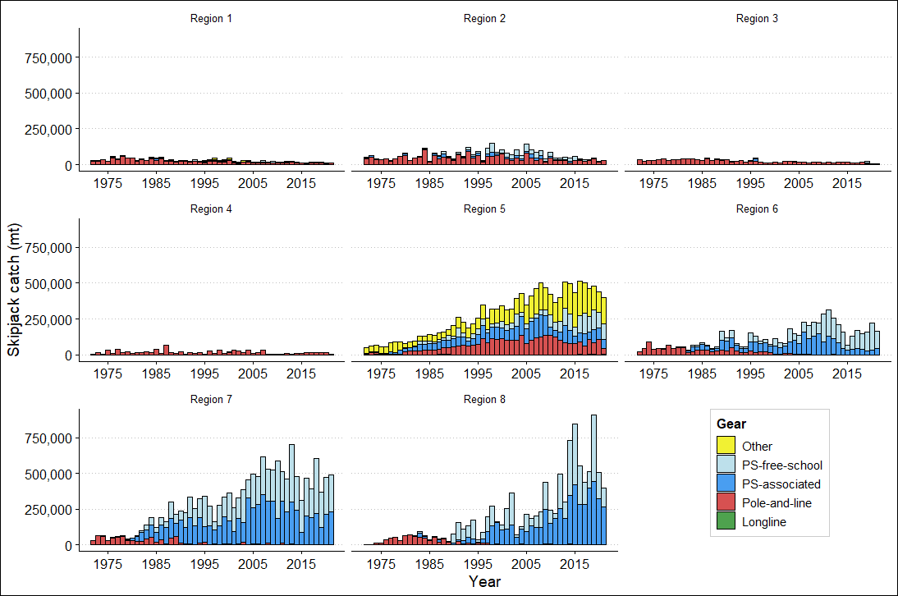

Figure SKJ-03. Annual catches of skipjack by gear type for each of the eight model regions.

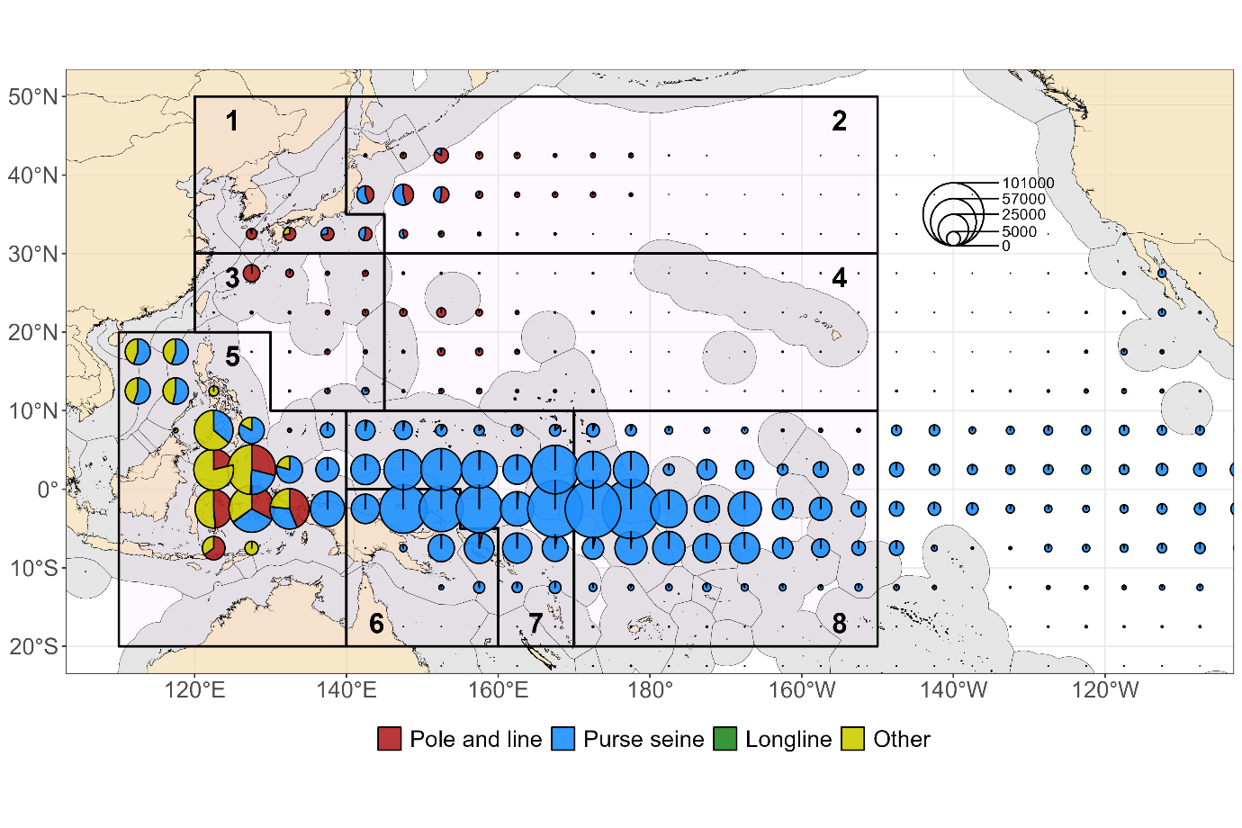

Figure SKJ-04. Distribution and magnitude of skipjack catches (mt) by gear type summed over the last 10 years (2012-2021) for 5 x 5 degree cells.

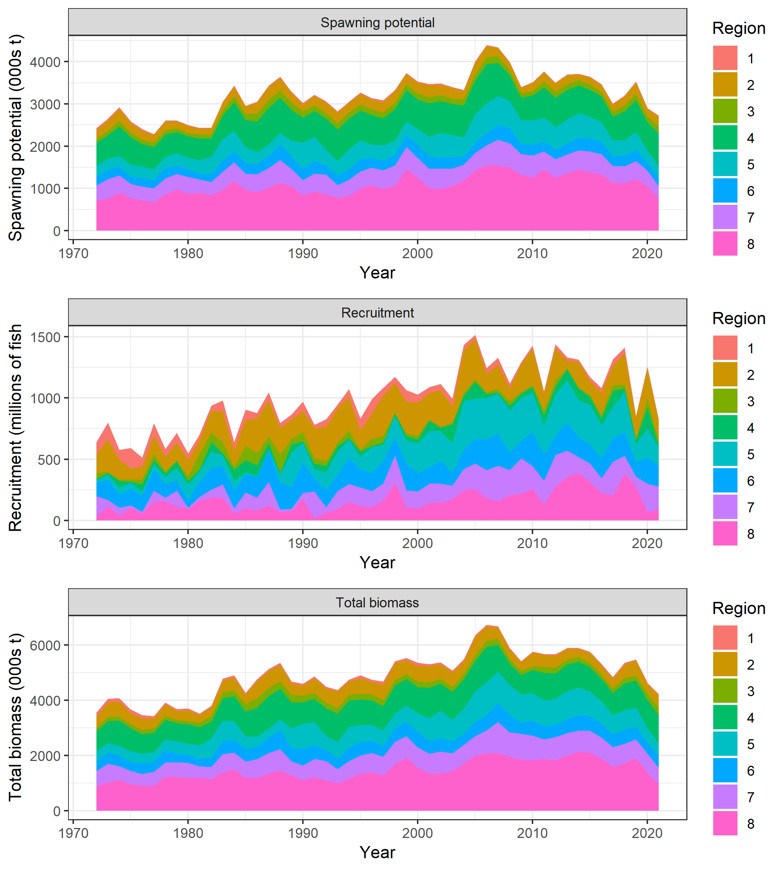
Figure SKJ-05. Estimated average quarterly recruitment, spawning potential and total biomass by model region from 1972-2021 for the 2022 skipjack diagnostic model, showing the relative proportions among regions.
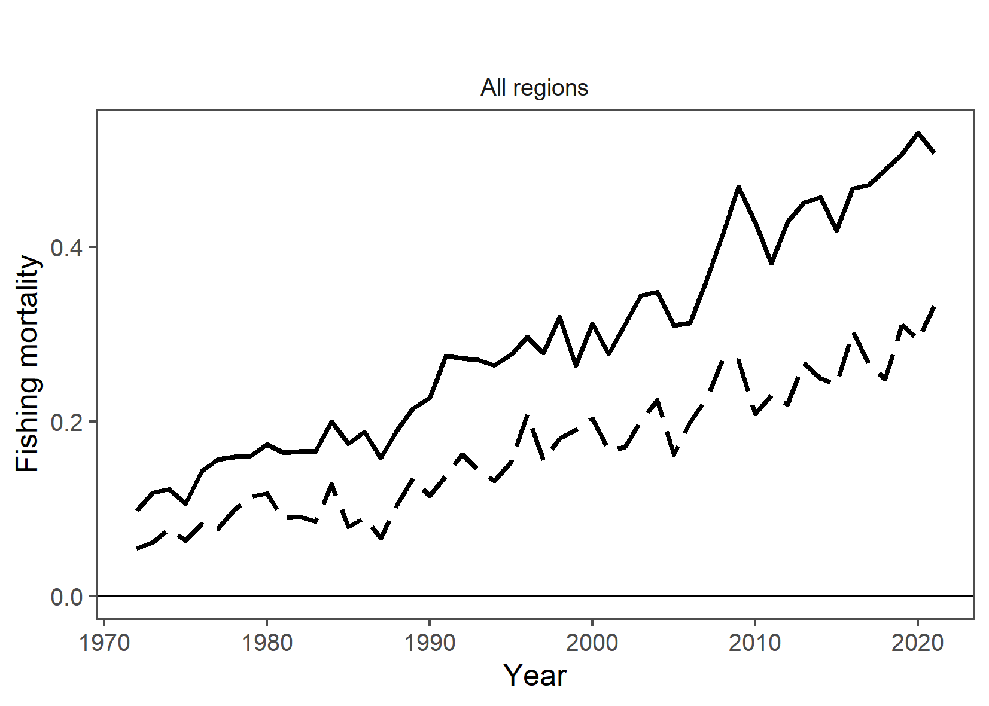
Figure SKJ-06. Estimated average quarterly adult (solid line) and juvenile (dashed line) fishing mortality for the diagnostic model from 1972-2021.

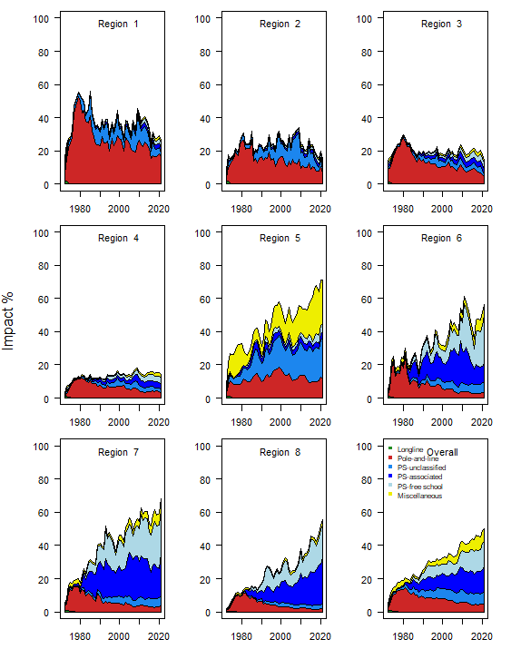
Figure SKJ-07. Estimates of reduction in spawning potential due to fishing (Fishery Impact = 1–
SBlatest/SBF=0) by region, and over all regions (lower right panel), attributed to various fishery
groups for the diagnostic model.
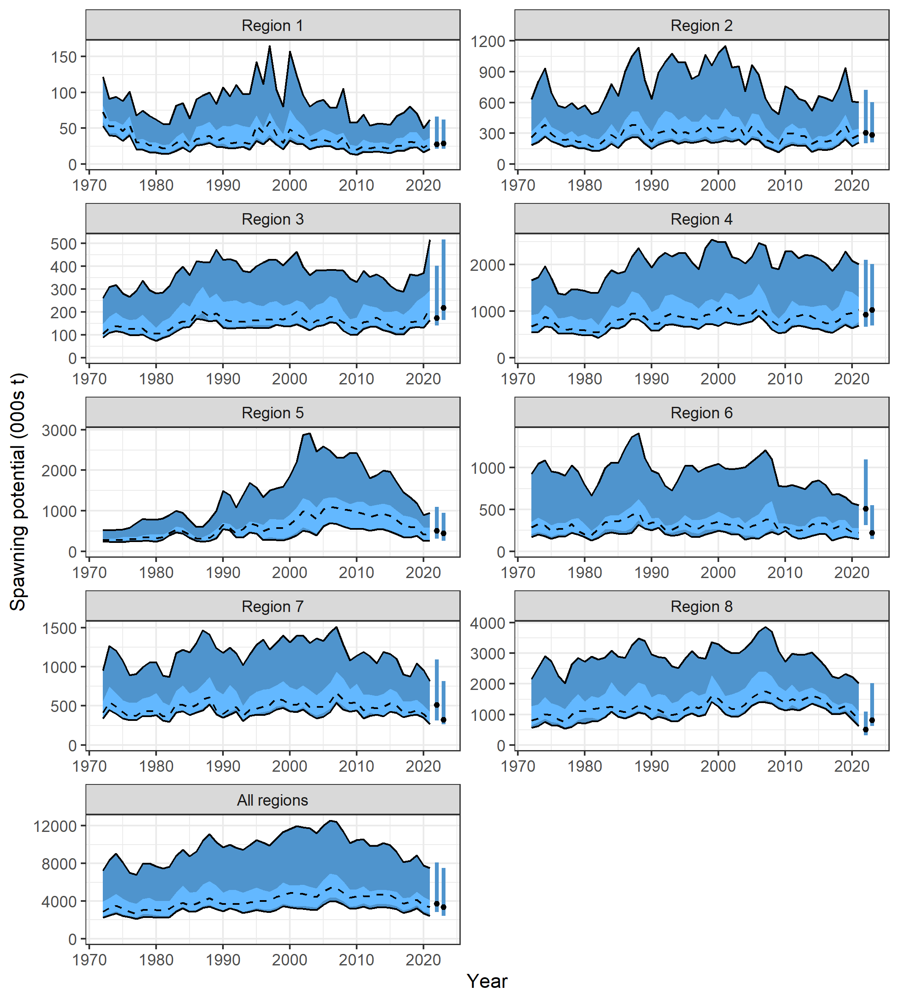

Figure SKJ-08. Trajectories of spawning potential (SB) across all models in the structural uncertainty grid over the period 1972-2021. The dashed line represents the median. The lighter band shows the 50th percentile, and the dark band shows the 80th percentile of the model estimates. The bars at the right of each ribbon indicate the median (black dots) and 80th percentile range for (left bar) SB_{recent} and (right bar) SB_{latest}.

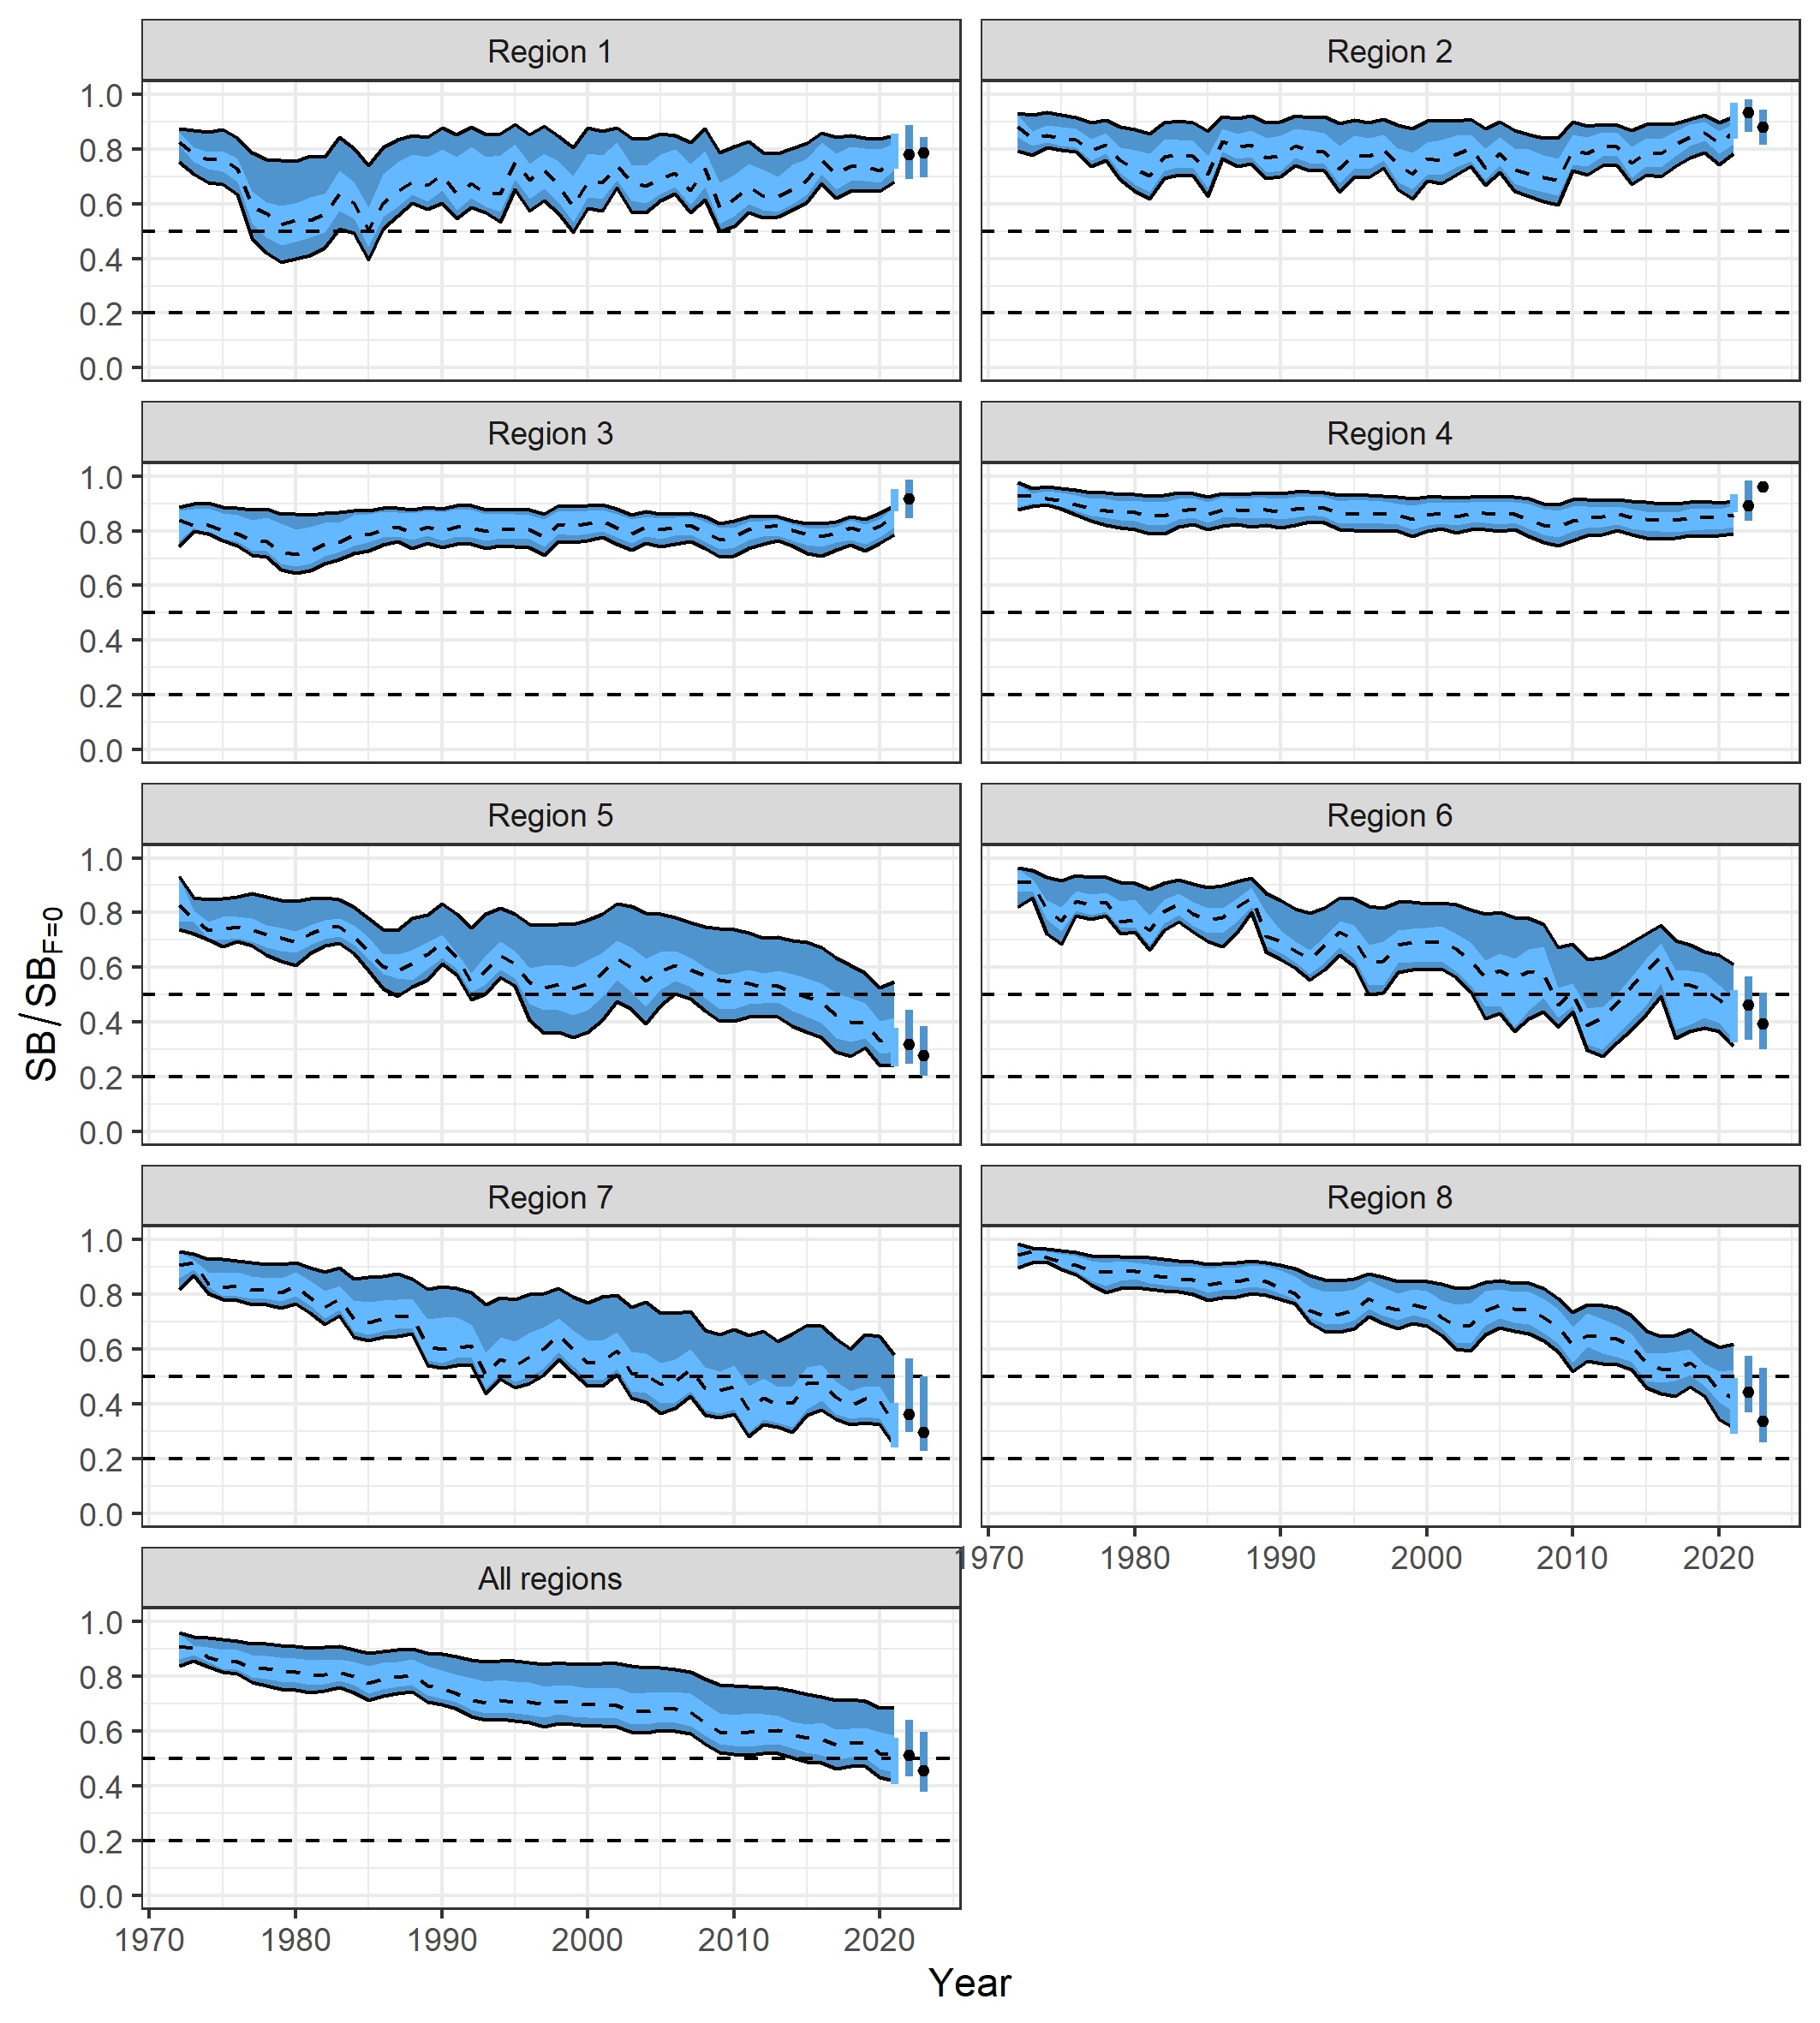
Figure SKJ-09. Trajectories of spawning potential depletion across all models in the structural uncertainty grid over the period 1972-2021. The dashed line represents the median. The lighter band shows the 50th percentile, and the dark band shows the 80th percentile of the model estimates. The bars at the right of each ribbon indicate the median (black dots) and 80th percentile range for (left bar) SB_{recent}/SB_{F=0} and (right bar) SB_{latest}/SB_{F=0}.

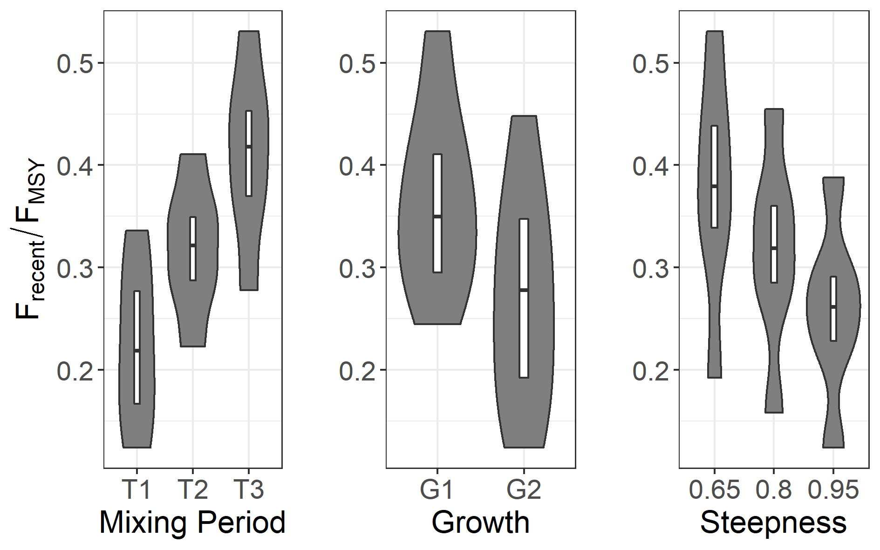

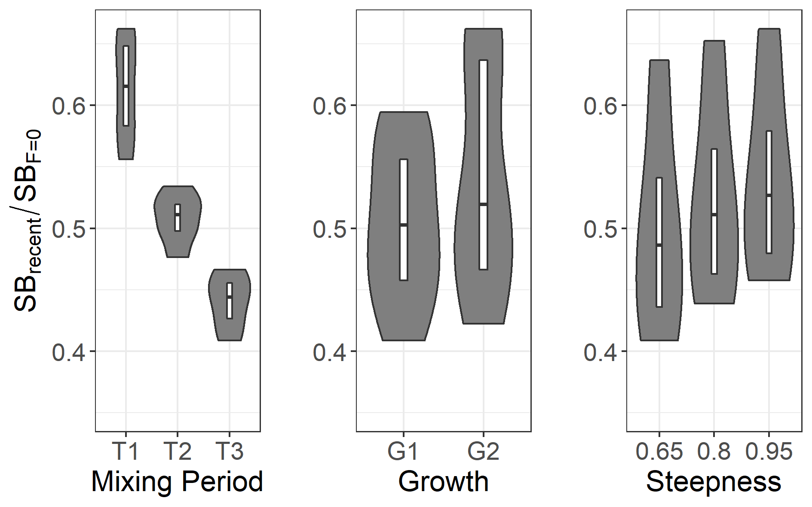

Figure SKJ-10. Box and violin plots summarizing (Top) the estimated F_{recent}/F_{MSY} and (Bottom) SB_{recent}/SB_{F=0} for each of the models in the structural uncertainty grid grouped by uncertainty axes (growth, tag mixing and steepness). The line in the white box is the median of the estimates, while the box shows the 50th percentile. The shaded area shows the probability distribution (or density) of the estimates of all models of the structural uncertainty grid.
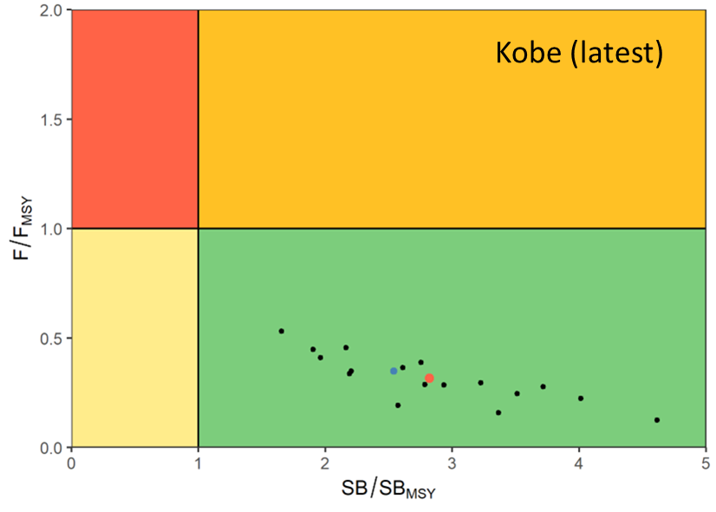
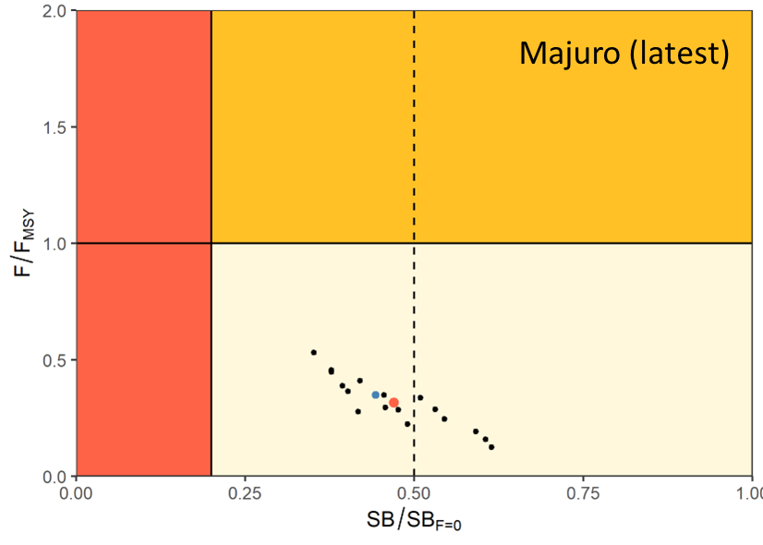
Figure SKJ-11. Kobe (top) and Majuro (bottom) plots summarising the results for each of the models in the structural uncertainty grid for the ‘latest’ (2021) period. The vertical dotted line on the Majuro plot is included to indicate the interim TRP of 0.50SB_{F=0} for the WCPFC-CA skipjack stock as specified in CMM 2021-01. The blue point is the diagnostic model, and the red point is the median.
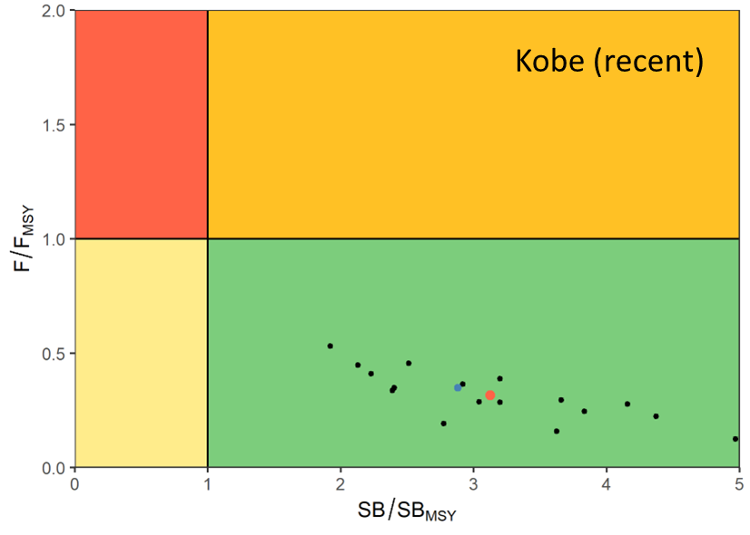
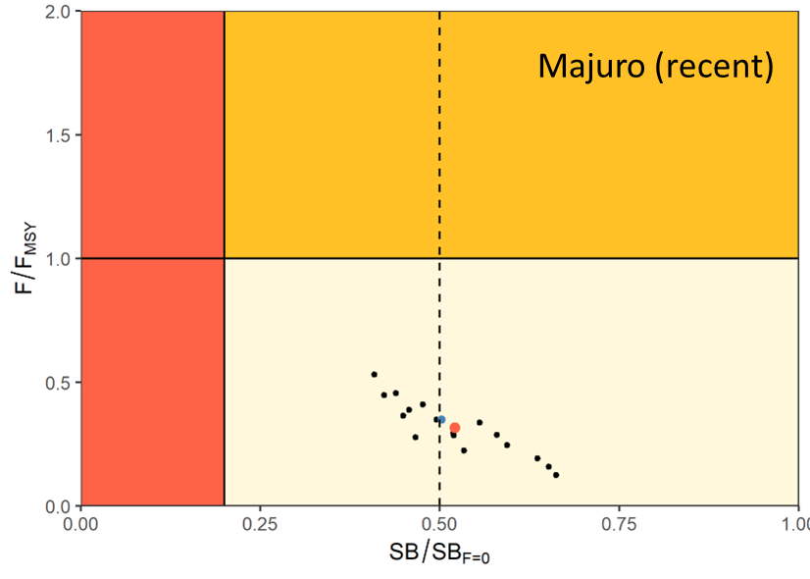
Figure SKJ-12. Kobe (top) and Majuro (bottom) plots summarising the results for each of the models in the structural uncertainty grid for the ‘recent’ (2018-2021) period. The vertical dotted line on the Majuro plot is included to indicate the interim TRP of 0.50SB_{F=0} for the WCPFC-CA skipjack stock as specified in CMM 2021-01. The blue point is the diagnostic model, and the red point is the median.

- SC18 noted that the skipjack assessment continues to show that the stock is currently moderately exploited and the level of fishing mortality is sustainable.

- SC18 noted that the stock was assessed to be above the adopted LRP and fished at rates below F_{MSY} with 100% probability. Therefore, the skipjack stock is not overfished, nor subject to overfishing. At the same time, it was also noted that fishing mortality is continuously increasing for both adult and juvenile stages while the estimated spawning potential has shown a declining trend since the mid to late 2000s, and spawning potential depletion reached a historically low level in recent years.

- SC18 noted that levels of fishing mortality and depletion differ between regions, and that fishery impact was highest in the tropical region (Regions 5, 6, 7 and 8 in the stock assessment model), mainly due to the purse seine fisheries in the equatorial Pacific and the “other” fisheries within the Western Pacific.

b. Management advice and implications

(i) Management advice specific to skipjack

- SC18 did not achieve a consensus on the management advice for skipjack tuna in the WCPO.

(ii) General recommendations for WCPFC stock assessments

- SC18 noted the challenge of fully reviewing the key inputs into WCPFC stock assessments and providing feedback within the time available. SC recommended that approaches that may address this issue be discussed at SC19 and recommended that the Scientific Services Provider develop a discussion paper to inform those discussions.

Model diagnostics

- Model diagnostics serve an important function in the stock assessment process. They are integral to the development of a sensible assessment model, and are critical for reviewers to assess whether proposed models are suitable for the provision of management advice. This is especially true at the SC where reviewers have a short period of time to review assessments and obtain clarification from the Scientific Services Provider about areas of concern.

- Key diagnostics are required for both the diagnostic case model and for models included in the structural uncertainty grid. In the case of 2022 WCPO skipjack SC18 thanked the assessment authors for updating the assessment report to include these diagnostics and note that the Shiny app is a useful tool. However, SC18 also noted a lack of consistency in the level of available diagnostics between assessments of different species. In light of this, SC18 recommended that SC19 consider guidelines for WCPFC stock assessments defining:
- The minimum set of diagnostics that should be provided for each model being considered for management advice;
- Consideration of the importance and interpretation of alternative model diagnostics depending on how the assessment is used to provide management advice (i.e., single best model vs. ensembles and structural uncertainty grids);
- For key input analyses, such as the preparation of standardized indices of abundance, the minimum set of diagnostics that should be included in the supporting working paper or information paper describing the analysis; and
- Guidelines for the graphical presentation of diagnostics to ensure legibility.

(iii) Research recommendations specific to the WCPO skipjack assessment

- SC18 identified a wide range of cross-cutting research recommendations for inclusion within the WCPFC tuna research plan for consideration, prioritisation and sequencing at SC19. SC18 noted the research recommendations made in SC18-SA-WP-01 (Stock assessment of skipjack tuna in the western and central Pacific Ocean: 2022) and suggested the following items for consideration as high-priority research areas:
- Hyperstability and effort creep in the CPUE indices, and incorporation of CPUE uncertainty in assessment results (i.e. inclusion as an axis in the structural uncertainty grid), including alternative model assumptions related to regional scaling
- Data conflicts that affect assessment outcomes, and approaches to resolving them.
- Review the model specification with the goal of conforming to the set of diagnostic criteria to determine whether an assessment model is suitable to provide management advice.
- Assumptions dealing with the parametrization of key model settings, such as the fishing effort regression used in the catch-conditioned approach to minimize their impact on estimates of stock status
- Tag mixing, including estimation using observed data, simulation, and simulation validation.

- SC18 noted the terms of reference (TOR) for Project 18X2a and 18X2b (Further development of ensemble model approaches for presenting stock assessment uncertainty) and Project 18X4 (Exploring evidence and mechanisms for a long-term increasing trend in recruitment of skipjack tuna in the equatorial Pacific and the development and modelling of defensible effort creep scenarios) in SC18-GN-IP-07, which would address further issues of importance.

- SC18 noted additional items that had relevance for both skipjack and wider WCPFC tuna stock assessments considered by the SC and ISC. These and additional items to consider where possible are further detailed below. Items also relevant to the upcoming WCPO yellowfin tuna peer review are denoted with an asterisk (*).
      - Indices of abundance: *
- Investigate a range of hypotheses which encompass the uncertainties in the spatial-temporal dynamics of the stock and the fishing effort.
- Refine effort creep scenarios for the Japanese pole-and-line fishery and equatorial purse seine fisheries.
- Develop alternative approaches for the interpolation of abundance into unfished areas when spatially averaging predictions to compute regional scalers. The use of preferential sampling models for standardizing CPUE data should be considered.
- Consider the biological limits to the spatiotemporal distribution of skipjack when making predictions of biomass in unfished areas with spatiotemporal models.
- Conduct analyses to incorporate additional process error in CPUE indices
- Evaluation of alternative sources of CPUE time series, such as FAD echo sounder buoys or additional indices for the purse seine fishery.

      - Data conflicts *
- Likelihood profiles show conflict between data sources included in the model. The cause of these conflicts should be identified and methods to address them should be explored.

      - Trend in estimated recruitment:
- Estimated WCPO skipjack recruitment steadily increased between 1975 and 2010. Possible explanations for this trend should be researched, including model misspecification. If the trend is related to model misspecification options to resolve it within the model should be presented, The SC noted the TOR for Project 18X4 (Exploring evidence and mechanisms for a long-term increasing trend in recruitment of skipjack tuna in the equatorial Pacific and the development and modelling of defensible effort creep scenarios) in SC18-GN-IP-07.

      - Recruitment distribution by region and season
- Consider the thermal limits to the spatiotemporal distribution of skipjack recruitment within the model settings.

      - Growth *
- Model diagnostics for each growth curve indicate poor fit to some components of the size data. Given the potential for spatial and temporal growth variation which any assessment cannot represent, recommend approaches to modeling growth and fitting size data that are robust to the potential for bias due to systematic lack of fit.
- Support epigenetic aging for skipjack in the long-term while work progressing age validation and age estimation using otolith and spines should still be pursued.

      - Tag mixing *
- Examine the utility of alternative approaches for including tagging data in the assessment, such as estimating movement and harvest rate parameters outside the assessment model and including them as priors.
- Review evidence for rates of tag mixing based on the tagging data included in the stock assessment.
- Consider the role of the Ikamoana simulation model in exploring scenarios of tag mixing, and the need for validation by comparing simulated and observed tag recovery patterns.

      - Tag reporting rates *
- Identify approaches to prevent tag reporting rates being estimated on the boundary, as these indicate some form of model misspecification such as incomplete tag mixing or data conflicts.

      - Model structure enabling a converged solution *
- Review the model structure as it relates to achieving a converged solution. This includes consideration of the spatial structure as well as confirming that estimated parameters are identifiable and well-determined. Consider the utility of such models for the provision of management advice, including evaluation of relevant CMMs.

      - Specification of the catch-conditioned model *
- Estimation of the required fishing mortality spline regression parameters attracted a large penalty in the likelihood and modified population scale. The impact of parameterization on estimated quantities should be examined.

      - Dirichlet-Multinomial set-up *
- Review grouping assumptions when setting up the Dirichlet-Multinomial likelihood for size composition data, and identify if the model is sensitive to grouping assumptions.

- SC18 recommended that SC19 consider the need for a review of the skipjack tuna stock assessment taking into account the outcomes of the 2023 yellowfin review.

SC17 2021 (FISHERY INDICATORS UPDATED)

Due to the virtual nature of SC17 with abbreviated agenda, the stock status and advice was not discussed. Refer to SC17-SA-IP-15 A compendium of fisheries indicators for target tuna stocks in the WCPFC Convention Area for updated fishery indicators.

SC16 2020 (FISHERY INDICATORS UPDATED)

Due to the virtual nature of SC17 with abbreviated agenda, the stock status and advice was not discussed. Refer to SC16-SA-WP-01 A compendium of fisheries indicators for target tuna stocks in the WCPFC Convention Area (24July) - Rev.01, for updated fishery indicators.

SC15 2019 (STOCK ASSESSMENT CONDUCTED)

- Stock status and trends

- SC15 noted that the total provisional catch in 2018 was 1,795,048 mt, a 10% increase from 2017 and a 1% decrease from 2013-2017. Purse seine catch in 2018 (1,469,520 mt) was a 15% increase from 2017 and a 2% increase from the 2013-2017 average. Pole and line catch (138,534 mt) was a 4% increase from 2017 and a 9% decrease from the average 2013-2017 catch. Catch by other gear (182,888 mt) was a 16% decrease from 2017 and 19% decrease from the average catch in 2013-2017.

- SC15 agreed to use the 8-region model to describe the stock status of skipjack tuna because SC15 considers that it better captures the biology of skipjack tuna than the existing 5 region structure. Stock status was determined over an uncertainty grid of 54 models with assumed weightings as illustrated in Table SKJ-01.

- The median values of recent (2015–2018) spawning biomass depletion (SB_{recent}/SB_{F=0}) and relative recent (2014–2017) fishing mortality (F_{recent}/F_{MSY}) over the uncertainty grid of 54 models (Table SKJ-02) were used to define stock status. The values of the upper 90th and lower 10th percentile of the empirical distributions of relative spawning biomass and relative fishing mortality from the uncertainty grid were used to characterize the probable range of stock status.

- The spatial structure used in the assessment model is shown in Figure SKJ-01. Time series of total annual catch (1000’s mt) by fishing gear for all regions is shown in Figure SKJ-02 and by region separately is shown in Figure SKJ-03. The annual average recruitment, spawning potential, and total biomass by model region for the diagnostic model are shown in Figure SKJ-04. The overall spawning potential summed across region for the diagnostic model is shown in Figure SKJ-05. The estimated annual average juvenile and adult fishing mortality for the diagnostic model is shown in Figure SKJ-06. The estimated impact of fishing (1 – SB_{latest}/SB_{F=0}) by region and overall regions for the diagnostic model is shown in Figure SKJ-07. The median and 80th percent quantile trajectories of fishing depletion for models in the weighted structural uncertainty grid in Table SKJ-01 is shown in Figure SKJ-08, where it can be seen that the median has been below the target since 2009. The Majuro plot shows the recent fishing mortality and spawning potential relative to the unfished spawning potential for all models in the structural uncertainty grid for (i) spawning potential in the recent time period (2015–2018) in Figure SKJ-09, and (ii) spawning potential in the latest time period (2018) in Figure SKJ-10. The Kobe plot shows the recent fishing mortality and spawning potential relative to spawning potential at MSY for all models in the structural uncertainty grid for (i) spawning potential in the recent time period (2015–2018) in Figure SKJ-11, and (ii) spawning potential in the latest time period (2018) in Figure SKJ-12.

- SC15 noted that the median level of spawning potential depletion from the uncertainty grid was SB_{recent}/SB_{F=0} = 0.44 with a probable range of 0.37 to 0.53 (80% probability interval). There were no individual models where SB_{recent}/SB_{F=0} < 0.2, which indicated that the probability that recent spawning biomass was below the LRP was zero.

- SC15 noted that the grid median F_{recent}/F_{MSY} was 0.45, with a range of 0.34 to 0.60 (80% probability interval) and that no values of F_{recent}/F_{MSY} in the grid exceed 1. Therefore, SC15 noted that there was a zero probability that the recent fishing mortality exceeds F_{MSY}.

- SC15 noted that the largest uncertainty in the structural uncertainty grid was due to the assumed tag mixing period. In addition, SC15 acknowledges that further study is warranted to investigate the uncertainty surrounding the appropriate mixing period for the tagging data.

- SC15 acknowledges that the spatial extent of the Japanese pole-and-line fishery has decreased over the time period and that the future use of this standardized CPUE index within future stock assessments is uncertain.

- Therefore, SC15 acknowledges that further study of alternative indices of abundance is warranted, such as investigation of standardizing the purse seine fishery and evaluation of the feasibility of conducting fishery independent surveys.

Table SKJ-01. Description of the updated structural sensitivity grid used to characterize uncertainty in the assessment.
Axis | Value | Relative weight
Steepness | 0.65 | 0.8
 | 0.80 | 1.0
 | 0.95 | 0.8
Growth | Low | 1.0
 | Diagnostic | 1.0
 | High | 1.0
Length composition | 50 | 0.8
Scalar | 100 | 1.0
 | 200 | 1.0
Tag mix | 1 | 1.0
 | 2 | 1.0

Table SKJ-02. Summary of reference points over the various models in the structural uncertainty grid. F_{mult} is the multiplier of recent (2014-2017) fishing mortality required to attain MSY, F_{recent} is the average fishing mortality of recent (2014-2017), SB_{recent} is the average spawning potential of recent years (2015-2018) and SB_{latest} is the spawning potential in 2018.
 | Mean | Median | Minimum | 10th %ile | 90th %ile | Maximum
C_{latest} | 1,755,328 | 1,755,693 | 1,749,846 | 1,753,471 | 1,757,057 | 1,757,083
Y_{Frecent} | 1,877,914 | 1,864,040 | 1,679,600 | 1,737,702 | 2,043,556 | 2,135,200
f_{mult} | 2.282 | 2.258 | 1.472 | 1.757 | 2.957 | 3.705
F_{MSY} | 0.223 | 0.222 | 0.180 | 0.189 | 0.264 | 0.270
MSY | 2,296,566 | 2,294,024 | 1,953,600 | 1,995,987 | 2,767,083 | 2,825,600
F_{recent}/F_{MSY} | 0.461 | 0.447 | 0.270 | 0.343 | 0.600 | 0.679
SB_{F=0} | 6,220,675 | 6,299,363 | 5,247,095 | 5,580,942 | 6,913,431 | 7,349,557
SB_{MSY} | 1,100,947 | 1,064,400 | 631,900 | 723,742 | 1,544,060 | 1,688,000
SB_{MSY}/SB_{F=0} | 0.175 | 0.176 | 0.117 | 0.131 | 0.225 | 0.23
SB _{latest}/SB_{F=0} | 0.414 | 0.415 | 0.325 | 0.36 | 0.487 | 0.525
SB _{latest}/SB_{MSY} | 2.468 | 2.382 | 1.551 | 1.779 | 3.356 | 3.925
SB _{recent}/SB_{F=0} | 0.440 | 0.440 | 0.336 | 0.372 | 0.530 | 0.551
SB _{recent}/SB_{MSY} | 2.623 | 2.579 | 1.601 | 1.892 | 3.613 | 4.139

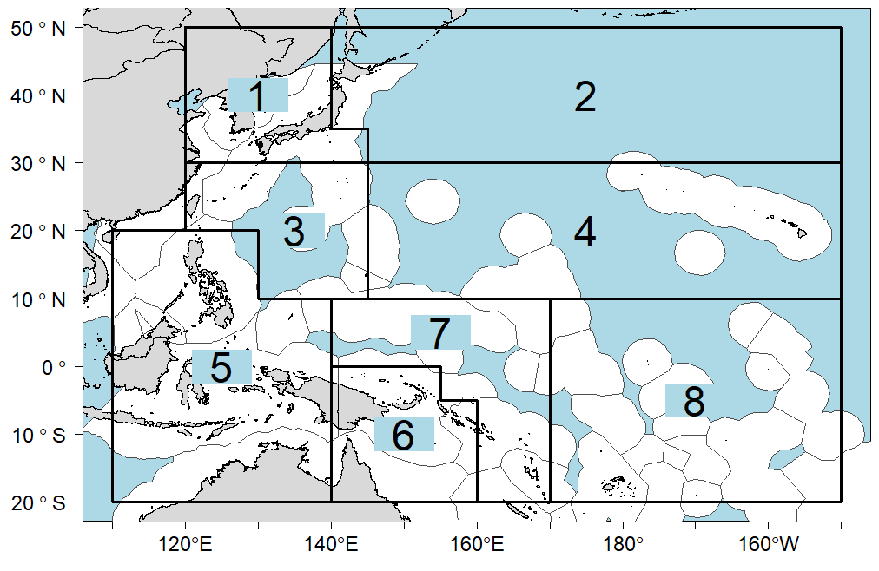 | 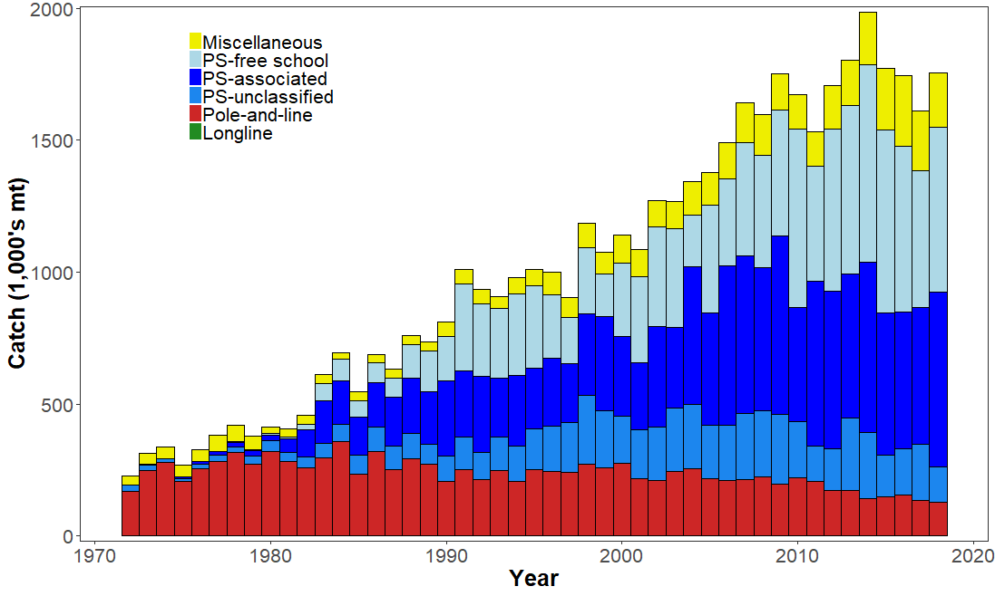
Figure SKJ-01. Eight region spatial structure used in the 2019 stock assessment model. | Figure SKJ-02. Time series of total annual catch (1000's mt) by fishing gear over the full assessment period.
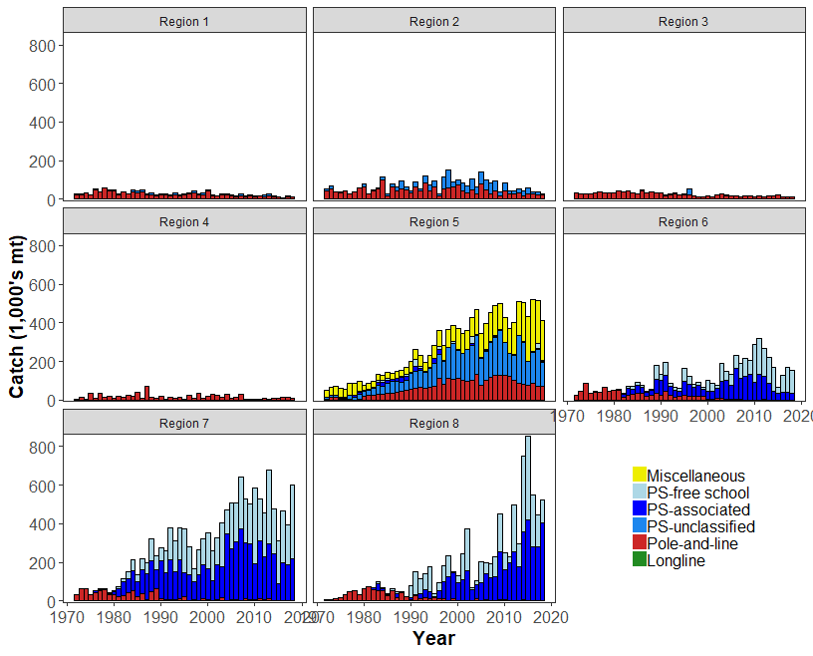 | 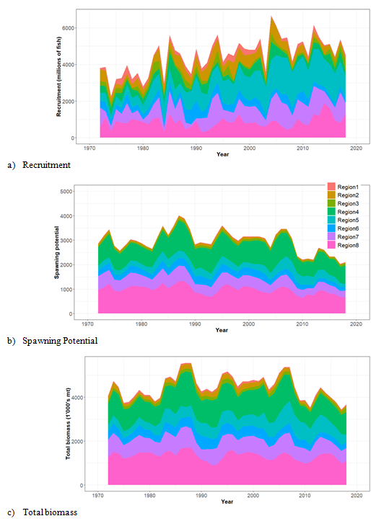
Figure SKJ-03. Time series of total annual catch (1000's mt) by fishing gear and assessment region over the full assessment period. | Figure SKJ-04. Estimated annual average recruitment, spawning potential and total biomass by model region for the diagnostic model, showing the relative sizes among regions.

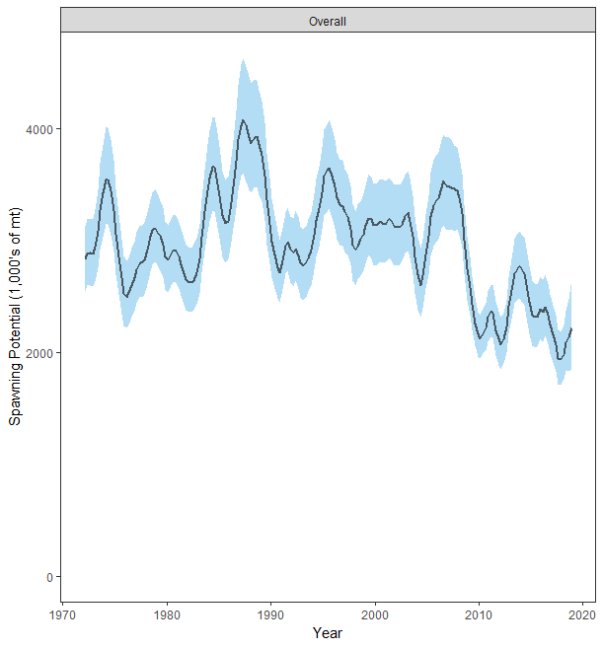 | 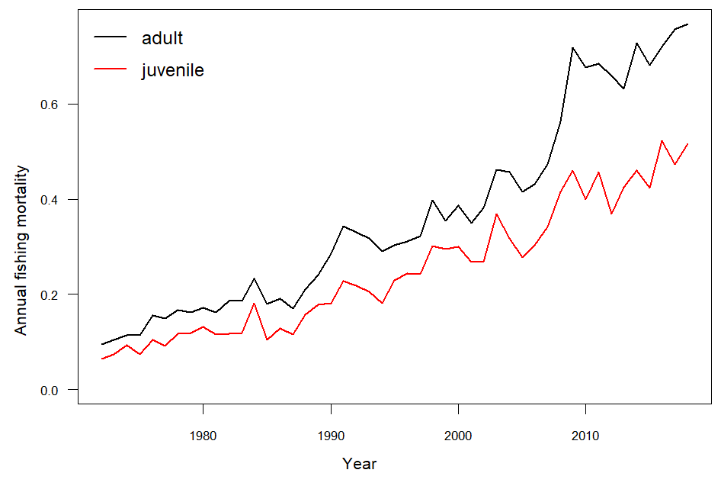
Figure SKJ-05. Estimated temporal overall spawning potential summed across regions from the diagnostic model, where the shaded region is ± 2 standard deviations (i.e., 95% CI). | Figure SKJ-06. Estimated annual average juvenile and adult fishing mortality for the diagnostic model.
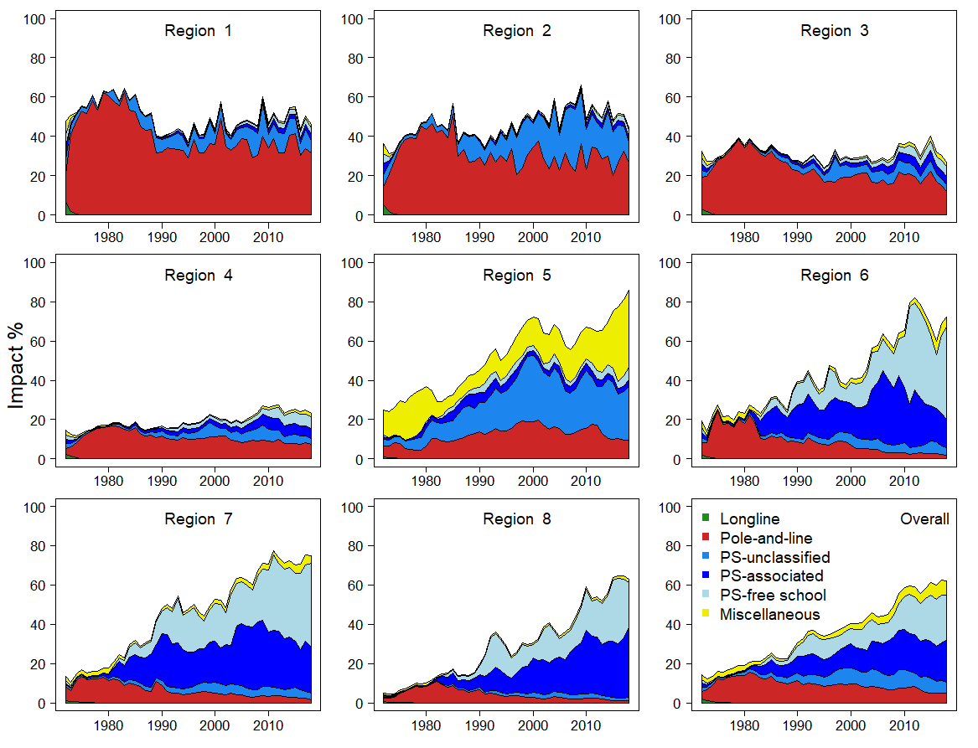 | 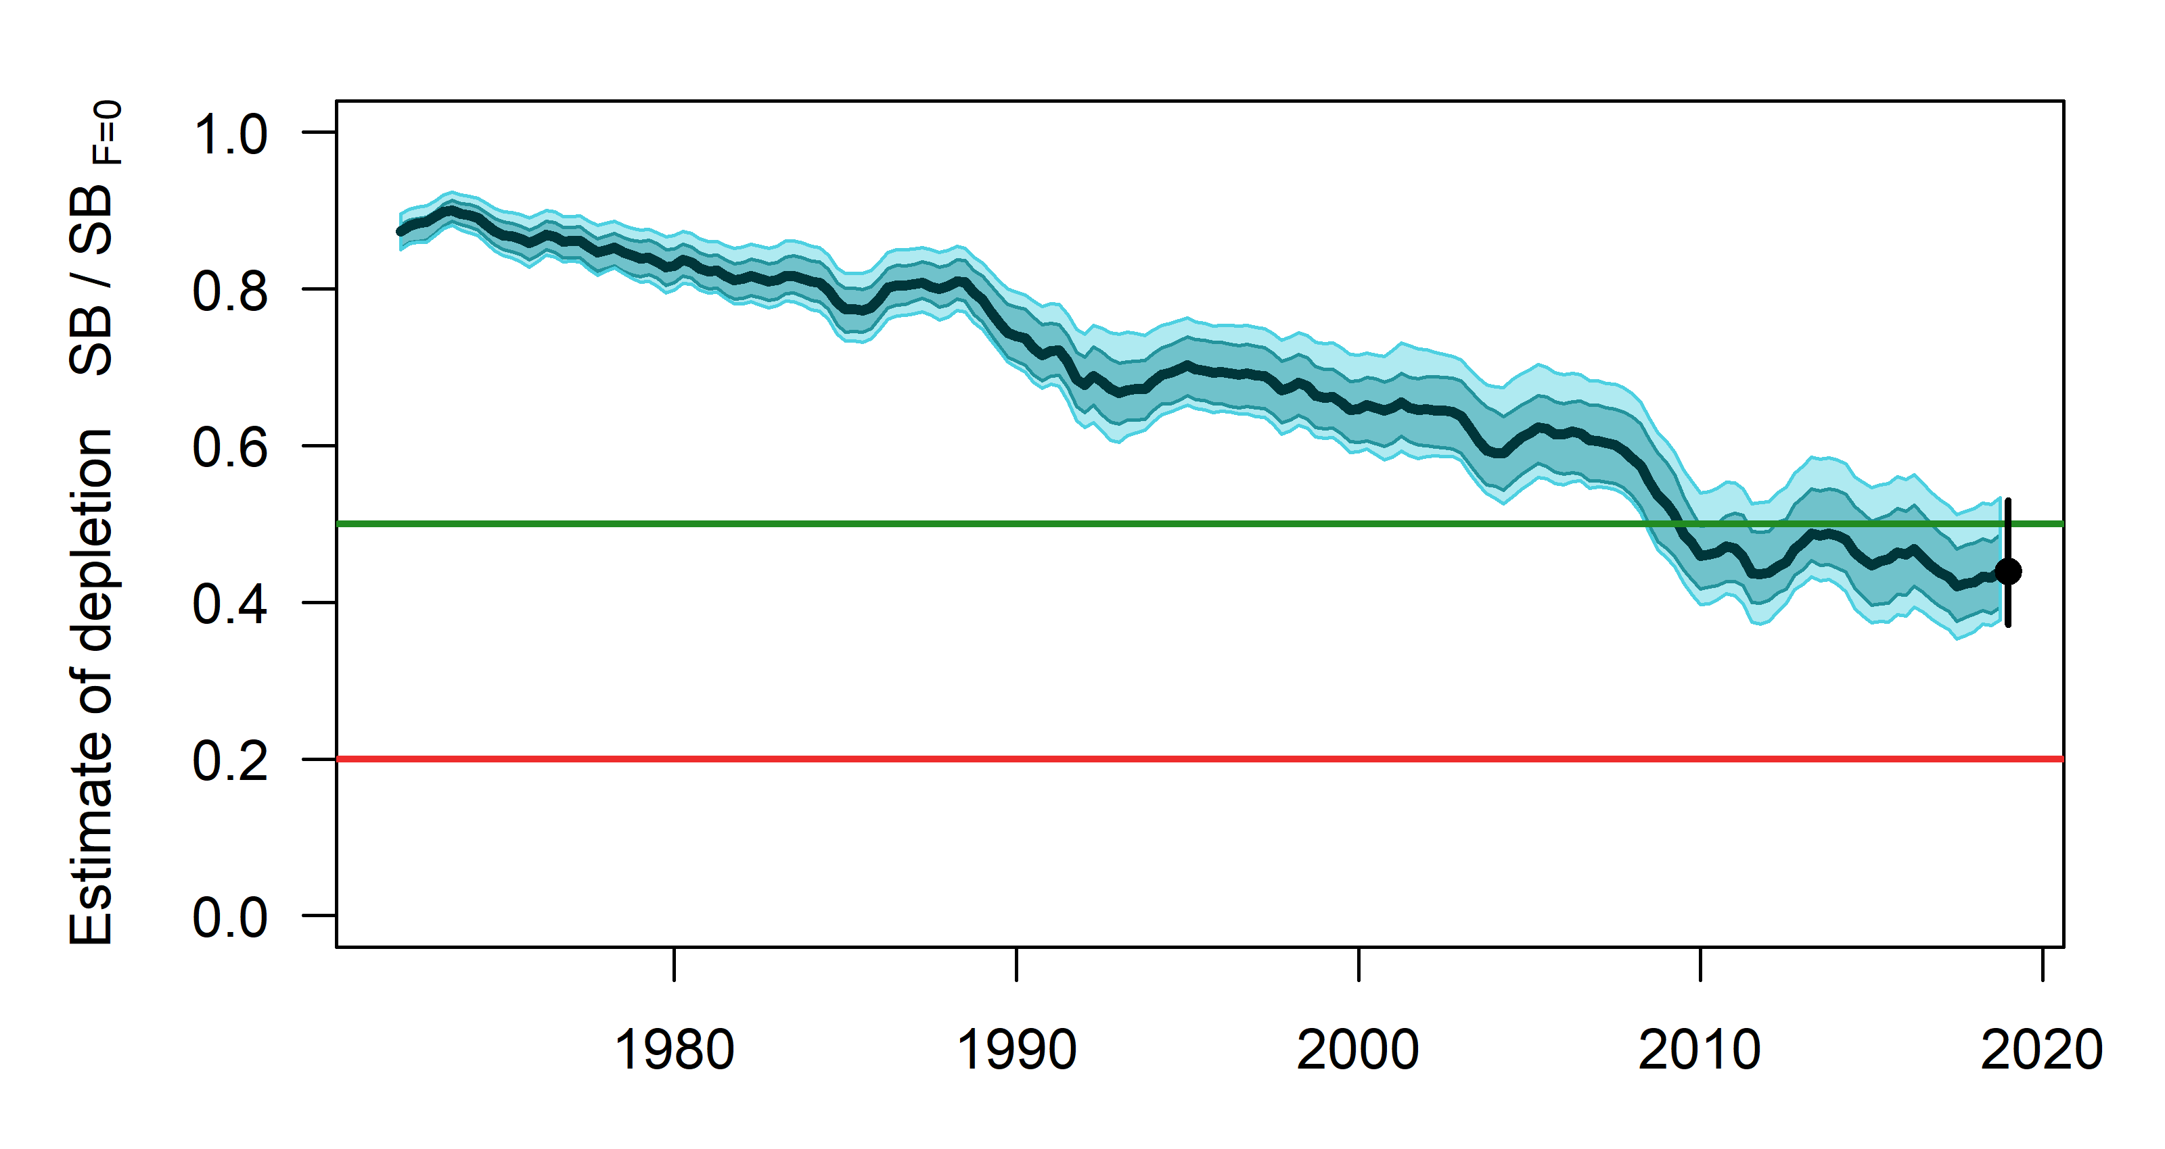
Figure SKJ-07. Estimates of reduction in spawning potential due to fishing (fishery impact = 1-SB _{latest}/SB _{F=0}) by region for the diagnostic model. | Figure SKJ-08. Plot showing the trajectories of spawning potential depletion for the model runs included in the structural uncertainty grid weighted by the values given in Table SKJ-01. Red horizontal line indicates the agreed limit reference point, the green horizontal line indicates the interim target reference point.

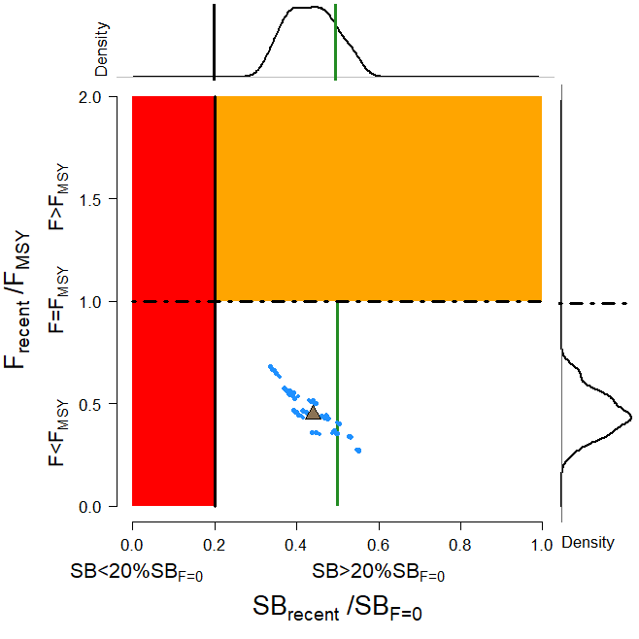  Figure SKJ-09. Majuro plot for the recent spawning potential (2015 – 2018) summarizing the results for each of the models in the structural uncertainty grid with weighting. The plots represent estimates of stock status in terms of spawning potential depletion and fishing mortality, and marginal distributions of each are presented. Vertical green line denotes the interim TRP. Brown triangle indicates the median of the estimates. The size of the circle relates to the weight of that particular model run. | 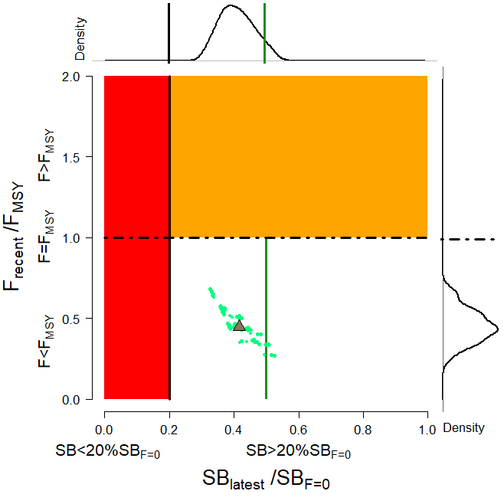  Figure SKJ-10. Majuro plot for the latest spawning potential (2018) summarizing the results for each of the models in the structural uncertainty grid with weighting. The plots represent estimates of stock status in terms of spawning potential depletion and fishing mortality, and marginal distributions of each are presented. Vertical green line denotes the interim TRP. Brown triangle indicates the median of the estimates. The size of the circle relates to the weight of that particular model run.
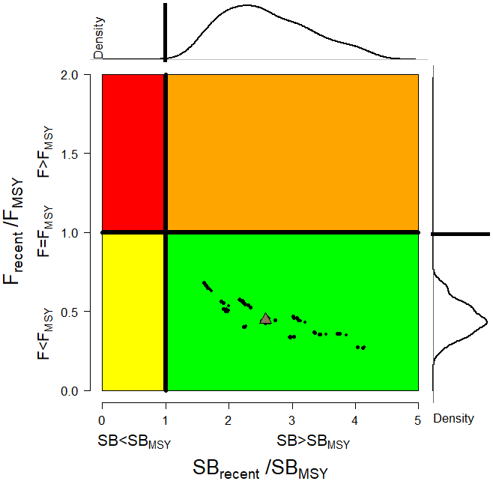  Figure SKJ-11. Kobe plot for the recent spawning potential (2015 – 2018) summarizing the results for each of the models in the structural uncertainty grid. The plots represent estimates of stock status in terms of spawning potential depletion and fishing mortality and marginal distributions of each are presented. Brown triangle indicates the median of the estimates. The size of the circle relates to the weight of that particular model run. | 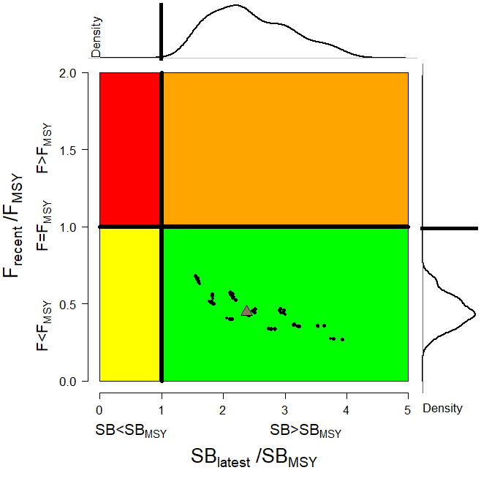  Figure SKJ-12. Kobe plot for the latest spawning potential (2018) summarizing the results for each of the models in the structural uncertainty grid. The plots represent estimates of stock status in terms of spawning potential depletion and fishing mortality and marginal distributions of each are presented. Brown triangle indicates the median of the estimates. The size of the circle relates to the weight of that particular model run.
- Management advice and implications

- SC15 noted that the skipjack assessment continues to show that the stock is currently moderately exploited and the level of fishing mortality is sustainable.

- The 2019 stock assessment includes additional data and a range of model improvements such as a change to the maturity schedule used in this assessment, with length-at-maturity now larger than in the previous assessment, which has resulted in a reduction in the estimate of potential spawning biomass, relative to the 2016 assessment.

- SC15 noted that the stock was assessed to be above the adopted Limit Reference Point and fished at rates below F_{MSY} with 100% probability. Therefore, the skipjack stock is not overfished, nor subject to overfishing. At the same time, it was also noted that fishing mortality is continuously increasing for both adult and juvenile while the spawning biomass reached the historical lowest level.

- The skipjack interim Target Reference Point (TRP) is 50% of spawning biomass in the absence of fishing. The trajectory of the median spawning biomass depletion indicates a long-term trend, and has been under the interim TRP since 2009 (i.e., for 10 years). Since the median spawning biomass has been consistently below the interim TRP, SC15 recommends that the Commission take appropriate management action to ensure that the biomass depletion level fluctuates around the TRP (e.g., through the adoption of a harvest control rule).

- Research Recommendations

- In order to maintain the quality of stock assessments for this important stock SC15 recommends:
- continuing work to develop an index of abundance based on purse seine data and from FAD acoustic sensors;
- evaluating the possibility of conducting fishery independent surveys to provide relative abundance indices;
- conducting regular large-scale tagging cruises and expanding the infrastructure for rapid return of recaptured tags in a manner that provides the best possible data for stock assessment purposes;
- investigating skipjack growth by validation studies of otolith readings and/or estimation of growth within MFCL from tag recapture data;
- attempting to provide finalized catch estimates to SPC no later than June 1st.

SC14 2018 (FISHERY INDICATORS UPDATED)

a. Stock status and trends

- SC14 noted that the total catch in 2017 was 1,624,162 mt, a 9% decrease from 2016 and comparable to the average from 2012-2016.

- Purse seine catch in 2017 (1,280,311 mt) was a 7% decrease from 2016 and a 12% decrease from the 2012-2016 average. Pole and line catch (123,132 mt) was a 21% decrease from 2016 and a 23% decrease from the average 2012-2016 catch. Catch by other gear (218,175 mt) was a 13% decrease from 2016 and 1% decrease from the average catch in 2012-2016.

- SC14 noted that under recent fishery conditions (2017 catch level for longline and other fisheries and effort level for purse seine), the skipjack stock was initially projected to decrease for a short period as recent relatively high recruitments move out of the stock. Median F₂₀₁₉/F_{MSY} = 0.47; median SB₂₀₁₉/SB_{F=0} = 0.45; median SB₂₀₁₉/SB_{MSY} = 1.67. In the longer term, assuming long term average recruitment, modest increases in the stock were projected.

b. Management advice and implications

- SC14 noted that no stock assessment has been conducted since SC12. Therefore, the advice from SC12 should be maintained to achieve the objectives set in CMM 2017-01, pending a new assessment or other new information. For further information on the management advice and implications from SC12, please see https://www.wcpfc.int/node/27769

c. Research Recommendations

- SC14 discussed a proposal for an alternative regional structure to be considered in the next skipjack stock assessment (SC14-SA-WP-04) and recommended that the pre-assessment workshop consider how this proposal might be included in the next assessment.

- SC14 supports an ongoing tagging program for skipjack tuna to ensure a reliable indicator of skipjack tuna abundance in the stock assessment.

- SC14 recommended that the Scientific Services Provider continue research on standardizing purse seine CPUE for use in the assessment.

SC13 2017 (FISHERY INDICATORS UPDATED)

- Stock status and trends

- SC13 noted that the total catch in 2016 (1,816,762 mt) was comparable to that in 2015 and a 2% increase over 2011-2015. (see SC13-SA-WP-02)

- Purse seine catch (1,408,110 mt) was comparable to both 2015 and the 2011-2015 average. Pole and line catch (151,441 mt) was a 1% decrease from 2015 and an 11% decrease from 2011-2015 average. Catches by other fisheries (251,470 mt) were 2% higher than in 2015 and 26% higher than 2011-2015 average.

- SC13 noted that under recent fishery conditions (2016 catch level for LL and other fisheries and effort level for purse seine), the skipjack stock was initially projected to decrease for a short period and then to increase as recent relatively high recruitments move through the stock. Median F₂₀₁₈/F_{MSY} = 0.37; median SB₂₀₁₈/SB_{F=0} = 0.47.

- Management advice and implications

- SC13 noted that no stock assessment has been conducted since SC12. Therefore, the advice from SC12 should be maintained, pending a new assessment or other new information. For further information on the management advice and implications from SC12, please see https://www.wcpfc.int/node/27769

SC12 2016 (STOCK ASSESSMENT CONDUCTED)

- Stock status and trends

- SC12 noted that the skipjack catch in 2015 was 1,827,750 mt, was a 9% decrease over 2014 and a 3% increase over the average for 2010-14.

- Purse seine skipjack catch in 2015 was 13% lower than that in 2014 and effort 21% lower.

- The SC12 was unable to reach consensus on the description of stock status based on the 2016 stock assessment.

- SC12 notes that the majority of member countries agreed on the following description of WCPO skipjack tuna status and trends.

Majority view of stock status and trends

- A majority of SC12 CCMs selected the reference case model as the base case to represent the stock status of skipjack tuna (column “Ref Case” in Table SKJ2). To characterize uncertainty, those CCMs chose the structural uncertainty grid. Summaries of important model quantities for these models are shown in Table SKJ2.

Table SKJ1. Description of the structural sensitivity grid used to characterise uncertainty in the assessment. The reference case option is denoted in bold face.
Axis | Levels | Option
Steepness | 3 | 0.65, 0.80, or 0.95
Mixing period | 2 | 1 quarter mixing, 2 quarters mixing
Length composition weighting | 3 | Sample sizes divided by 10, 20, or 50
Tagging overdispersion | 3 | Default level, Estimated, or Fixed (moderate) level

Table SKJ2: Estimates of management quantities for the selected stock assessment models. For the purpose of this assessment, “recent” is the average over the period 2011–2014 and “latest” is 2015. The column “Ref Case” shows summaries for the reference case and the remaining columns are the quantiles of the structural uncertainty grid, e.g. 5% and 50% are the 5% quantile and the median (50% quantile), respectively. Option 1 in the text recommends basing management advice on the reference case model and considering the uncertainty represented by the 5% and 95% quantile columns. Option 2 recommends basing management advice on the range of model runs in the structural uncertainty grid, as represented by the 5% and 95% quantile columns.
Quantity | Ref Case | 50% | 5% | 25% | 75% | 95%
$$C_{latest}$$ | 1,679,528 | 1,679,444 | 1,678,646 | 1,679,170 | 1,679,497 | 1,679,592
$$MSY$$ | 1,891,600 | 1,875,600 | 1,618,060 | 1,785,400 | 1,976,700 | 2,199,880
$${Y_{F}}_{recent}$$ | 1,594,800 | 1,607,000 | 1,486,660 | 1,533,200 | 1,755,200 | 1,808,860
$$f_{mult}$$ | 2.23 | 2.07 | 1.57 | 1.85 | 2.29 | 2.62
$$F_{MSY}$$ | 0.24 | 0.24 | 0.21 | 0.22 | 0.26 | 0.28
$${F_{recent}/F}_{MSY}$$ | 0.45 | 0.48 | 0.38 | 0.44 | 0.54 | 0.64
$${SB}_{MSY}$$ | 1,626,000 | 1,628,000 | 1,258,700 | 1,425,750 | 1,852,750 | 2,166,100
$${SB}_{0}$$ | 6,764,000 | 6,359,500 | 5,214,050 | 5,853,750 | 7,095,250 | 8,340,450
$${SB}_{F=0}$$ | 7,221,135 | 6,876,526 | 5,778,079 | 6,408,578 | 7,425,353 | 8,555,240
$${{SB}_{latest}/SB}_{0}$$ | 0.62 | 0.55 | 0.43 | 0.49 | 0.59 | 0.71
$${{SB}_{latest}/SB}_{F=0}$$ | 0.58 | 0.51 | 0.39 | 0.47 | 0.57 | 0.67
$${{SB}_{latest}/SB}_{MSY}$$ | 2.56 | 2.15 | 1.6 | 1.81 | 2.43 | 3.08
$${{SB}_{recent}/SB}_{F=0}$$ | 0.52 | 0.49 | 0.4 | 0.46 | 0.52 | 0.57
$${{SB}_{recent}/SB}_{MSY}$$ | 2.31 | 2.04 | 1.58 | 1.82 | 2.32 | 2.65

- Trends in estimated recruitment, spawning biomass, fishing mortality and depletion are shown in Figures SKJ 1-4.
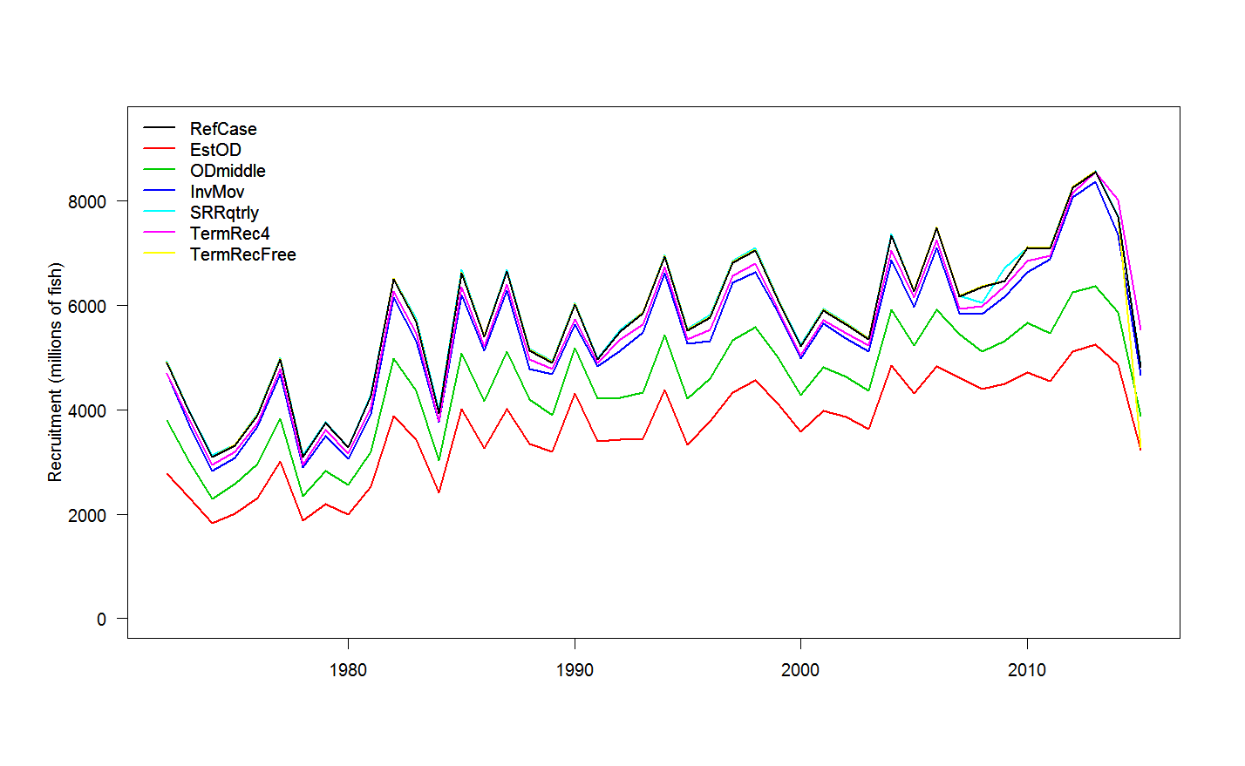 | 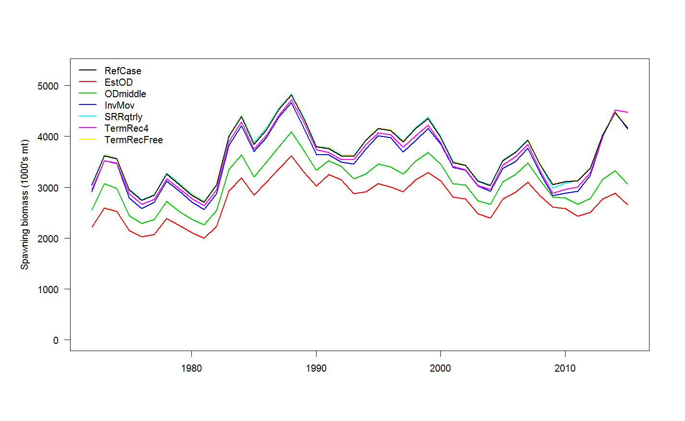
Figure SKJ1: Estimated annual recruitment (millions of fish) for the WCPO obtained from the reference case model and six additional runs. | Figure SKJ2: Estimated annual average spawning potential for the WCPO obtained from the reference case model and six additional runs.
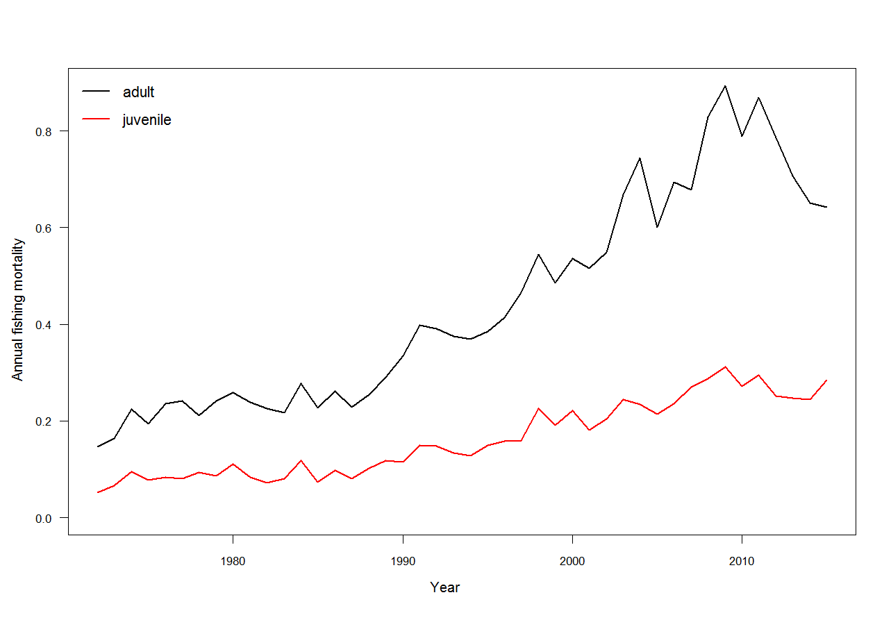 | 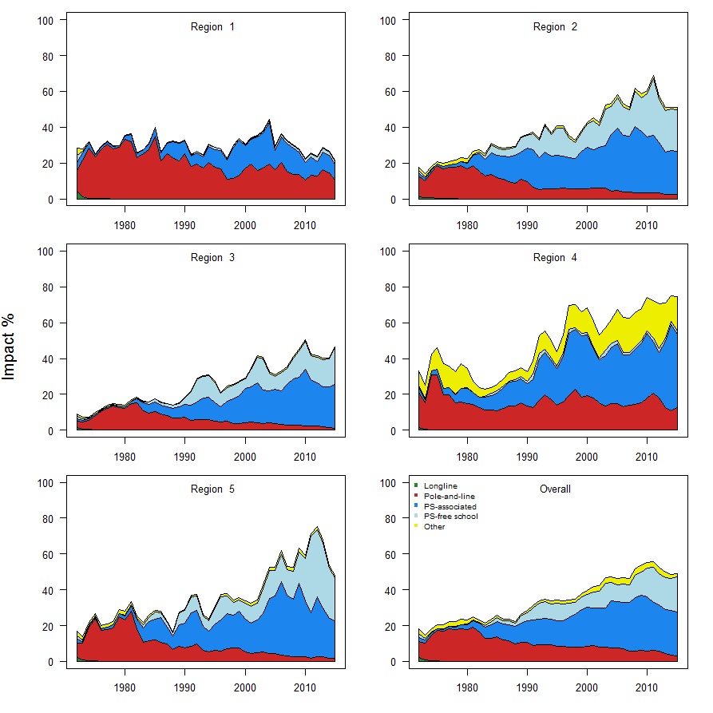
Figure SKJ3: Estimated annual average juvenile and adult fishing mortality for the WCPO obtained from the reference case model. | Figure SKJ4: Estimates of reduction in spawning potential due to fishing (fishery impact = 1-SB_{t}/SB_{t,F=0}) by region and for the WCPO attributed to various fishery groups for the reference case model.

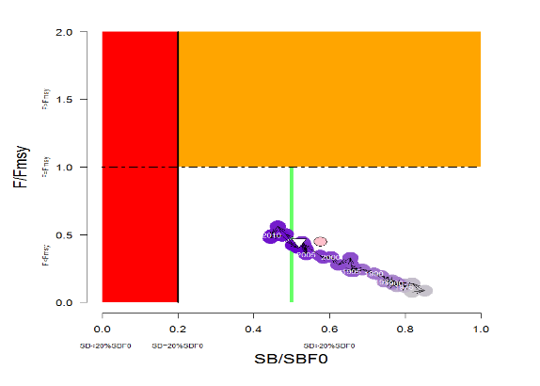  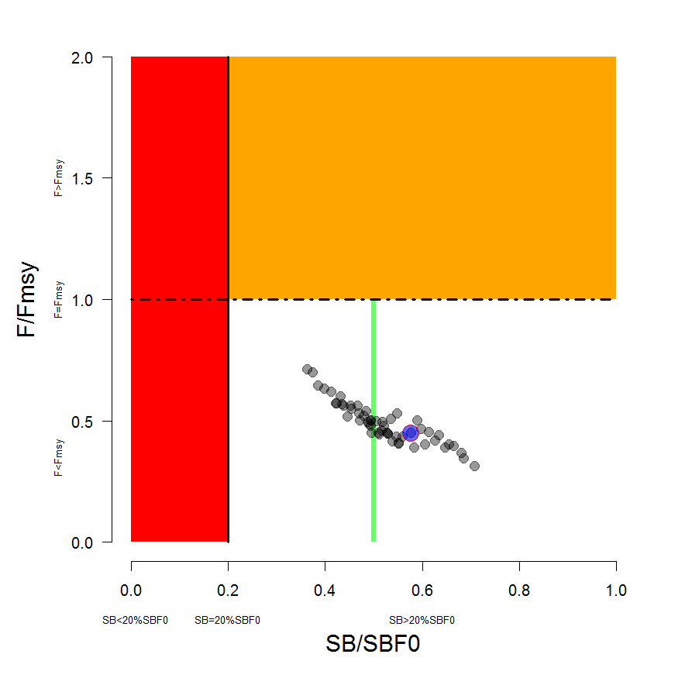 | 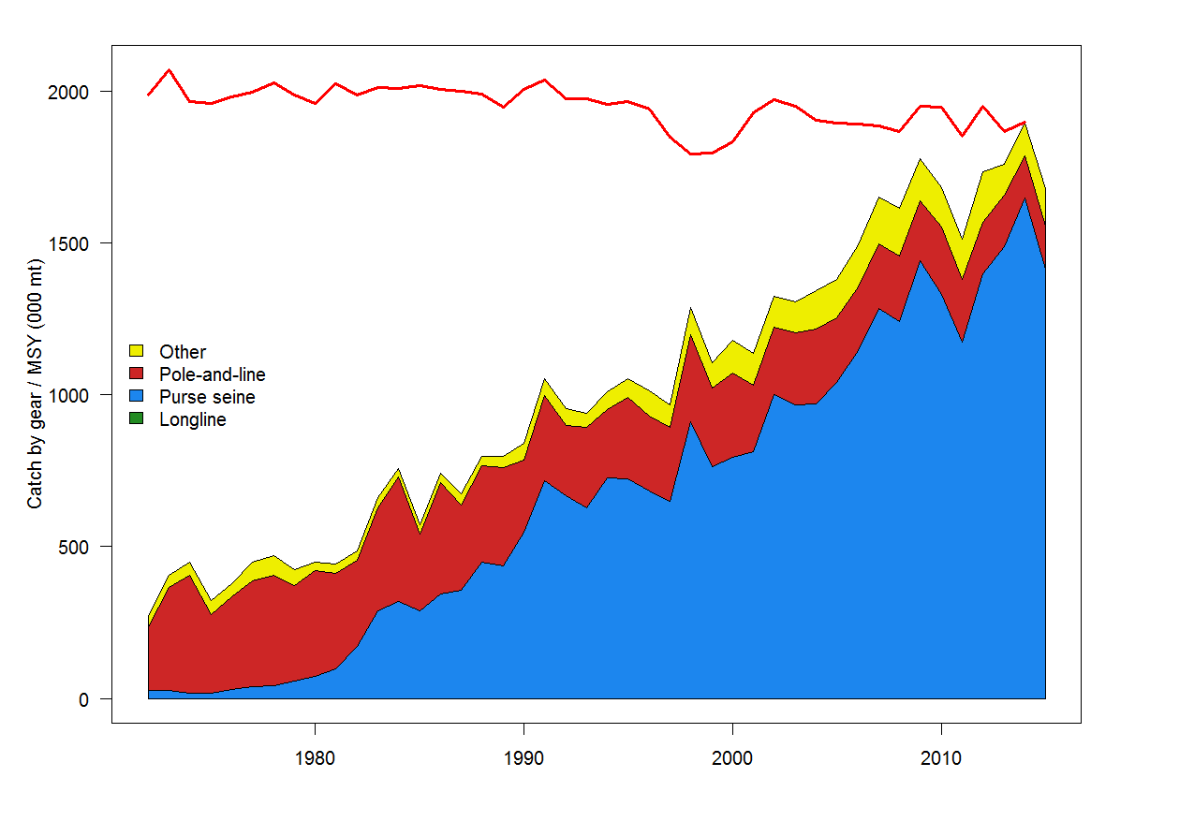
Figure SKJ5: Temporal trend for the reference case model (top) and the structural uncertainty grid (bottom panel) in stock status relative to SB_{F=0} (x-axis) and F_{MSY} (y-axis). The red zone represents spawning potential levels lower than the agreed LRP, which is marked with the solid black line (0.2SB_{F=0}). The orange region is for fishing mortality greater than F_{MSY} (F=F_{MSY}; marked with the black dashed line). The green line indicates the interim target reference point 50%SBF=0. | Figure SKJ6: History of annual estimates of MSY compared with catches of three major fisheries for the reference case model.

- Dynamics of most model quantities are relatively consistent with the results of the 2014 stock assessment, although there has been a period of several subsequent years with high recruitments and increased spawning biomass.

- Fishing mortality of all age-classes is estimated to have increased significantly since the beginning of industrial tuna fishing, but fishing mortality still remains below the level that would result in the MSY (F_{recent}/F_{MSY} = 0.45 for the reference case), and is estimated to have decreased moderately in the last several years. Across the reference case and the structural uncertainty grid F_{recent}/F_{MSY} varied between 0.38 (5% quantile) to 0.64 (95% quantile). This indicates that overfishing is not occurring for the WCPO skipjack tuna stock (Figure SKJ 5).

- The estimated MSY of 1,891,600 mt is moderately higher than the 2014 estimate due to the adoption of an annual, rather than quarterly, stock-recruitment relationship. Recent catches are lower than, but approaching, this MSY value (Figure SKJ 6).

- The latest (2015) estimate of spawning biomass is well above both the level that will support MSY (SBlatest/SBMSY = 2.56, for the reference case model) and the adopted LRP of 0.2 SBF=0 (SBlatest/SBF=0 = 0.58, for the reference case model), and SBlatest/SBF=0 was relatively close to the adopted interim target reference point (0.5 SBF=0) for all models explored in the assessment (structural uncertainty grid: median = 0.51, 5% and 95% quantiles = 0.39 and 0.67).

Alternative view of stock status and trends

- China, Japan and Chinese Taipei considered it is not possible to select a base-case model from various sensitivity models in the 2016 assessment, given the advice from the Scientific Service Provider that a suite of the sensitivity models were plausible. Therefore, these members considered that it would be more appropriate to provide advice to WCPFC13 on skipjack stock status based on the range of uncertainty expressed by the alternative model runs in the sensitivity analysis rather than based on the single base case model (represented by the 5% and 95% quantiles of the structural sensitivity grid presented in Table SKJ2).

- The estimated MSY of the WCPO skipjack stock ranges from 1,618,060 mt (5% quantile) to 2,199,880 mt (95% quantile) across the alternative skipjack stock assessment models represented in the sensitivity grid. These CCMs also noted that some alternative models indicate that the 2015 biomass is below the adopted TRP of 0.5SBF=0.

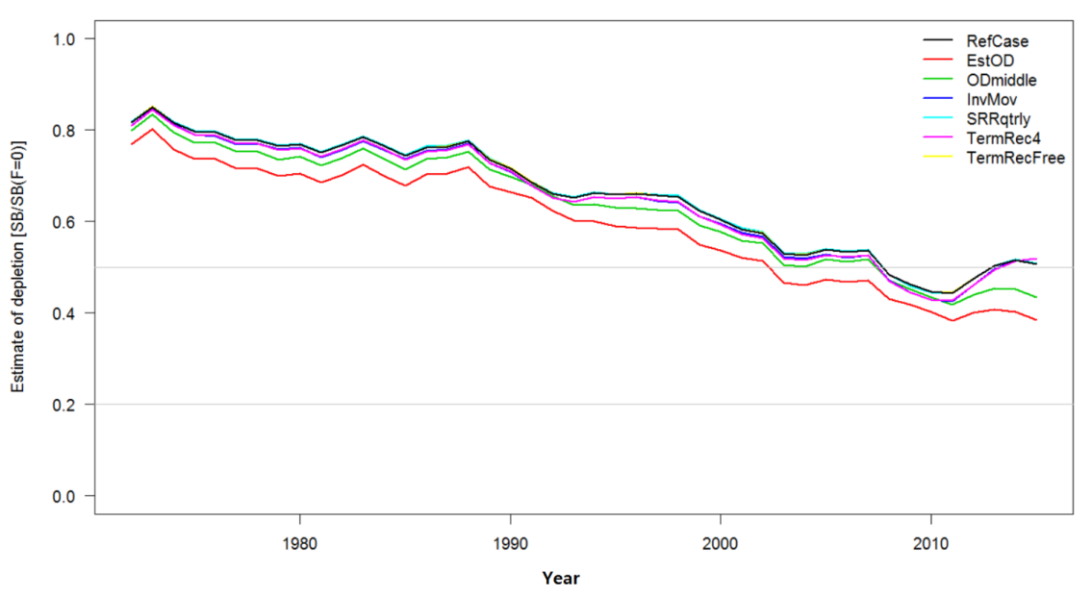
Figure SKJ 7. Estimated fisheries depletion SB/SBF=0, for each of the sensitivity models.

Management advice and implications

- SC12 noted that the skipjack assessment continues to show that the stock is currently moderately exploited and fishing mortality level is sustainable. The recent catches are fluctuating around and some models also indicate that the stock is currently under the TRP.

- SC12 noted that fishing is having a significant impact on stock size and can be expected to affect catch rates. The stock distribution is also influenced by changes in oceanographic conditions associated with El Niño and La Niña events, which impact on catch rates and stock size. Additional purse-seine effort will yield only modest gains in long-term skipjack tuna catches and may result in a corresponding increase in fishing mortality for bigeye and yellowfin tunas. The management of total effort in the WCPO should recognize this.

- SC12 noted that skipjack spawning biomass is now around the adopted TRP and SC12 recommends that the Commission take action to keep the spawning biomass near the TRP and also advocates for the adoption of harvest control rules based on the information provided.

- In order to maintain the quality of stock assessments for this important stock, SC12 recommends 1) continued work on developing an index of abundance based on purse seine data; 2) regular large scale tagging cruises and complementary tagging work continue to be undertaken in a way that provides the best possible data for stock assessment purposes.

- SC12 also notes that the current method of calculating the TRP is based on the most recent 10 years of recruitment information. However, the information on spawning potential, SB2015, which is used to evaluate current stock status relative to the TRP can change very rapidly for skipjack which mature at age 1 and this rapid maturation may provide an optimistic status evaluation when recruitment is estimated have an increasing trend but is estimated with substantial uncertainty, as is currently observed in the case of skipjack which does not have a fishery-independent index of recruitment strength.

- There is ongoing concern by at least one CCM that high catches in the equatorial region may be causing a range contraction of WCPO skipjack tuna, thus reducing skipjack tuna availability to fisheries conducted at higher latitudes than the Pacific equatorial region. SC12 reiterates the advice of SC11 whereby there is no demonstrated statistical evidence for SKJ range contraction. As a result, SC12 recommends that ongoing research on range contraction of skipjack tuna be continued in the framework of Project 67.

Useful References

SC21-SA-WP-02 WCPO skipjack tuna stock assessment (Rev.03)

Refer to the SC21 website for additional information

Previous Assessments

SC18-SA-WP-01 Stock assessment of skipjack tuna in the western and central Pacific Ocean: 2022 (29July2022) - Rev.05 https://meetings.wcpfc.int/node/16242

SC15-SA-WP-05 Stock assessment of skipjack tuna in the western and central Pacific Ocean (Rev.02). https://www.wcpfc.int/node/42931

SC12-SA-WP-04 Stock assessment of skipjack tuna in the western and central Pacific Ocean. https://www.wcpfc.int/node/27490

SC10-SA-WP-05 Stock assessment of skipjack tuna in the western and central Pacific Ocean. (Rev 1 25 July 2014) https://wcpfc.int/node/18998

SC7-SA-WP-04 Stock assessment of skipjack tuna in the western and central Pacific Ocean (Rev.1 - 04August2011). https://wcpfc.int/node/2787

SC6-SA-WP-10 Stock Assessment of skipjack tuna in the western and central Pacific Ocean. Rev.1. https://wcpfc.int/node/2468

SC4-SA-WP-04 Stock assessment of skipjack tuna in the western and central Pacific Ocean. https://wcpfc.int/node/2008

SC1-SA-WP-04 Stock assessment of skipjack tuna in the western and central Pacific Ocean. https://wcpfc.int/node/1887

R Shiny app for exploring the diagnostics and outputs from the 2022 WCPO skipjack stock assessment is available at: https://ofp-sam.shinyapps.io/GridSKJ2022/
https://meetings.wcpfc.int/node/16222

