

The Commission for the Conservation and Management of
Highly Migratory Fish Stocks in the Western and Central Pacific Ocean

Scientific Committee

PACIFIC BLUEFIN TUNA (Thunnus orientalis)

Stock Status AND Management Advice

Contents
SC20 2024 (BENCHMARK ASSESSMENT) 2
SC19 2023 (NO STOCK ASSESSMENT) 4
SC18 2022 (BENCHMARK ASSESSMENT) 4
SC17 2021 (NO STOCK ASSESSMENT) 13
SC16 2020 (BENCHMARK ASSESSMENT) 13
SC15 2019 (FISHERY INDICATORS UPDATED) 27
SC14 2018 (STOCK ASSESSMENT CONDUCTED) 30
SC13 2017 (FISHERY INDICATORS UPDATED) 36
References 37

SC20 2024 (BENCHMARK ASSESSMENT)

  - Stock status and trends

- SC20 welcomed the completion of a benchmark assessment for Pacific bluefin tuna and noted the following stock status and trends information from ISC24:

While there are few Pacific bluefin tuna (PBF) catch records prior to 1952, PBF landing records are available dating back to 1804 from coastal Japan and to the early 1900s for U.S. fisheries operating in the EPO. Based on these landing records, PBF catch is estimated to be high from 1929 to 1940, with a peak catch of approximately 47,635 t (36,217 t in the WPO and 11,418 t in the EPO) in 1935; thereafter catches of PBF dropped precipitously due to World War II. PBF catches increased significantly in 1949 as Japanese fishing activities expanded across the North Pacific Ocean. By 1952, a more consistent catch reporting process was adopted by most fishing nations and estimated annual catches of PBF fluctuated widely from 1952-2022 (Figure [1]). During this period reported catches peaked at 40,383 t in 1956 and reached a low of 8,653 t in 1990. The reported catch in 2021 and 2022 was 15,107 t and 17,458 t, respectively, including non-member countries of the International Scientific Committee for Tuna and Tuna-like Species in the North Pacific Ocean (ISC). Management measures were implemented by Regional Fisheries Management Organizations (RFMOs) beginning in 2011 (WCPFC in 2011 and IATTC in 2012) and became stricter in 2015. While a suite of fishing gears has been used to catch PBF, the majority of the catch is currently made by purse seine fisheries (Figure [2]). Catches during 1952-2022 were predominantly composed of juvenile PBF; the catch of age 0 PBF has increased significantly since the early 1990s but declined as the total catch in weight declined since the mid-2000s and due to stricter control of juvenile catch (Figures [1 and 3]).

Population dynamics were estimated using a fully integrated age-structured model (Stock Synthesis (SS) v3.30) fitted to catch (retained and discarded), size-composition, and catch-per-unit of effort (CPUE) based abundance index data from 1983 to 2023, provided by Members of (ISC), Pacific Bluefin Tuna Working Group (PBFWG) and non-ISC countries obtained from the WCPFC official statistics. Life history parameters included a length-at-age relationship from otolith-derived ages and natural mortality estimates from a tag-recapture study and empirical-life history methods.

In 2024, the PBFWG conducted a benchmark stock assessment. The PBFWG critically reviewed all aspects of the model, and some modifications were made to improve the model. A total of 26 fleets were defined for use in the stock assessment model based on country/gear/season/region stratification until the end of the fishing year 2022 (June 2023). Quarterly observations of catch and size compositions, when available, were used as inputs to the model to describe the removal processes. Annual estimates of standardized CPUE from the Japanese distant water, offshore, and coastal longline, the Chinese Taipei longline, and the Japanese troll fleets were used as measures of the relative abundance of the population. The CPUE of Japanese longline (adult index) after 2020 and Japanese troll (recruitment index) after 2010 were not included in the model, as these observations may be biased due to additional management measures in Japan. The assessment model was fitted to the input data in a likelihood-based statistical framework. Maximum likelihood estimates of model parameters, derived outputs, and their variances were used to characterize stock status and to develop stock projections.

One of the major changes made in this assessment is that the PBFWG decided to shorten the stock assessment model by starting in 1983 instead of 1952. This adjustment was implemented because more reliable data are available after 1983. Additionally, the adoption of a shorter model period enhances flexibility and can accommodate diverse productivity assumptions. This flexibility is an important feature as this model will be used in the upcoming PBF management strategy evaluation (MSE). The PBFWG confirmed that the results and management quantities of the longer period model and the shorter period model are consistent and that the change in the duration of the assessment model does not affect the management advice (Figure 4). A simple update of the 2022 stock assessment with new data estimated slightly higher relative biomass after 2011, reflecting an underestimating tendency of the past model (Figure 4). Other changes include refined parameterization of selectivity to reduce model residuals and shortening of the recruitment index from 1983-2016 to 1983-2010. The truncation of the recruitment index was supported by various analyses as described in the main body of the assessment report and was considered appropriate to reduce the SSB retrospective bias (Mohn’s ρ for 10 years-retrospective analysis in the base case is -0.06), which was observed in several previous assessment models. After these modifications, the base-case model fits better to the input data and shows good prediction skill (the root mean square error of the Taiwanese longline CPUE for the predicted 7-year period was 0.24, see Figure 5). The PBFWG therefore concluded that the model is appropriate for generating management advice. Due to those changes, recent relative biomass was scaled up to some extent (see Figure 4) as the retrospective bias was reduced.

After conducting thorough reviews and implementing necessary modifications, the PBFWG found that the 2024 base-case model is consistent with the previous assessment results, that it fits the data well, that the results are internally consistent among most of the data sources, and that the model has improved overall by addressing the issues previously identified. The model diagnostics have confirmed that the base-case model captures the production function of PBF well, thus its estimated biomass scale is reliable, and that the model has good predictability. Based on these findings, the PBFWG concluded that the 2024 assessment model reliably represents the population dynamics and provides the best available scientific information for the PBF stock.

The base-case model results show that: (1) spawning stock biomass (SSB) fluctuated throughout the assessment period (fishing years 1983-2022); (2) the SSB steadily declined from 1996 to 2010; (3) the SSB has rapidly increased since 2011; (4) fishing mortality (F%SPR) decreased from a level producing about 1% of SPR in 2004-2009 to a level producing 23.6% of SPR in 2020-2022; and (5) SSB in 2022 increased to 23.2% of SSB_{F=0}, achieving the second rebuilding target by WCPFC and IATTC in 2021. Based on the model diagnostics, the estimated biomass trend throughout the assessment period is considered robust. The SSB in 2022 was estimated to be 144,483 t (Table 1 and Figure 6), more than 10 times of its historical low in 2010. An increase in immature fish (0-3 years old) is observed in 2016-2019 (Figure 7), likely resulting from reduced fishing mortality on this age group. This led to a substantial increase in SSB after 2019. The method to estimate confidence interval was changed from bootstrapping in the previous assessments to normal approximation of the Hessian matrix.

Historical recruitment estimates have fluctuated since 1983 without an apparent trend (Figure 6). Currently, stock projections assume that future recruitment will fluctuate around the historical (1983-2020 FY) average recruitment level. Previously, no significant autocorrelation was found in recruitment estimates, supporting the use in the projections of recruitment sampled at random from the historical time series. In addition, now that SSB has recovered to 23.2%SSB_{F=0}, the PBFWG considers the assumption that the future recruitment will fluctuate within the historical range to be reasonable. The PBFWG also confirmed that the distributions of historical recruitment from the updated long-term model (1952-2022) and the present base-case model (1983-2022) are comparable.

The recruitment index based on the Japanese troll CPUE has proven to be an informative indicator of recruitment in PBF assessments. However, the PBFWG found that the catchability of the recruitment index may have been affected by the adoption of a new licensing system and an increase in troll catch for farming operations after 2010, as well as management interventions after 2016. In addition, an examination of model diagnostics suggested that fitting to the recruitment index after 2010 degraded model prediction skill and increased the SSB retrospective pattern. Therefore, for this assessment, the PBFWG extended the approach of the 2022 assessment and terminated the recruitment index after 2010. This was considered appropriate because even in the absence of a recruitment index, the model still has other reliable and mutually consistent data to estimate SSB and recruitments, in particular the adult indices.
Although the recruitments are well estimated for most of the time series, the recruitment estimates in the terminal period (2019-2022) are more uncertain than other years (Figure 6), which is also shown in the retrospective analysis of recruitment. The recruitment estimate in the terminal year (2022) is uninformed by data and was hence based on the stock recruitment relationship and close to the estimated unfished recruitment. Therefore, recent recruitment estimates should be treated with caution.

Additional evidence on recent recruitment trends was examined by the PBFWG using the newly developed standardized CPUE index from the Japanese troll monitoring program for 2011-2023 (Figure 8). Although the PBFWG concluded that it was premature to include this index in the base-case model, this index is believed to provide a good qualitative indication of recruitment trends. With regard to the recent low recruitment period estimated by the base-case model (2019-2021), the monitoring index showed relatively low recruitment in 2019 and 2020, but relatively high recruitment in 2021-2023. Based on this evidence and the uncertainty in the retrospective analysis of recruitment previously noted, the PBFWG considered the 2021 recruitment estimate from the base-case model to be less reliable. Therefore, the PBFWG decided to start using resampled historical recruitment from 2021, rather than 2022, for the projections.

This, in effect, means that the recruitment in 2021 is assumed to be around the historical average, and if in fact it is lower than assumed, though the PBFWG believes it unlikely from the survey index (Figure 8), the near-term projection results would become more pessimistic.

Estimated age-specific fishing mortalities (F) on the stock during the periods of 2012-2014 and 2020-2022, compared with 2002-2004 estimates (the reference period for the WCPFC Conservation and Management Measure), are presented in Figure 9.

Figure 10 depicts the historical impacts of the harvest by the fleets on the PBF stock, showing the estimated biomass when fishing mortality from the respective fleets is zero. Note that trends in fishery impact back to 1970 were computed using the base-case model extended to 1952. Historically, the WPO coastal fisheries group has had the greatest impact on the PBF stock, but since about the early 1990s the WPO purse seine fishery group targeting small fish (ages 0-1) has had a greater impact and the effect of this group in 2022 was greater than any of the other fishery groups. The impact of the EPO fisheries group was large before the mid-1980s, decreasing significantly thereafter. The WPO longline fisheries group has had a limited effect on the stock throughout the analysis period because the impact of a fishery on a stock depends on both the number and size of the fish caught by each fleet; i.e., catching a high number of smaller juvenile fish can have a greater impact on future spawning stock biomass than catching the same weight of larger mature fish. In 2022, the estimated cumulative impact proportion between WPO and EPO fisheries is about 83% and 17%, respectively. There is greater uncertainty regarding discards than other fishery impacts because the impact of discarding is not based on observed data. Currently, the amount of discard is assumed to be 6% of the reported release in EPO and 5% of the catch in WPO, lacking reliable data.

- SC20 noted the following stock status information from ISC24:

PBF spawning stock biomass (SSB) has increased substantially in the last 12 years. These biomass increases coincide with a decline in fishing mortality, particularly for fish aged 0 to 3, over the last decade. The latest (2022) SSB is estimated to be 23.2% of SSB_{F=0} and the probability that it is above 20%SSB_{F=0} is 75.9%.

Based on these findings, the following information on the status of the Pacific bluefin tuna stock is provided:

  - No biomass-based limit or target reference points have been adopted for PBF, but the PBF stock is not overfished relative to 20%SSB_{F=0}, which has been adopted as a biomass-based reference point for some other tuna species by the IATTC and WCPFC. SSB of PBF reached its initial rebuilding target (SSBMED = 6.3%SSB_{F=0}) in 2017, 7 years earlier than originally anticipated by the RFMOs, and its second rebuilding target (20%SSB_{F=0}) in 2021; and

  - No fishing mortality-based reference points have been adopted for PBF by the IATTC and WCPFC. The recent (2020-2022) F%SPR is estimated to be 23.6% and thus the PBF stock is not subject to overfishing relative to some of the F-based reference points proposed for tuna species (Table PBF-02), including F20%SPR.

Table PBF-01. Total biomass, spawning stock biomass, recruitment, spawning potential ratio, and depletion ratio of Pacific bluefin tuna (Thunnus orientalis) estimated by the base-case model, for the fishing years 1983-2022.
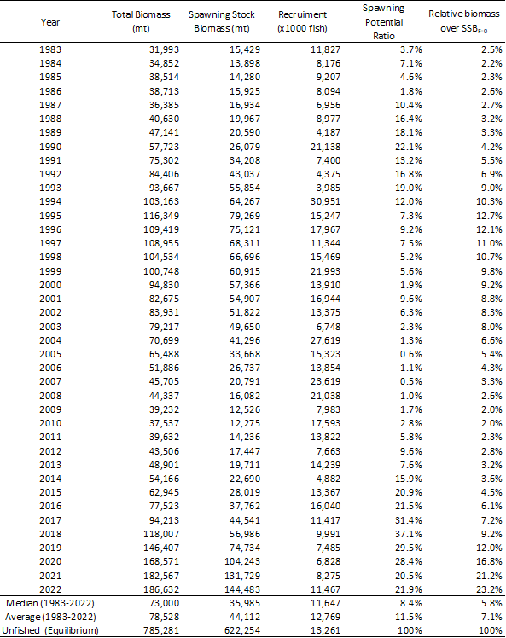

Table PBF-02. Ratios of the estimated fishing mortalities (Fs and 1-SPRs for 2002-04, 2012-14, 2020-2022) relative to potential fishing mortality-based reference points, and terminal year SSB (t) for each reference period, and depletion ratios for the terminal year of the reference period for Pacific bluefin tuna (Thunnus orientalis) from the base-case model. F_{max}: Fishing mortality (F) that maximizes equilibrium yield per recruit (Y/R). Fxx%SPR: F that produces a given % of the unfished spawning potential (biomass) under equilibrium conditions.
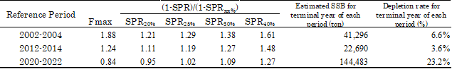

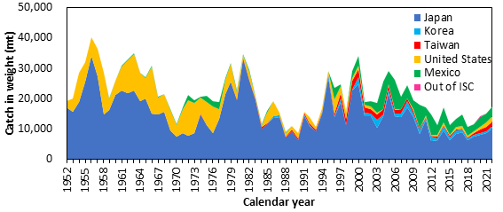

Figure PBF-01. Annual catch (tons) of Pacific bluefin tuna (Thunnus orientalis) by ISC member countries from 1952 through 2022 (calendar year) based on ISC official statistics.

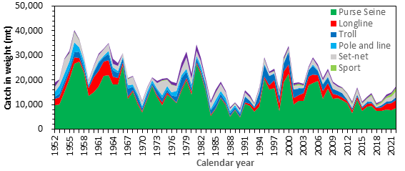

Figure PBF-02. Annual catch (tons) of Pacific bluefin tuna (Thunnus orientalis) by gear type by ISC member countries from 1952 through 2022 (calendar year) based on ISC official statistics.
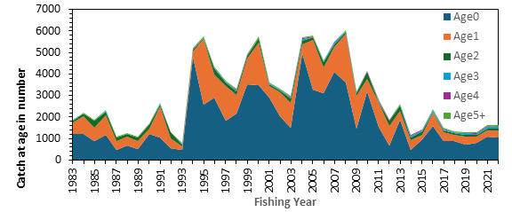
Figure PBF-03. Estimated annual catch-at-age (number of fish) of Pacific bluefin tuna (Thunnus orientalis) by fishing year estimated by the base-case model (1983-2022)

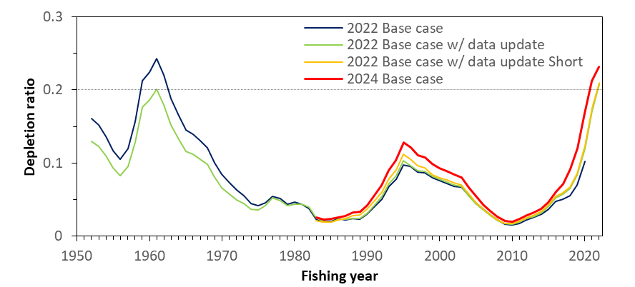
Figure PBF-04. Comparison of the trajectory of relative biomass (SSB/SSB_{F=0}, depletion ratio) of the assessment models bridging from the 2022 base-case to the 2024 base-case (2022 base-case, 2022 base-case with data-update, 2022 base-case with data-update Short (1983-), and the 2024 base-case model). The 2022 base case with data update and the 2022 base case with data update Short (1983-) almost overlap towards the end. SSB is spawning stock biomass, and SSB _{F=0} is the expected SSB under average recruitment conditions without fishing. The horizontal line represents 20%SSB_{F=0} (the second biomass rebuilding target).

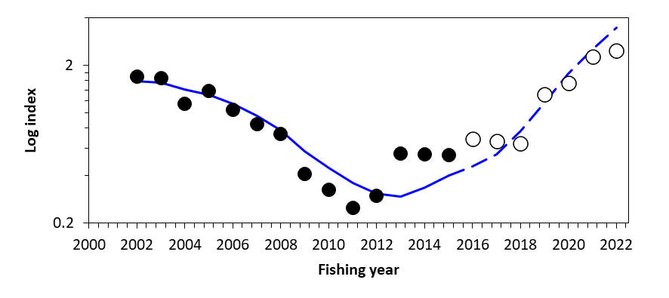
Figure PBF-05. Result for hindcasting of the recent 7 years (2016-2022) based on the catch at age. The expected (blue solid line) and predicted (blue dashed lines) Taiwanese longline CPUE index from the age-structured production model, where CPUE observations were removed for the recent 7 years. The solid circles represent the observations used in the model, and open circles represent the missing values.
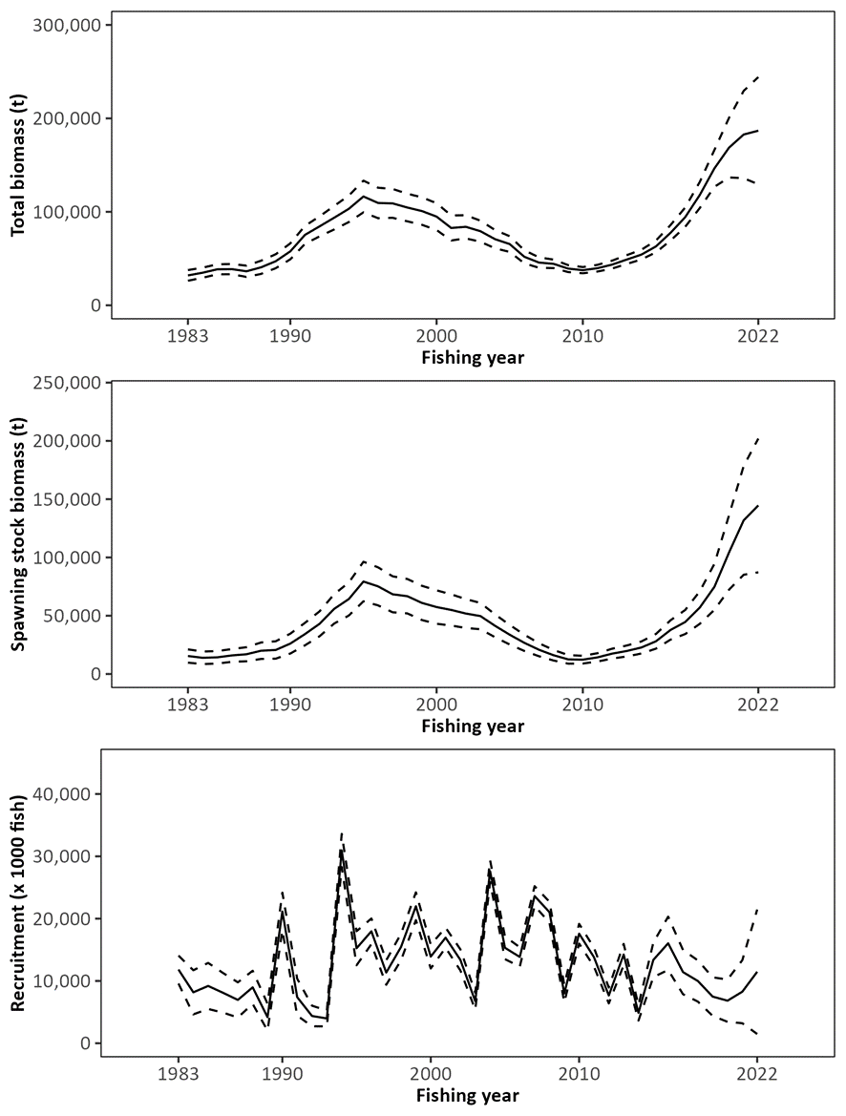
Figure PBF-06. Trajectory of total stock biomass (top), spawning stock biomass (middle), and recruitment (bottom) of Pacific bluefin tuna (Thunnus orientalis) (1983-2022) estimated from the base-case model. The solid line is the point estimate, and dashed lines delineate the 90% confidence interval. The method used to estimate the confidence interval was changed from bootstrapping in the previous assessments to the normal approximation of the Hessian matrix.
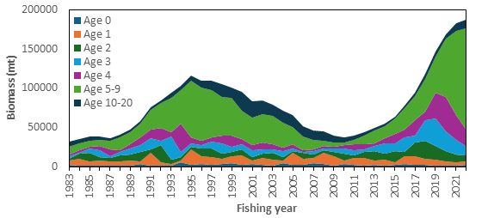
Figure PBF-07. Total biomass (tons) by age of Pacific bluefin tuna (Thunnus orientalis) estimated from the base-case model (1983-2022). Note that the recruitment estimates for 2019-2022 are more uncertain than for other years.

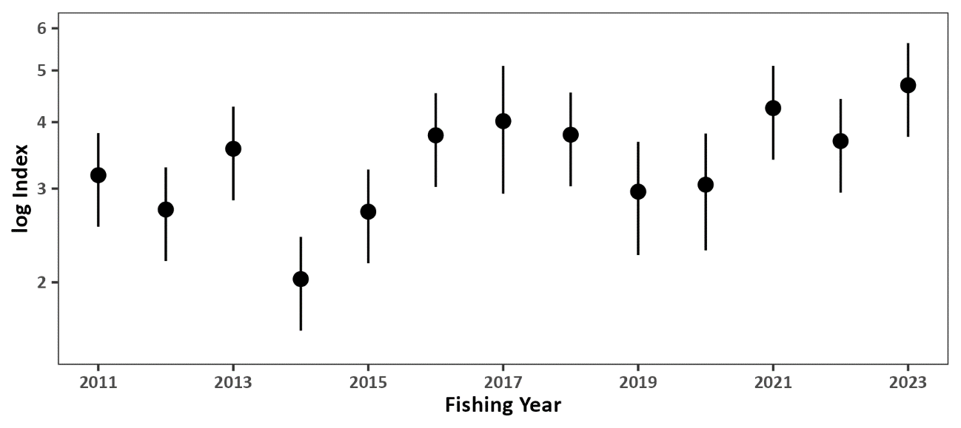
Figure PBF-08. Standardized CPUE index from the Japanese recruitment monitoring program (2011-2023). The bar represents the 95% confidence interval.

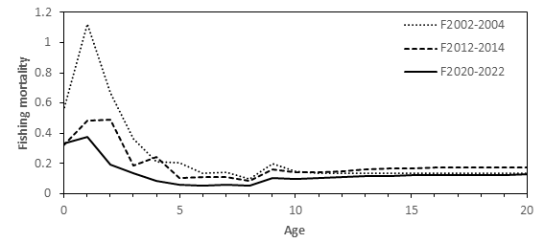
Figure PBF-09. Geometric means of annual age-specific fishing mortalities (F) of Pacific bluefin tuna (Thunnus orientalis) for 2002-2004 (dotted line), 2012-2014 (dashed line), and 2020-2022 (solid line).
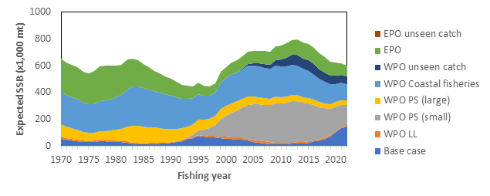
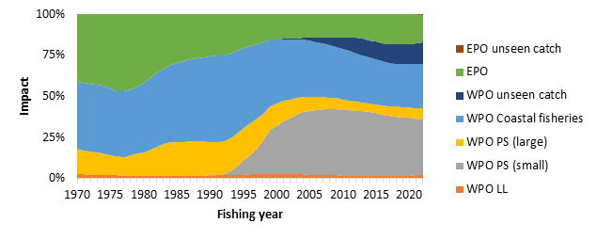
Figure PBF-10. The trajectory of the spawning stock biomass of a simulated population of Pacific bluefin tuna (Thunnus orientalis) when zero fishing mortality is assumed, estimated by the base-case long-term model. (top: absolute SSB, bottom: relative SSB). In 2022, the estimated cumulative impact proportion between WPO and EPO fisheries is about 83% and 17%, respectively. Fisheries group definition: WPO longline fisheries: F1-4. WPO purse seine fisheries for large fish: F5-7. WPO purse seine fisheries for small fish: F8-11. WPO coastal fisheries: F12-19. EPO fisheries: F20-23. WPO unaccounted fisheries: F24, 25. EPO unaccounted fisheries: F26. For exact fleet definitions, please see the 2024 PBF stock assessment report. Although larger PBF have been caught by the Korean offshore large-scale purse seine in recent years, this fleet is included in “WPO PS (small)” because of their historical selectivity.

- Management advice and implications

- SC20 noted the following management advice from ISC24:

The WCPFC and IATTC adopted an initial rebuilding biomass target (the median SSB estimated for the period from 1952 through 2014) and a second rebuilding biomass target (20%SSBF=0 under average recruitment) but not a fishing mortality reference level. The previous (2022) assessment estimated the initial rebuilding biomass target (SSBMED1952-2014) to be 6.3%SSB_{F=0} and the corresponding fishing mortality expressed as SPR of F6.3%SPR (Table [2]). The Kobe plot shows that the point estimate of the SSB2022 was 23.2%SSB_{F=0} and that the recent (2020-2022) fishing mortality corresponds to F23.6%SPR (Table [1] and Figure [10]). The apparent increase in F in the terminal period compared to the historical low in 2018 (F37.1%SPR) is a result of low recruitment in this period. As noted, the recruitment estimates in recent years are more uncertain and this result needs to be interpreted with caution.

After the steady decline in SSB from 1996 to the historically low level in 2010, the PBF stock has started recovering, and recovery has been more rapid in recent years, coinciding with the implementation of stringent management measures. The 2022 SSB was 10 times higher than the historical low and is above the second rebuilding target adopted by the WCPFC and IATTC, which was achieved in 2021. The stock has recovered at a faster rate than anticipated when the Harvest Strategy to foster rebuilding (WCPFC HS 2017-02) was implemented in 2014. The fishing mortality (F%SPR) in 2020-2022 is at a level producing 23.6%SPR. According to the requests from WCPFC and IATTC, future projections under various scenarios were conducted. The projection scenarios and their results, the figure of projection results, “future Kobe plot”, and “future impact plot” are provided as Tables [3-5], Figures [12, 13, and 14], respectively. In addition, the results of additional projections which were requested by the Join Working Group of IATTC-WCPFC NC is provided in Appendix 2 of the stock assessment report (SC20-SA-WP-08, Table A2.1-A2.3, Figure A2.1).

Based on these findings, the following information on the conservation of the Pacific bluefin tuna stock is provided:

- The PBF stock is recovering from the historically low biomass in 2010 and has exceeded the second rebuilding target (20%SSBF=0). The risk of SSB falling below 7.7%SSBF=0 (interim LRP for tropical tunas in IATTC) at least once in 10 years is negligible;
- The projection results show that increases in catches are possible. However, the risk of falling below the second rebuilding target will increase with larger increases in catch;
- The projection results assume that the CMMs are fully implemented and are based on certain biological and other assumptions. For example, these future projection results do not contain assumptions about discard mortality. Discard mortality may need to be considered as part of future increases in catch; and
- Given the uncertainty in future recruitment and the influence of recruitment on stock biomass as well as the impact of changes in fishing operations due to the management, monitoring recruitment and SSB should continue. Research on a recruitment index for the stock assessment should be pursued, and maintenance of a reliable adult abundance index should be ensured. In addition, accurate catch information is the foundation of good stock assessment.

Table PBF-03. Future projection scenarios for Pacific bluefin tuna (Thunnus orientalis).
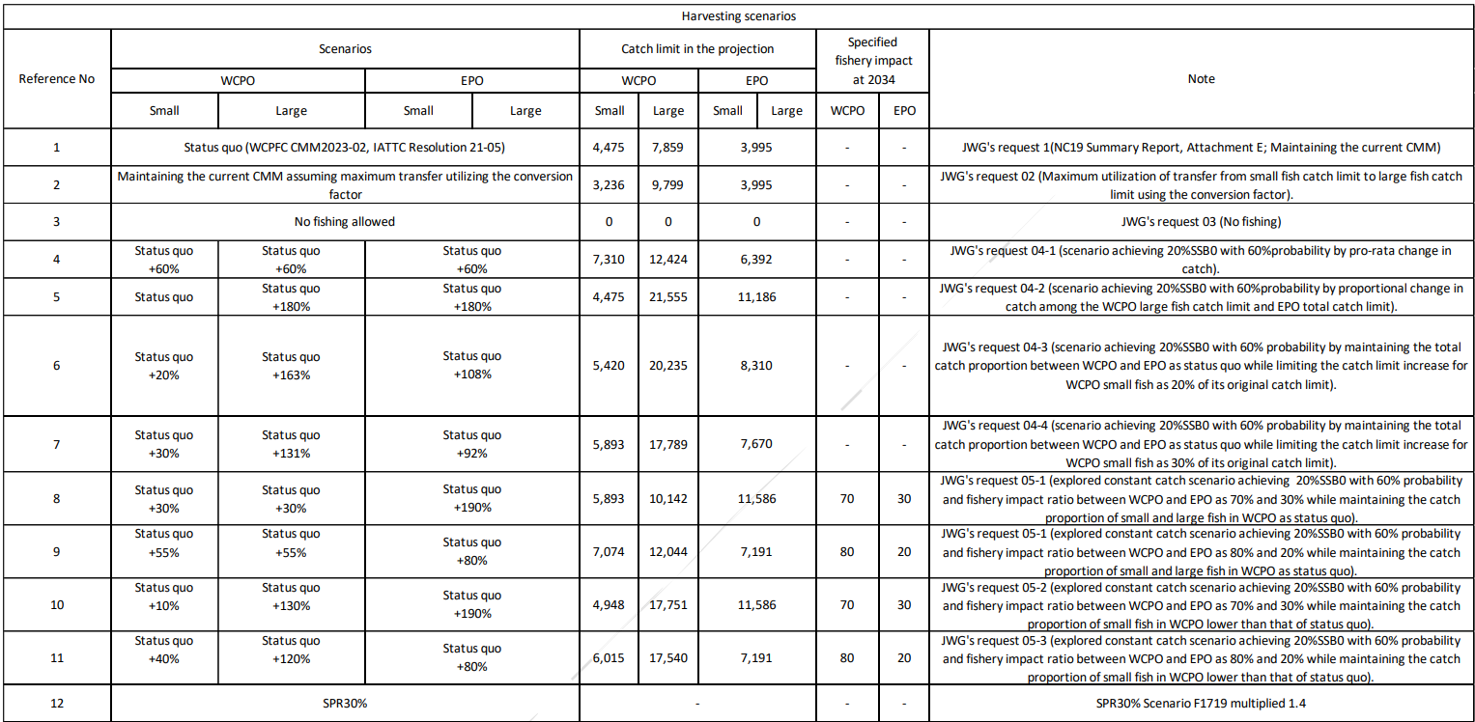 * The numbering of Scenarios is different from those given by the IATTC-WCPFC NC Joint WG meeting.
* Fishing mortality in scenario 3 was kept at zero. The catch limit for scenario 12 is calculated to achieve SPR 30% and allocated to fleets proportionately.
* The Japanese unilateral measure (transferring 250 mt of the catch upper limit from that for small PBF to that for large PBF during 2022-2034) is reflected in the projections.
Table PBF-04. Future projection scenarios for Pacific bluefin tuna (Thunnus orientalis) and their probability of achieving various target levels by various time schedules based on the base-case model.
*The numbering of Scenarios is different from those given by the IATTC-WCPFC NC Joint WG meeting and is the same as Table PBF-03.
* Recruitment is resampled from historical values.

Table PBF-05. Expected yield for Pacific bluefin tuna (Thunnus orientalis) under various harvesting scenarios based on the base-case model.
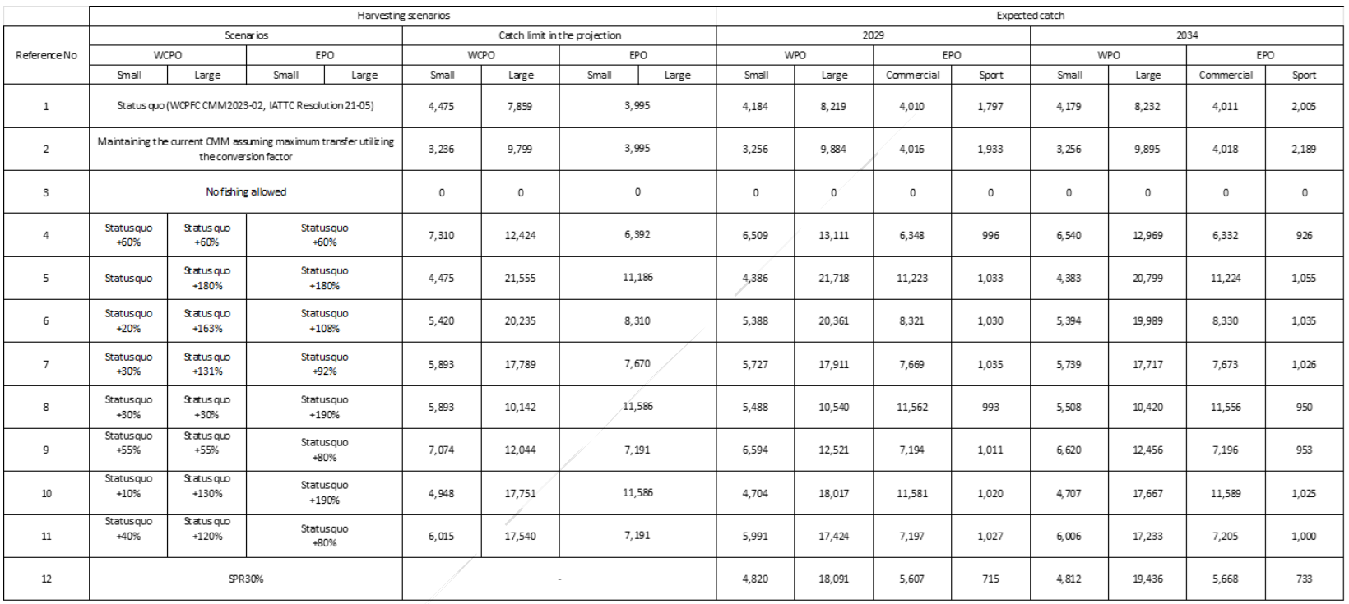
* Korean catch reflects the recent catch proportion for small and large, thus expected catches do not match with catch allocations.

Table PBF-A2.1. Harvest scenarios used in the projection for Pacific bluefin tuna (Thunnus orientalis).
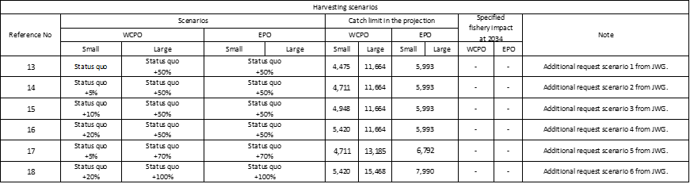

Table PBF-A2.2. Future projection scenarios for Pacific bluefin tuna (Thunnus orientalis) and their probability of achieving various target levels by various time schedules based on the base-case model.
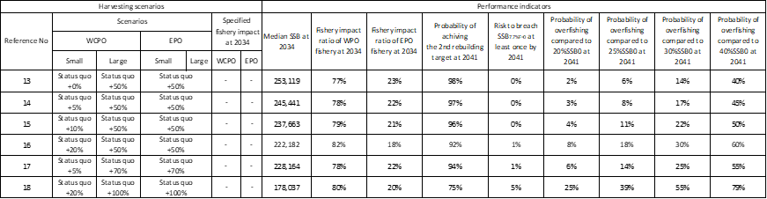

Table PBF-A2.3. Expected annual yield for Pacific bluefin tuna (Thunnus orientalis) under various harvesting scenarios based on the base-case model.
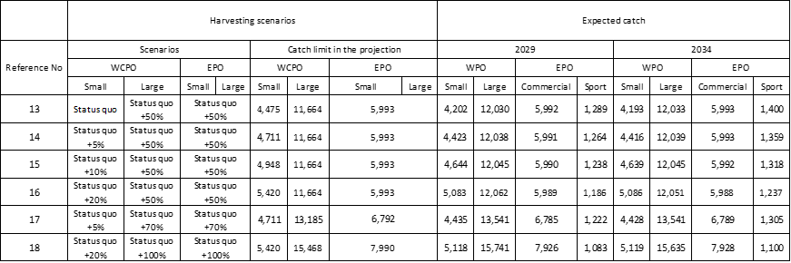
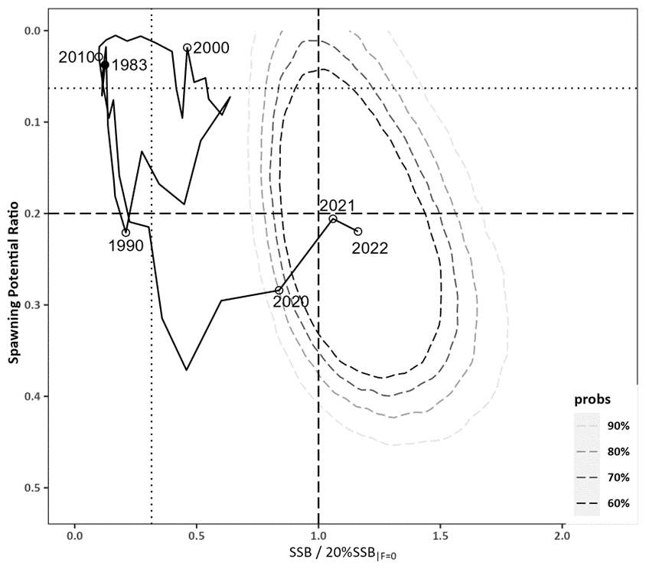
Figure PBF-11. Kobe plot for Pacific bluefin tuna (Thunnus orientalis) estimated from the base-case model from 1983 to 2022. The X-axis shows the annual SSB relative to 20%SSB_{F=0} and the Y-axis shows the spawning potential ratio (SPR) as a measure of fishing mortality. Vertical and horizontal dashed lines show 20%SSB_{F=0} (which corresponds to the second biomass rebuilding target) and the corresponding fishing mortality that produces SPR, respectively. Vertical and horizontal dotted lines show the initial biomass rebuilding target (SSB_{MED} = 6.3%SSB_{F=0}) and the corresponding fishing mortality that produces SPR, respectively. SSB_{MED} is calculated as the median of estimated SSB over 1952-2014 from the 2022 assessment. The apparent increase of F in the terminal period is a result of low recruitment in this period. As noted, the recruitment estimates in recent years are more uncertain and this result needs to be interpreted with caution. Contour plots represent 60% to 90% of two probability density distributions in SSB and SPR for 2022. The method used to estimate the confidence interval was changed from bootstrapping in the previous assessments to resampling from the multi-variate log-normal distribution. The probability distribution for the area where SPR is below zero is not shown as such SPR values are not biologically possible.
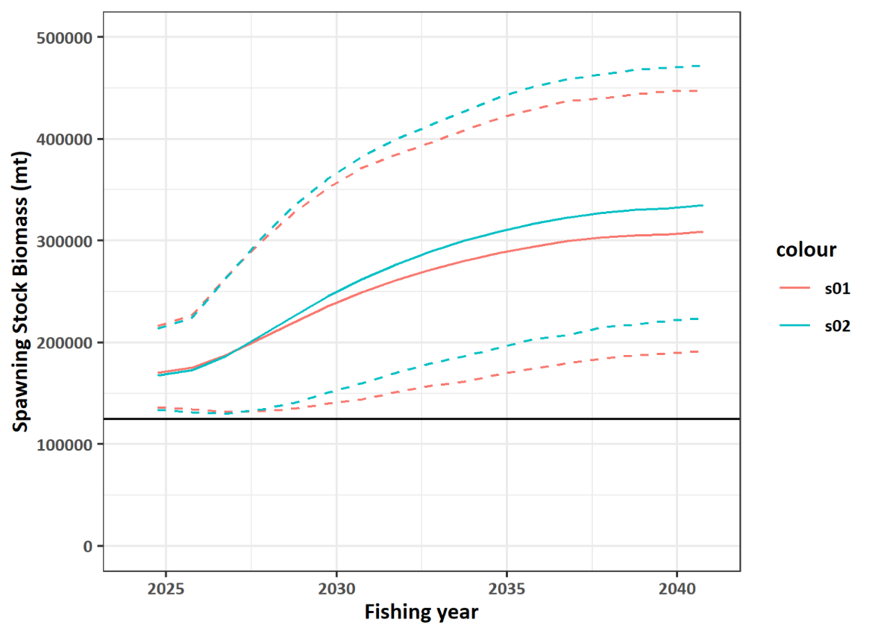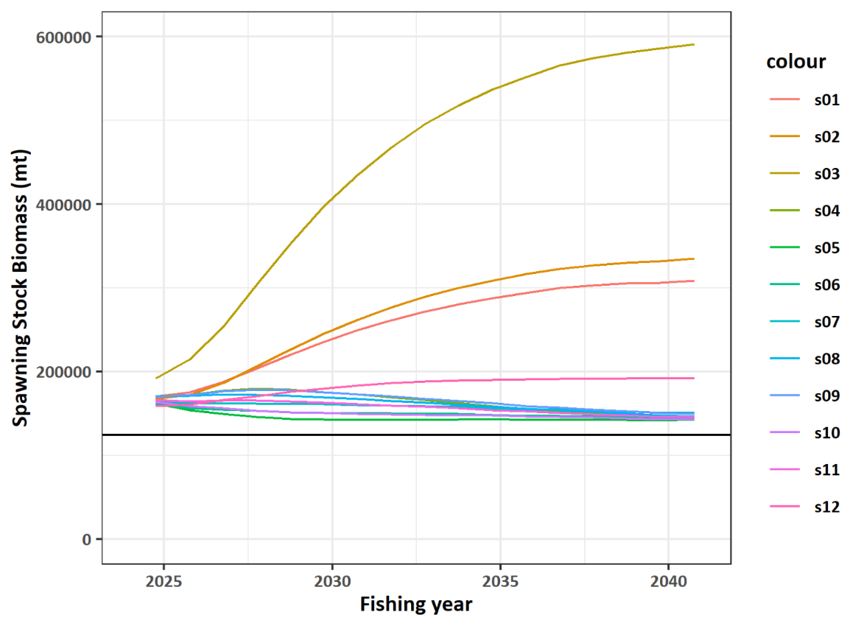
Figure PBF-12. Comparisons of various projection results for Pacific bluefin tuna (Thunnus orientalis) obtained from projection results. (Top) Median of scenarios 1 and 2 (solid lines) and their 90% confidence intervals (dotted lines). (Bottom) Median of all harvest scenarios examined from Table 3. The horizontal line represents the second rebuilding target.
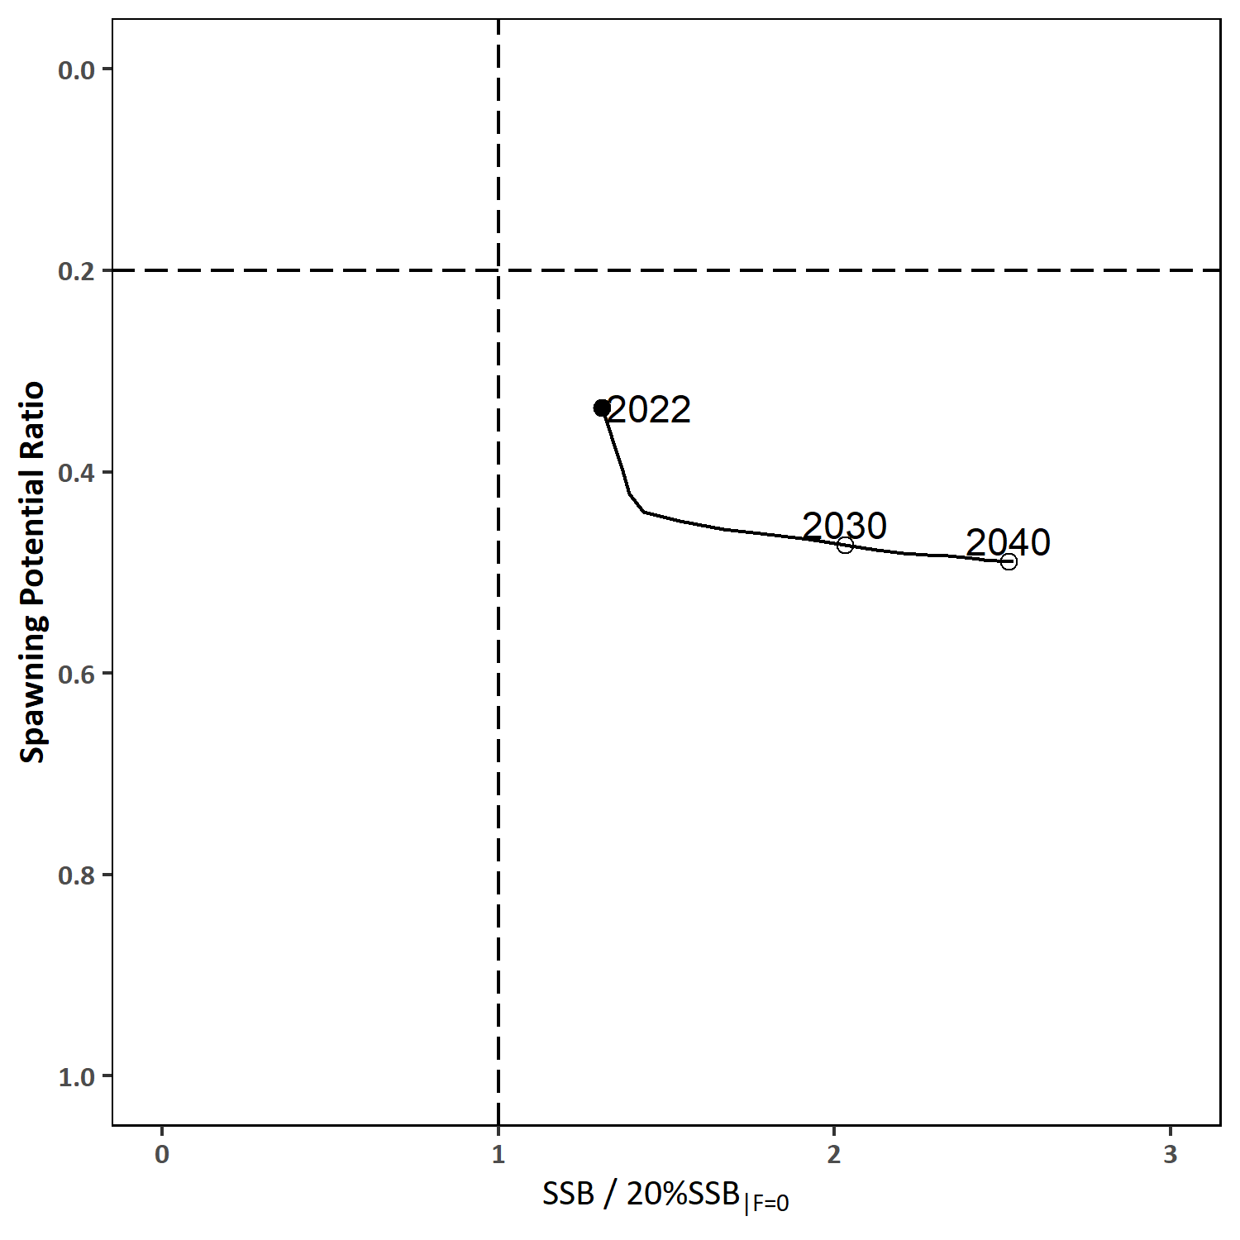
Figure PBF-13. “Future Kobe Plot” of projection results for Pacific bluefin tuna (Thunnus orientalis) from Scenario 1 in Table 3. Vertical and horizontal dashed lines show 20%SSB_{F=0} (which corresponds to the second biomass rebuilding target) and the corresponding fishing mortality that produces SPR, respectively.
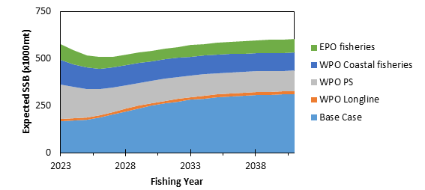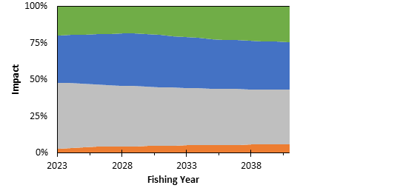

Figure PBF-14. “Future impact plot” from projection results for Pacific bluefin tuna (Thunnus orientalis) from Scenario 1 in Table 3. The top figure shows absolute biomass and the bottom figure shows relative impacts. The impact is calculated based on the expected increase of SSB in the absence of the respective group of fisheries.
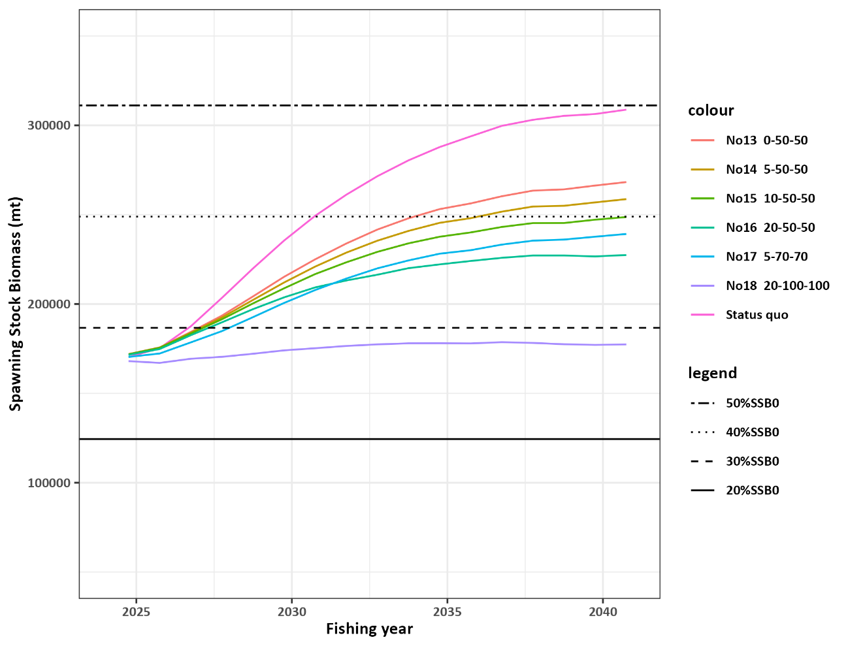

Figure PBF-A2.1 Comparisons of various projected median SSB for all harvest scenarios examined for Pacific bluefin tuna (Thunnus orientalis) obtained from projection results.

SC19 2023 (NO STOCK ASSESSMENT)

SC19 did not include Pacific bluefin tuna in its abbreviated agenda in 2023. Therefore, the stock status description from SC18 is still current. For further information on the stock status and trends from SC18, please see SC18-SA-WP-05

SC18 2022 (BENCHMARK ASSESSMENT)

- Status and trends

- SC18 welcomed successful completion of an updated Pacific bluefin tuna (PBF) stock assessment and noted the following stock status and conservation information provided by ISC.

PBF spawning stock biomass (SSB) has gradually increased in the last 10 years, and the rate of increase is accelerating. These biomass increases coincide with a decline in fishing mortality, particularly for fish aged 0 to 3, over the last decade. The latest (2020) SSB is estimated to be 10.2% of SSB₀.
  - No biomass-based limit or target reference points have been adopted for PBF, but the PBF stock is overfished relative to the potential biomass-based reference points (20%SSB₀) adopted for other tuna species by the IATTC and WCPFC. On the other hand, SSB reached its initial rebuilding target (SSB_{MED} = 6.3%SSB₀) in 2019, 5 years earlier than originally anticipated by the RFMOs.
  - No fishing mortality-based reference points have been adopted for PBF by the IATTC and WCPFC. The recent (2018-2020) F_{%SPR} is estimated to produce a fishing intensity of 30.7%SPR and is below the level corresponding to overfishing for many F-based reference points proposed for tuna species (Table PBF2), including SPR20%.

- SC18 noted that while the gradual improvement of the Pacific bluefin tuna stock is a step in the right direction, it must be remembered that the current spawning biomass of the stock is only 10.2% of the unfished level. This is well below the LRP of 20% adopted for the key tuna species in WCPFC and suggests the Pacific bluefin tuna stock remains overfished relative to the LRP of key tuna species.

- SC18 noted some CCMs encourage a precautionary approach towards the management of Pacific bluefin tuna until such time as the second rebuilding target is met, especially as the stock assessment and projection results are based on certain assumptions, including those on future recruitment, that may not always be met.

- SC18 supported the continued monitoring of recruitment and spawning stock biomass, and research on a recruitment index for the stock assessment given the uncertainty in future recruitment and the influence of recruitment on stock biomass, as well as the impact of changes in fishing operations due to management changes.

- Management advice and implications

- SC18 noted that the updated stock assessment presented at SC18 indicates that the stock is likely recovering as planned or possibly faster, which suggests that the measures incorporated in CMM 2021-02 appear to be working as intended.

- SC18 recommended that the Commission exercise a precautionary approach, and noted that the PBF stock is still in a depleted state (10.2% of SSB₀) when it considers any revisions to the current CMM. Consideration of any increases to the catch limit needs to be weighted against reducing the probability of recovering to the second rebuilding target.

- SC18 further welcomed ISC’s effort on further investigation of structural uncertainty to incorporate it in future management advice.

- SC18 noted the following management information from ISC:

After the steady decline in SSB from 1996 to the historically low level in 2010, the PBF stock has started recovering, and recovery has been more rapid in recent years, consistent with the implementation of stringent management measures. The 2020 SSB was above the initial rebuilding target but remains below the second rebuilding target adopted by the WCPFC and IATTC. However, stock recovery is occurring at a faster rate than anticipated by managers when the Harvest Strategy to foster rebuilding (WCPFC HS 2017-02) was implemented in 2014. The fishing mortality (F_{%SPR}) in 2018-2020 has been reduced to a level producing 30.7%SPR, the lowest observed in the time series. Based on these findings, the following information on the conservation of the Pacific bluefin tuna stock is provided:
- The PBF stock is recovering from the historically low biomass in 2010 and has exceeded the initial rebuilding target (SSB_{MED1952-2014}) five years earlier than expected. The rate of recovery is increasing and under all projection scenarios evaluated, it is very likely the second rebuilding target (20%SSB₀ with 60% probability) will be achieved (probabilities > 90%) by 2029 (Table PBF-3). The risk of SSB falling below the historical lowest observed SSB at least once in 10 years is negligible.
- The projection results show that increases in catches are possible without affecting the attainment of the second rebuilding objective. Increases in catch should consider both the rebuilding rate and the distribution of catch between small and large fish.
- The projection results assume that the CMMs are fully implemented and are based on certain biological and other assumptions. For example, these future projection results do not contain assumptions about discard mortality. Although the impact of discards on SSB is small compared to other fisheries, discards should be considered in future harvest scenarios.
- Given the uncertainty in future recruitment and the influence of recruitment on stock biomass as well as the impact of changes in fishing operations due to the management, monitoring recruitment and SSB should continue and research on a recruitment index for the stock assessment should be pursued.
- The results of projections from sensitivity models with lower productivity assumptions show that this conservation information is robust to uncertainty in stock productivity.

Table PBF-1. Total biomass, spawning stock biomass, recruitment, and spawning potential ratio of Pacific bluefin tuna (Thunnus orientalis) estimated by the base-case model, 1952-2020.
Table PBF-2. Ratios of the estimated fishing mortalities (Fs and 1-SPRs for 2002-04, 2011-13, 2016-18) relative to potential fishing mortality-based reference points, and terminal year SSB (t) for each reference period, and depletion ratios for the terminal year of the reference period for Pacific bluefin tuna (Thunnus orientalis) from the base-case model. F_{max}: Fishing mortality (F) that maximizes equilibrium yield per recruit (Y/R). F_{0.1}: F at which the slope of the Y/R curve is 10% of the value at its origin. F_{med}: F corresponding to the inverse of the median of the observed R/SSB ratio. F_{x%SPR}: F that produces given % of the unfished spawning potential (biomass) under equilibrium condition.

Table PBF-3. Future projection scenarios for Pacific bluefin tuna (Thunnus orientalis) and their probability of achieving various target levels by various time schedules based on the base-case model.
* The Reference number of Scenario is different from those given by the IATTC-WCPFC NC Joint WG meeting.
* Fishing mortality for scenario 1 is specified as average level of age-specific fishing mortality during 2002-2004, which is the reference years in the WCPFC. Higher levels of the fishing mortality are specified for other scenarios to fulfill their quota in those projections.
* The Japanese unilateral measure (transferring 250 mt of catch upper limit from that for small PBF to that for large PBF during 2020-2034) is reflected in the projections.

Table PBF-4. Expected yield for Pacific bluefin tuna (Thunnus orientalis) under various harvesting scenarios based on the base-case model.

* Catch limits for EPO commercial fisheries are applied for the catch of both small and large fish made by the fleets.
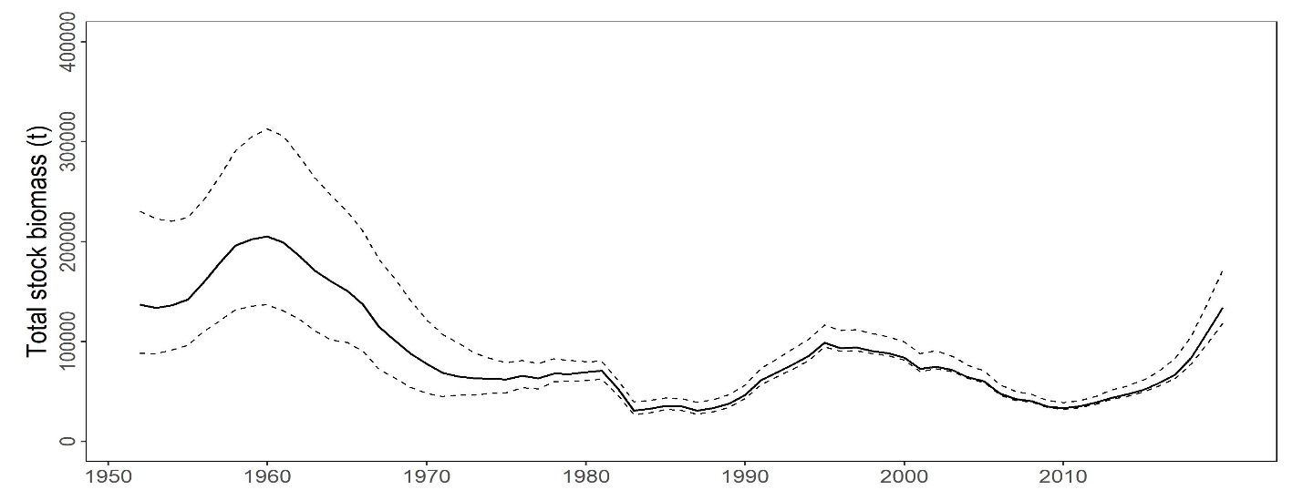
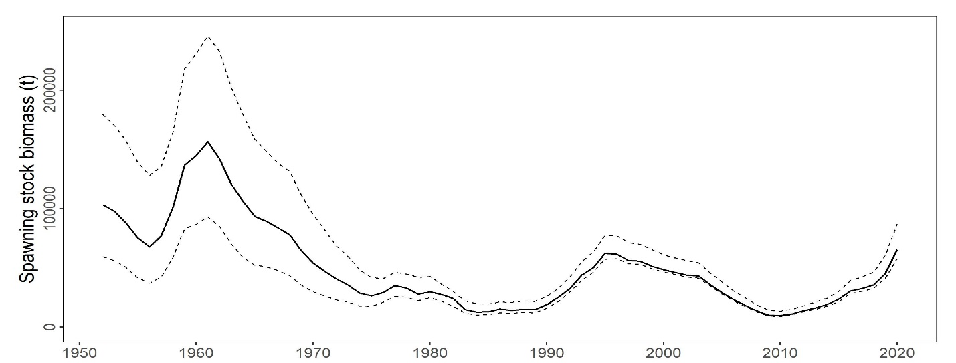
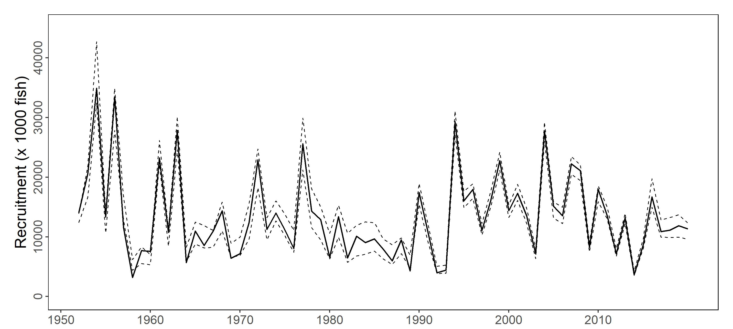

Figure PBF-1. Total stock biomass (top), spawning stock biomass (middle), and recruitment (bottom) of Pacific bluefin tuna (Thunnus orientalis) (1952-2020) estimated from the base-case model. The solid line is the point estimate and dashed lines delineate the 90% confidence interval.

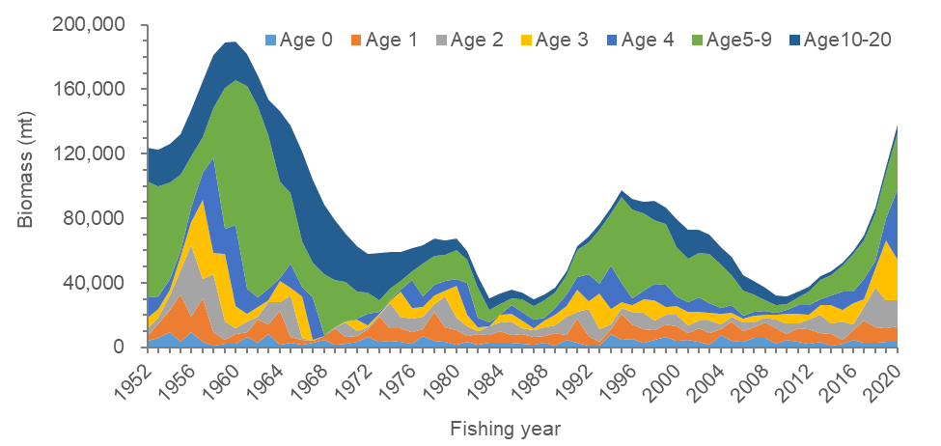
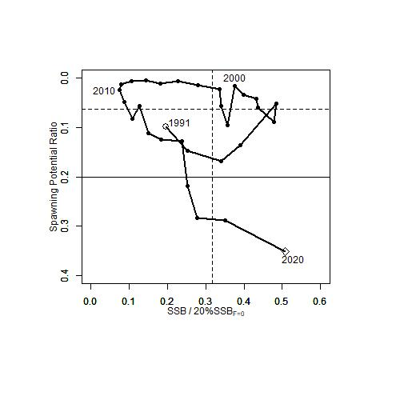
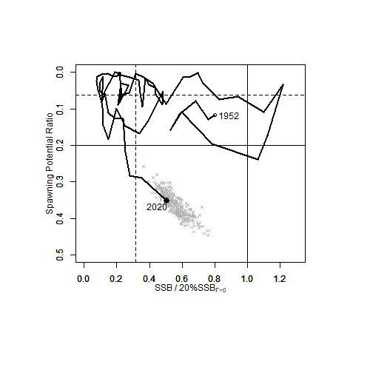
Figure PBF-2. Total biomass (tonnes) by age of Pacific bluefin tuna (Thunnus orientalis) estimated from the base-case model (1952-2020).

Figure PBF-3. Kobe plots for Pacific bluefin tuna (Thunnus orientalis) estimated from the base-case model. The X-axis shows the annual SSB relative to 20%SSB₀ and the Y-axis shows the spawning potential ratio (SPR) as a measure of fishing mortality. Vertical and horizontal solid lines in the left figure show 20%SSB₀ (which corresponds to the second biomass rebuilding target) and the corresponding fishing mortality that produces SPR, respectively. Vertical and horizontal broken lines in both figures show the initial biomass rebuilding target (SSB_{MED} = 6.3%SSB₀) and the corresponding fishing mortality that produces SPR, respectively. SSB_{MED} is calculated as the median of point estimates of SSB over 1952-2014 by the base case model. The left figure shows the historical trajectory, where the open circle indicates the first year of the assessment (1952), solid circles indicate the last five years of the assessment (2014-2020), and grey crosses indicate the uncertainty of the terminal year estimated by bootstrapping. The right figure shows the trajectory of the last 30 years.
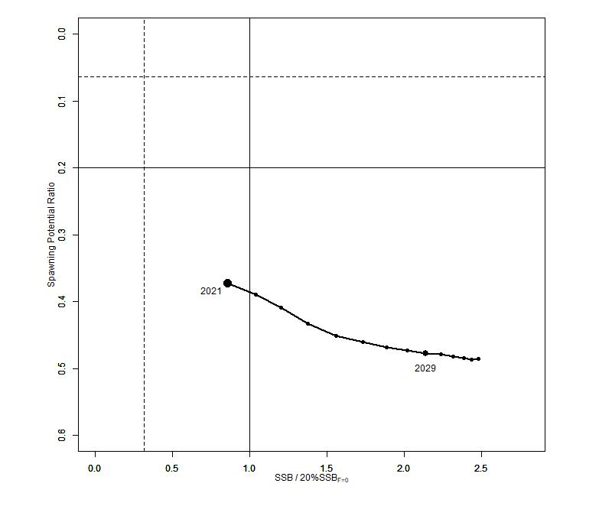
Figure PBF-4. “Future Kobe Plot” of projection results for Pacific bluefin tuna (Thunnus orientalis) from Scenario 1 from Table PBF-3.

SC17 2021 (NO STOCK ASSESSMENT)

SC17 did not include Pacific bluefin tuna in its abbreviated agenda in 2021 due to its virtual nature during the COVID-19 situation. Therefore, the stock status description from SC16 is still current. For further information on the stock status and trends from SC16, please see SC16-SA-WP-06 or https://meetings.wcpfc.int/node/11696

SC16 2020 (BENCHMARK ASSESSMENT)

    - Review of 2020 Pacific bluefin tuna stock assessment

- H. Fukuda, lead modelerfor the ISC Bluefin Tuna Working Group (PBFWG) made a detailed report on the benchmark stock assessment for PBF conducted by the ISC PBFWG in March 2020 (SC16-SA-WP-06). Several modifications — such as the spatio-temporal modeling for CPUE standardization, more detailed modeling of fisheries, inclusions of newly available size data and discard information, and bias correction for the projection results —were made to improve the assessment.

- Population dynamics during 1952-2018 were modelled using quarterly observations of catch and size compositions, when available, as well as the annual estimates of standardized CPUE based abundance indices. The assessment model was fitted to those input data in a likelihood-based statistical framework. Based on the diagnostic analysis, the PBFWG concluded that the new base-case model represents the data sufficiently and there is an internal consistency among the assumptions of the assessment model and input data. The new base-case model also showed consistent results with the 2016 and 2018 assessments. The ISC plenary 20 considered the 2020 assessment results as the best available scientific information on Pacific bluefin tuna.

- The stock projections were developed based on the bootstrap replicates of the base-case model and the future harvesting scenarios, which were requested by the WCPFC and IATTC. For the sake of precautionarily in the light of current low level of the SSB and the possible future low recruitment produced thereby, the future recruitments until the stock recovered to the initial rebuilding target were resampled from relatively low recruitment period (1980-1989). For the following years, future recruitments were randomly resampled from whole stock assessment period.

    - Stock status and trends

- SC16 noted that the ISC provided the following conclusions on the stock status of Pacific bluefin tuna.

The base-case model results show that: (1) spawning stock biomass (SSB) fluctuated throughout the assessment period (fishing years 1952-2018); (2) the SSB steadily declined from 1996 to 2010; (3) there has been a slow increase of the stock biomass continues since 2011; (4) total biomass in 2018 exceeded the historical median with an increase in immature fish; and (5) fishing mortality (F_{%SPR}) declined from a level producing about 1% of SPR in 2004-2009 to a level producing 14% of SPR in 2016- 2018 (Table PBF1). Based on the model diagnostics, the estimated biomass trend for the last 30 years is considered robust although SSB prior to the 1980s is uncertain due to data limitations. The SSB in 2018 was estimated to be around 28,000 t (Table PBF1 and Figure PBF-1), which is a 3,000 t increase from 2016 according to the base-case model. An increase of young fish (0-2 years old) is observed in 2016-2018 (Figure PBF-2), likely resulting from low fishing mortality on those fish (Figure PBF-3) and is expected to accelerate the recovery of SSB in the future.

Historical recruitment estimates have fluctuated since 1952 without an apparent trend. Relatively low recruitment levels estimated in 2010-2014 were of concern in the 2016 assessment. The 2015 recruitment estimate is lower than the historical average while the 2016 recruitment estimate (about 17 million fish) is higher than the historical average (Table PBF-1 and Figure PBF-1). The recruitment estimates for 2017 and 2018, which are based on fewer observations and more uncertain, are below the historical average.

Estimated age-specific fishing mortalities (F) on the stock during the periods of 2011-2013 and 2016-2018 compared with 2002-2004 estimates (the reference period for the WCPFC Conservation and Management Measure) are presented in Figure PBF-3. A substantial decrease in estimated F is observed in ages 0-2 in 2016-2018 relative to the previous years. Note that stricter management measures in the WCPFC and IATTC have been in place since 2015.

Figure PBF-5 depicts the historical impacts of the fleets on the PBF stock, showing the estimated biomass when fishing mortality from the respective fleets is zero. Historically, the WPO coastal fisheries group has had the greatest impact on the PBF stock, but since about the early 1990s the WPO purse seine fishery group targeting small fish (ages 0-1) has had a greater impact and the effect of this group in 2018 was greater than any of the other fishery groups. The impact of the EPO fisheries group was large before the mid-1980s, decreasing significantly thereafter. The WPO longline fisheries group has had a limited effect on the stock throughout the analysis period because the impact of a fishery on a stock depends on both the number and size of the fish caught by each fleet; i.e., catching a high number of smaller juvenile fish can have a greater impact on future spawning stock biomass than catching the same weight of larger mature fish. There is greater uncertainty regarding discards than other fishery impacts because the impact of discarding is not based on observed data.

- SC16 noted the following stock status from ISC:

The WCPFC and IATTC adopted an initial rebuilding biomass target (the median SSB estimated for the period from 1952 through 2014) and a second rebuilding biomass target (20%SSB_{F=0} under average recruitment), without specifying a fishing mortality reference level. The 2020 assessment estimated the initial rebuilding biomass target (SSB_{MED1952-2014}) to be 6.4%SSB_{F=0} and the corresponding fishing mortality expressed as F_{6.4%SPR}. The Kobe plot shows that the point estimate of the SSB₂₀₁₈ was 4.5%SSB_{F=0} and the recent (2016-2018) fishing mortality corresponds to F_{14%SPR} (Table PBF-1 and Figure PBF-4). Although no reference points have been adopted to evaluate the status of PBF, an evaluation of stock status against some common reference points (Table PBF-2) shows that the stock is overfished relative to biomass-based limit reference points adopted for other species in WCPFC (20%SSB_{F=0}) and fishing mortality has declined but not reached the level corresponding to that reference point (F_{20%SPR}).

The PBF spawning stock biomass (SSB) has gradually increased in the last 8 years (2011-2018). Young fish (age 0-2) shows a more rapid increase in recent years (Figure PBF-1 and PBF2). These changes in biomass coincide with a decline in fishing mortality over the last decade (Figure PBF-3). Based on these findings, the following information on the status of the Pacific bluefin tuna stock is provided:

- The latest (2018) SSB is estimated to be 4.5% of SSB_{F=0} which is increased from 4.0% in 2016 (Figure PBF-4 and Table PBF1). No biomass-based limit or target reference points have been adopted for PBF. However, the PBF stock is overfished relative to the potential biomass-based reference points (SSB_{MED} and 20%SSB_{F=0}) adopted for other tuna species by the IATTC and WCPFC.
- The recent (2016-2018) F_{%SPR}is estimated to produce 14%SPR (Figure PBF-4 and Table PBF2). Although no fishing mortality-based limit or target reference points have been adopted for PBF by the IATTC and WCPFC, recent fishing mortality is above the level producing 20%SPR. However, the stock is subject to rebuilding measures including catch limits and the capacity of the stock to rebuild is not compromised, as shown by the projection results.

- In addition, SC16 noted that, although the WCPFC has not established any reference points for PBF, recent fishing mortality is above the level producing 20%SPR, which is the second rebuilding target established by the WCPFC indicating that overfishing is taking place relative to the possible reference point of 20%SPR and some of the other commonly used F-related reference points. SC16 also noted that the projection results, while projected from a single base case model, estimate that the stock may continue to rebuild.

- SC16 noted that regarding the probability of meeting the rebuilding targets, the approach taken in this assessment is not based on the structural uncertainty grid approach used to characterize uncertainty in the assessment of other stocks in the WCPO. The majority of CCMs recommend that such an approach is adopted in future, especially when using these models to drive management action.

- However, ISC currently does not see the need for structural uncertainty grid because of internal consistency of the assessment model of PBF.

    - Management advice and implications

- SC16 noted that the improved recruitment in 2016, relative to recent years, noted by SC14 in the previous assessment has now been followed by two much lower recruitments. Apart from the low recruitment in 2014 these estimated recruitments for 2017 and 2018 are the lowest since the early 1990s, while noting that the recruitment in these years is uncertain. The majority of CCMs noted that, given ongoing uncertainty in the stock-recruitment relationship and the very low levels of current spawning biomass estimated by this assessment (4.5%), future recruitments may remain low until there is sufficient recovery in spawning biomass. Indeed, the increase seen in young fish in recent years may be transient unless followed up with a series of higher recruitments.

- While SC16 recognized the existence of an interim Harvest Strategy for this stock, noting ongoing concerns of low stock size, the current level of overfishing relative to the possible reference point of 20%SPR and some of the other commonly used F-related reference points, and uncertain future recruitments, the majority of CCMs reiterate their advice from SC14 and urge the Commission to take a precautionary approach to the management of Pacific Bluefin tuna, especially in relation to the timing of increasing catch levels, until the rebuilding of the stock to higher biomass levels is achieved.

- SC16 also noted the following conservation information from ISC:

After the steady decline in SSB from 1995 to the historically low level in 2010, the PBF stock has started recovering slowly, consistent with the management measures implemented in 2014-2015. The spawning stock biomass in 2018 was below the two biomass rebuilding targets adopted by the WCPFC while the 2016-18 fishing mortality (F_{%SPR}) has reduced to a level producing 14%SPR.
The projection results based on the base-case model under several harvest and recruitment scenarios and time schedules requested by the RFMOs are shown in Tables PBF3 and PBF4. The projection results show that PBF SSB recovers to the biomass-based rebuilding targets due to reduced fishing mortality by applying catch limits as the stock increases (Figure PBF-6). In most of the scenarios, the SSB biomass is projected to recover to the initial rebuilding target (SSB_{MED}) in the fishing year 2020 (April of 2021) with a probability above the 60% level prescribed in the WCPFC CMM 2019-02 (Table PBF4).
A Kobe chart and impacts by fleets estimated from future projections under the current management scheme are provided for information, (Figures PBF6 and PBF7, respectively). Because the projections include catch limits, fishing mortality (F_{x%SPR}) is expected to decline, i.e., SPR will increase, as biomass increases. Further stratification of future impacts is possible if the allocation of increased catch limits among fleets/countries is specified.

Based on these findings, the following conservation information is provided:
- Under all examined scenarios the initial goal of WCPFC and IATTC, rebuilding to SSB_{MED} by 2024 with at least 60% probability, is reached and the risk of SSB falling below historical lowest observed SSB at least once in 10 years is negligible.
- The projection results assume that the CMMs are fully implemented and are based on certain biological and other assumptions. For example, these future projection results do not contain assumptions about discard mortality. Although the impact of discards on SSB is small compared to other fisheries (Figure PBF-7), discards should be considered in the harvest scenarios.
- Given the low SSB, the uncertainty in future recruitment, and the influence of recruitment has on stock biomass, monitoring recruitment and SSB should continue so that the recruitment level can be understood in a timely manner.

Table PBF-1. Total biomass, spawning stock biomass, recruitment, and spawning potential ratio of Pacific bluefin tuna (Thunnus orientalis) estimated by the base-case model, 1952-2018.

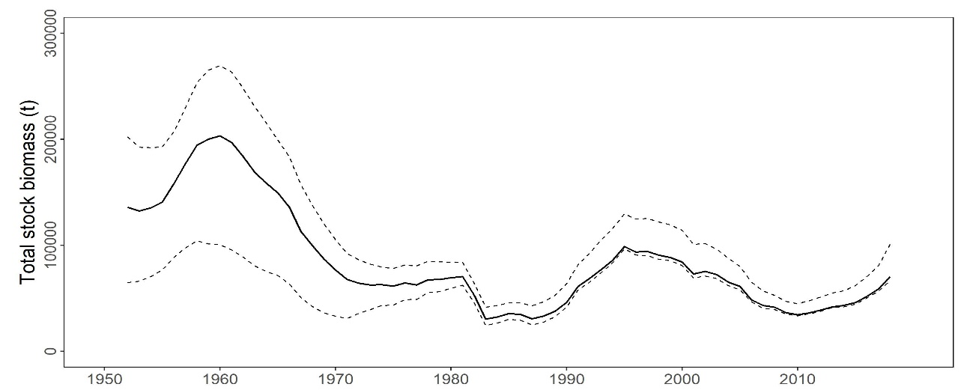
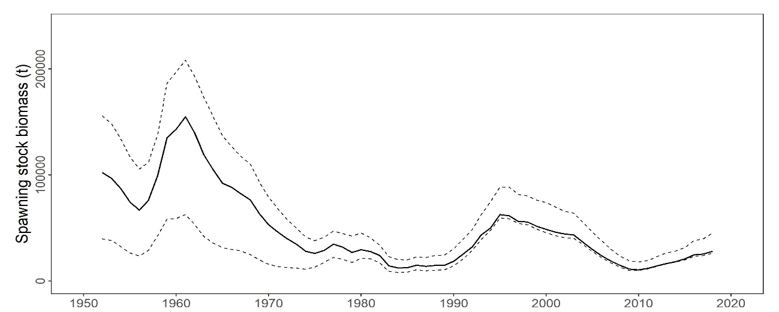
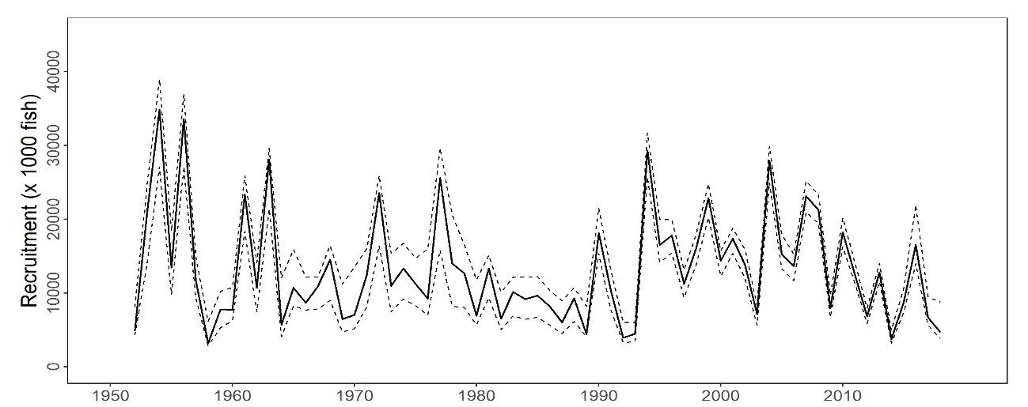

Figure PBF-1. Total stock biomass (top), spawning stock biomass (middle), and recruitment (bottom) of Pacific bluefin tuna (Thunnus orientalis) (1952-2018) estimated from the base-case model. The solid line is the point estimate and dashed lines delineate the 90% confidence interval.

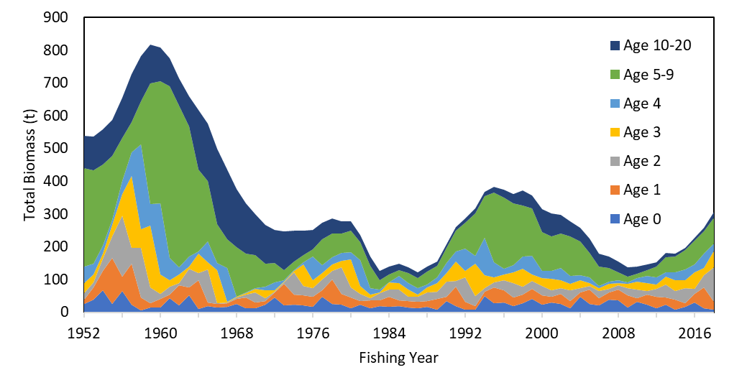
Figure PBF-2. Total biomass (tonnes) by age of Pacific bluefin tuna (Thunnus orientalis) estimated from the base-case model (1952-2018).

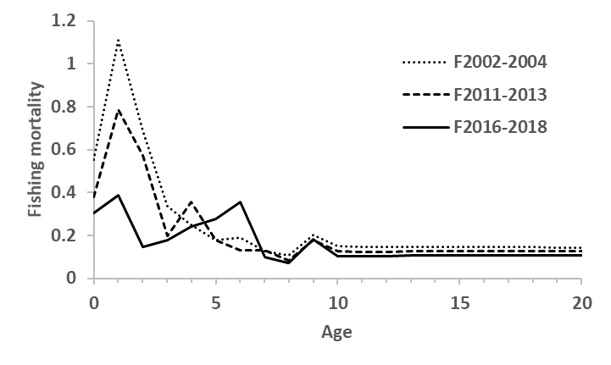
Figure PBF-3.Geometric means of annual age-specificfishing mortalities (F) of Pacific bluefin tuna (Thunnus orientalis) for 2002-2004 (dotted line), 2011-2013 (broken line) and 2016-2018 (solid line).

Table PBF-2. Ratios of the estimated fishing mortalities (Fs and 1-SPRs for 2002-04, 2011-13, 2016-18) relative to potential fishing mortality-based reference points, and terminal year SSB (t) for each reference period, and depletion ratios for the terminal year of the reference period for Pacific bluefin tuna (Thunnus orientalis) from the base-case model. F_{max}: Fishing mortality (F) that maximizes equilibrium yield per recruit (Y/R). F_{0.1}: F at which the slope of the Y/R curve is 10% of the value at its origin. F_{med}: F corresponding to the inverse of the median of the observed R/SSB ratio. F_{xx%SPR}: F that produces given % of the unfished spawning potential (biomass) under equilibrium condition.

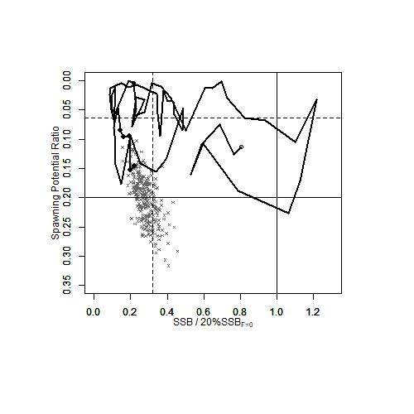
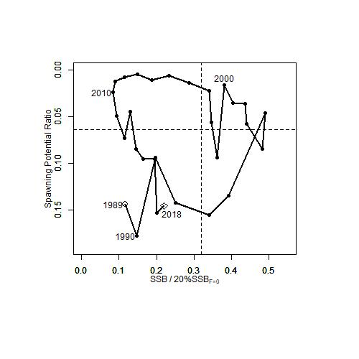

Figure PBF-4. Kobe plots for Pacific bluefin tuna (Thunnus orientalis) estimated from the base-case model. The X-axis shows the annual SSB relative to 20%SSB_{F=0} and the Y-axis shows the spawning potential ratio (SPR) as a measure of fishing mortality. Vertical and horizontal solid lines in the left figure show 20%SSB_{F=0} (which corresponds to the second biomass rebuilding target) and the corresponding fishing mortality that produces SPR, respectively. Vertical and horizontal broken lines in both figures show the initial biomass rebuilding target (SSB_{MED} = 6.4%SSB_{F=0}) and the corresponding fishing mortality that produces SPR, respectively. SSB_{MED} is calculated as the median of estimated SSB over 1952-2014. The left figure shows the historical trajectory, where the open circle indicates the first year of the assessment (1952), solid circles indicate the last five years of the assessment (2014-2018), and grey crosses indicate the uncertainty of the terminal year estimated by bootstrapping. The right figure shows the trajectory of the last 30 years.

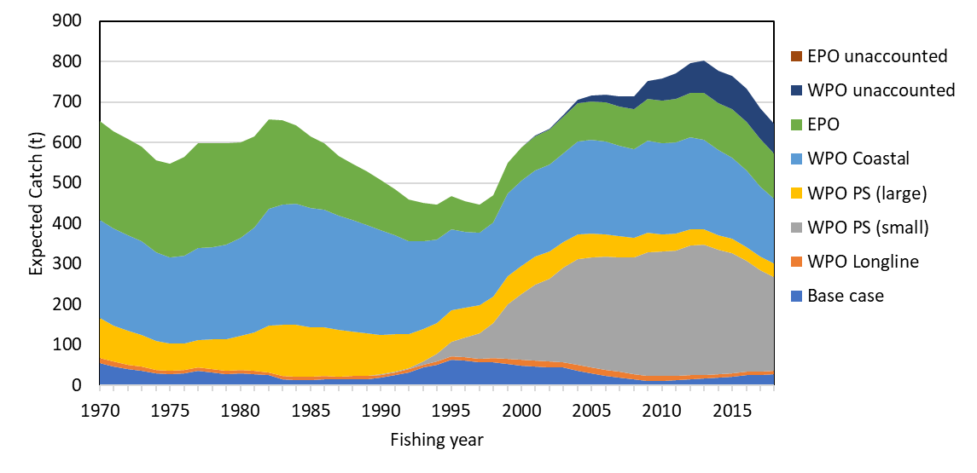
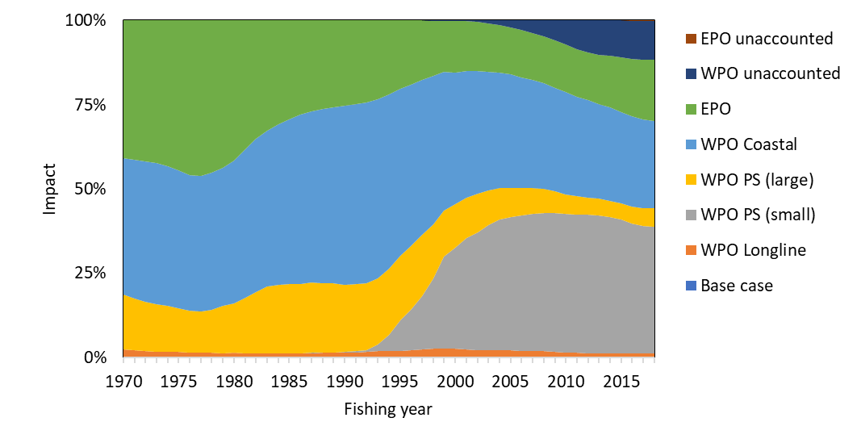
Figure PBF-5. The trajectory of the spawning stock biomass of a simulated population of Pacific bluefin tuna (Thunnus orientalis) when zero fishing mortality is assumed, estimated by the base-case model. (top: absolute SSB, bottom: relative SSB). Fisheries group definition; WPO longline fisheries: F1, F12, F17, 23. WPO purse seine fisheries for small fish: F2, F3, F18, F20. WPO purse seine fisheries for large fish: F4, F5. WPO coastal fisheries: F6-11, F16, F19. EPO fisheries: F13, F14, F15, F24. WPO unaccounted fisheries: F21, 22. EPO unaccounted fisheries: F25. For exact fleet definitions, please see the 2020 PBF stock assessment report on the ISC website.

Table PBF-3. Future projection scenarios for Pacific bluefin tuna (Thunnus orientalis) and their probability of achieving various target levels by various time schedules based on the base-case model.

* The numbering of Scenarios is different from those given by the IATTC-WCPFC NC Joint WG meeting and same as Table 3.
* Recruitment is switched from low recruitment during 1980-1989 to average recruitment over the whole assessment period in the following year of achieving the initial rebuilding target.

Table PBF-4. Expected yield for Pacific bluefin tuna (Thunnus orientalis) under various harvesting scenarios based on the base-case model.

* Catch limits for EPO commercial fisheries are applied for the catch of both small and large fish made by the fleets.

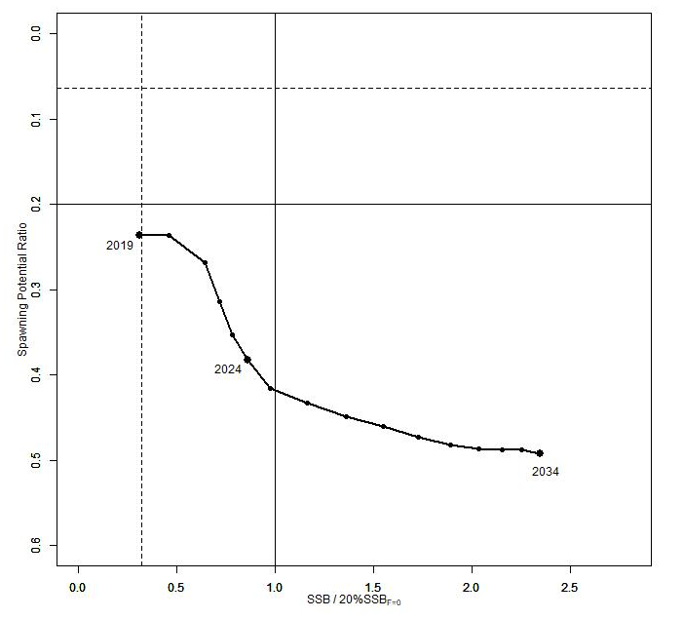
Figure PBF-6. “Future Kobe Plot” of projection results for Pacific bluefin tuna (Thunnus orientalis) from Scenario 1 from Table PBF3.

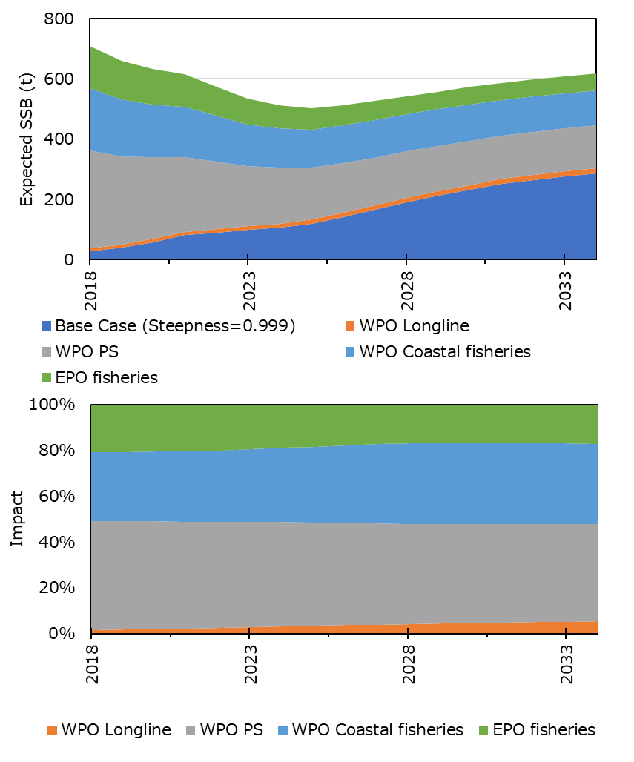
Figure PBF-7. “Future impact plot” from projection results for Pacific bluefin tuna (Thunnus orientalis) from Scenario 1 of Table S-3. The impact is calculated based on the expected increase of SSB in the absence of the respective group of fisheries.

SC15 2019 (FISHERY INDICATORS UPDATED)

  - Stock Status and trends

- SC15 noted that no stock assessment was conducted for Pacific bluefin tuna in 2019. Therefore, the stock status description from SC14 is still current. For further information on the stock status and trends from SC14, please see https://www.wcpfc.int/node/32155

- SC15 noted that the total Pacific bluefin tuna catch by ISC members in 2018 was 10,148 mt, a 31% decrease from 2017 and a 25% decrease from the 2013-2017 average. Pacific bluefin tuna is caught by various fishing gears including purse seine, longline, set net, troll, pole-and-line, handline and recreational fisheries. The detailed catch information by fishery is available in the ISC19 Plenary Report (SC15-GN-IP-02).

  - Management advice and implications

- SC15 advises the Commission to note the current very low level of spawning biomass (3.3% B₀), the current level of overfishing, and that the projections are strongly influenced by the inclusion of a relatively high but uncertain recruitment in 2016. While noting that additional positive signs of Pacific bluefin tuna stock were observed after the last assessment, and while noting that the agreed Harvest Control Rule could allow for catch limit increases, some of CCMs recommended a precautionary approach to the management of Pacific bluefin tuna until the rebuilding of the stock to higher biomass levels is achieved.

- One CCM recommended that ISC consider a grid approach for taking into account the structural uncertainty for the provision of stock status and management advice.

- SC15 also noted the following management advice of ISC19:

“The following requests were made to ISC by the IATTC-WCPFC NC Joint Working Group meeting in September 2018 at NC14 (see Attachment E of NC14 Summary Report (https://www.wcpfc.int/node/31946)). Responses from ISC PBFWG are provided below the requests.

Request 1: review the updated abundance indices, including recruitment index, up to 2017 to evaluate the need to change its scientific advice in 2018.

Response from ISC
The WG noted that some positive signs for the PBF stock were observed after the last assessment. In the 2018 assessment, the projections were considered optimistic because they were influenced by a high but uncertain recruitment in the terminal year (2016). The WG notes that the Japanese troll recruitment index value estimated for 2017 is similar to its historical average (1980-2017), that Japanese recruitment monitoring indices in 2017 and 2018 are higher than the 2016 value and that there is anecdotal evidence that larger fish are becoming more abundant in the EPO, although this information needs to be confirmed for the next stock assessment expected in 2020.

After reviewing the updated CPUE indices as well as the Japanese recruitment monitoring results, the PBFWG recommends maintaining the conservation advice from ISC18 (in 2018) that the projection mimicking the current management measures under the low recruitment scenario resulted in an estimated 98% probability of achieving the initial rebuilding target (6.7%SSB_{F=0}) by 2024 and that of achieving the second rebuilding target (20%SSB_{F=0}) 10 years after the achievement of the initial rebuilding target or by 2034, whichever is earlier, is 96%.

In the projections reported here, the projected future SSBs are the medians of the 6,000 individual SSB calculated for each 300 bootstrap replicates (i.e. catch, CPUE and size) to capture the uncertainty of parameter estimations followed by 20 stochastic simulations based on the different future recruitment time series. The projection assumes that each harvesting scenario is fully implemented and is based on certain biological or other assumptions of base case assessment model. If conditions change, the projection results would be more uncertain.

Request 2: Conduct projections of harvest scenarios shown below based on 2018 assessment and provide probability of achieving initial and 2nd rebuilding targets in accordance with paragraph 2.1 of HS2017-02.

Scenarios for catch increase
West Pacific |  | East Pacific
Small fish | Large fish
0 | 600t | 400t
5% | 1300t | 700t
10% | 1300t | 700t
5% | 1000t | 500t
0 | 1650t | 660t
5% |  | 5%
10% |  | 10%
15% |  | 15%
* 250t transfer of catch limit from small fish to large fish by Japan is assumed to continue until 2020.

Response from ISC
PBFWG conducted projections in the same manner as in the 2018 assessment. The recruitment scenario followed paragraph 2.1 of WCPFC Harvest Strategy 2017-02; and was kept at a low level (re-sampling from 1980-1989) until the initial rebuilding target is achieved and then changed to the historical average level.

The projection results are shown in Table PBF-02 and Figure PBF-01. The results show that increasing the catch limit of small PBF (<30 kg) in the WPO has the largest impact on the probability of achieving the interim and 2nd rebuilding targets. In addition, an overall increase in catch from the current limits, particularly a 15% increase, has the largest impact on achieving rebuilding targets.

Table PBF-01. Future projection scenarios for Pacific bluefin tuna (Thunnus orientalis).

Table PBF-02. Probability of achieving targets under projection scenarios for Pacific bluefin tuna. Future projection scenarios for Pacific bluefin tuna and their probability of achieving various target levels by various time schedules based on the 2018 base-case model.

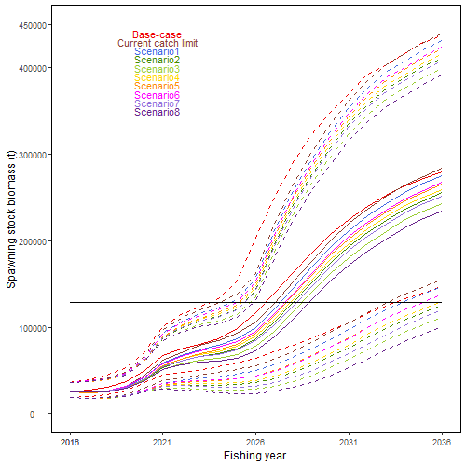
Figure PBF-01. Time series of the projected spawning stock biomass by various harvest scenarios listed on the Table PBF-01. Each colored solid and broken lines indicate the median spawning stock biomass and its 95% confidence intervals, respectively. The black dotted and solid lines are corresponded to the spawning stock biomasses of the initial and second rebuilding targets of Pacific bluefin tuna, respectively.

SC14 2018 (STOCK ASSESSMENT CONDUCTED)

Stock status and trends

- SC14 noted that ISC provided the following conclusions on the stock status of Pacific bluefin tuna:

The base-case model results show that: (1) SSB fluctuated throughout the assessment period, (2) SSB steadily declined from 1996 to 2010; and (3) the slow increase of the stock continues since 2011 including the most recent two years (2015-2016). Based on the model diagnostics, the estimated biomass trend for the last 30 years is considered robust although SSB prior to the 1980s is uncertain due to data limitations. Using the base-case model, the 2016 SSB (terminal year) was estimated to be around 21,000 t in the 2018 assessment, which is an increase from 19,000 t in 2014 (Table PBF-1 and Figure PBF-11).

Historical recruitment estimates have fluctuated since 1952 without an apparent trend. The low recruitment levels estimated in 2010-2014 were a concern in the 2016 assessment. The 2015 recruitment estimate is lower than the historical average while the 2016 recruitment estimate (15.988 million fish) is higher than the historical average (13.402 million fish) (Figure PBF-4, Table PBF-1-1). The uncertainty of the 2016 recruitment estimate is higher than in previous years because it occurs in the terminal year of the assessment and is mainly informed by one observation from the troll age-0 CPUE index. The troll CPUE series has been shown to be a good predictor of recruitment, with no apparent retrospective error in the recruitment estimates of the terminal year given the current model construction. As the 2016 recruits grow and are observed by other fleets, the magnitude of this year class will be more precisely estimated in the next stock assessment. The above average recruitment estimated in 2016 had a positive impact on the projection results.

Estimated age-specific fishing mortalities (F) on the stock during the periods 2012-2014 and 2015-2016 compared with 2002-2004 estimates (the base period for the WCPFC Conservation and Management Measure) are presented in Figure PBF-2. A substantial decrease in estimated F is observed in ages 0-2 in 2015-2016 from the previous years. Note that stricter management measures in the WCPFC and IATTC have been in place since 2015.

The WCPFC adopted an initial rebuilding biomass target (the median SSB estimated for the period 1952 through 2014) and a second rebuilding biomass target (20%SSB_{F=0} under average recruitment), without specifying a fishing mortality reference level. The 2018 assessment estimated the initial rebuilding biomass target to be 6.7%SSB_{F=0} and the corresponding fishing mortality expressed as SPR of F_{6.7%SPR} (Table PBF-2). SPR is the ratio of the cumulative spawning biomass that an average recruit is expected to produce over its lifetime when the stock is fished at the current intensity to the cumulative spawning biomass that could be produced by an average recruit over its lifetime if the stock was unfished. Because the projections include catch limits, fishing mortality is expected to decline, i.e., F_{x%SPR} will increase, as biomass increases. The Kobe plot shows that the point estimate of the SSB₂₀₁₆ was 3.3%SSB_{F=0} and the 2016 fishing mortality corresponds to F_{6.7%SPR} (Figure PBF-3).

Table PBF-3 provides an evaluation of stock status against some common reference points. It shows that the PBF stock is overfished relative to biomass-based limit reference points adopted for other species in WCPFC (20%SSB_{F=0}) and is subject to overfishing relative to most of the common fishing intensity-based reference points.

Figure PBF-4 depicts the historical impacts of the fleets on the PBF stock, showing the estimated biomass when fishing mortality from respective fleets is zero. Historically, the WPO coastal fisheries group has had the greatest impact on the PBF stock, but since about the early 1990s the WPO purse seine fleets, in particular those targeting small fish (ages 0-1), have had a greater impact, and the effect of these fleets in 2016 was greater than any of the other fishery groups. The impact of the EPO fishery was large before the mid-1980s, decreasing significantly thereafter. The WPO longline fleet has had a limited effect on the stock throughout the analysis period, because the impact of a fishery on a stock depends on both the number and size of the fish caught by each fleet; i.e., catching a high number of smaller juvenile fish can have a greater impact on future spawning stock biomass than catching the same weight of larger mature fish.

- SC14 noted the following stock status from ISC:

Based on these findings, the following information on the status of the Pacific bluefin tuna stock is provided:
- No biomass-based limit or target reference points have been adopted to evaluate the overfished status for PBF. However, the PBF stock is overfished relative to the potential biomass-based reference points evaluated (SSB_{MED} and 20%SSB_{F=0}, Table PBF-3 and Figure PBF-3).
- No fishing intensity-based limit or target reference points have been adopted to evaluate overfishing for PBF. However, the PBF stock is subject to overfishing relative to most of potential fishing intensity-based reference points evaluated (Table PBF-3 and Figure PBF-3).

- SC14 noted that the total PBF catch in 2017 was 14,707 mt, 11% increase from 2016 and 9% increase from the average 2012-2016. PBF is caught by various fishing gears including purse seine, longline, set net, troll, pole-and-line, handline and recreational fisheries. The detailed catch information by fishery is available in ISC 2018 stock assessment (SC14-SA-WP-06).
b. Management advice and implications

- SC14 advises the Commission to note the current very low level of spawning biomass (3.3% B₀), the current level of overfishing, and that the projections are strongly influenced by the inclusion of a relatively high but uncertain recruitment in 2016. The majority of CCMs recommended a precautionary approach to the management of Pacific Bluefin tuna, especially in relation to the timing of increasing catch levels, until the rebuilding of the stock to higher biomass levels is achieved.

- SC14 noted the following conservation advice from ISC:

After the steady decline in SSB from 1995 to the historical low level in 2010, the PBF stock appears to have started recovering slowly. The 2016 stock biomass is below the two biomass rebuilding targets adopted by the WCPFC while the 2015-2016 fishing intensity (spawning potential ratio) is at a level corresponding to the initial rebuilding target.

The 2018 base case assessment results are consistent with the 2016 model results. However, the 2018 projection results are more optimistic than the 2016 projections, mainly due to the inclusion of the relatively good recruitment in 2016, which is above the historical average level (119%) and twice as high as the median of the low recruitment scenario (which occurred 1980-1989).

Based on these results, the following conservation information is provided:
          - The projection based on the base-case model mimicking the current management measures by the WCPFC (CMM 2017-08) and IATTC (C-16-08) under the low recruitment scenario resulted in an estimated 98% probability of achieving the initial biomass rebuilding target (6.7%SSBF=0) by 2024. This estimated probability is above the threshold (75% or above in 2024) prescribed by the WCPFC Harvest Strategy (Harvest Strategy 2017-02) (scenario 0 of Table PBF-4; see also Figure PBF-5 and Figure PBF-6). The low recruitment scenario is more precautionary than the recent 10 years recruitment scenario.
          - The Harvest Strategy specifies that recruitment switches from the low recruitment scenario to the average recruitment scenario beginning in the year after achieving the initial rebuilding target. The estimated probability of achieving the second biomass rebuilding target (20%SSBF=0) 10 years after the achievement of the initial rebuilding target or by 2034, whichever is earlier, is 96% (scenario 1 of Table PBF-3, Table PBF-4, and Table PBF-5; Figure PBF-5 and Figure PBF-6). This estimate is above the threshold (60% or above in 2034) prescribed by the WCPFC Harvest Strategy. However, it should be recognized that these projection results are strongly influenced by the inclusion of the relatively high, but uncertain recruitment estimate for 2016.

The Harvest Strategy adopted by WCPFC (Harvest Strategy 2017-02) guided projections conducted by ISC to provide catch reduction options if the projection results indicate that the initial rebuilding target will not be achieved or to provide relevant information for potential increase in catch if the probability of achieving the initial rebuilding target exceeds 75%. The projection results showed that the probability of achieving the initial rebuilding target was above the level (75% or above in 2024) prescribed in the WCPFC Harvest Strategy. Accordingly, the ISC examined some optional scenarios with higher catch limits, which can be found in Appendix 1 of the PBF 2018 stock assessment report (SC14-SA-WP-06).

Research needs

Given the low SSB, the uncertainty in future recruitment, and the influence of recruitment on stock biomass, monitoring of recruitment and SSB should be strengthened so that the recruitment trends can be understood in a timely manner.

Table PBF-1. Total biomass, spawning stock biomass and recruitment of Pacific bluefin tuna (Thunnus orientalis) estimated by the base-case model, where coefficient of variation (CV) measures relative variability defined as the ratio of the standard deviation to the mean.
Table PBF-2. Spawning stock biomass and fishing intensity of Pacific bluefin tuna (Thunnus orientalis) in 1995 (recent high biomass), 2002-2004 (WCPFC reference year biomass), 2011 (biomass 5 years ago), and 2016 (latest) to those of the adopted WCPFC biomass rebuilding targets. SPR is used as a measure of fishing intensity; the lower the number the higher the fishing intensity that year.
 | Initial rebuilding target | Second rebuilding target | 1995  (recent high) | 2002-2004 (reference year) | 2011  (5 years ago) | 2016  (latest)
Biomass (%SSBF=0) | SSB median1952-2014 = 6.7% | 20% | 10.4% | 7.1% | 2.1% | 3.3%
SPR | 6.7% | 20% | 5.1% | 3.4% | 4.9% | 6.7%

Table PBF-3. Ratios of the estimated fishing intensities mortalities (Fs and 1-SPRs for 2002-04, 2012-14, 2015-16) relative to potential fishing intensity-based reference points, and terminal year SSB (t) for each reference period, and depletion ratios for the terminal year of the reference period for Pacific bluefin tuna (Thunnus orientalis).

Table PBF-4. Future projection scenarios for Pacific bluefin tuna (Thunnus orientalis).
*1 F indicates the geometric mean values of quarterly age-specific fishing mortality during 2002-2004.
*2 The Japanese unilateral measure (transferring 250 mt of catch upper limit from that for small PBF to that for large PBF during 2017-2020) would be reflected.
*3 Fishing mortality for the EPO commercial fishery was assumed to be high enough to fulfill its catch upper limit (F multiplied by two). The fishing mortality for the EPO recreational fishery was assumed to be the F2009-11 average level.
*4 In scenario 0, the future recruitments were assumed to be the low recruitment (1980-1989) level forever. In other scenarios, recruitment was switched from low recruitment to average recruitment from the next year of achieving the initial rebuilding target.

Table PBF-5. Future projection scenarios for Pacific bluefin tuna (Thunnus orientalis) and their probability of achieving various target levels by various time schedules based on the base-case model.
*1 In scenario 0, the future recruitments were assumed to be the low recruitment (1980-1989) level forever. In other scenarios, recruitment was switched from low recruitment to average recruitment from the next year of achieving the initial rebuilding target.
Table PBF-6. Expected yield for Pacific bluefin tuna (Thunnus orientalis) under various harvesting scenarios based on the base-case model.

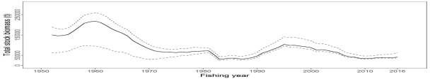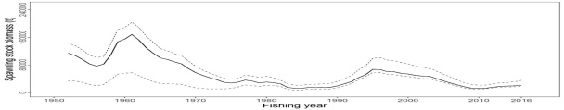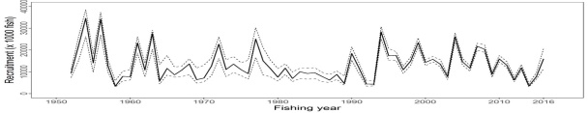 | 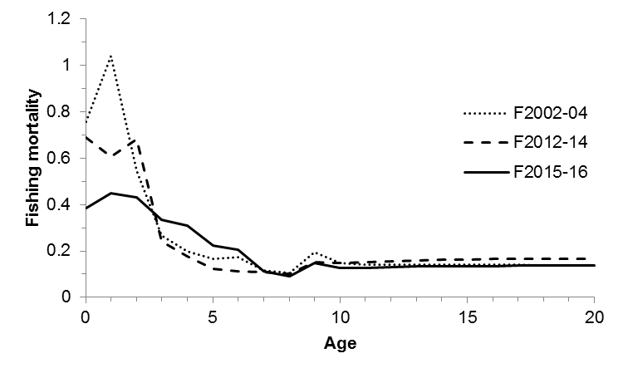
Figure PBF-1. Total stock biomass (top), spawning stock biomass (middle) and recruitment (bottom) of Pacific bluefin tuna (Thunnus orientalis) from the base-case model. The solid lines indicate point estimates and the dashed lines indicate the 90% confidence intervals. | Figure PBF-2. Geometric means of annual age-specific fishing mortalities of Pacific bluefin tuna (Thunnus orientalis) in 2002-2004 (dotted line), 2012-2014 (dashed line), and 2015-2016 (solid line).

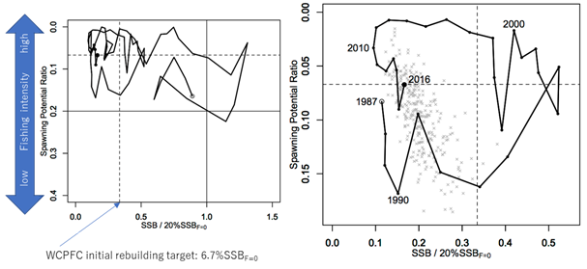  Figure PBF-3. Kobe plots for Pacific bluefin tuna (Thunnus orientalis). X axis shows the annual SSB relative to 20%SSB_{F=0} and the Y axis shows the spawning potential ratio as a measure of fishing intensity. Solid vertical and horizontal lines in the left figure show 20%SSB_{F=0} (which corresponds to the second biomass rebuilding target) and the corresponding fishing intensity, respectively. Dashed vertical and horizontal lines in both figures show the initial biomass rebuilding target (SSB_{MED} = 6.7%SSB_{F=0}) and the corresponding fishing intensity, respectively. SSB_{MED} is calculated as the median of estimated SSB over 1952-2014. The left figure shows the historical trajectory, where the open circle indicates the first year of the assessment (1952) while solid circles indicate the last five years of the assessment (2012-2016). The right figure shows the trajectory of the last 30 years, where grey dots indicate the uncertainty of the terminal year. | 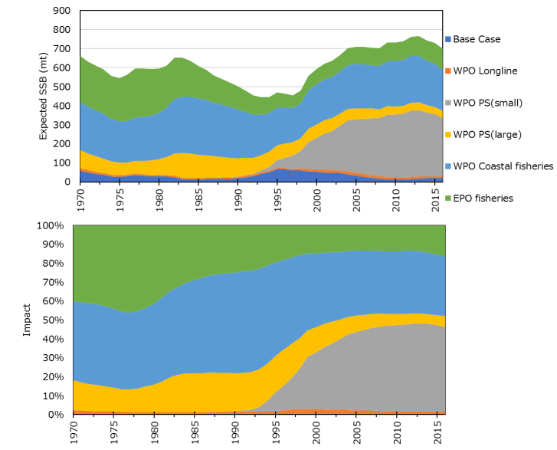
 | Figure PBF-4. Trajectory of the spawning stock biomass of a simulated population of Pacific bluefin tuna (Thunnus orientalis) when zero fishing mortality is assumed, estimated by the base-case model (top: absolute impact, bottom: relative impact). Fleet definition; WPO longline: F1, F12, F17. WPO purse seine for small fish: F2, F3, F18. WPO purse seine: F4, F5. WPO coastal fisheries: F6-11, F16, F19. EPO fisheries: F13, F14, F15.

 | 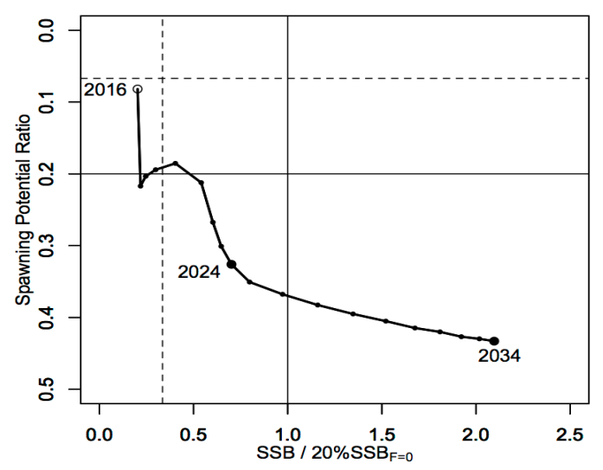
Figure PBF-5. Comparison of future SSB of Pacific bluefin tuna (Thunnus orientalis) under the current management measures assuming low recruitment using the 2016 assessment (scenario 2016 lowR), assuming low recruitment using the 2018 assessment (scenario 0), and assuming a shift of the recruitment scenario from low to average after achieving the initial rebuilding target using the 2018 assessment (scenario 1). | Figure PBF-6. A projection result (scenario 1 from Table PBF-4) for Pacific bluefin tuna (Thunnus orientalis) in a form of Kobe plot. The X axis shows the SSB value relative to 20%SSB_{F=0} (second rebuilding target) and the Y axis shows the spawning potential ratio as a measure of fishing intensity. Vertical and horizontal solid lines indicate the second rebuilding target (20%SSB_{F=0}) and the corresponding fishing intensity, respectively, while vertical and horizontal dashed lines indicate the initial rebuilding target (SSB_{MED} = 6.7%SSB_{F=0}) and the corresponding fishing intensity, respectively.

SC13 2017 (FISHERY INDICATORS UPDATED)

- Stock status and trends

- SC13 noted that no stock assessments were conducted for Pacific bluefin tuna in 2017. Therefore, the stock status descriptions from SC12 are still current. For further information on the stock status and trends from SC12, please see https://www.wcpfc.int/node/27769

- Management advice and implications

- SC13 noted that no management advice has been provided since SC12. Therefore, the advice from SC12 should be maintained, pending a new assessment or other new information. For further information on the management advice and implications from SC12, please see https://www.wcpfc.int/node/27769

References

SC18-SA-WP-05 Stock assessment of Pacific bluefin tuna in the Pacific Ocean

SC16-SA-WP-06 Stock Assessment of Pacific Bluefin Tuna in the Pacific Ocean in 2020 https://www.wcpfc.int/node/46614

For current information related to Northern Stocks Working Group Reports and the ISC Plenary Report:
http://isc.fra.go.jp/reports/isc/isc20_reports.html

SC15-SA-IP-20 Report of the Pacific Bluefin Tuna Working Group Intersessional Workshop (ISC19 – ANNEX 08). https://www.wcpfc.int/node/43327

SC14-SA-WP-06 Stock Assessment of Pacific Bluefin Tuna (Thunnus orientalis) in the Pacific Ocean in 2018. https://www.wcpfc.int/node/31024

SC12-SA-WP-07 Pacific Bluefin Stock Assessment. https://www.wcpfc.int/node/27559

SC10-SA-WP-11 Stock Assessment of Bluefin Tuna in the Pacific Ocean in 2014. https://wcpfc.int/node/19201

SC9-SA-WP-10 Stock assessment of Pacific bluefin tuna in 2012 (Rev 1). https://wcpfc.int/node/4731

SPR (spawning potential ratio) is the ratio of the cumulative spawning biomass that an average recruit is expected to produce over its lifetime when the stock is fished at the current fishing level to the cumulative spawning biomass that could be produced by an average recruit over its lifetime if the stock was unfished. F%SPR: F that produces % of the spawning potential ratio (i.e., 1-%SPR).
SSB_{F=0} is the expected spawning stock biomass under average recruitment conditions without fishing.
SPR (spawning potential ratio) is the ratio of the cumulative spawning biomass that an averagerecruit is expected to produce over its lifetime when the stock is fished at the current fishing level to thecumulative spawning biomass that could be produced by an average recruit over its lifetime if the stock was unfished. F%SPR: F that produces % of the spawning potential ratio.
The IATTC has adopted the first rebuilding target, the second target is to be discussed at a future IATTC meeting.

