

The Commission for the Conservation and Management of
Highly Migratory Fish Stocks in the Western and Central Pacific Ocean

Scientific Committee

North Pacific Albacore Tuna (Thunnus alalunga)

Stock Status and Management Advice

Contents
SC19 2023 (STOCK ASSESSMENT CONDUCTED) 2
SC16 2020 (STOCK ASSESSMENT CONDUCTED) 10
SC15 2019 (FISHERY INDICATORS UPDATED) 16
SC14 2018 (FISHERY INDICATORS UPDATED) 16
SC13 2017 (STOCK ASSESSMENT CONDUCTED) 16
References 20

SC19 2023 (STOCK ASSESSMENT CONDUCTED)

Stock status and trends

- SC19 noted that the ISC provided the following conclusions on the stock status of North Pacific albacore:
- Estimated summary biomass (males and females at age-1+) declined at the beginning of the time series until 2004 (Figure NPALB-1A). Subsequently, the summary biomass fluctuated without a trend until 2018, after which the biomass rapidly increased to historically high levels. It should be noted that the high summary biomass estimates during 2018 – 2021 were highly uncertain and should be treated with caution (Figure NPALB-1A). These high summary biomass estimates were due to historically high recruitment estimates in 2017 (~433 million fish; 95% CI: 194 – 671 million fish) (Figure NPALB-1C). However, it should be noted that the recruitment estimates in the last 5 years (2017- 2021) were highly uncertain and should be treated with caution. Estimated female SSB exhibited a similar population trend to the summary biomass, albeit with a lag of several years, and showed an initial decline until 2007 followed by fluctuations without a clear trend through 2021 (Figure NPALB-1B).

- The average fishing intensity during 2018 – 2020 was estimated to be F59_{%SPR} (95% CI: F72_{%SPR} – F46_{%SPR}), which was relatively moderate and resulted in a population with an SPR of approximately 59%. Instantaneous fishing mortality at age (F-at-age) was similar in both sexes through age-5, peaking at age-4 and declining to a low at age-6, after which males experienced higher F-at-age than females up to age 12 (Figure NPALB-2). Juvenile albacore aged 2 to 4 years comprised approximately 64% of the annual catch-at-age in numbers between 1994 and 2021 (Figure NPALB-3) due to the larger fishery impact of surface fisheries (primarily troll, pole-and-line), which remove juvenile fish, relative to longline fisheries, which primarily remove adult fish (Figure NPALB-4).

- Stock status is depicted in relation to the target (F45_{%SPR},), threshold (30%SSB_{current, F=0}), and limit (14%SSB_{current, F=0}) reference points (Figure NPALB-5A; Table NPALB-1). The estimated female SSB has never fallen below the threshold and limit reference points since 1994, albeit with large uncertainty in the terminal year (2021) estimates. However, the estimated fishing intensity for five years (1999, 2002, 2003, 2004, and 2007) have exceeded the target reference point. Even when alternative hypotheses about key model uncertainties such as growth were evaluated, the point estimate of female SSB in 2021 (SSB₂₀₂₁) did not fall below the threshold and limit reference points, although the risk increases with this more extreme assumption (Figure NPALB-5B). However, estimated average fishing intensity during 2018-2020 (F₂₀₁₈₋₂₀₂₀) did exceed the target reference point under one of these alternative hypotheses but did not exceed the average fishing intensity during 2002 – 2004 (Figure NPALB-5B; Table NPALB-1).

- The SSB₂₀₂₁ was estimated to be approximately 54% (95% CI: 40 – 68%) of SSB_{current, F=0} and 1.8 (95% CI: 1.3 – 2.3) times greater than the estimated threshold reference point (Figure NPALB-6A and Table NPALB-1). The estimated current fishing intensity (F₂₀₁₈₋₂₀₂₀) was estimated to be F59_{%SPR} (95% CI: F72_{%SPR} – F46_{%SPR}) and was lower than both the F45_{%SPR} target reference point and the average fishing intensity during 2002 – 2004 (Figure NPALB-6B and Table NPALB-1).

- SC19 noted the following stock status from ISC:
- The stock is likely not overfished relative to the threshold (30%SSB_{current, F=0}) and limit (14%SSB_{current, F=0}) reference points adopted by the WCPFC and IATTC, and

- The stock is likely not experiencing overfishing relative to the adopted target reference point (F45_{%SPR}).

- Current fishing intensity (F2018-2020) is lower than the fishing intensity from the 2002-2004 period (the reference level for IATTC Resolution C-05-02 and WCPFC CMM 2019-03).

Management advice and implications

- SC19 noted the following conservation information from the ISC:
- Two harvest scenarios were projected to evaluate impacts on the management objectives of IATTC and WCPFC for this stock: 1) maintain SSB above the limit reference point, with a probability of at least 80% over the next 10 years; 2) maintain depletion of total biomass around historical (2006—2015) average depletion over the next 10 years; and 3) maintain fishing intensity at or below the target reference point with a probability of at least 50% over the next 10 years (WCPFC HS 2022-01; IATTC Resolution C-22-04).

- The constant fishing intensity scenario showed that the current fishing intensity (F₂₀₁₈₋₂₀₂₀) is expected to result in female SSB increasing to 90,098 t (95% CI: 23,218—156,978t) and an SSB/SSB_{current,F=0} ratio of 0.54 by 2031. Over the next 10 years, there was: 1) a 97.7% probability of the female SSB remaining above the 14%SSB_{current, F=0} LRP for all 10 years; 2) a 72.0% probability of the total biomass (age-1+) being above the average of 2006 – 2015 for any year; and 3) a 95.5% probability of the fishing intensity remaining at or below the F45_{%SPR} TRP for any year (Figure NPALB-7).

- The randomly resampled fishing intensity scenario showed that if future fishing intensity is similar to the 2005 – 2019 period, it is expected to result in female SSB increasing to 87,669 t (95% CI: 22,219 – 153,119 t) and a SSB/SSB_{current, F=0} ratio of 0.52 by 2031. Over the next 10 years, there was: 1) a 98.1 % probability of the female SSB remaining above the 14%SSB_{current, F=0} LRP for all 10 years; 2) a 69.5 % probability of the total biomass (age-1+) being above the average of 2006 – 2015 for any year; and 3) a 79.6 % probability of the fishing intensity remaining at or below the F45_{%SPR} TRP for any year (Figure NPALB-8).

- Based on these findings, the following conservation information was provided by ISC:
- If fishing intensity over the next ten years is maintained at the current fishing intensity (F₂₀₁₈₋₂₀₂₀), then female SSB is expected to remain around 54%SSB_{current, F=0} (90,098 t), with a 97.7% probability of the female SSB remaining above the 14% SSB_{current, F=0} LRP for all ten years, and the management objectives of IATTC and WCPFC will likely be met.

- If fishing intensity over the next ten years is similar to the 2005-2019 period, then female SSB is expected to decrease to 52%SSBc_{urrent, F=0} (87,669 t), with a 98.1% probability of the female SSB remaining above the 14% SSB_{current, F=0} LRP for all ten years, and the management objectives of IATTC and WCPFC will likely be met.

Table NPALB-1. Estimates of maximum sustainable yield (MSY), female spawning stock biomass (SSB), fishing intensity (F), and reference point ratios for north Pacific albacore tuna for: 1) the base case model; 2) two important sensitivity models due to uncertainty in growth parameters; and 3) a model representing an update of the 2020 base case model to 2023 data. SSB0, SSB_{current}, _{F=0} and SSB_{MSY} are the expected female SSB of a population in the equilibrium, unfished state; in the current, dynamic, unfished state; and at MSY, respectively. The Fs in this table are indicators of fishing intensity based on spawning potential ratio (SPR) and calculated as %SPR. SPR is the ratio of the equilibrium SSB per recruit that would result from the estimated F-at-age relative to that of an unfished population. Depletion is calculated as the proportion of the age-1+ biomass during the specified period relative to an unfished age-1+ equilibrium biomass. The model representing an update of the 2020 base case model is similar to but not identical to the 2020 base case model due to changes in data preparation and model structure.
* Model may not have converged and uncertainty estimates were unreliable because of the lack of a positive, definite Hessian matrix.
† A value of >1 for the depletion ratio indicates higher age-1+ biomass in 2021 relative to the 2006 –2015 period.
§ Higher %SPR values indicate lower fishing intensity levels.
¶ Values of >1 for ratios of F_{%SPR} to F_{%SPR}-based reference points indicate fishing intensity levels lower than the reference points.

Quantity | Base Case | Growth  CV = 0.06 for L_{inf} | Growth  All parameters estimated | Update of 2020 base case model to 2023 data*
MSY (t) | 121,880 | 93,167 | 144,792 | 97,777
SSB_{MSY} (t) | 23,154 | 18,133 | 30,435 | 18,756
SSB₀ (t) | 165,567 | 128,155 | 198,913 | 132,570
SSB_{current, F=0} (2021 estimate) | 129,581 | 97,368 | 155,542 | 93,808
SSB₂₀₂₁/SSB_{current, F=0} | 0.54 | 0.36 | 0.65 | 0.39
SSB₂₀₂₁/30%SSB_{current, F=0} | 1.81 | 1.21 | 2.17 | 1.31
SSB₂₀₂₁/14%SSB_{current, F=0} | 3.87 | 2.6 | 4.65 | 2.81
†Depletion₂₀₂₁/Depletion₂₀₀₆₋₂₀₁₅ | 1.34 | 1.33 | 1.37 | 1.3
§ F_{%SPR, 2018-2020} (%SPR) | 59.0 | 41.4 | 70.4 | 43.2
§ F_{%SPR, 2011-2020} (%SPR) | 55.0 | 36.6 | 63.8 | 37.9
¶ F_{%SPR, 2018-2020}/F_{%SPR, MSY} | 2.04 | 1.42 | 2.78 | 1.47
¶ F_{%SPR, 2011-2020}/F45_{%SPR} | 1.22 | 0.81 | 1.42 | 0.84
¶ F_{%SPR, 2018-2020}/F45_{%SPR} | 1.31 | 0.92 | 1.56 | 0.96
¶ F_{%SPR, 2018-2020}/F_{%SPR, 2002-2004} | 1.48 | 1.63 | 1.40 | 1.25

Figure NPALB-1. Maximum likelihood estimates of (A) age-1+ biomass (B), female spawning biomass (SSB), and (C) age-0 recruitment of north Pacific albacore tuna (Thunnus alalunga). Dashed lines (A and B) and vertical bars (C) indicate 95% confidence intervals. Closed black circle and error bars in (B) and (C) are the maximum likelihood estimate and 95% confidence intervals of unfished female spawning biomass, SSB0, and unfished recruitment, respectively, at equilibrium (Figure ES3 from SC19-SA-WP-08).

Figure NPALB-2. Estimated sex-specific instantaneous fishing mortality-at-age (F-at-age) for the 2023 base case model, averaged across 2018-2020 (Figure ES4 from SC19-SA-WP-08).

Figure NPALB-3. Historical catch-at-age of north Pacific albacore (Thunnus alalunga) estimated by the 2023 base case model (Figure ES5 from SC19-SA-WP-08).

Figure NPALB-4. Fishery impact analysis on north Pacific albacore (Thunnus alalunga) showing female spawning biomass (SSB) (red) estimated by the 2023 base case model as a percentage of dynamic, unfished female SSB (SSB_{current, F=0}). Colored areas show the relative proportion of fishing impact attributed to longline (green) and surface (blue) fisheries (primarily troll and pole-and-line gear but including all other gears except longline) (Figure ES6 from SC19-SA-WP-08).

Figure NPALB-5. Stock status phase plot showing the status of the north Pacific albacore (Thunnus alalunga) stock relative to the biomass-based threshold (30%SSB_{current, F=0}) and limit (14%SSB_{current, F=0}) reference points, and fishing intensity-based target reference point (F45_{%SPR}) over the modeling period (1994 – 2021). Blue triangle indicates the start year (1994) and black circle with 95% confidence intervals indicates the terminal year (2021). (B) Stock status plot showing current stock status and 95% confidence intervals of the base case model (black circle), an important sensitivity run of CV = 0.06 for Linf in the growth model (gray square), an important sensitivity run with an estimated growth model (purple triangle), and a model representing an update of the 2020 base case model to 2023 data (red diamond). 95% confidence intervals are not shown for the update of the 2020 base case model (red diamond) because the model did not have a positive definite Hessian matrix and uncertainty estimates were unreliable. Red zones in both panels indicate female SSBs falling below the limit reference point while the orange zones indicate female SSBs between the threshold and limit reference points. Green zones indicate female SSBs above the threshold reference point and fishing intensity levels below the target reference point. Yellow areas indicate female SSBs above the threshold reference point and fishing intensity levels above the target reference point. The Fs in this figure are indicators of fishing intensity based on spawning potential ratio (SPR) and calculated as %SPR. SPR is the ratio of the equilibrium SSB per recruit that would result from the estimated F-at-age relative to that of an unfished population. A higher %SPR indicates lower fishing intensity. Current fishing intensity values and SSB/SSB_{current,F=0} ratios in (B) were calculated as the average during 2018- 2020 (F_{%SPR}, 2018-2020) and 2021 (SSB2021/SSB_{current, F=0}), respectively. The model representing an update of the 2020 base case model is similar to but not identical to the 2020 base case model due to changes in data preparation and model structure (Figure ES7 from SC19-SA-WP-08).

Figure NPALB-6. (A) Estimated dynamic biomass ratio (SSB/SSB_{current, F=0}) of north Pacific albacore relative to biomass-based threshold (30%SSB_{current, F=0}) (orange dotted line) and limit (14%SSB_{current, F=0}) reference points (red dashed line) over the modeling period (1994 – 2021); and (B) estimated fishing intensity relative to the fishing intensity-based target reference point (F45_{%SPR}) over the modeling period (1994 – 2021). Light and dark gray areas indicate 95% and 60% confidence intervals respectively. The limit reference point is considered to be breached if the lower bound of the 60% confidence intervals overlaps the limit reference point (Figure ES8 from SC19-SA-WP-08).
Figure NPALB-7. Future projection results under a constant fishing intensity (F₂₀₁₈₋₂₀₂₀) harvest scenario. Solid lines indicate mean values, uncertainty ranges indicate 60% and 95% confidence intervals, and the dashed line is the reference point, respectively. (A) Annual changes in spawning biomass; (B) Interannual changes in fishing mortality (F_{%SPR}); (C) Projected ratios to the limit reference point thresholds; and (D) Projected ratios to management targets for the total biomass (Figure ES9 from SC19-SA-WP-08).

Figure NPALB-8. Future projection results under a randomly F (2005-2019) scenario. Solid lines indicate mean values, and uncertainty ranges indicate 60% and 95% confidence intervals, and the dashed line is the reference point, respectively. (A) Annual changes in spawning biomass; (B) Interannual changes in fishing mortality (F_{%SPR}); (C) Projected ratios to the limit reference point thresholds; and (D) Projected ratios to management targets for the total biomass (Figure ES10 from SC19-SA-WP-08).

SC16 2020 (STOCK ASSESSMENT CONDUCTED)

    - Review of the 2020 North Pacific albacore tock assessment

- S. Teo (USA)presented SC16-SA-WP-05 Stock Assessment of Albacore Tuna in the North Pacific Ocean in 2020, which detailed the data, biological parameters, model, model diagnostics and sensitivities, and results of the North Pacific albacore stock assessment conducted by ISC’s Albacore Working Group in 2020.

- All available fishery data for North Pacific albacore for the 1994-2018 period were used in the stock assessment. Catch and size composition data were compiled and assigned to 35 fisheries defined for this assessment (based on flag, gear, area, and season). The same abundance index as the 2017 assessment was fitted in the base case model. The North Pacific albacore stock was assessed using a length-based, age-, and sex-structured Stock Synthesis (SS Version 3.30.14.08) model over the 1994-2018 period and it was assumed that there is instantaneous mixing of albacore on a quarterly basis. Biological parameters like growth, natural morality (M) and stock-recruitment steepness, were the same as for the 2017 assessment. All fisheries were assumed to have dome-shaped length selectivity curves, and age-based selectivity for ages 1-5 were also estimated for surface fisheries (troll and pole-and-line) to address age-based changes in juvenile albacore availability and movement. Selectivity curves were also assumed to vary over time for several fleets.

- Maximum likelihood estimates of model parameters, derived outputs, and their uncertainties from the base case model were used to characterize stock status. Based on model diagnostics, the ALBWG concluded that the base case model was able to estimate the stock production function and the effect of fishing on the abundance of the north Pacific albacore stock. Due to the moderate exploitation levels relative to stock productivity, the production function was weakly informative about north Pacific albacore stock size, resulting in asymmetric uncertainty in the stock’s absolute scale, with more uncertainty in the upper limit of the stock than the lower limit. It is important to note that the primary aim of estimating the female SSB in this assessment was to determine whether the estimated SSB was lower than the limit reference point (i.e., determine whether the stock is in an overfished condition). Since the lower bound is better defined, it adds confidence to the evaluation of stock condition relative to the limit reference point.Several sensitivity analyses were conducted to evaluate model performance or the range of uncertainty resulting from changes in model parameters, including natural mortality, stock-recruitment steepness, growth, starting year, selectivity patterns, and weighting of size composition data.

    - Stock status and trends

- SC16 noted that the ISC provided the following conclusions on the stock status of North Pacific albacore:

The Northern Committee (NC) of the Western and Central Pacific Fisheries Commission (WCPFC), which manages this stock together with the Inter American Tropical Tuna Commission (IATTC), adopted a biomass-based limit reference point (LRP) in 2014 (https://www.wcpfc.int/harvest-strategy) of 20% of the current spawning stock biomass when F=0 (20%SSB_{current, F=0}). The 20%SSB_{current, F=0} LRP is based on dynamic biomass and fluctuates depending on changes in recruitment. For north Pacific albacore tuna, this LRP is calculated as 20% of the unfished dynamic female spawning biomass in the terminal year of this assessment (i.e., 2018) (https://www.wcpfc.int/meetings/nc13). However, neither the IATTC nor the WCFPC have adopted F-based limit reference points for the north Pacific albacore stock.

Stock status is depicted in relation to the limit reference point (LRP; 20%SSB_{current, F=0}) for the stock and the equivalent fishing intensity (F_{20%}; calculated as 1-SPR_{20%}) (Figure NPALB-1). Fishing intensity (F, calculated as 1-SPR) is a measure of fishing mortality expressed as the decline in the proportion of the spawning biomass produced by each recruit relative to the unfished state. For example, a fishing intensity of 0.8 will result in a SSB of approximately 20% of SSB₀ over the long run. Fishing intensity is considered a proxy of fishing mortality.

The Kobe plot shows that the estimated female SSB has never fallen below the LRP since 1994, albeit with large uncertainty in the terminal year (2018) estimates. Even when alternative hypotheses about key model uncertainties such as growth were evaluated, the point estimate of female SSB in 2018 (SSB₂₀₁₈) did not fall below the LRP, although the risk increases with this more extreme assumption (Figure NPALB-1). The SSB₂₀₁₈ was estimated to be 58,858 t (95% CI: 27,751 – 89,966 t) and 2.30 (95% CI: 1.49 – 3.11) times greater than the estimated LRP threshold of 25,573 t (95% CI: 19,150 – 31,997 t) (Table NPALB-1). Current fishing intensity, F₂₀₁₅₋₂₀₁₇ (0.50; 95% CI: 0.36 – 0.64; calculated as 1- SPR₂₀₁₅₋₂₀₁₇) , was at or lower than all seven potential F-based reference points identified for the north Pacific albacore stock (Table NPALB-1).

- SC16 noted the following stock status from ISC:

Based on these findings, the following information on the status of the north Pacific albacore stock is provided:

- The stock is likely not overfished relative to the limit reference point adopted by the Western and Central Pacific Fisheries Commission (20%SSB_{current, F=0}), and

- No F-based reference points have been adopted to evaluate overfishing. Stock status was evaluated against seven potential reference points. Current fishing intensity (F₂₀₁₅₋₂₀₁₇) is likely at or below all seven potential reference points (see ratios in Table NPALB-1).

- Management advice and implications

- SC16 noted the following conservation information from ISC:

Two harvest scenarios were projected to evaluate impacts on future female SSB: F constant at the 2015-2017 rate over 10 years (F₂₀₁₅₋₂₀₁₇) and constant catch (average of 2013-2017 = 69,354 t) over 10 years. Median female SSB is expected to increase to 62,873 t (95% CI: 45,123 - 80,622 t) by 2028, with a low probability of being below the LRP by 2028, if fishing intensity remains at the 2015-2017 level (Figure NPALB-2). If future catch is held constant at 69,354 t, the female SSB is expected to increase to 66,313 t (95% CI: 33,463 - 99,164 t) by 2028 and the probability that female SSB will be below the LRP by 2028 is slightly higher than the constant F scenario (Figure NPALB-3). Although the projections appear to underestimate the future uncertainty in female SSB trends, the probability of breaching the LRP in the future is likely small if the future fishing intensity is around current levels.

Based on these findings, the following information is provided:

- If a constant fishing intensity (F₂₀₁₅₋₂₀₁₇) is applied to the stock, then median female spawning biomass is expected to increase to 62,873 t and there will be a low probability of falling below the limit reference point established by the WCPFC by 2028.

- If a constant average catch (C₂₀₁₃₋₂₀₁₇ = 69,354 t) is removed from the stock in the future, then the median female spawning biomass is also expected to increase to 66,313 t and the probability that SSB falls below the LRP by 2028 will be slightly higher than the constant fishing intensity scenario.

Table NPALB-1. Estimates of maximum sustainable yield (MSY), female spawning biomass (SSB), and fishing intensity (F) based reference point ratios for north Pacific albacore tuna for: 1) the base case model; 2) an important sensitivity model due to uncertainty in growth parameters; and 3) a model representing an update of the 2017 base case model to 2020 data. SSB₀ and SSB_{MSY} are the unfished biomass of mature female fish and at MSY, respectively. The Fs in this table are indicators of fishing intensity based on SPR and calculated as 1-SPR so that the Fs reflect changes in fishing mortality. SPR is the equilibrium SSB per recruit that would result from the current year’s pattern and intensity of fishing mortality. Current fishing intensity is based on the average fishing intensity during 2015-2017 (F₂₀₁₅₋₂₀₁₇). 20%SSB_{current, F=0} is 20% of the current unfished dynamic female spawning biomass, where current refers to the terminal year of this assessment (i.e., 2018). The model representing an update of the 2017 base case model is highly similar to but not identical to the 2017 base case model due to changes in data preparation and model structure.
Quantity | Base Case | Growth  CV = 0.06 for L_{inf} | Update of 2017 base case model to 2020 data
MSY (t) ^{A} | 102,236 | 84,385 | 113,522
SSB_{MSY} (t)^{B} | 19,535 | 16,404 | 21,431
SSB₀ (t)^{B} | 136,833 | 113,331 | 152,301
SSB₂₀₁₈ (t) ^{B} | 58,858 | 34,872 | 77,077
SSB₂₀₁₈/20%SSB_{current, F=0} ^{B} | 2.30 | 1.63 | 2.63
F₂₀₁₅₋₂₀₁₇ | 0.50 | 0.64 | 0.43
F₂₀₁₅₋₂₀₁₇/F_{MSY} | 0.60 | 0.77 | 0.52
F₂₀₁₅₋₂₀₁₇/F_{0.1} | 0.57 | 0.75 | 0.49
F₂₀₁₅₋₂₀₁₇/F_{10%} | 0.55 | 0.71 | 0.48
F₂₀₁₅₋₂₀₁₇/F_{20%} | 0.62 | 0.80 | 0.54
F₂₀₁₅₋₂₀₁₇/F_{30%} | 0.71 | 0.91 | 0.62
F₂₀₁₅₋₂₀₁₇/F_{40%} | 0.83 | 1.06 | 0.72
F₂₀₁₅₋₂₀₁₇/F_{50%} | 1.00 | 1.27 | 0.86
A – MSY includes male and female juvenile and adult fish
B – Spawning stock biomass (SSB) in this assessment refers to mature female biomass only.

A | B
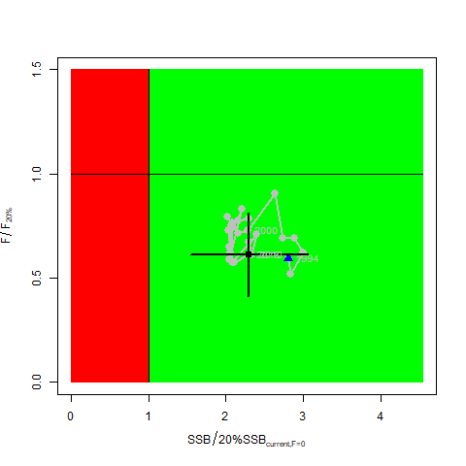 | 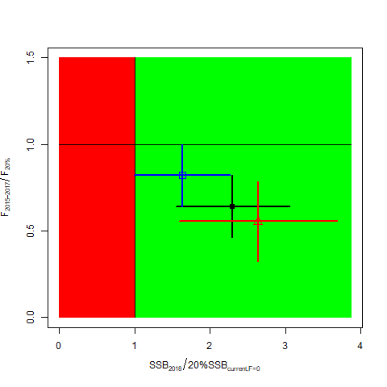
Figure NPALB-1. (A)Kobe plot showing the status of the north Pacific albacore (Thunnus alalunga) stock relative to the 20%SSB_{current, F=0} biomass-based limit reference point, and equivalent fishing intensity (F_{20%}; calculated as 1-SPR_{20%}) over the base case modeling period (1994-2018). Blue triangle indicates the start year (1994) and black circle with 95% confidence intervals indicates the terminal year (2018). (B) Kobe plot showing current stock status and 95% confidence intervals of the base case model (black; closed circle), an important sensitivity run of CV = 0.06 for L_{inf} in the growth model (blue; open square), and a model representing an update of the 2017 base case model to 2020 data (red; open triangle). The coefficients of variation of the SSB/20%SSB_{current, F=0} ratios are assumed to be the same as for the SSB/20%SSB₀ ratios. Fs in this figure is not based on instantaneous fishing mortality. Instead, the Fs are indicators of fishing intensity based on SPR and calculated as 1-SPR so that the Fs reflects changes in fishing mortality. SPR is the equilibrium SSB per recruit that would result from the current year’s pattern and intensity of fishing mortality. Current fishing intensity is calculated as the average fishing intensity during 2015-2017 (F₂₀₁₅₋₂₀₁₇), while current female spawning biomass refers to the terminal year of this assessment (i.e., 2018). The model representing an update of the 2017 base case model is highly similar to but not identical to the 2017 base case model due to changes in data preparation and model structure.

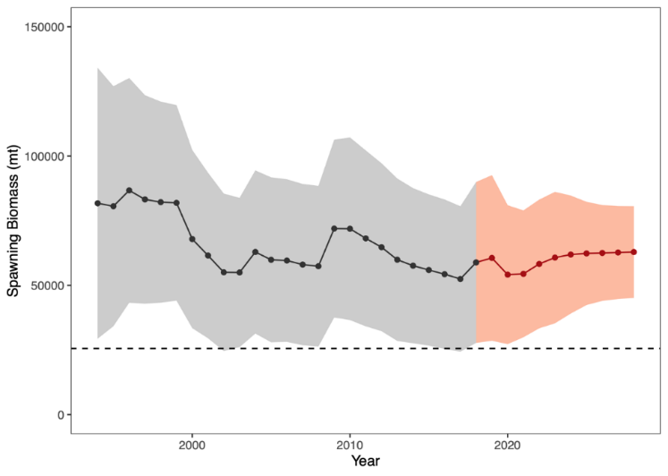
Figure NPALB-2. Historical and future trajectory of north Pacific albacore (Thunnus alalunga) female spawning biomass (SSB) under a constant fishing intensity (F₂₀₁₅₋₂₀₁₇) harvest scenario. Future recruitment is based on the expected recruitment variability. Black line and gray area indicates maximum likelihood estimates and 95% confidence intervals (CI), respectively, of historical female SSB, which includes parameter uncertainty. Red line and red area indicates mean value and 95% CI of projected female SSB, which only includes future recruitment variability and SSB uncertainty in the terminal year. Dashed black line indicates the 20%SSB_{current F=0} limit reference point for 2018 (25,573 t).

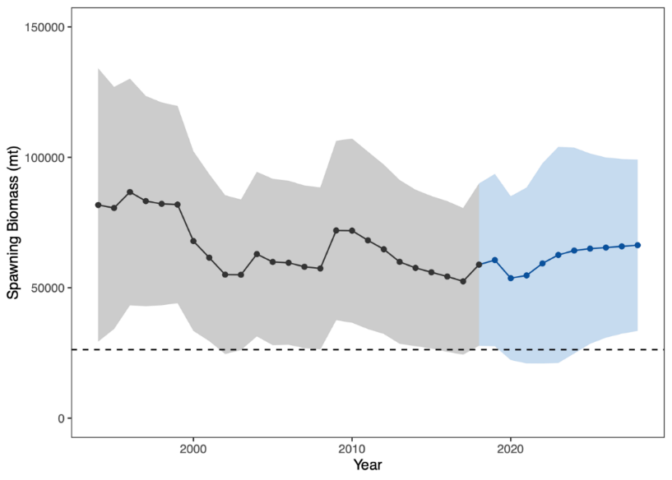
Figure NPALB-3. Historical and future trajectory of north Pacific albacore (Thunnus alalunga) female spawning biomass (SSB) under a constant catch (average 2013-2017 = 69,354 t) harvest scenario. Future recruitment is based on the expected recruitment variability. Black line and blue area indicates maximum likelihood estimates and 95% confidence intervals (CI), respectively, of historical female SSB, which includes parameter uncertainty. Blue line and blue area indicates mean value and 95% CI of projected female SSB, which only includes future recruitment variability and SSB uncertainty in the terminal year. Dashed black line indicates the 20%SSB_{current F=0} limit reference point for 2018 (25,573 t).

SC15 2019 (FISHERY INDICATORS UPDATED)

  - Stock status and trends

- SC15 noted that no stock assessments were conducted for North Pacific albacore in 2019. Therefore, the stock status descriptions from SC13 are still current for North Pacific albacore. For further information on the stock status and trends from SC13, please see https://www.wcpfc.int/node/29904. Updated information on catches was not compiled for and reviewed by SC15.

- SC15 noted that the provisional total NPALB catch by Canada, Japan, USA, Korea, Mexico and Chinese Taipei in 2018 was 49,300 mt, a 9% decrease from 2017 and a 24% decrease from the 2013-2017 average. The detailed catch information by fishery is available in ISC 2019 report (SC15-GN-IP-02). North Pacific albacore is caught by various fishing gears including longline, troll, and pole-and-line.

  - Management Advice and implications

- SC15 noted that no management advice has been provided since SC13 for North Pacific albacore. Therefore, the advice from SC13 should be maintained, pending a new assessment or other new information. For further information on the management advice and implications from SC13, please see https://www.wcpfc.int/node/29904

SC14 2018 (FISHERY INDICATORS UPDATED)

- Stock Status and trends

      - SC14 noted that no stock assessments were conducted for North Pacific albacore in 2018. Therefore, the stock status descriptions from SC13 are still current for North Pacific albacore. Updated information on catches was not compiled for and reviewed by SC14.

- Management advice and implications

      - SC14 noted that no management advice has been provided since SC13 for North Pacific albacore. Therefore, the advice from SC13 should be maintained, pending a new assessment or other new information. For further information on the management advice and implications from SC13, please see below.

SC13 2017 (STOCK ASSESSMENT CONDUCTED)

- ISC presented working paper SC13-SA-WP-09 Stock assessment of albacore tuna in the North Pacific Ocean in 2017.

- Stock status and trends

- SC13 noted that the ISC provided the following conclusions on the stock status of North Pacific albacore.

- Stock status is depicted in relation to the limit reference point (LRP; 20%SSBcurrent, F=0) for the stock and the equivalent fishing intensity (F20%; calculated as 1-SPR20%) (Fig. NPALB-1). Fishing intensity (F, calculated as 1-SPR) is a measure of fishing mortality expressed as the decline in the proportion of the spawning biomass produced by each recruit relative to the unfished state. For example, a fishing intensity of 0.8 will result in a SSB of approximately 20% of SSB0 over the long run. Fishing intensity is considered a proxy of fishing mortality.

- The Kobe plot shows that the estimated female SSB has never fallen below the LRP since 1993, albeit with large uncertainty in the terminal year (2015) estimates. Even when alternative hypotheses about key model uncertainties such as natural mortality and growth were evaluated, the point estimate of female SSB in 2015 (SSB2015) did not fall below the LRP, although the risk increases with these more extreme assumptions (Figure NPALB-1). The SSB2015 was estimated to be 80,618 t and was 2.47 times greater than the LRP threshold of 32,614 t (Table ES1). Current fishing intensity, F2012-2014 (calculated as 1- SPR2012-2014), was lower than potential F-based reference points identified for the north Pacific albacore stock, except F50% (calculated as 1-SPR50%) (Table NPALB-1). Based on these findings, the following information on the status of the north Pacific albacore stock is provided:
- The stock is likely not overfished relative to the limit reference point adopted by the Western and Central Pacific Fisheries Commission (20%SSBcurrent F=0), and
- No F-based reference points have been adopted to evaluate overfishing. Stock status was evaluated against seven potential reference points. Current fishing intensity (F2012-2014) is below six of the seven reference points (see ratios in Table ES-1), except F50%.

- Management advice and implications

- SC13 noted the following conservation information from the ISC.

- The current exploitation level (F2010–2012) is estimated to be below that of F2002–2004, which led to the implementation of conservation and management measures (CMMs) for the North Pacific albacore stock in the EPO (IATTC Resolution C-05-02 supplemented by Resolution C-13-03) and the WCNPO (WCPFC CMM 2005-03). Assuming average historical recruitment and fishing at a constant current F, median female SSB is expected to remain relatively stable between the 25th and median historical percentiles over both the short- and long-term, with a 13% probability that female SSB falls below the SSB-ATHL threshold during a 25-year projection period. In contrast, if a low recruitment scenario is assumed, then median female SSB declines under both harvest scenarios (constant F2010–2012, constant F2002–2004) and the probability that it falls below the SSB-ATHL threshold in the 25-year projection period increases to 65% as calculated by the ALBWG and noted above. The high recruitment scenario is more optimistic, with median future SSB increasing above the historical median SSB and the estimated probability of falling below the SSB-ATHL threshold is correspondingly low at 3%.

Table NPALB-1. Estimates of maximum sustainable yield (MSY), female spawning biomass (SSB) quantities, and fishing intensity (F) based reference point ratios for north Pacific albacore tuna for the base case assessment and important sensitivity analyses. SSB0 and SSBMSY are the unfished biomass of mature female fish and at MSY, respectively. The Fs in this table are not based on instantaneous fishing mortality. Instead, the Fs are indicators of fishing intensity based on SPR and calculated as 1-SPR so that the Fs reflects changes in fishing mortality. SPR is the equilibrium SSB per recruit that would result from the current year’s pattern and intensity of fishing mortality. Current fishing intensity is based on the average fishing intensity during 2012-2014 (F2012-2014).
Quantity | Base Case | M = 0.3 y⁻¹ | Growth  CV = 0.06 for L_{inf}
MSY (t) ^{A} | 132,072 | 92,027 | 118,836
SSB_{MSY} (t) ^{B} | 24,770 | 42,098 | 22,351
SSB₀ (t) ^{B} | 171,869 | 270,879 | 156,336
SSB₂₀₁₅ (t) ^{B} | 80,618 | 68,169 | 63,719
SSB₂₀₁₅/20%SSB_{current, F=0} ^{B} | 2.47 | 1.31 | 2.15
F₂₀₁₂₋₂₀₁₄ | 0.51 | 0.74 | 0.57
F₂₀₁₂₋₂₀₁₄/F_{MSY} | 0.61 | 0.89 | 0.68
F₂₀₁₂₋₂₀₁₄/F_{0.1} | 0.58 | 0.90 | 0.65
F₂₀₁₂₋₂₀₁₄/F_{10%} | 0.56 | 0.81 | 0.63
F₂₀₁₂₋₂₀₁₄/F_{20%} | 0.63 | 0.91 | 0.71
F₂₀₁₂₋₂₀₁₄/F_{30%} | 0.72 | 1.04 | 0.81
F₂₀₁₂₋₂₀₁₄/F_{40%} | 0.85 | 1.21 | 0.96
F₂₀₁₂₋₂₀₁₄/F_{50%} | 1.01 | 1.47 | 1.16
A – MSY includes male and female juvenile and adult fish
B – Spawning stock biomass (SSB) in this assessment refers to mature female biomass only.

A | B
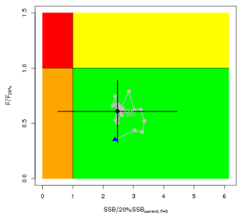 | 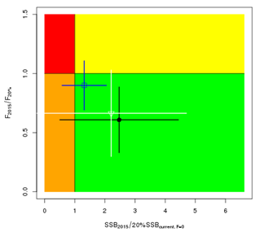
Figure NPALB-1. (A) Kobe plot showing the status of the north Pacific albacore (Thunnus alalunga) stock relative to the 20%SSBcurrent_{, F=0} biomass-based limit reference point, and equivalent fishing intensity (F20%; calculated as 1-SPR20%) over the base case modelling period (1993-2015). Blue triangle indicates the start year (1993) and black circle with 95% confidence intervals indicates the terminal year (2015). (B) Kobe plot showing stock status and 95% confidence intervals in the terminal year (2015) of the base case model (black; closed circle) and important sensitivity runs with M = 0.3 y⁻¹ for both sexes (blue; open square), and CV = 0.06 for Linf in the growth model (white; open triangle). Fs in this figure are not based on instantaneous fishing mortality. Instead, the Fs are indicators of fishing intensity based on SPR and calculated as 1-SPR so that the Fs reflects changes in fishing mortality. SPR is the equilibrium SSB per recruit that would result from the current year’s pattern and intensity of fishing mortality.

References

SC16-SA-WP-05 Stock Assessment of Albacore Tuna in the North Pacific Ocean in 2020 https://www.wcpfc.int/node/46613

For current information related to Northern Stocks Working Group Reports and the ISC Plenary Report:
http://isc.fra.go.jp/reports/isc/isc20_reports.html

SC13-SA-WP-09 Stock Assessment of Albacore in the North Pacific Ocean in 2017 Rev 2(approved version) (29 July 2017). Report of the Albacore Working Group (ISC).
https://www.wcpfc.int/node/29522

SC10-SA-WP-12 Stock Assessment of Albacore Tuna in the North Pacific Ocean in 2014. https://wcpfc.int/node/19202

SC7-SA-WP-10 Stock assessment of albacore tuna in the North Pacific Ocean in 2011. https://wcpfc.int/node/2860

It should be noted that the constant catch scenario is inconsistent with current management approaches for north Pacific albacore tuna adopted by the Inter-American Tropical Tuna Commission (IATTC) and the Western and Central Pacific Fisheries Commission (WCPFC).

