

The Commission for the Conservation and Management of
Highly Migratory Fish Stocks in the Western and Central Pacific Ocean

Scientific Committee

wcpo Bigeye Tuna (Thunnus obesus)

Stock Status and Management Advice

Contents
SC19 2023 (STOCK ASSESSMENT CONDUCTED) 2
SC16 2020 (STOCK ASSESSMENT CONDUCTED) 13
SC15 2019 (FISHERY INDICATORS UPDATED) 24
SC14 2018 (ASSESSMENT UPDATE CONDUCTED) 25
SC13 2017 (STOCK ASSESSMENT CONDUCTED) 35
References 46

SC19 2023 (STOCK ASSESSMENT CONDUCTED)

- Stock status and trends

- The 2023 WCPO bigeye tuna assessment provides stock status based upon a 54-model structural uncertainty grid with four axes: steepness with three levels, tag mixing period with two levels, and size and age composition data with three levels each, as illustrated in Table BET-01. SC19 recommended that the proposed axes of uncertainty be accepted and that all models should be weighted equally. The SC19 noted that an important improvement in the structural uncertainty grid was the inclusion of estimation uncertainty for each of the models in the grid.

- SC19 noted that the most influential axes of uncertainty in the grid were steepness and tag mixing period.

- The spatial structure used in the 2023 stock assessment is shown in Figure BET-01. Time series of total annual catch by fishing gear over the full assessment period is shown in Figure BET-02. The time series of total annual catch by fishing gear and assessment region is shown in Figure BET-03. Estimated annual spawning potential, average recruitment, and total biomass by model region is shown in Figure BET-04. Estimated trend in spawning potential depletion (SB/SB_{F=0}) for the 54 models in the structural uncertainty grid is shown in Figure BET-05, and juvenile and adult fishing mortality rates from the diagnostic model is shown in Figure BET-06. Estimates of the reduction in spawning potential due to fishing by region are shown in Figure BET-07. A comparison of the dynamic MSY for the diagnostic model compared with annual catch by the main gear types are shown in Figure BET-08, and estimated age specific fishing mortality for the diagnostic model, by region and overall are in Figure BET-09.

- SC19 noted that the preliminary estimate of total catch of WCPO bigeye tuna for 2022 was 140,664 mt which was similar to the 2021 level. Longline catch in 2022 (54,800 mt) was similar to the 2021 catch and lower than the recent ten-year average and understood to be partly due to the impacts of the COVID-19 pandemic. Purse-seine catch in 2022 (62,811 mt) was also similar to the 2021 catch, and lower than the recent ten-year average (Figure BET-02).

- The 2023 WCPO bigeye tuna stock assessment median depletion from the model grid for the recent period (2018-2021; SB_{recent}/SB_{F=0}) was 0.35 (10th to 90th percentile interval of 0.30 to 0.40, including estimation and structural uncertainty, Table BET-02). For all models in the grid SB_{recent}/SB_{F=0} was above the biomass limit reference point. The recent median fishing mortality (2017-2020; F_{recent}/F_{MSY}) was 0.59 (10th to 90th percentile interval of 0.46 to 0.74, including estimation and structural uncertainty, Table BET-02). For all models in the grid, F_{recent}/F_{MSY} was less than one.

- SC19 noted that the results show that both total and spawning potential has been continuously declining since the late 1950s through until the mid-1970’s, followed by a more gradual decline through to the present (Figure BET-04).

- SC19 noted that the catch in the last year of the assessment (2021) was less than the median MSY (164,640 mt), which is a 17% increase in the estimated MSY for bigeye tuna from the 2020 stock assessment (140,720 mt).

- Majuro (Figure BET-10) and Kobe (Figure BET-11) plots show that the stock status estimates across the 54 models are all within plot zones that indicate that the stock is not overfished nor undergoing overfishing.

Table BET-01. Description of the updated structural sensitivity grid used to characterize uncertainty in the assessment with bolded values indicating the diagnostic case (Table 3 from SC19-SA-WP-05).
Axis | Value 1 | Value 2 | Value 3
Steepness | 0.65 | 0.8 | 0.95
Tag mixing (# quarters) | 1 | 2
Size data weighting divisor | 10 | 20 | 40
Age data weighting | 0.5 | 0.75 | 1

Table BET-02. Summary of reference points over the 54 models in the structural uncertainty grid. Note that “recent” is the average over the period 2018-2021 for SB and fishing mortality, while “latest” is 2021. The values of the upper 90th and lower 10th percentiles of the empirical distributions are also shown. F_{mult} is the multiplier of recent (2018-2021) fishing mortality required to produce MSY (Table 5 from SC19-SA-WP-05).
 | Mean | Median | Minimum | 10th percentile | 90th percentile | Maximum
C_{latest} | 139,314 | 139,199 | 138,527 | 138,947 | 139,939 | 140,347
Y_{Frecent} | 37,982 | 37,805 | 33,400 | 34,365 | 42,369 | 42,980
F_{MSY} | 0.06 | 0.06 | 0.04 | 0.04 | 0.07 | 0.08
F_{mult} | 1.69 | 1.67 | 2.27 | 2.17 | 1.35 | 1.22
MSY | 162,248 | 164,640 | 137,920 | 143,112 | 180,820 | 184,440
F_{recent}/F_{MSY} | 0.59 | 0.59 | 0.37 | 0.46 | 0.74 | 0.99
SB_{F=0} | 1,952,050 | 1,921,715 | 1460,378 | 1,612,630 | 2,356,598 | 2,561,690
SB_{MSY} | 393,037 | 376,300 | 225,100 | 277,230 | 534,330 | 595,900
SB_{MSY}/SB_{F=0} | 0.20 | 0.20 | 0.15 | 0.17 | 0.23 | 0.24
SB_{latest}/SB_{F=0} | 0.34 | 0.34 | 0.27 | 0.30 | 0.38 | 0.40
SB_{latest}/SB_{MSY} | 1.76 | 1.77 | 1.16 | 1.28 | 2.31 | 2.46
SB_{recent}/SB_{F=0} | 0.35 | 0.35 | 0.28 | 0.31 | 0.40 | 0.41
SB_{recent}/SB_{MSY} | 1.82 | 1.83 | 1.20 | 1.32 | 2.38 | 2.54
Including estimation uncertainty
 | Mean | median | min | 10%ile | 90%ile | max
SB_{recent}/SB_{F=0} | 0.35 | 0.35 | 0.25 | 0.30 | 0.40 | 0.46
F_{recent}/F_{MSY} | 0.59 | 0.59 | 0.37 | 0.46 | 0.74 | 0.99
SB_{recent}/SB_{MSY} | 1.82 | 1.79 | 0.94 | 1.32 | 2.41 | 2.96

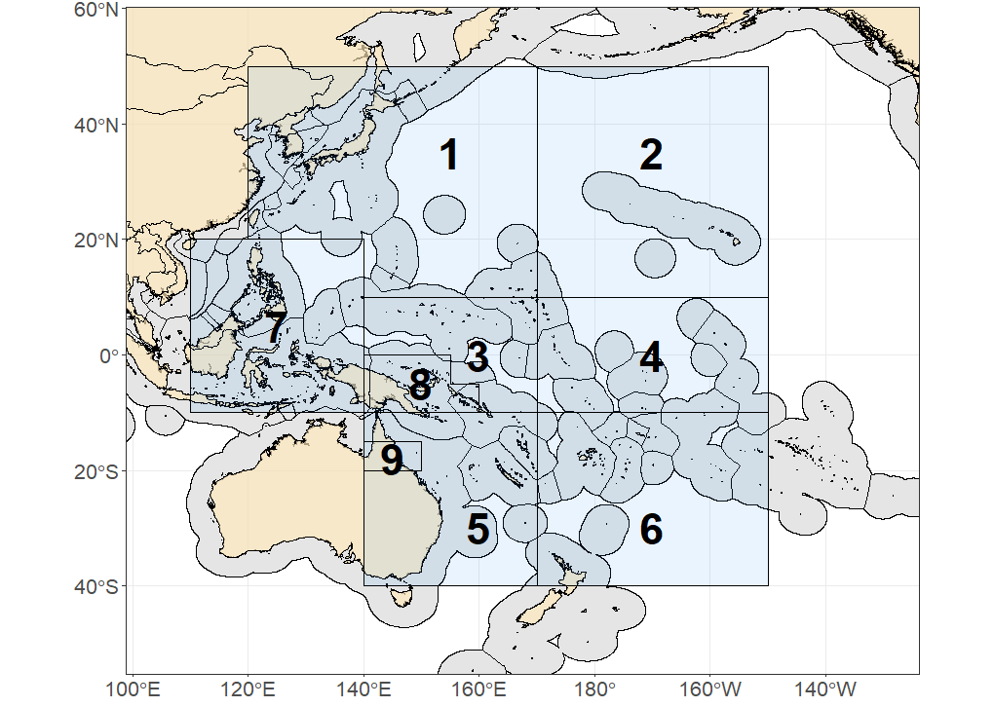
Figure BET-01. Spatial structure for the 2023 bigeye tuna stock assessment (Figure 1 from SC19-SA-WP-05).
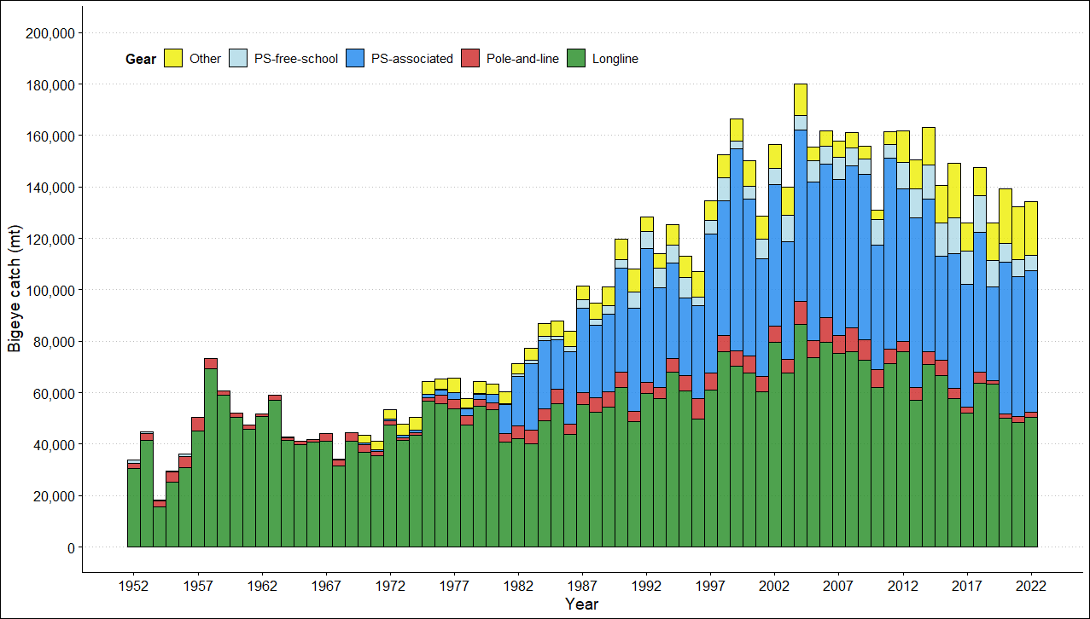

Figure BET-02. Time series of total annual catch (1000s mt) by fishing gear for the diagnostic model over the full assessment period. The different colors refer to longline (green), pole-and-line (red), purse seine (blue), purse seine associated (dark blue), purse seine unassociated (light blue), miscellaneous (yellow), and index (gray). Note that the catch by longline gear has been converted into catch-in-weight from catch-in-numbers and so may differ from the annual catch estimates presented in (Williams et al., 2023), however these catches enter the model as catch-in-numbers (Figure 3 from SC19-SA-WP-05).

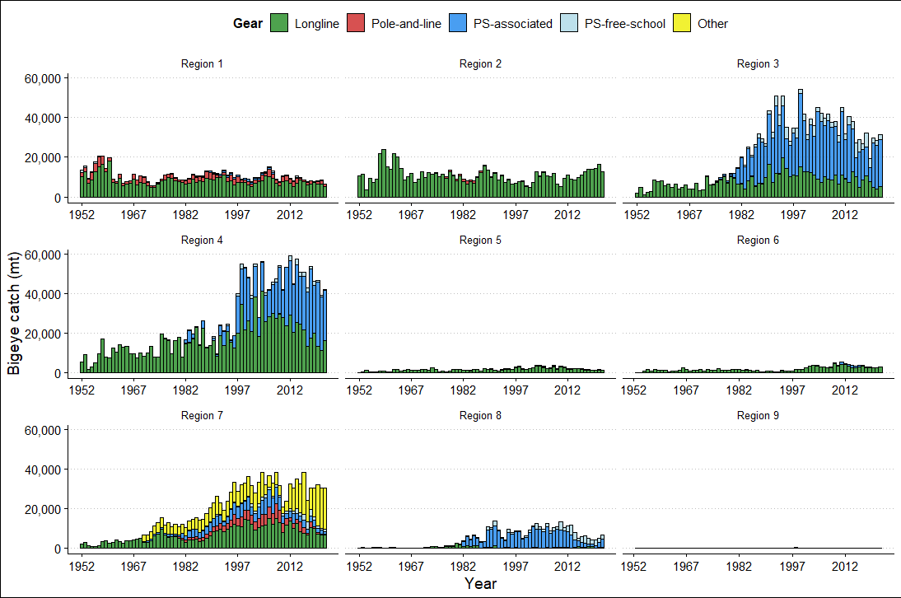

Figure BET-03. Annual catches of bigeye by gear type for each of the nine model regions (Figure 4 from SC19-SA-WP-05).
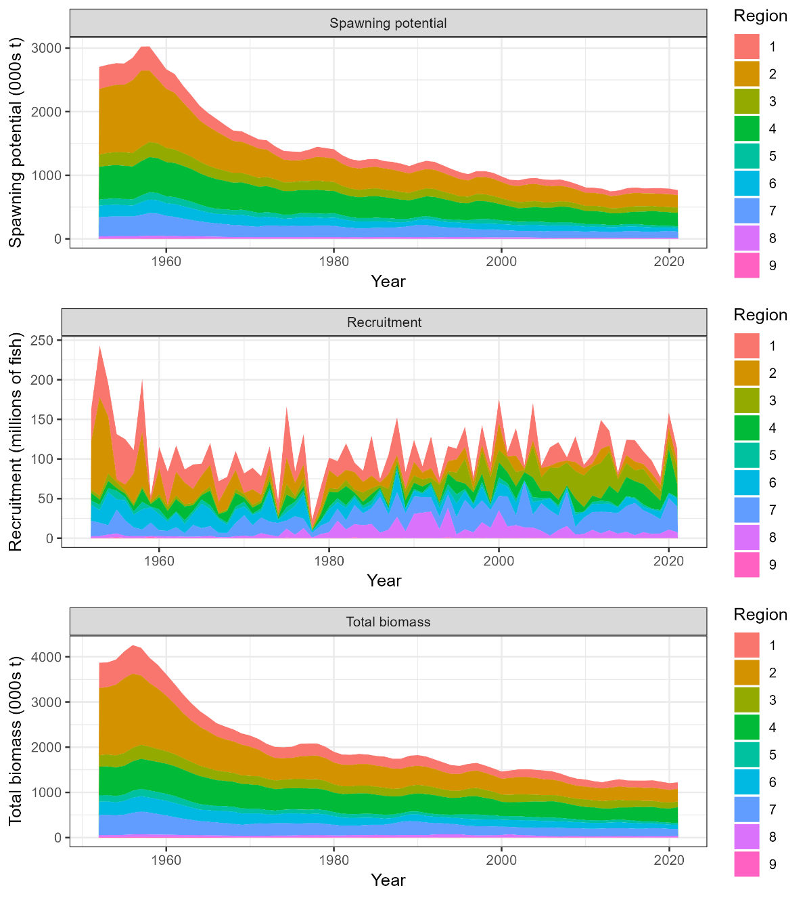

Figure BET-04. Time series of estimated annual spawning potential, recruitment and total biomass by model region for the diagnostic model, showing the relative proportions among regions. Note the data represent the averages of the quarterly model time steps for each year for spawning potential and total biomass and the sum of the quarterly recruitment estimates for annual recruitment (Figure 49 from SC19-SA-WP-05).
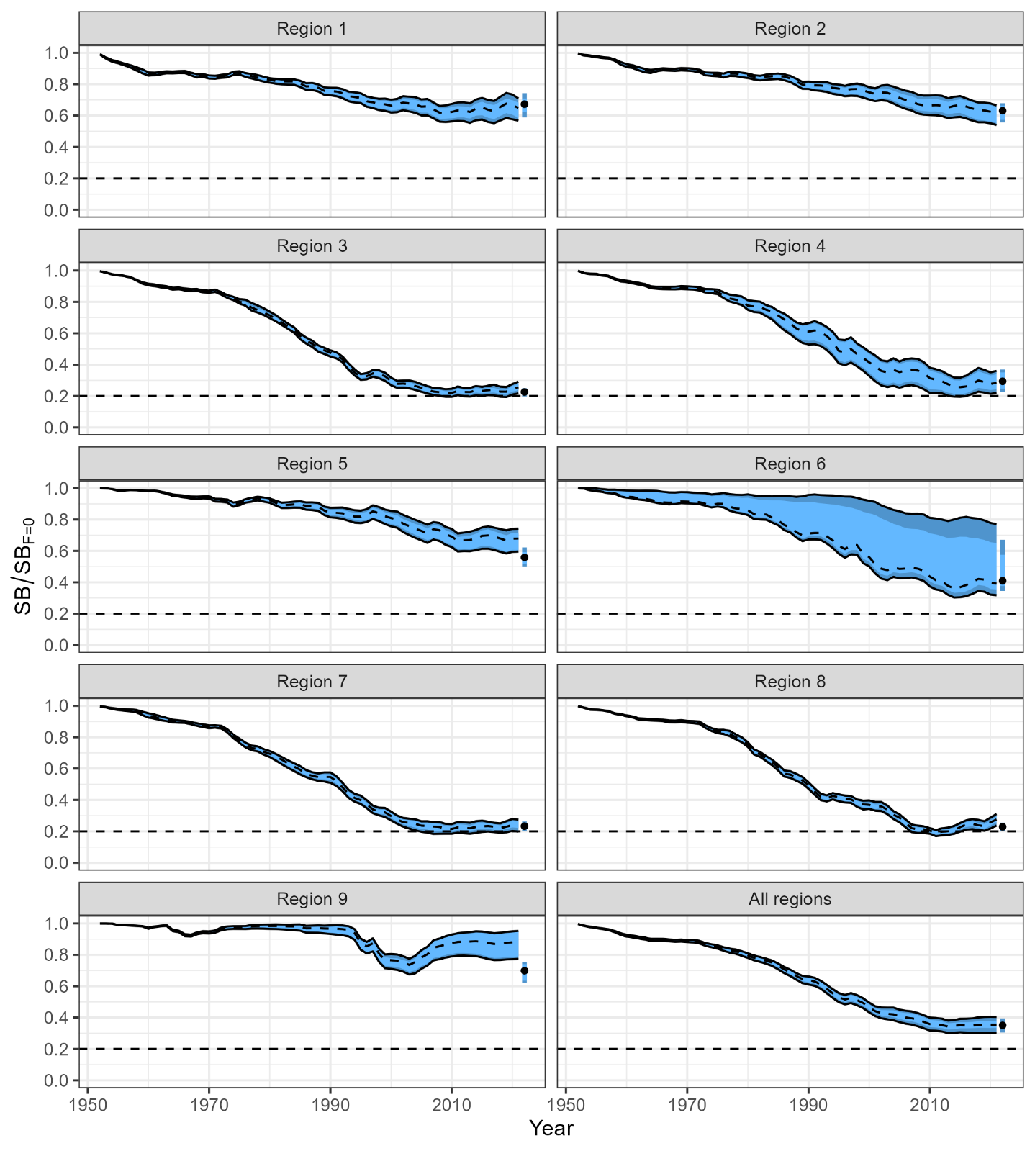
Figure BET-05. Estimated spawning depletion across all models in the structural uncertainty grid over the period 1952-2021. The lighter band shows the 25th and 75th percentiles, and the dark band shows the 10th and 90th percentiles of the model estimates. The bar at the right of each ribbon indicates the median (black dots) with the 10th and 90th percentiles for SB_{recent}/SB_{F=0} (Figure 63 from SC19-SA-WP-05).

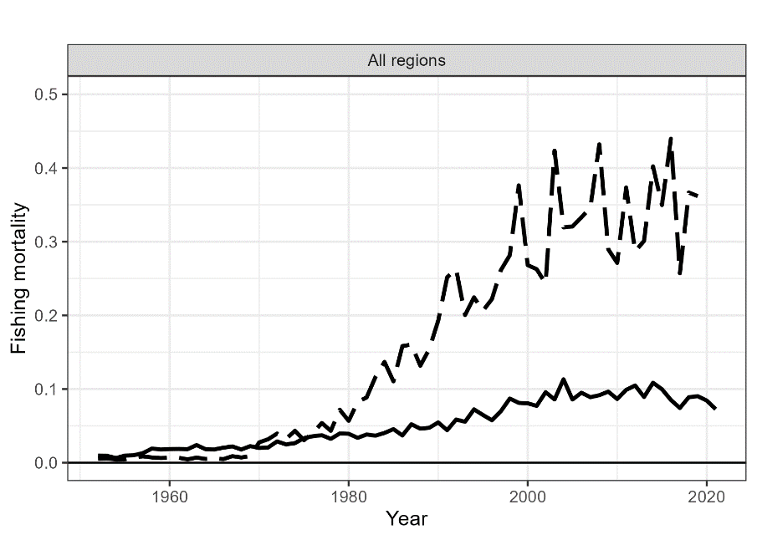
Figure BET-06. Estimated annual average adult (solid line) and juvenile (dashed line) fishing mortality for the 2023 diagnostic model (Figure 54 from SC19-SA-WP-05).
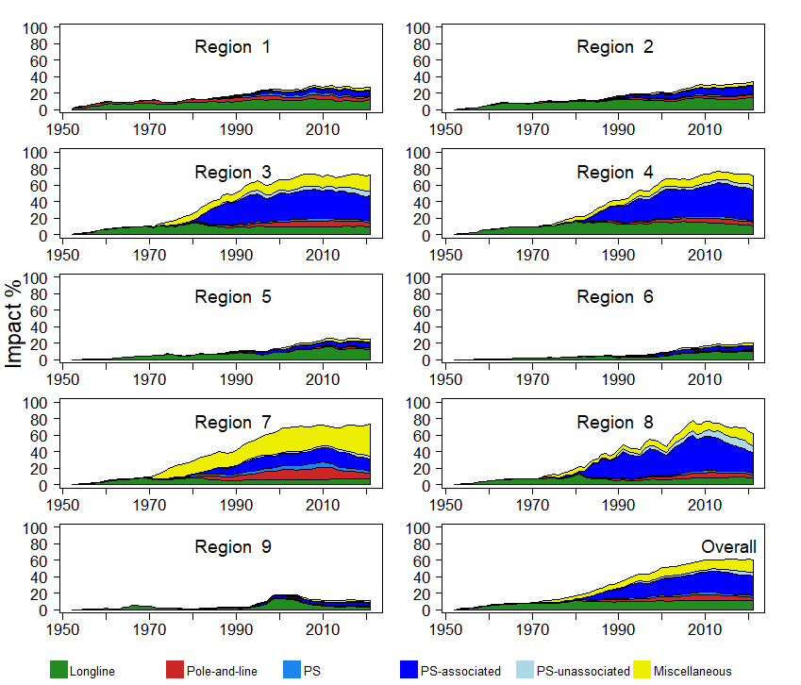
Figure BET-07. Estimates of reduction in spawning potential due to fishing (fishery impact = (1-SB_{t}/SB_{t,F=0}) * 100%) by region, and over all regions (lower right panel), attributed to various fishery groups for the 2023 diagnostic model (Figure 70 from SC19-SA-WP-05).
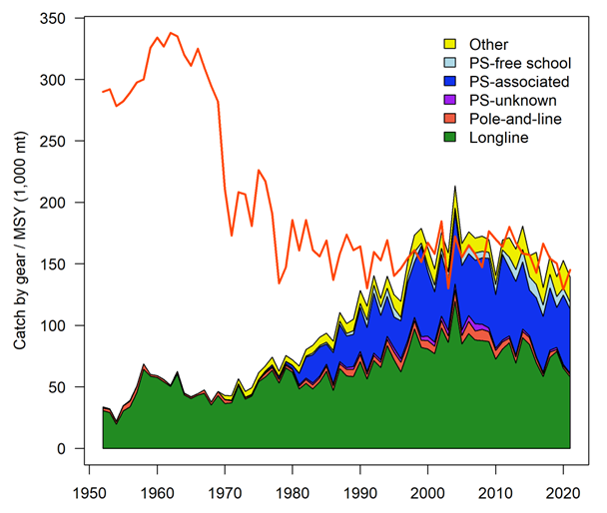
Figure BET-08. History of the annual estimates of MSY (red line) for the diagnostic model compared with annual catch by the main gear types. Note that this is a ‘dynamic’ MSY (Figure 72 from SC19-SA-WP-05).
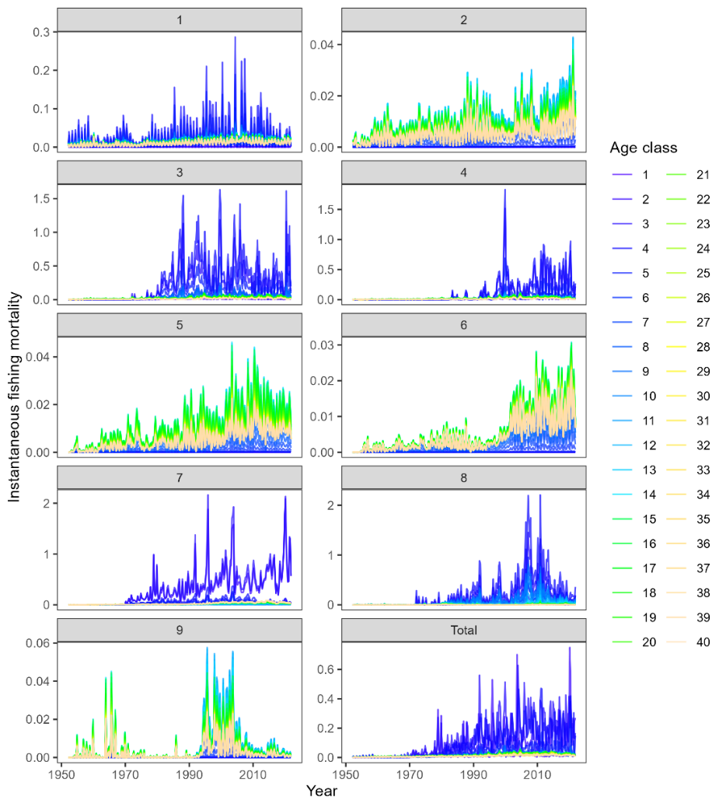
Figure BET-09 Estimated age specific fishing mortality for the diagnostic model, by region and overall (Figure 55 from SC19-SA-WP-05).
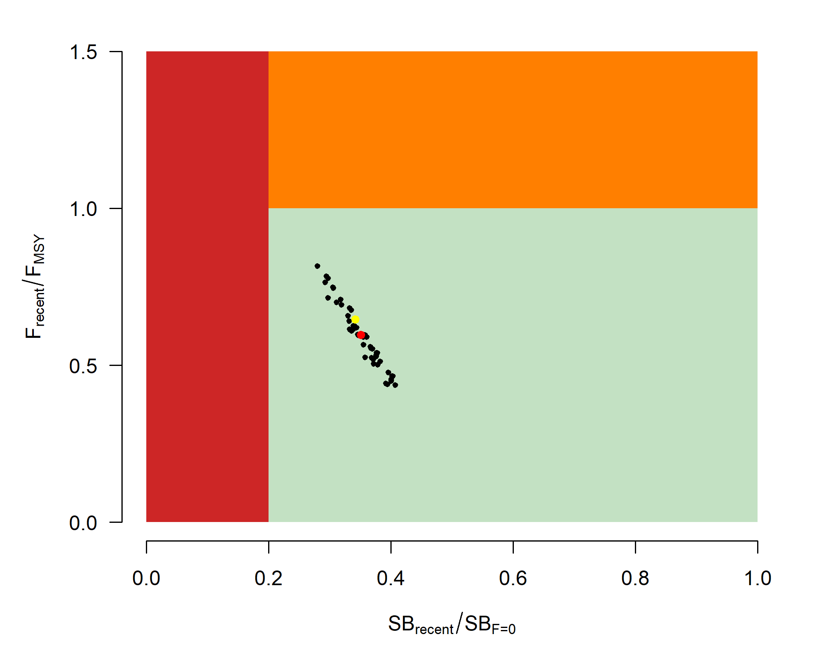
Figure BET-10. Majuro plot for the recent spawning potential (2018–2021) summarizing the results for each of the models in the structural uncertainty grid. The plots represent estimates of stock status in terms of spawning biomass depletion and fishing mortality. The yellow point is the 2023 diagnostic model and red point is the median (Figure 68 from SC19-SA-WP-05).
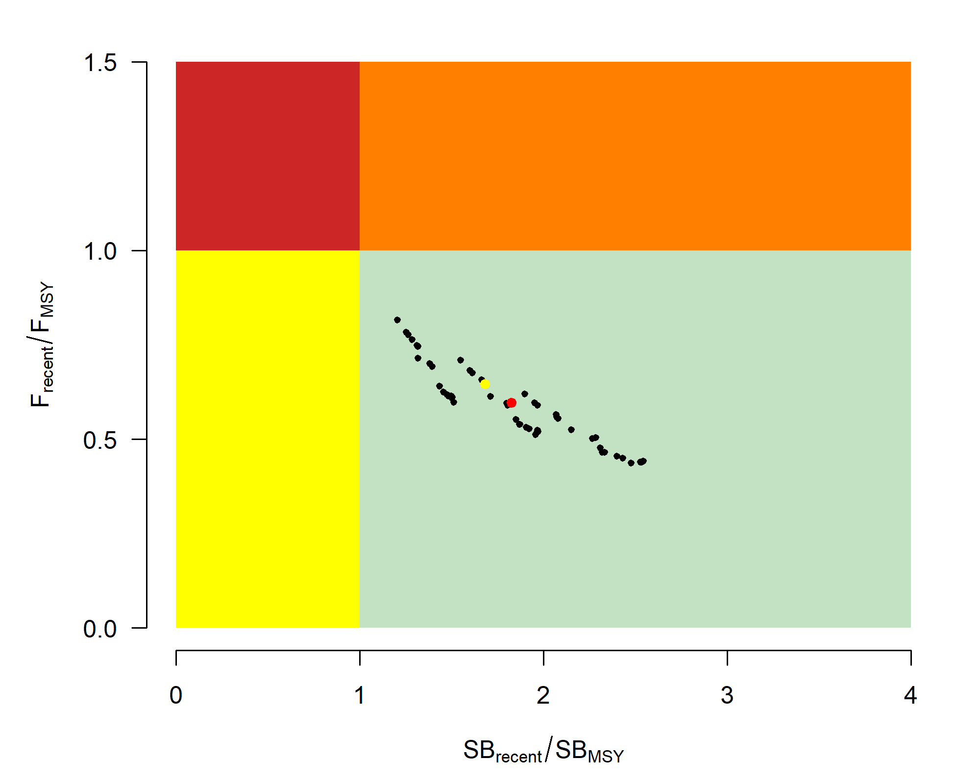
Figure BET-11. Kobe plot for the recent spawning potential (2018–2021) summarizing the results for each of the models in the structural uncertainty grid. The plots represent estimates of stock status in terms of spawning biomass depletion and fishing mortality. The yellow point is the 2023 diagnostic model and red point is the median (Figure 68 from SC19-SA-WP-05).
- Management advice and implications

- The objective for bigeye tuna in CMM 2021-01 (the Tropical Tuna Measure) – to maintain the spawning biomass depletion ratio at or above the average SB/SB_{F=0} for 2012-2015 – is being achieved. SB_{recent}/SB_{F=0} (35%) is very close to the average SB/SB_{F=0} for 2012-2015 (34%) calculated across the unweighted grid.

- The WCPO bigeye tuna spawning biomass is above the biomass LRP, and F_{recent} is below F_{MSY} for all models in the uncertainty grid. The stock is very likely not experiencing overfishing (100% probability F_{recent}<F_{MSY}) and is not in an overfished condition (0% probability SB_{recent}/SB_{F=0}<LRP).

- SC19 also noted that average fishing mortality rates for juvenile and adult age-classes have increased throughout the period of the assessment (Figure BET-08), although more so for juveniles which have experienced considerably higher annual fishing mortality than adults (Figure BET-06). The purse-seine associated fishery has the most impact, with that of the miscellaneous and longline fisheries also being notable (Figure BET-07). Higher fishing mortality rates on juvenile bigeye tuna reduces the realized yield per recruit for the bigeye fishery.

- SC19 noted that levels of fishing mortality and depletion differ among regions, and that fishery impact was higher in the tropical regions (Regions 3, 4, 7 and 8 in the stock assessment model), with particularly high fishing mortality on juvenile bigeye tuna in these regions.

- There is also evidence that the overall stock status is buffered with biomass and low exploitation in the temperate region (1, 2, 6 and 9) and most of the predicted movement is within the equatorial region. Exchange rates between temperate and tropical regions are estimated to be low.

- SC19 noted that the reduction of fishing mortality on fisheries that take juveniles could increase bigeye fishery yields and reduce any further impacts on spawning biomass of this stock. SC19 also noted that this could require considering the impact to other fisheries and stocks.

- The interim objective of bigeye tuna stock under CMM 2021-01 is to maintain the depletion level of the stock at or above the average SB/SB_{F=0} for 2012-2015. The recent depletion level of bigeye tuna is close to this interim objective. SC19 noted that while the projection results based on the 2023 bigeye tuna assessment were not available for SC19 to review, this information will be available for the 4th tropical tuna management workshop and will provide the Commission guidance on future expected levels of fishing mortality and the outcomes relative to the interim or future management objectives.

- Research Recommendations

- SC19 adopted several research recommendations for the further development and improvement of the WCPO bigeye tuna stock assessment, and suggested these be considered for potential inclusion in the Tuna Assessment Research Plan (TARP):
Continued collection of more representative biological data (e.g., age composition) and tagging data.
  - Develop additional CPUE index series testing key uncertainties about the analysis (e.g., regional vs. global model, classification of catchability vs. abundance covariates, etc.) and explore those as one-off sensitivities to the stock assessment.
  - Consideration of options to account for effort creep in CPUE standardization and/or the assessment model.
  - Simulation study to explore appropriate spatial structure of the stock assessment with a focus on simplifying the spatial structure (e.g., areas-as-fleets and/or 6 region structure) given the estimates of limited movement rates among regions.
  - Investigation of the 2023 model specifications with respect to the increase in unfished SSB over time for the tropical regions (3, 4, 7 and 8).
  - Yield per recruit analyses comparing fishery sectors with different selectivity patterns.
  - Evaluation of the variability and plausibility of estimated growth and mortality-at-age relationship across the structural uncertainty grid.
  - Additional one-off sensitivities exploring key uncertainties in biological assumptions, model specification, and data inputs (e.g., tag mixing, data weighting, and growth).
  - Identification of key parameters that are either highly correlated or highly sensitive to the jittering procedure to inform possible changes in model specification with the aim to decrease model complexity and/or sensitivity to starting conditions.
  - Exploration of seasonal and regional growth traits for the stock assessment.
  - Comprehensive review of the representativeness of the size composition data given conflicts identified in the likelihood profiles.
  - Investigation of the 2023 model specifications that lead to the inversion of the effect of the weight vs. tagging data signal on the total biomass, as shown in the likelihood profile.
  - Further exploration of the advantages and disadvantages of strategies to decrease model sensitivity to starting conditions, including but not limited to multi-start approaches.
  - Pursue development of tag mixing diagnostics and approaches, and investigate the impacts of tag mixing assumptions.

SC16 2020 (STOCK ASSESSMENT CONDUCTED)

- Stock status and trends

- The median values of relative recent (2015-2018) spawning biomass depletion (SB_{recent}/ SB_{F=0}) and relative recent (2014-2017) fishing mortality (F_{recent}/F_{MSY}) over the uncertainty grid of 24 models (Table BET-1) were used to define stock status. The values of the upper 90thand lower 10thpercentiles of the empirical distributions of relative spawning biomass and relative fishing mortality from the uncertainty grid were used to characterize the probable range of stock status.

- A description of the updated structural sensitivity grid used to characterize uncertainty in the assessment is illustrated in Table BET-1. The spatial structure used in the 2020 stock assessment is shown in Figure BET-1. Time series of total annual catch by fishing gear over the full assessment period is shown in Figure BET-2. The time series of total annual catch by fishing gear and assessment region is shown in Figure BET-3. Estimated annual average recruitment, spawning potential, and total biomass by model region is shown in Figure BET-4. Estimated trends in spawning potential by region for the diagnostic case is shown in Figure BET-5, and juvenile and adult fishing mortality rates from the diagnostic model is shown in Figure BET-6. Estimates of the reduction in spawning potential due to fishing by region is shown in Figure BET-7. Time-dynamic percentiles of depletion (SB_{t}/SB_{t,F=0}) for the 24 models are shown in Figure BET-8. A Majuro and Kobe plot summarising the results for each of the 24 models in the structural uncertainty grid are shown in Figures BET 9 and 10, respectively. Projections are illustrated in Figures BET-11 and BET-12. Table BET-2 provides a summary of reference points over the 24 models in the structural uncertainty grid.

- A number of investigative models were run with growth, such as: 1) Oto-Only, a growth curve that was a ﬁxed Richards growth curve based on high-readability otoliths, 2) Tag-Int: a growth curve that was a ﬁxed Richards growth curve based on the same high-readability otolith data-set in addition to bigeye tuna tag-recapture data, and 3) Est-Richards: A conditional age-length data-set was constructed from the combined daily and annual otolith dataset. The Oto-Only growth model predicted very high levels of biomass and corresponding low level of depletion. The Est Richards growth model showed sensitivity to the initial values given for the estimated growth parameters. The implausible results from the Oto-Only growth and differing results from the Est-Richards indicate questions still remain regarding bigeye tuna growth.

- SC16 requested the bigeye tuna assessment to try and fit the data for those small bigeye tuna as they are increasingly caught by domestic fisheries in region 7, but the current diagnostic model does not fit those fish that well because the L1 parameter is larger than most of those fish. SPC could consider additional developments to Multifan-CL to model greater variability in size around the growth curve at small ages.

- The most inﬂuential grid axis is the size-frequency data-weighting axis and further research is required to develop model diagnostics and objective criteria for model inclusion.

Table BET-1. Description of the updated structural sensitivity grid used to characterize uncertainty in the assessment. The starred levels denote those assumed in the model diagnostic case.
Axis | Value 1 | Value 2 | Value 3 | Value 4
Steepness | 0.65 | 0.8 * | 0.95
Natural mortality | Diagnostic* (0.112) | M-hi  (0.146)
Size frequency weighting | 20* | 60 | 200 | 500

Table BET-2. Summary of reference points over the 24 models in the structural uncertainty grid. Note that “recent” is the average over the period 2015-2018 for SB and 2014-2017 for fishing mortality, while “latest” is 2018. The values of the upper 90th and lower 10th percentiles of the empirical distributions are also shown. F_{mult} is the multiplier of recent (2014-2017) fishing mortality required to attain MSY.
 | Mean | Median | Minimum | 10thpercentile | 90th percentile | Maximum
C_{latest} | 159,738 | 159,288 | 157,297 | 157,722 | 162,033 | 162,271
Y_{Frecent} | 136,568 | 134,940 | 117,800 | 124,668 | 149,424 | 161,520
f_{mult} | 1.45 | 1.38 | 0.83 | 0.98 | 2.03 | 2.33
F_{MSY} | 0.05 | 0.05 | 0.04 | 0.04 | 0.07 | 0.07
MSY | 146,715 | 140,720 | 117,920 | 125,628 | 179,164 | 187,520
F_{recent}/F_{MSY} | 0.74 | 0.72 | 0.43 | 0.49 | 1.02 | 1.21
SB_{F=0} | 1,395,173 | 1,353,367 | 903,708 | 982,103 | 1,780,138 | 1,908,636
SB_{MSY} | 320,162 | 321,550 | 192,500 | 219,810 | 443,730 | 482,700
SB_{MSY}/SB_{F=0} | 0.23 | 0.23 | 0.19 | 0.2 | 0.26 | 0.26
SB _{latest}/SB_{F=0} | 0.38 | 0.38 | 0.23 | 0.3 | 0.47 | 0.51
SB _{latest}/SB_{MSY} | 1.7 | 1.67 | 0.95 | 1.23 | 2.15 | 2.6
SB _{recent}/SB_{F=0} | 0.4 | 0.41 | 0.21 | 0.27 | 0.52 | 0.55
SB _{recent}/SB_{MSY} | 1.78 | 1.83 | 0.87 | 1.18 | 2.32 | 2.84

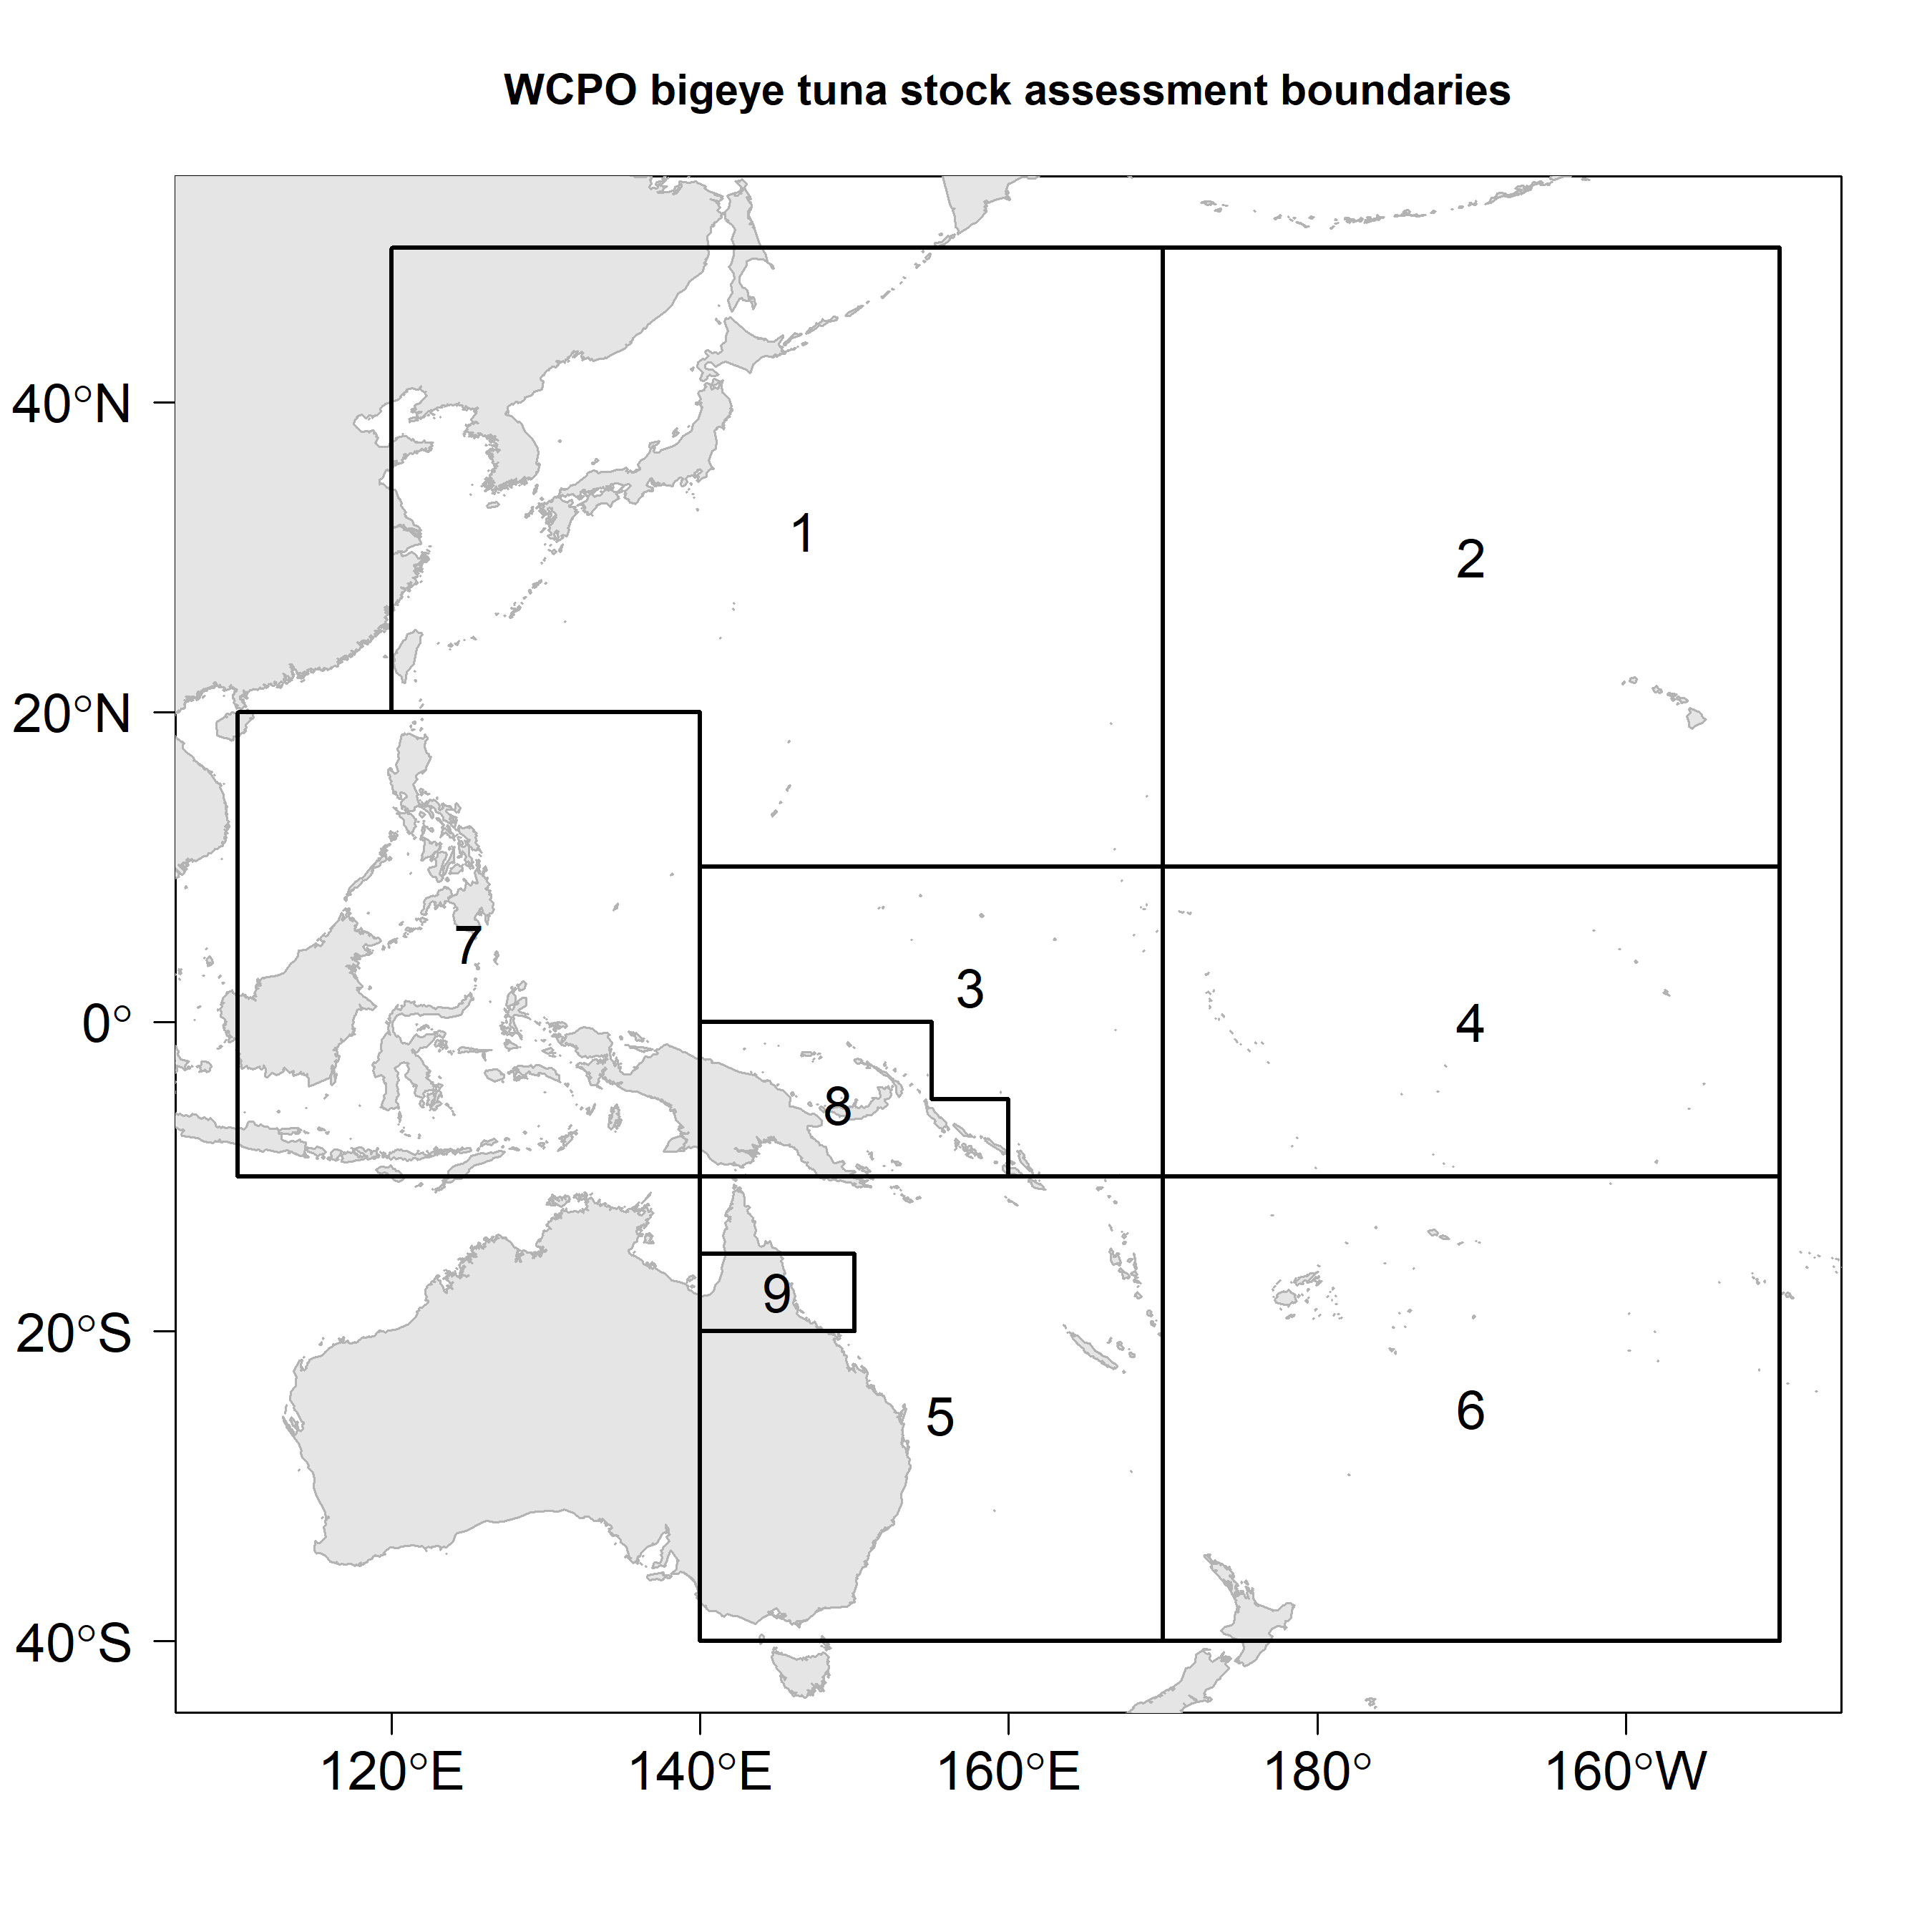
Figure BET-1.Spatial structure for the 2020 bigeye tuna stock assessment.
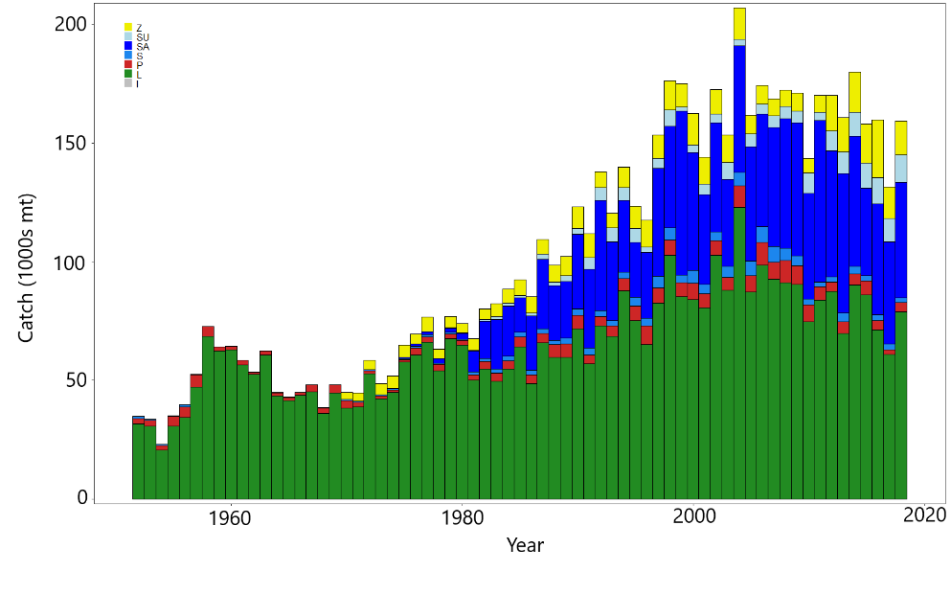
Figure BET-2. Time series of total annual catch (1000s mt) by fishing gear for the diagnostic model over the full assessment period. The different colors refer to longline (green), pole-and-line (red), purse seine (blue), purse seine associated (dark blue), purse seine unassociated (light blue), miscellaneous (yellow), and index (gray). Note that the catch by longline gear has been converted into catch-in-weight from catch-in-numbers and so may differ from the annual catch estimates presented in (Williams et al., 2020), however these catches enter the model as catch-in-numbers.
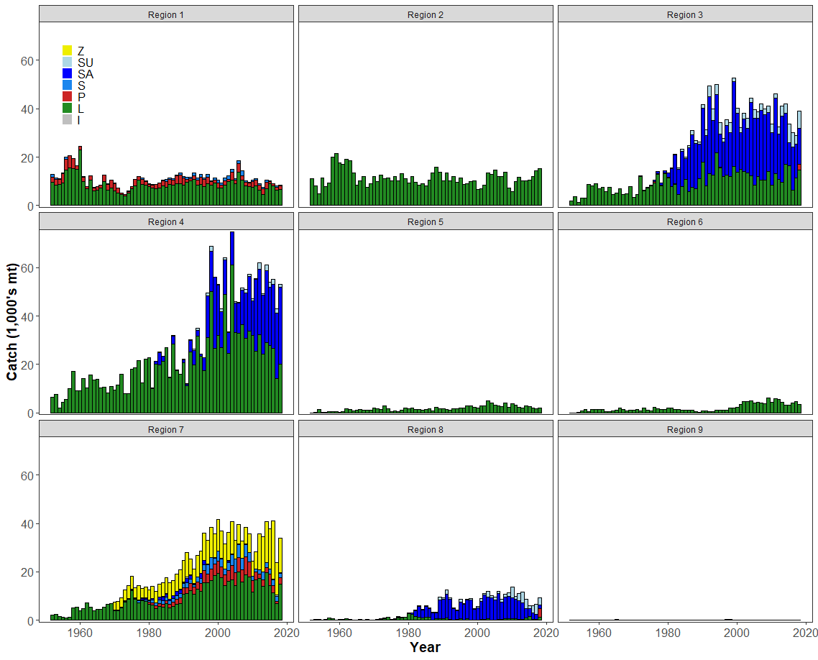
Figure BET-3. Time series of total annual catch (1000s mt) by fishing gear and assessment region for the diagnostic model over the full assessment period. The different colors refer to longline (green), pole-and-line (red), purse seine (blue), purse seine associated (dark blue), purse seine unassociated (light blue), miscellaneous (yellow), and index (gray).
- Recruitment
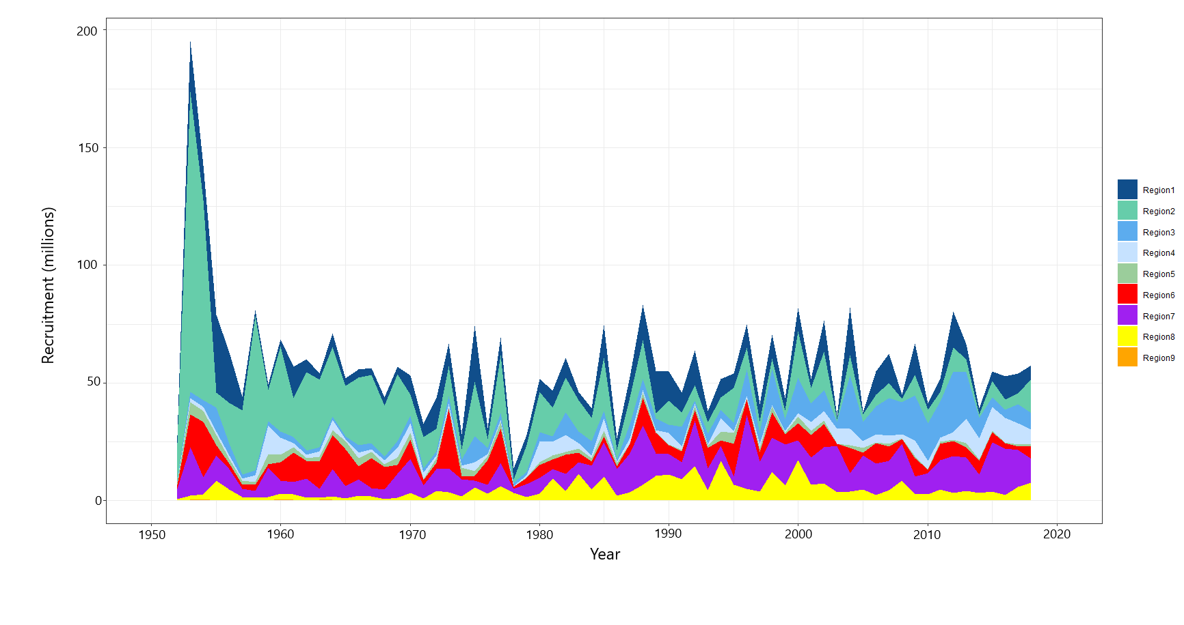
- Spawning Potential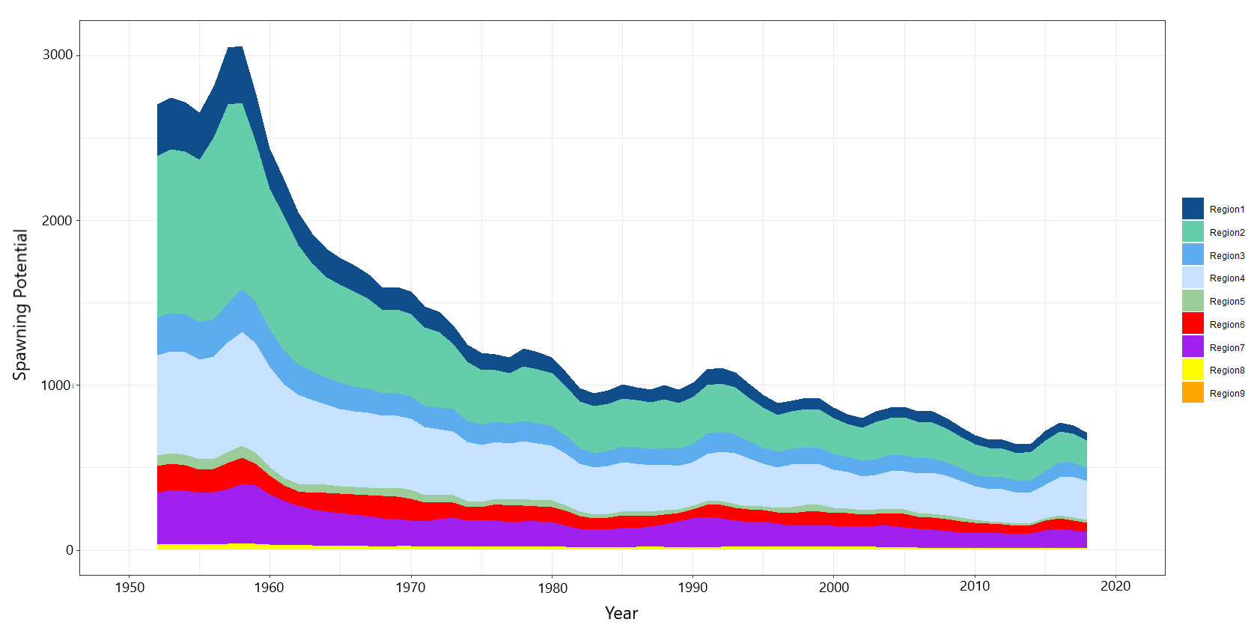
- Total biomass
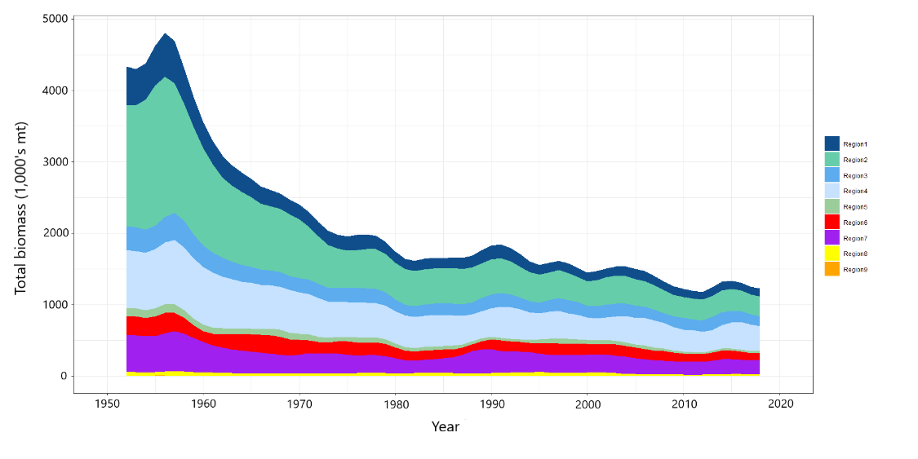
Figure BET-4. Estimated (a) annual average recruitment, (b) spawning potential and (c) total biomass by model region for the diagnostic model, showing the relative sizes among regions.

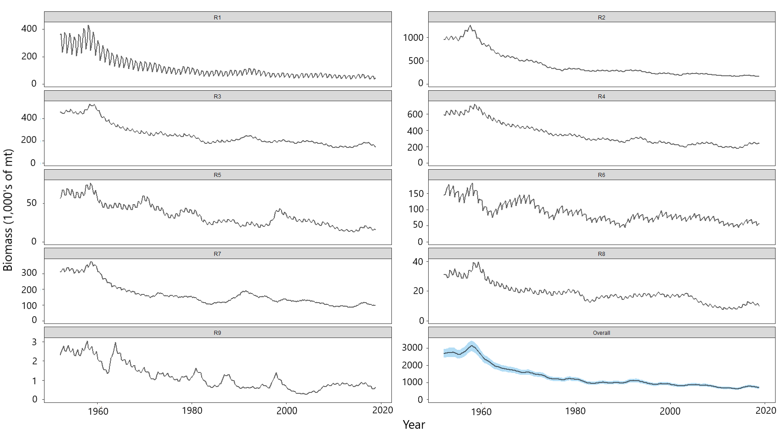
Figure BET-5. Estimated seasonal, temporal spawning potential by model region for the diagnostic model. The asymptotic 95% confidence interval as calculated using the delta-method is shown for the “Overall” region. Note that the scale of the y-axis is not constant across regions.

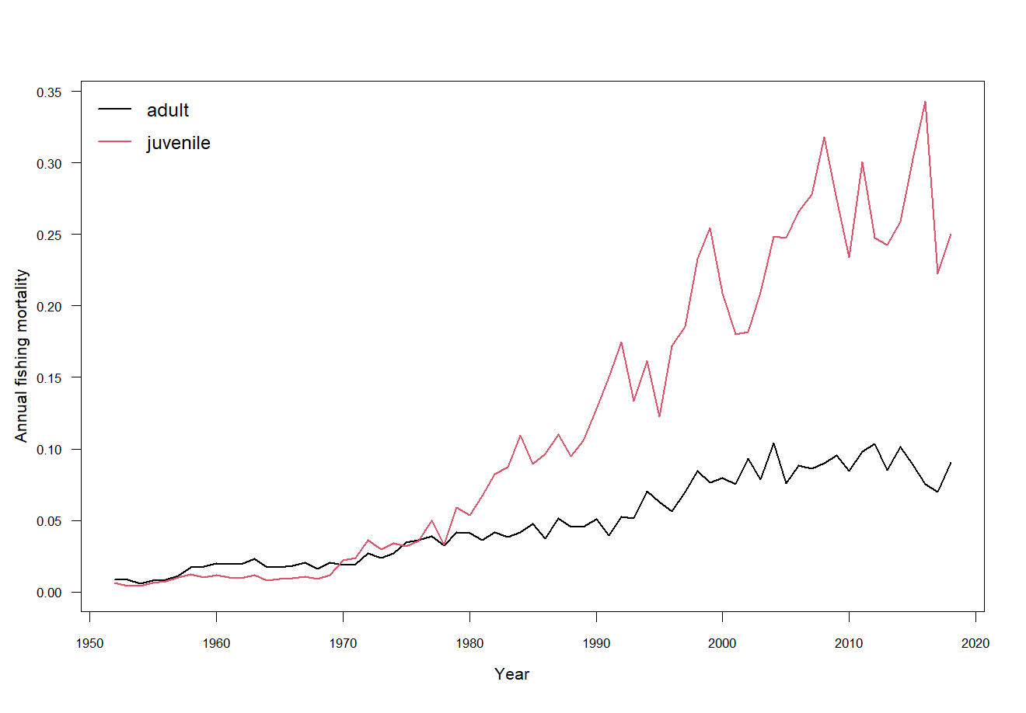
Figure BET-6. Estimated annual average juvenile and adult fishing mortality for the diagnostic model.
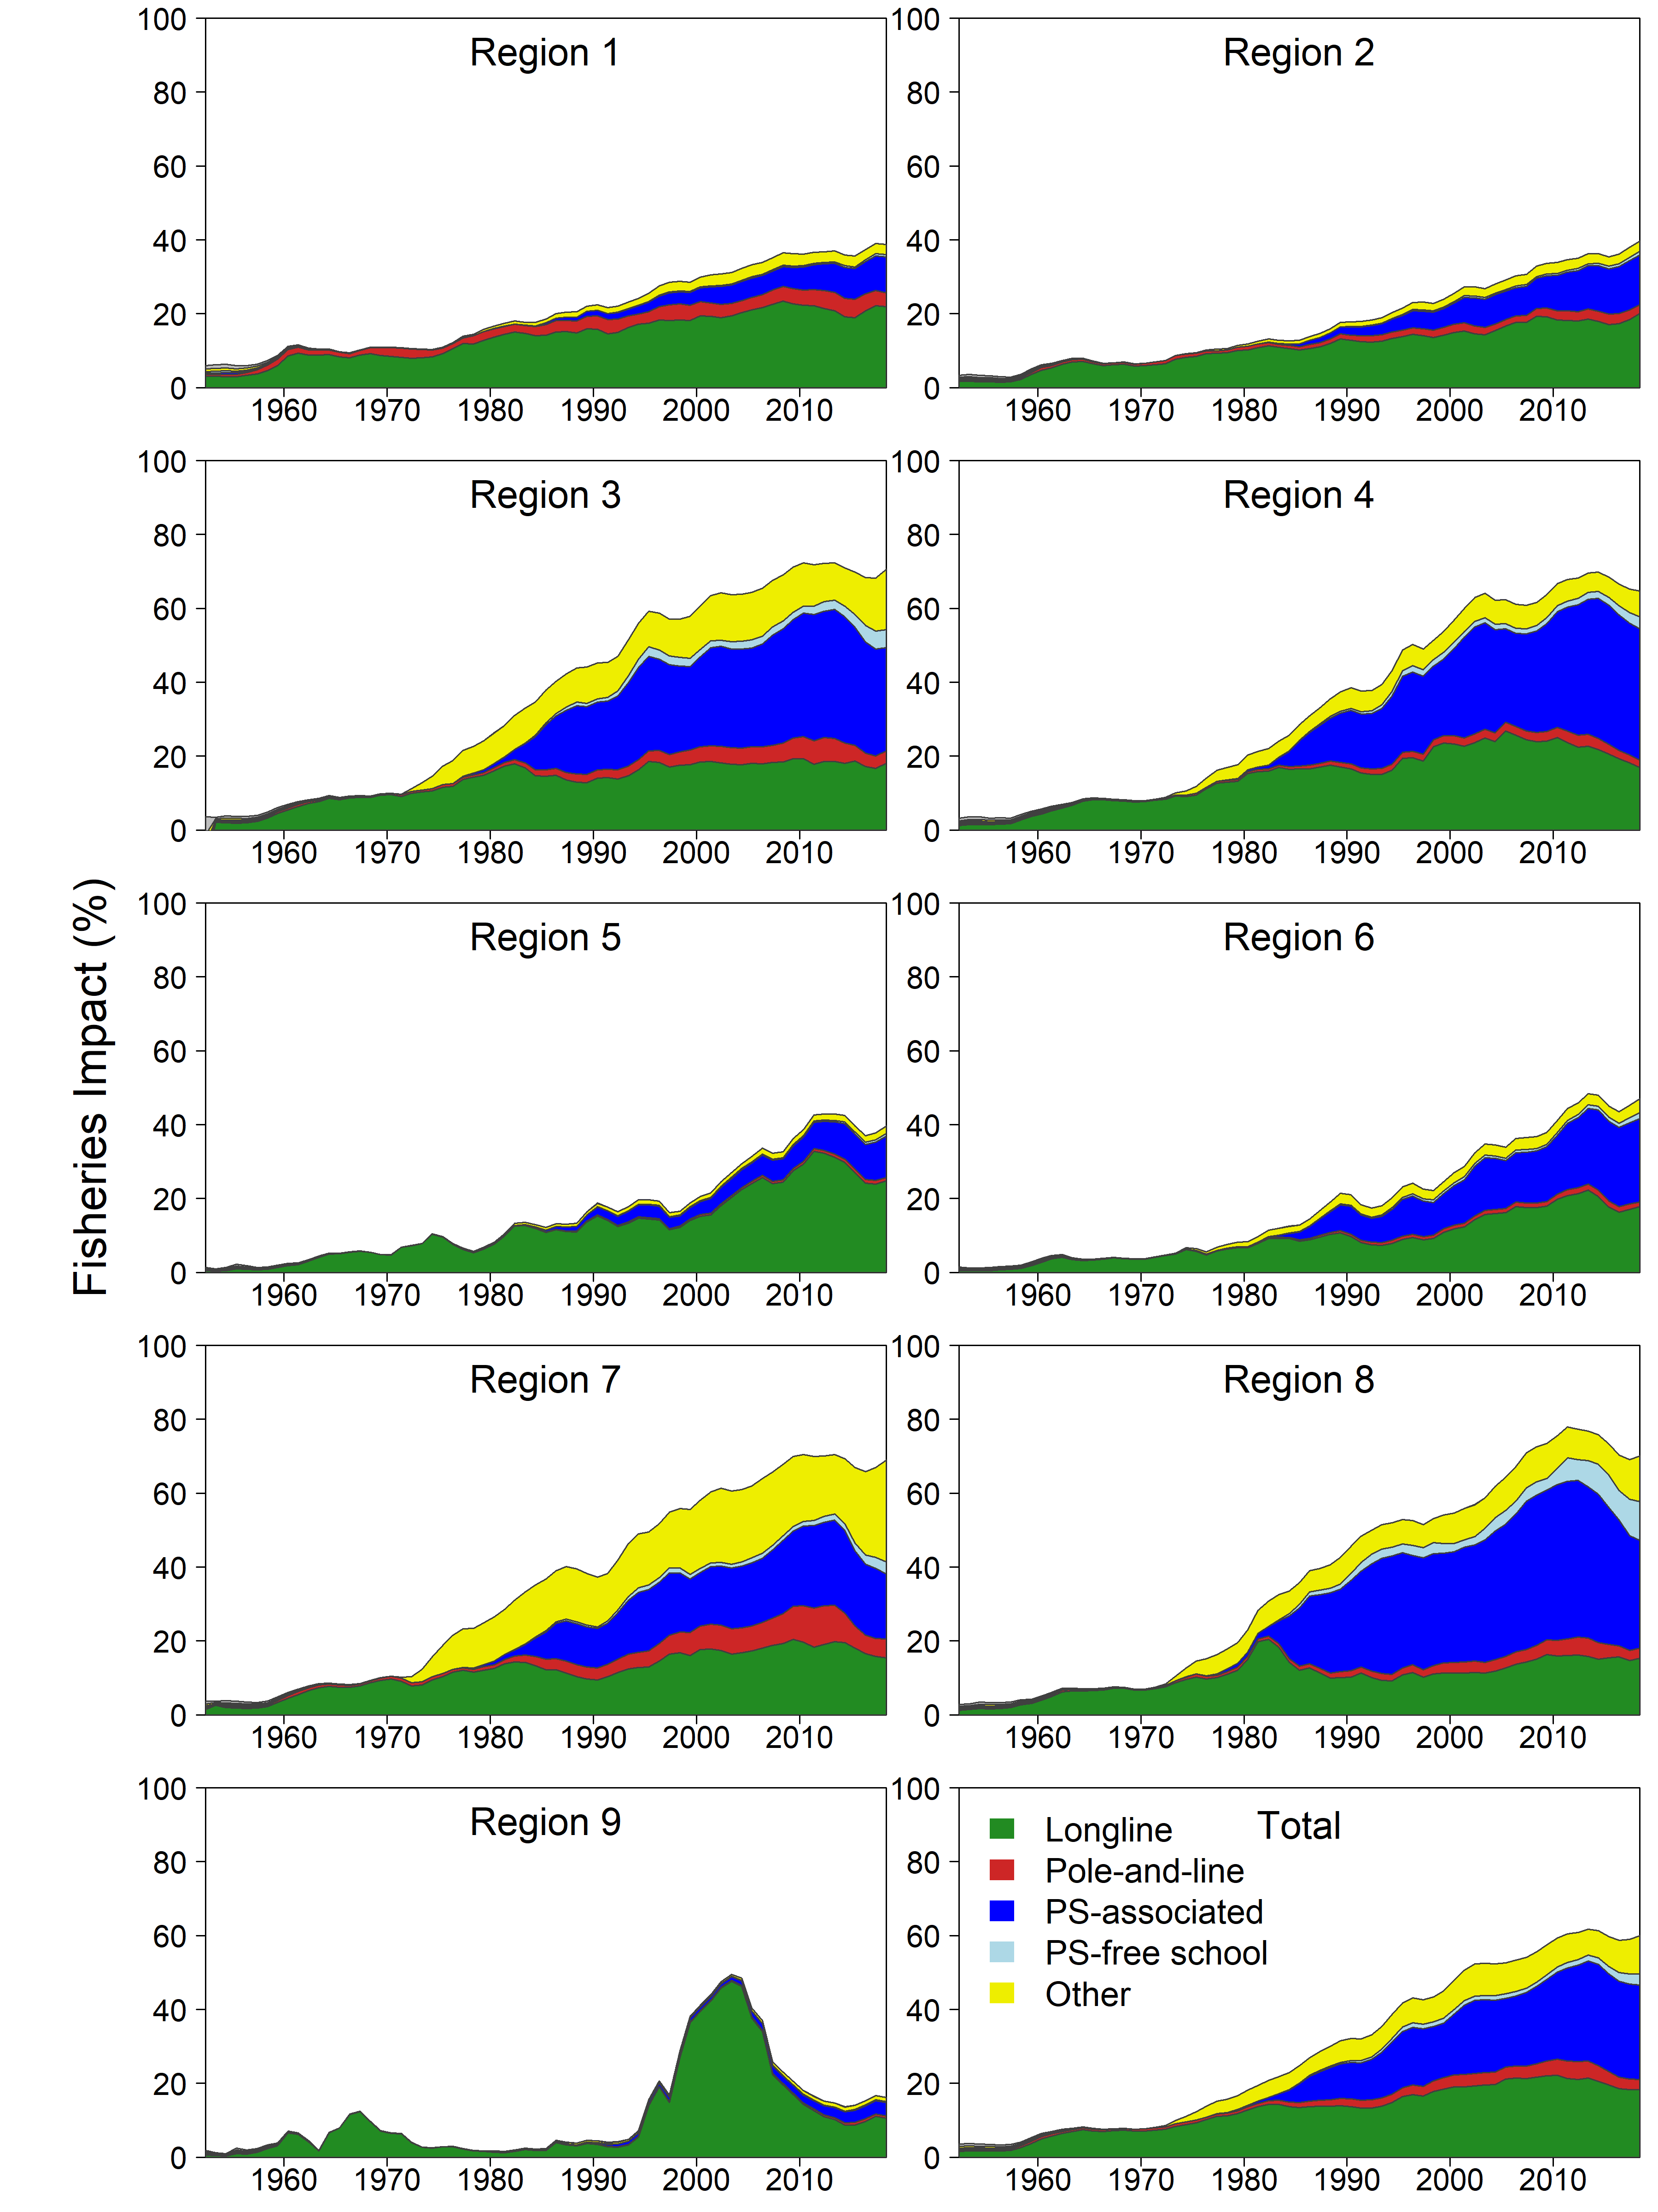

Figure BET-7.Estimates of reduction in spawning potential due to fishing (fishery impact = (1-SB_{t}/SB_{t;F=0}) * 100%) by region, and over all regions (lower right panel), attributed to various fishery groups for the diagnostic model.

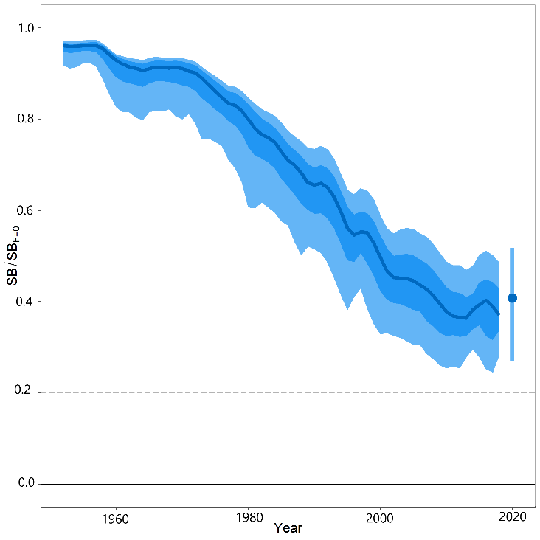
Figure BET-8. Time-dynamic percentiles of depletion (SB_{t}/SB_{t;F=0}) and median (dark line) across all 24 models in the structural uncertainty grid. The lighter band shows the 10th to 90th percentiles around the median, and the dark band shows the 50th percentile around the median. The median SB_{recent}/SB_{F=0} and 80th percentile is shown on the right by the dot and line.
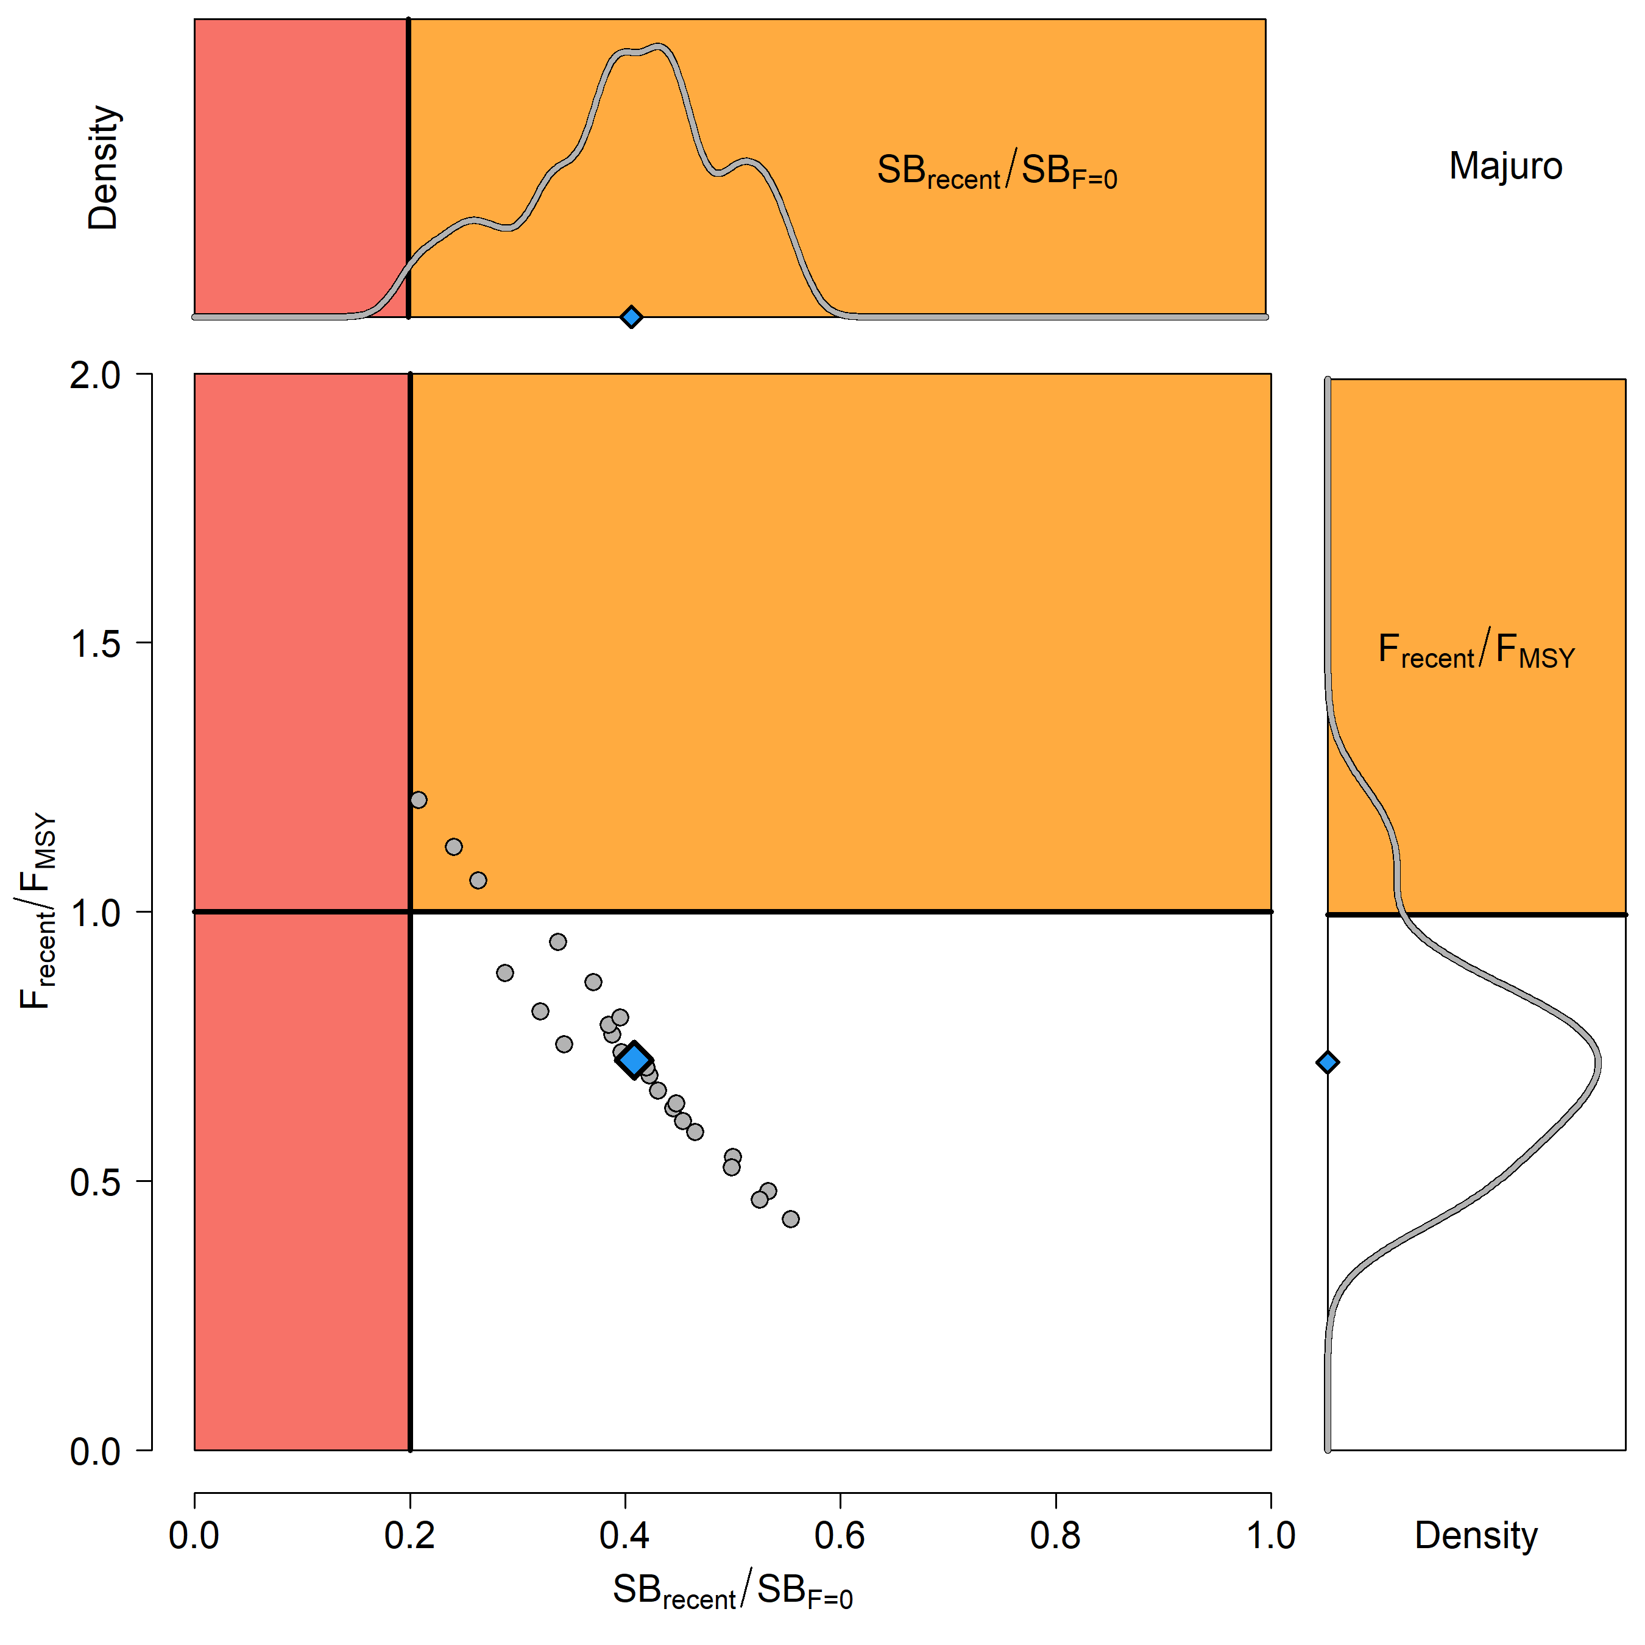

Figure BET-9. Majuro plot for the recent spawning potential (2015–2018) summarizing the results for each of the models in the structural uncertainty grid. The plots represent estimates of stock status in terms of spawning biomass depletion and fishing mortality, and marginal distributions of each are presented. The median is shown in blue.

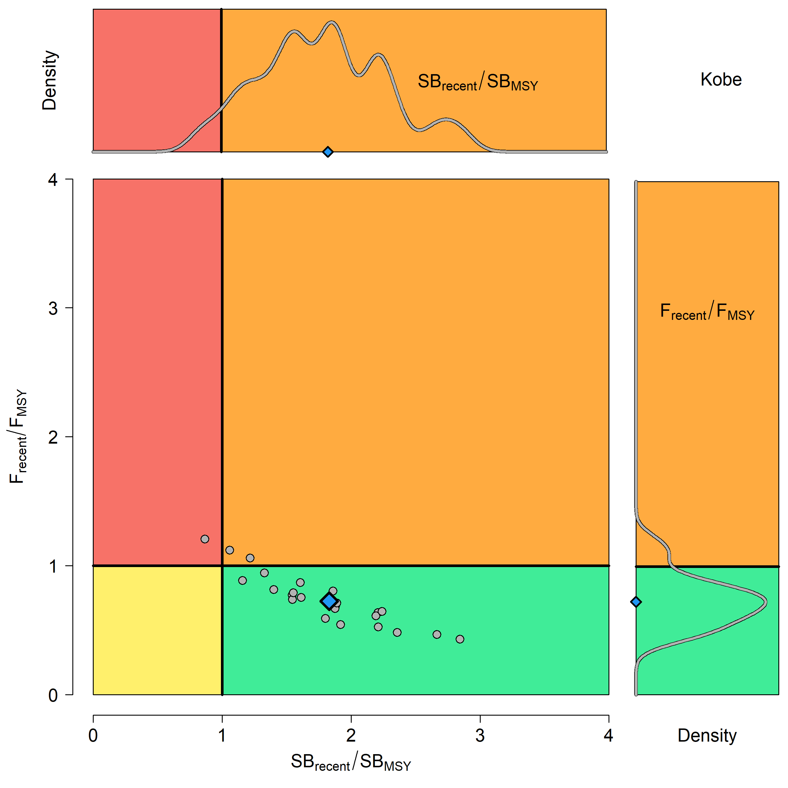

Figure BET-10. Kobe plot for the recent spawning potential (2015–2018) summarizing the results for each of the models in the structural uncertainty grid. The plots represent estimates of stock status in terms of spawning biomass depletion and fishing mortality. Marginal distributions of each are presented. The median is shown in blue.
Figure BET-11. Time series of bigeye tuna spawning potential SB_{t}/SB_{F=0}, where SB_{F=0} is the average SB from t-10 to t-1, relative to the current year t, from the uncertainty grid of assessment models for the period 2000 to 2018, and stochastic projection results for the period 2019 to 2048 assuming 2016-2018 average catches in longline and other fisheries and 2018 effort in purse seine fisheries continue. Vertical gray line at 2018 represents the last year of the assessment. During the projection period (2019-2048) levels of recruitment variability are assumed to match those over the short-term period (2008-2017). The red horizontal dashed line represents the agreed limit reference point.

Figure BET-12. Time series of bigeye tuna spawning potential SB_{t}/SB_{F=0}, where SB_{F=0} is the average SB from t-10 to t-1, relative to the current year t, from the uncertainty grid of assessment models for the period 2000 to 2018, and stochastic projection results for the period 2019 to 2048 assuming 2016-2018 average catches in longline and other fisheries and 2018 effort in purse seine fisheries continue. Vertical gray line at 2018 represents the last year of the assessment. During the projection period (2019-2048) levels of recruitment variability are assumed to match those over the long-term period (1962-2017). The red horizontal dashed line represents the agreed limit reference point.

- SC16 noted that the results from the uncertainty grid adopted by SC16 show that the stock has been continuously declining for about 60 years since the late 1950s, except for the recent small increase from 2015 to 2016 with biomass declining thereafter.

- SC16 also noted that the median value of relative recent (2015-2018) spawning biomass depletion (SB₂₀₁₅₋₂₀₁₈/ SB_{F=0}) was 0.41 with a 10thto 90th percentiles of 0.27 to 0.52.

- SC16 further noted that there was 0% probability (0 out of 24 models) that the recent (2015-2018) spawning biomass had breached the adopted limit reference point (LRP).

- SC16 noted that there has been a long-term increase in fishing mortality for both juvenile and adult bigeye tuna and while juvenile fishing mortality is higher than that of the adult fish, both adult and juvenile fishing mortality rates have stabilised somewhat since 2008 and have fluctuated without trend since that time.

- SC16 noted that the median recent fishing mortality (F_{2014-2017t}/F_{MSY}) was 0.72 with a 10th to 90th percentile interval of 0.49 to 1.02.

- SC16 noted that there was a roughly 12.5% probability (3 out of 24 models) that the recent (2014-2017) fishing mortality was above F_{MSY}.

- SC16 noted the results of stochastic projections (Figures BET-11 and BET-12) from the 2020 assessment which indicated the potential stock consequences of ﬁshing at “status quo” conditions (2016–2018 average longline and other fishery catch and 2018 purse seine effort levels) and short-term recruitment scenario using the uncertainty framework approach endorsed by SC. Projections indicate that median SB₂₀₂₅/SB_{F=0} = 0.47; median SB₂₀₃₅/SB_{F=0} = 0.49 and median SB₂₀₄₅/SB_{F=0} = 0.49. The risk that SB₂₀₄₈/SB_{F=0} is less than the Limit Reference Point is 0%.

- SC16 noted the results of stochastic projections from the long-term recruitment scenario using the uncertainty framework approach endorsed by SC. Projections indicate that median SB₂₀₂₅/SB_{F=0} = 0.42; median SB₂₀₃₅/SB_{F=0} = 0.44 and median SB₂₀₄₅/SB_{F=0} = 0.45. The risk that SB₂₀₄₈/SB_{F=0} is less than the Limit Reference Point is 5%.

- Management advice and implications

- SC16 noted that the preliminary estimate of total catch of WCPO bigeye tuna for 2019 was 135,680 mt, a 9% decrease from 2018 and an 8% decrease from the average 2014-2018. Longline catch in 2019 (68,371 mt) was a 0% decrease from 2018 and a 2% increase from the 2014-2018 average. Purse seine catch in 2019 (50,819 mt) was a 22% decrease from 2018 and a 17% decrease from the 2014-2018 average. Pole and line catch (1,400 mt) was a 66% decrease from 2018 and a 66% decrease from the average 2014-2018 catch. Catch by other gear totalled 15,090 mt and was a 33% increase from 2018 and 1% increase from the average catch in 2014-2018.

- SC16 noted that the catch in the last year of the assessment (2018) was median 159,288 mt which was greater than the median MSY (140,720 mt).

- Based on the uncertainty grid adopted by SC16, the WCPO bigeye tuna spawning biomass is above the biomass LRP and recent F is very likely below F_{MSY}. The stock is not overfished (100%probability SB/SB_{F=0}>LRP) and likely not experiencing overfishing (87.5% probability F<F_{MSY}).

- SC16 noted that levels of fishing mortality and depletion differ among regions, and that fishery impact was higher in the tropical regions (Regions 3,4,7 and 8 in the stock assessment model), with particularly high fishing mortality on juvenile bigeye tuna in these regions. There is also evidence that the overall stock status is buffered with biomass kept at more elevated level overall by low exploitation in the temperate regions (1, 2, 6 and 9). SC16 therefore re-iterates that WCPFC17 could continue to consider measures to reduce fishing mortality from fisheries that take juveniles, with the goal to increase bigeye fishery yields and reduce any further impacts on the spawning biomass for this stock in the tropical regions.

- Based on those results, SC16 recommends as a precautionary approach that the fishing mortality on bigeye tuna stock should not be increased from the level that maintains spawning biomass at 2012-2015 levels until the Commission can agree on an appropriate target reference point.

SC15 2019 (FISHERY INDICATORS UPDATED)

- Stock Status and trends
- SC15 noted that no stock assessment was conducted for WCPO bigeye tuna in 2019. Therefore, the stock status description from SC14 is still current. For further information on the stock status and trends from SC14, please see https://www.wcpfc.int/node/32155

- SC15 noted that the total bigeye catch in 2018 was 145,402 mt, a 13% increase from 2017 and a 1% decrease from the average 2013-2017.

- Longline catch in 2018 (71,305 mt) was a 23% increase from 2017 and a 7% increase from the 2013-2017 average. Purse seine catch in 2018 (64,119 mt) was a 10% increase from 2017 and a 4% increase from the 2013-2017 average. Pole and line catch (1,677 mt) was a 3% increase from 2017 and a 60% decrease from the average 2013-2017 catch. Catch by other gear (8,301 mt) was a 25% decrease from 2017 and 45% decrease from the average catch in 2013-2017.

- SC15 noted that under recent fishery conditions, the bigeye stock is initially projected to increase as recent estimated recruitments support adult stock biomass. Adult stock biomass is then projected to decline slightly before again increasing. Projected fishing mortality is below F_{MSY} (median F₂₀₂₀/F_{MSY} = 0.62, the risk of F₂₀₂₀ > F_{MSY} = 0%) and projected median spawning biomass is above the LRP (SB₂₀₂₀/SB_{F=0} = 0.2) (median SB₂₀₂₀/SB_{F=0} = 0.41; median SB₂₀₂₀/SB_{MSY} = 1.79. Risk that SB₂₀₂₀ < LRP = 0%). Projections are from the updated model runs of Vincent et al. (2018).

- Management advice and implications

- SC15 noted that no stock assessment has been conducted since SC14. Therefore, the advice from SC14 should be maintained, pending a new assessment or other new information. For further information on the management advice and implications from SC14, please see https://www.wcpfc.int/node/32155

- Research recommendations

- SC15 reviewed progresses for the research recommendations from SC14 for bigeye growth and noted that the following research issues need to be addressed further, after classifying these research items as short-term (preferably before SC16) and long-term (preferably before the scheduled 2023 stock assessment).
  - Develop MULTIFAN-CL functionality that can accommodate spatial variation in growth rates and movement between western and eastern Pacific to consider the appropriateness of delineating the two stocks at 150˚W (long-term).
  - Carry out further otolith age validation studies for fish in the western and central Pacific. Consider chemically marking fish at release in future tagging programs and then analyzing otoliths from recaptured marked fish (long-term). Apply other age validation methodology including radiocarbon age validation (short to long-term). SC15 noted potential issues of the spatial pattern of radiocarbon in the Pacific Ocean and its implications for mobile adult tuna.
  - Continue to develop and document protocols for daily and annual ageing by IATTC and WCPFC (short-term).
  - Continue efforts under Project 94 to collect very small bigeye caught by the Indonesian, Vietnamese, and Philippines domestic fisheries in region 7 to aid in the estimation of the size at age-1 qtr-1 parameter (L1) within the assessment model (short to long-term).
  - Compile a high confidence tagging dataset for growth analysis and develop integrated growth models incorporating the tagging data and the otolith data (short-term).
  - Conduct sensitivity analysis using alternative growth models in the stock assessment, if new growth models are developed such as an integrated growth model (short -term), a conditional age-at-length growth model (short-term), and other growth models after conducting further growth analysis listed above.
  - Undertake a genetic stock structure analysis (long-term).

SC14 2018 (ASSESSMENT UPDATE CONDUCTED)

- Stock Status and trends

- The median values of relative recent (2012-2015) spawning biomass depletion (SB_{recent}/ SB_{F=0}) and relative recent (2011-2014) fishing mortality (F_{recent}/F_{MSY}) over the uncertainty grid of 36 models (Table BET-1) were used to define stock status. The values of the upper 90th and lower 10th percentiles of the empirical distributions of relative spawning biomass and relative fishing mortality from the uncertainty grid were used to characterize the probable range of stock status.

- A description of the updated structural sensitivity grid used to characterize uncertainty in the assessment is set out in Table BET-1. Time series of total annual catch by fishing gear over the full assessment period is shown in Figure BET-1. Estimated trends in spawning biomass depletion for the 36 models in the structural uncertainty grid is shown in Figure BET-2, and juvenile and adult fishing mortality rates from the diagnostic case model is show in BET-3. Figure BET-4 displays Majuro plots summarising the results for each of the models in the structural uncertainty grid. Figures BET-5 show Kobe plots summarising the results for each of the models in the structural uncertainty grid. Table BET-2 provides a summary of reference points over the 36 models in the structural uncertainty grid.

- SC14 agreed to use the “updated new growth” model to describe the stock status of BET because SC14 considered it to be the best available scientific information. By removing results using the old growth model, the stock status becomes considerably more optimistic. However, SC14 also notes that questions remain regarding the “updated new growth” model.

- Therefore, SC14 acknowledges that further study is warranted related to the new growth model, in particular as to the cause of the difference of growth between EPO and WCPO. An inter-laboratory ageing workshop is planned for late 2018 to review ageing approaches in the WCPO and EPO and to resolve differences, if they exist.

- In addition, SC14 acknowledges that further study is warranted to refine the tagging dataset in the WCPO to assist validating age estimates of bigeye in the WCPO. SC14 further notes that adopting the new growth curve generates new broader questions related to the BET stock assessment and agreed that several aspects need to be investigated further to inform future assessments.

Table BET-1. Description of the updated structural sensitivity grid used to characterize uncertainty in the assessment.
Axis | Levels | Option
Steepness | 3 | 0.65, 0.80, 0.95
Growth | 1 | ‘Updated new growth’
Tagging over-dispersion | 2 | Default level (1), fixed (moderate) level
Size frequency weighting | 3 | Sample sizes divided by 10, 20, 50
Regional structure | 2 | 10°N regions, 20°N regions

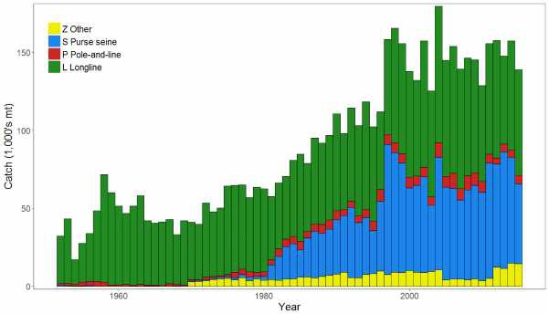

Figure BET-1. Time series of total annual catch (1000's mt) by fishing gear over the full assessment period.

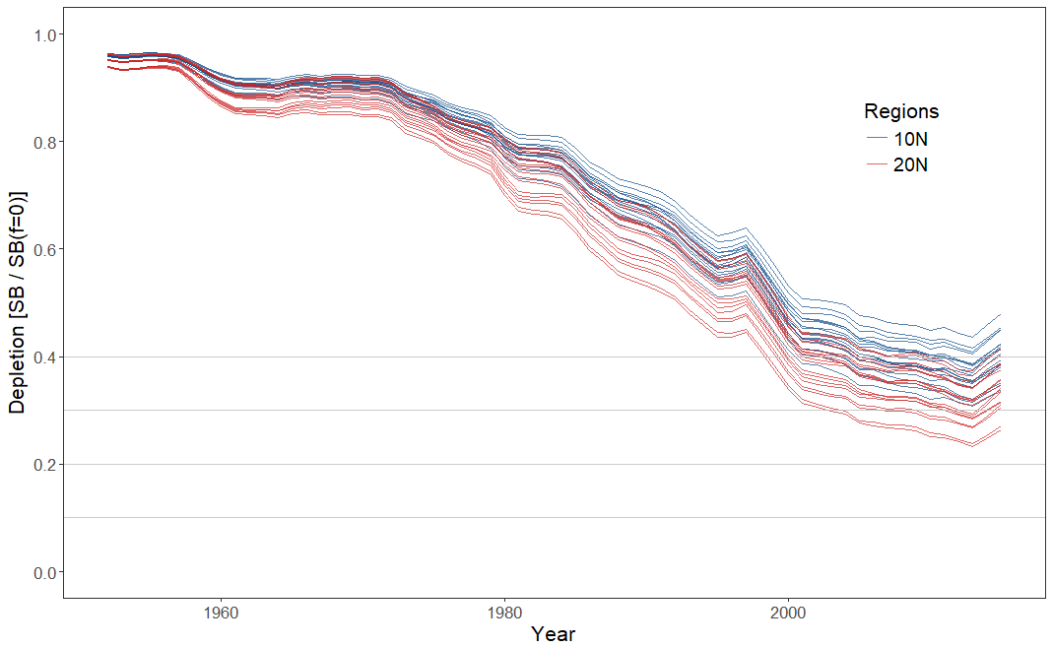
Figure BET-2. Plot showing the trajectories of spawning biomass depletion for the 36 model runs included in the structural uncertainty grid. The colours depict the models in the grid with the 10°N and 20°N spatial structures.

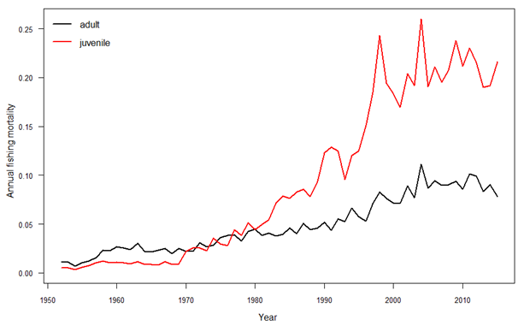
Figure BET-3. Estimated annual average juvenile and adult fishing mortality for the diagnostic case model.

SB_{recent} (2012-2015) / SB_{F=0} | SB_{latest} (2015) / SB_{F=0}
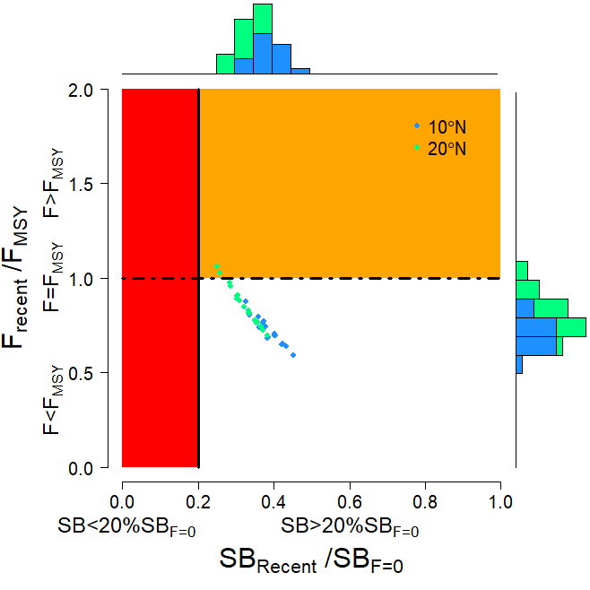 | 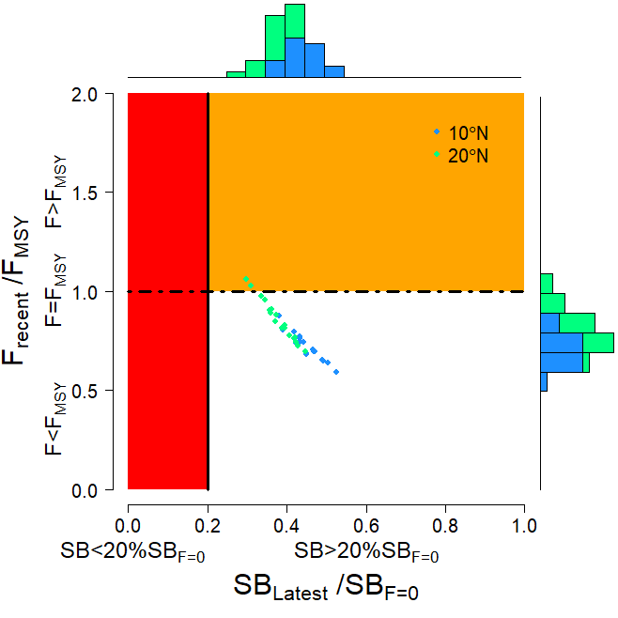
Figure BET-4. Majuro plot summarising the results for each of the models in the structural uncertainty grid. The plots represent estimates of stock status in terms of spawning biomass depletion and fishing mortality. The red zone represents spawning biomass levels lower than the agreed limit reference point, which is marked with the solid black line. The orange region is for fishing mortality greater than FMSY (FMSY is marked with the black dashed line). In the upper panel, the points represent SBrecent/SBF=0, where SBrecent is the mean SB over 2012-2015. In the lower panel, the points represent SB_{latest}/SB_{F=0}, where SB_{latest} is from 2015. In both panels the colours depict the models in the grid with the 10°N and 20°N regional structures.

SB_{recent} (2012-2015) / SB_{MSY} | SB_{latest} (2015) / SB_{MSY}
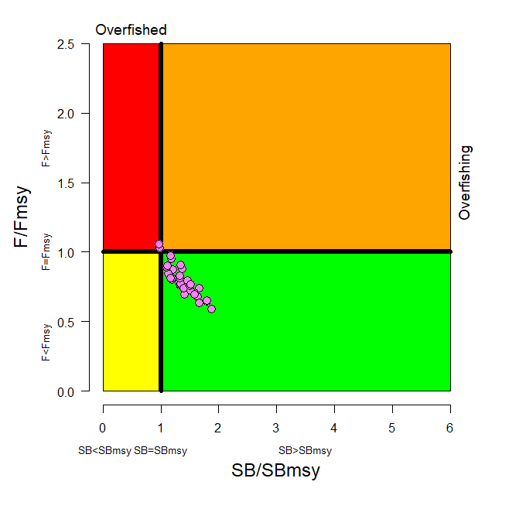 | 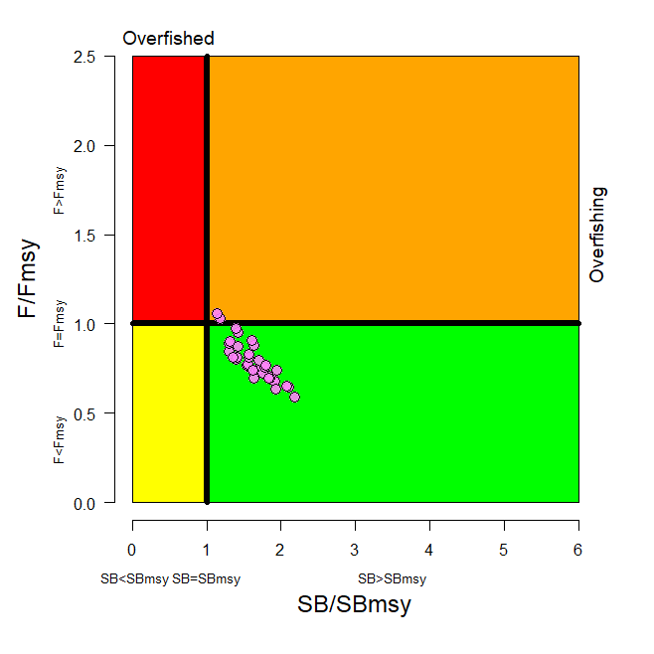
Figure BET-5. Kobe plot summarising the results for each of the models in the structural uncertainty grid. In the upper panel, the points represent SBrecent/SBMSY, where SBrecent is the mean SB over 2012-2015. In the lower panel, the points represent SB_{latest}/SB_{MSY}, where SB_{latest} is from 2015.

Table BET-2. Summary of reference points over the 36 models in the structural uncertainty grid. Note that SBrecent/SBF=0 is calculated where SBrecent is the mean SB over 2012-2015 at the request of the Scientific Committee.
 | Mean | Median | Min | 10% | 90% | Max
C_{latest} | 152,148 | 151,846 | 148,888 | 148,936 | 154,971 | 155,577
YF_{recent} | 154,180 | 153,220 | 133,120 | 141,140 | 170,720 | 172,280
f_{mult} | 1.291 | 1.301 | 0.946 | 1.075 | 1.499 | 1.690
F_{MSY} | 0.050 | 0.049 | 0.044 | 0.045 | 0.054 | 0.056
MSY | 158,551 | 159,020 | 133,520 | 143,040 | 173,880 | 180,120
F_{recent}/F_{MSY} | 0.789 | 0.768 | 0.592 | 0.667 | 0.931 | 1.058
SB₀ | 1,674,833 | 1,675,500 | 1,261,000 | 1,415,500 | 1,941,000 | 2,085,000
SB_{F=0} | 1,841,609 | 1,858,775 | 1,509,007 | 1,632,014 | 2,043,108 | 2,139,644
SB_{MSY} | 471,956 | 476,050 | 340,700 | 386,600 | 577,400 | 614,200
SB_{MSY}/SB₀ | 0.281 | 0.280 | 0.260 | 0.262 | 0.300 | 0.302
SB_{MSY}/SB_{F=0} | 0.255 | 0.255 | 0.226 | 0.235 | 0.280 | 0.287
SB_{latest}/SB₀ | 0.456 | 0.456 | 0.346 | 0.392 | 0.523 | 0.568
SB_{latest}/SB_{F=0} | 0.414 | 0.420 | 0.298 | 0.351 | 0.480 | 0.526
SB_{latest}/SB_{MSY} | 1.633 | 1.624 | 1.146 | 1.306 | 1.933 | 2.187
SB_{recent}/SB_{F=0} | 0.353 | 0.358 | 0.251 | 0.295 | 0.412 | 0.452
SB_{recent}/SB_{MSY} | 1.394 | 1.377 | 0.963 | 1.117 | 1.659 | 1.879

- SC14 noted that there has been a long-term decrease in spawning biomass from the 1950s to the present for bigeye tuna and that this is consistent with previous assessments.

- SC14 also noted that the central tendency of relative recent (2012-2015) spawning biomass depletion was median (SB_{recent}/SB_{F=0}) = 0.36 with a range of 0.30 to 0.41 (80% probability interval).

- SC14 further noted that there was 0% probability (0 out of 36 models) that the recent spawning biomass had breached the adopted LRP.

- SC14 noted that there has been a long-term increase in fishing mortality for both juvenile and adult bigeye tuna, consistent with previous assessments.

- SC14 also noted that the central tendency of relative recent fishing mortality was median (Frecent/FMSY) = 0.77 with an 80% probability interval of 0.67 to 0.93.

- SC14 further noted that there was a roughly 6% probability (2 out of 36 models) that the recent fishing mortality was above FMSY.

- SC14 also noted that, regardless of the choice of uncertainty grid, the assessment results show that the stock has been continuously declining for about 60 years since the late 1950’s, except for the recent small increase.

- SC14 also noted the continued relatively higher levels of depletion in the equatorial and western Pacific (specifically Regions 3, 4, 7 and 8) and the associated higher levels of impact, especially on juvenile bigeye tuna, in these regions due to the associated purse-seine fisheries and the ‘other’ fisheries within the western Pacific (as shown in Figures 46 and 47 of SC13-SA-WP-03).

- Table BET-3 summarises the median values of SB/SB_{F=0} and F/F_{MSY} achieved in the long term, along with the potential risk of breaching the limit reference point (LRP) and exceeding F_{MSY}, under each of the future fishing and recruitment combinations. Figure 1 presents the corresponding distributions of long term SB/SB_{F=0} and Figure 2 those for F/F_{MSY}. Potential outcomes under the 2013-15 average and CMM scenario conditions were
strongly influenced by the assumed future recruitment levels.

- Under the assumption that recent positive recruitments will continue into the future, spawning biomass relative to unfished levels is predicted to increase from recent levels under all examined future scenarios by 0-18% (SB₂₀₄₅/SB_{F=0} ranges from 0.36 to 0.42; Table BET-3, Figure BET-6). While future uncertainty in stock status increases due to stochastic future recruitment levels, the risk of future spawning biomass falling below the LRP falls to between 0 and 5%, due to the improved overall stock size. Fishing mortality falls slightly under both the status quo and optimistic scenarios, assuming recent recruitment. However, fishing mortality increases under the pessimistic scenario, but remains below F_{MSY} (30% risk of F > F_{MSY} Table BET-3, Figure BET-7).

- Under the assumption that less positive long-term recruitments are experienced in the future, spawning biomass relative to unfished levels will decline under all scenarios (SB₂₀₄₅/SB_{F=0} ranges from 0.25 to 0.30). The risk of spawning biomass falling below the LRP increases to between 17 and 32% (Table BET-3). In all fishing scenarios, fishing mortality increases relative to recent levels (by 109-138%) and is well above F_{MSY}. Risk of fishing mortality exceeding F_{MSY} ranges from 93 to 98%.

- It should be noted that even under assumption of long term recruitment levels, the risk of exceeding the LRP in the short-term ranges between 2% and 7% (2020) and 12% and 26% (2025), with only the pessimistic scenario exceeding the 20% level of risk in 2025. (Table BET-4)

Table BET-3. Including ‘2013-15 average levels’
Median values of reference point levels (adopted limit reference point (LRP) of 20% SBF=0; FMSY) and risk1 of breaching reference points from the 2017 bigeye stock assessment incorporating updated growth information, and in 2045 under the three future harvest scenarios (2013-15 average fishing levels, optimistic and pessimistic) and alternative recruitment hypotheses. ‘Updated new growth’ runs only.
Scenario |  | Scalars relative to 2013-2015 |  | Median SB₂₀₄₅/SB_{F=0} | Median SB₂₀₄₅/SB_{F=0}  v  SB₂₀₁₂₋₁₅/SB_{F=0} | Median  F₂₀₄₁₋₂₀₄₄/F_{MSY} | Median F₂₀₄₁₋₂₀₄₄/ F_{MSY} vs  F₂₀₁₁₋₁₄/ F_{MSY} | Risk
Recruitment | Fishing level | Purse seine | Longline |  |  |  |  | SB₂₀₄₅ < LRP | F>F_{MSY}
Bigeye assessment (‘recent’ levels) |  |  |  | 0.36 | - | 0.77 | - | 0% | 6%
Recent | 2013-15 avg | 1 | 1 | 0.42 | 1.18 | 0.73 | 0.95 | 0% | 11%
Recent | Optimistic | 1.11 | 0.98 | 0.41 | 1.15 | 0.75 | 0.98 | 0% | 13%
Recent | Pessimistic | 1.12 | 1.35 | 0.36 | 1.00 | 0.89 | 1.15 | 5% | 30%
Long-term | 2013-15 avg | 1 | 1 | 0.30 | 0.84 | 1.60 | 2.09 | 17% | 93%
Long-term | Optimistic | 1.11 | 0.98 | 0.29 | 0.82 | 1.64 | 2.13 | 18% | 94%
Long-term | Pessimistic | 1.12 | 1.35 | 0.25 | 0.70 | 1.84 | 2.38 | 32% | 98%
¹ note risk within the stock assessment is calculated as the (weighted) number of models falling below the LRP (X / 36 models). Risk under a projection scenario is the number of projections across the grid that fall below the LRP (X / 3600 (36 models x 100 projections).

Table BET-4. Median values of SB/SBF=0 and associated risk of breaching the adopted limit reference point (LRP) of 20% SBF=0 in 2020, 2025 and 2045 under the three future harvest scenarios (2013-15 average fishing levels, optimistic and pessimistic) and alternative recruitment hypotheses. ‘Updated new growth’ runs only.
Scenario |  | Scalars relative to 2013-2015 |  | Median SB₂₀₂₀/SB_{F=0} | Median SB₂₀₂₅/SB_{F=0} | Median SB₂₀₄₅/SB_{F=0} | Risk SB₂₀₂₀ < LRP | Risk SB₂₀₂₅ < LRP | Risk SB₂₀₄₅ < LRP
Recruitment | Fishing level | Purse seine | Longline
Recent | 2013-15 avg | 1 | 1 | 0.42 | 0.41 | 0.42 | 0% | 1% | 0%
Recent | Optimistic | 1.11 | 0.98 | 0.41 | 0.40 | 0.41 | 0% | 1% | 0%
Recent | Pessimistic | 1.12 | 1.35 | 0.38 | 0.35 | 0.36 | 0% | 4% | 5%
Long-term | 2013-15 avg | 1 | 1 | 0.35 | 0.30 | 0.30 | 2% | 12% | 17%
Long-term | Optimistic | 1.11 | 0.98 | 0.35 | 0.30 | 0.29 | 2% | 13% | 18%
Long-term | Pessimistic | 1.12 | 1.35 | 0.32 | 0.26 | 0.25 | 7% | 26% | 32%

Recent recruitments | Long-term recruitment
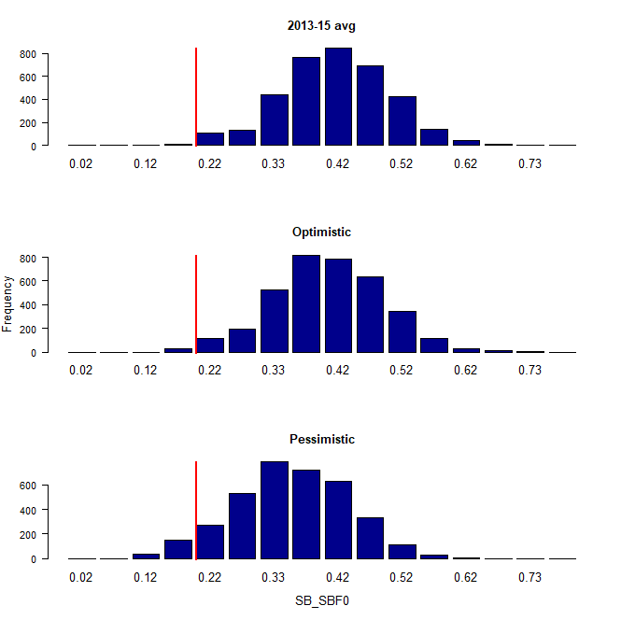 | 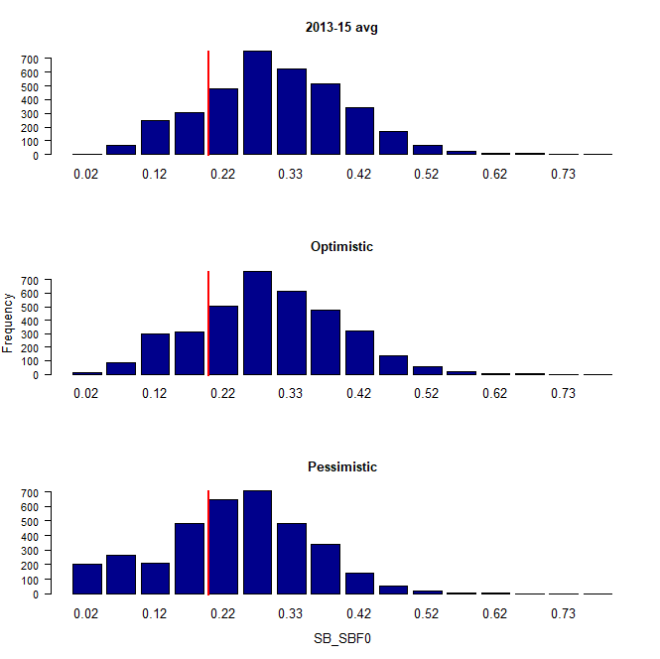
Figure BET-6. Distribution of SB2045/SBF=0 assuming recent and long term recruitment conditions (left and right columns, respectively), under the three future fishing scenarios: 2013-15 avg (2013-15 average conditions, top row); optimistic conditions (middle row); and pessimistic conditions (bottom row). Projection results from ‘updated new growth’ models (3,600 projections) only where the red line indicates the LRP.

Recent recruitments | Long-term recruitment
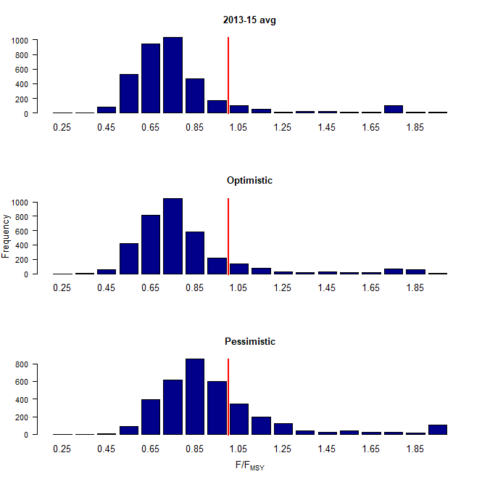 | 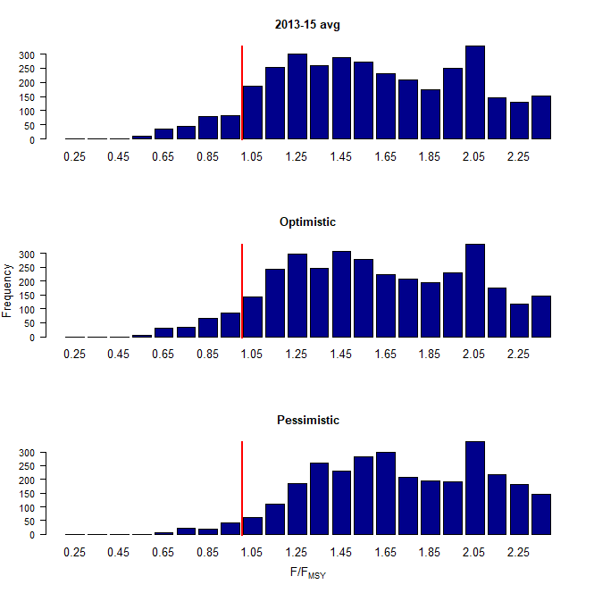
Figure BET-7. Distribution of F/F_{MSY} assuming recent and long term recruitment conditions (left and right columns, respectively), under the three future fishing scenarios: 2013-15 avg (2013-15 average conditions, top row); optimistic conditions (middle row); and pessimistic conditions (bottom row). Projection results from ‘updated new growth’ models (3,600 projections) only.

Recent recruitments | Long-term recruitment
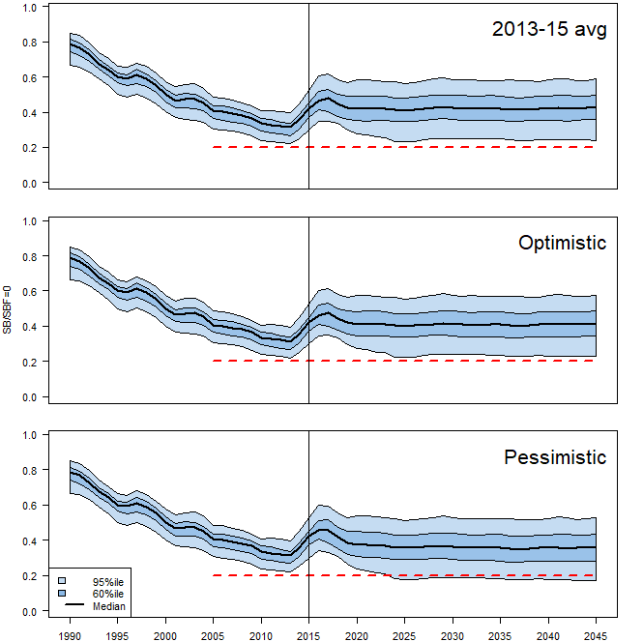 | 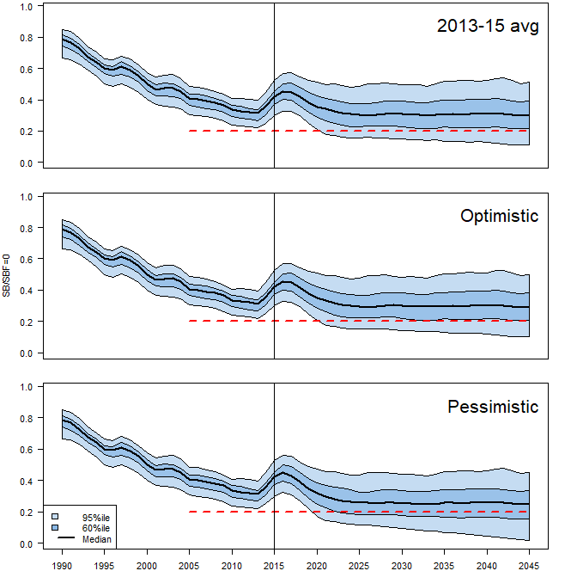
Figure BET-8. Time series of WCPO bigeye tuna spawning biomass (SB/SBF=0) from the uncertainty grid of assessment model runs for the period 1990 to 2015 (the vertical line at 2015 represents the last year of the assessment), and stochastic projection results for the period 2016 to 2045 under the three future fishing scenarios (“2013-15 avg”, “Optimistic” and “Pessimistic”; rows). During the projection period (2016-2045) levels of recruitment variability are assumed to match those over the “recent” time period (2005-2014; left panel) or the time period used to estimate the stock-recruitment relationship (1962-2014; right panel). The red dashed line represents the agreed limit reference point.

- Management advice and implications

- SC14 noted that the preliminary estimate of total catch of WCPO bigeye tuna for 2017 was 126,929t, a 17% decrease from 2016 and a 19% decrease from the average 2012-2016. Longline catch in 2017 (58,164t) was an 8% decrease from 2016 and a 19% decrease from the 2012-2016 average. Purse seine catch in 2017 (56,194t) was a 12% decrease from 2016 and a 13% decrease from the 2012-2016 average. Pole and line catch (1,411t) was a 65% decrease from 2016 and a 70% decrease from the average 2012-2016 catch. Catch by other gear (11,160t) was a 48% decrease from 2016 and 28% decrease from the average catch in 2012-2016.

- Based on the uncertainty grid adopted by SC14, the WCPO bigeye tuna spawning biomass is above the biomass LRP and recent F is very likely below FMSY. The stock is not experiencing overfishing (94% probability F<F_{MSY}) and it is not in an overfished condition (0% probability SB/SB_{F=0}<LRP).

- Although SC14 considers that the updated assessment is consistent with the previous assessment, SC14 also advises that the amount of uncertainty in the stock status results for the 2018 assessment update is lower than for the previous assessment due to the exclusion of old information on bigeye tuna growth.

- SC14 noted that levels of fishing mortality and depletion differ among regions, and that fishery impact was higher in the tropical region (Regions 3, 4, 7 and 8 in the stock assessment model), with particularly high fishing mortality on juvenile bigeye tuna in these regions. SC14 therefore recommends that WCPFC15 could continue to consider measures to reduce fishing mortality from fisheries that take juveniles, with the goal to increase bigeye fishery yields and reduce any further impacts on the spawning biomass for this stock in the tropical regions.

- SC14 noted that according to CMM-17-01 bigeye tuna SB/SB_{F=0} is to be maintained above the 2012-2015 level (SB_{recent}/SB_{F=0} = 0.36; Table BET-3) pending the agreement on a TRP. SC14 also noted that the projection results based on scenarios estimating CMM2017-01 indicated a high level of uncertainty on the levels of spawning stock biomass relative to the LRP and the objective of CMM-2017-01 in 2045. Under the scenario assuming long-term average recruitment continues into the future there was a high risk (add value) of breaching the LRPs and a zero probability of achieving the objective of CMM-2017-01, while under the scenario which assumes higher more recent recruitments continues into the future there was a low risk (add value) of breaching the LRPs and a 100% probability of achieving the objective of CMM-2017-01.

- However, SC14 also noted that the projections assume that longline catches would be maintained regardless of the decrease in biomass. This may result in unlikely high levels of effort. Therefore, the catch estimates under the long-term recruitment scenario, especially in the longer term projections, are more uncertain.

- Based on these results, SC14 recommends that WCPFC15 takes note of the results of the projections in relation achieving CMM-2017-01 and as a precautionary approach that the fishing mortality on bigeye tuna stock should not be increased from the recent average (2011-2014) level to maintain spawning biomass at or above the 2012-2015 average, until the Commission can articulate the management objectives and agree on an appropriate target reference point (TRP) for BET, although one CCM considers that SC14 could provide more options for the commission to consider.

- Research Recommendations

- SC14 noted that the acceptance of the new growth model for BET raises a number of issues in relation to patterns of growth and stock structure of BET across the Pacific Ocean and recommended that the following research issues need to be addressed:

- Two different growth models separated at 150˚W effectively means that Pacific BET should be assessed as a two-stock resource between the WCPO and EPO. However, catch information indicates that the fishing grounds near 150˚W are a core area of BET catch, thus influencing the assessments of both the WCPFC and IATTC. Also, tagging information suggests movement of BET between the WCPO and EPO. Therefore, the appropriateness off delineating the two stocks at 150˚W needs to be investigated.
- The new growth analysis suggests area variant growth across the Pacific. While the level of variation is seen to be relatively small within the WCPO (and possibly within the margins of observation error), there is a suggestion of substantial change in growth around the boundary between the WCPO and the EPO (c.f. Figure 14 in SA-WP-01). The reasons for this suggested change in growth remains unknown, but SC14 noted the utility of collecting more information from the regions either side of this boundary to inform a greater understanding of possible changes in growth around this area. While the incorporation of area-variant growth within the assessment model would also help explore this issue, SC14 noted the difficulty of this task.
- SC11 concluded that the stock status of WCPO BET from the Pan-Pacific assessment and the WCPO-only assessment were similar when the growth models were similar in the EPO and WCPO. This conclusion needs to be revisited in light of the different growth between EPO and WCPO by adopting the new growth.

- The following additional research activities were also recommended by SC14 in order to improve the understanding of the age and growth of BET across the Pacific:

- A WCPO growth model based on size composition and tagging data, as well as the use of additional modeling approaches (e.g., length-conditional), should also be evaluated.
- Collaboration with the IATTC to analyze bigeye growth from otolith and tagging data collected across the entire Pacific, to better characterize the apparent regional difference in growth between the WCPO and EPO, and possible environmental determinants of such differences.
- Analyzing the same otoliths by different laboratories, to build confidence in ageing estimates and to estimate ageing error.
- Continued development of a high-confidence tagging dataset for growth analysis, with particular focus on larger bigeye tuna and events with reliable measurements at release. Such data would assist with the validation of the age estimates of large bigeye in the WCPO and could potentially be incorporated directly into the assessment model as an additional data set. However, a reliable measurement of both length at release and recapture are necessary to accurately estimate incremental growth.
- Collect otoliths of very small bigeye that are captured by the Indonesian, Vietnamese, and Philippines domestic fisheries in region 7 and estimate age through daily ring counts to aid in the estimation of the size at age-1 qtr⁻¹ parameter (L1) within the assessment model.

SC13 2017 (STOCK ASSESSMENT CONDUCTED)

- Stock status and trends

- The median values of relative recent (2012-2015) spawning biomass (SBrecent/ SBF=0) and relative recent fishing mortality (Frecent/FMSY) over the uncertainty grid were used to measure the central tendency of stock status. The values of the upper 90th and lower 10th percentiles of the empirical distributions of relative spawning biomass and relative fishing mortality from the uncertainty grid were used to characterize the probable range of stock status.

- A description of the updated structural sensitivity grid used to characterize uncertainty in the assessment was set out in Table BET-1. Time series of total annual catch by fishing gear for the diagnostic case model over the full assessment period is shown in Figure BET-1. Estimated annual average recruitment, spawning potential, juvenile and adult fishing mortality and fishing depletion for the diagnostic case model are shown in Figures BET-2 – BET-5. Figures BET-6 and BET-7 display Majuro plots summarising the results for each of the models in the structural uncertainty grid. Figures BET-8 and BET-9 show Kobe plots summarising the results for each of the models in the structural uncertainty grid. Figure BET-10 provides estimated time-series (or “dynamic”) Majuro and Kobe plots from the bigeye ‘diagnostic case’ model run. Figure BET-11 provides estimates of reduction in spawning potential due to fishing by region, and over all regions attributed to various fishery groups (gear-types) for the diagnostic case model. Table BET-2 provides a summary of reference points over the 72 models in the structural uncertainty grid.

Table BET-1. Description of the updated structural sensitivity grid used to characterize uncertainty in the assessment.
Axis | Levels | Option
Steepness | 3 | 0.65, 0.80, 0.95
Growth | 2 | ‘Old growth’, ‘New growth’
Tagging over-dispersion | 2 | Default level (1), fixed (moderate) level
Size frequency weighting | 3 | Sample sizes divided by 10, 20, 50
Regional structure | 2 | 2017 regions, 2014 regions

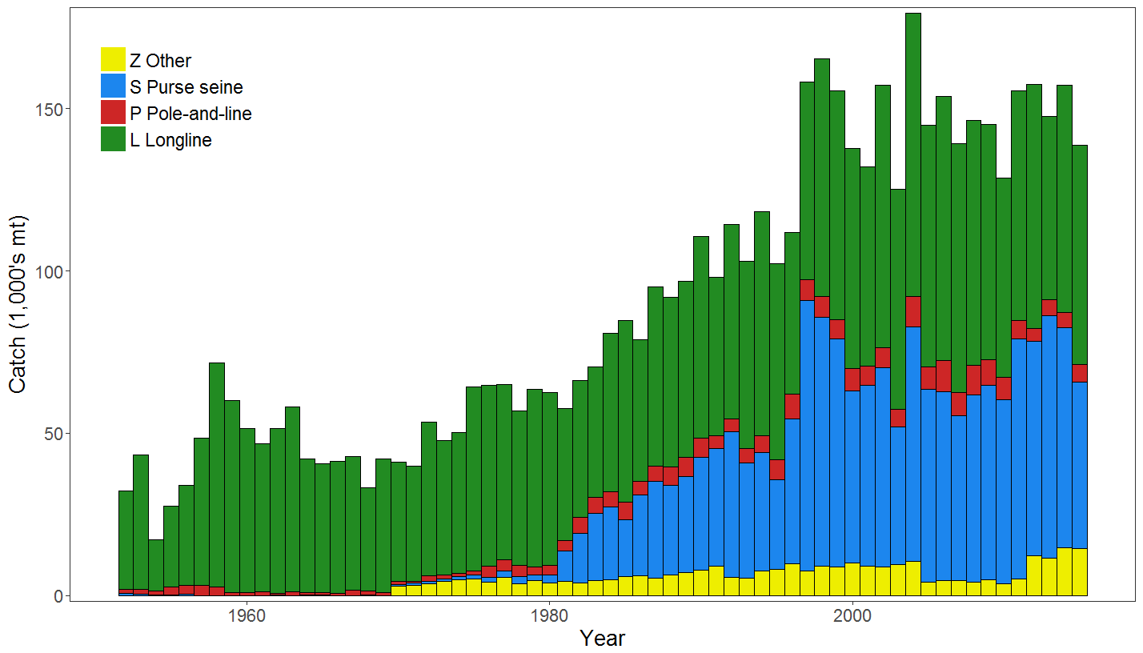
Figure BET-1. Time series of total annual catch (1000's mt) by fishing gear for the diagnostic case model over the full assessment period.

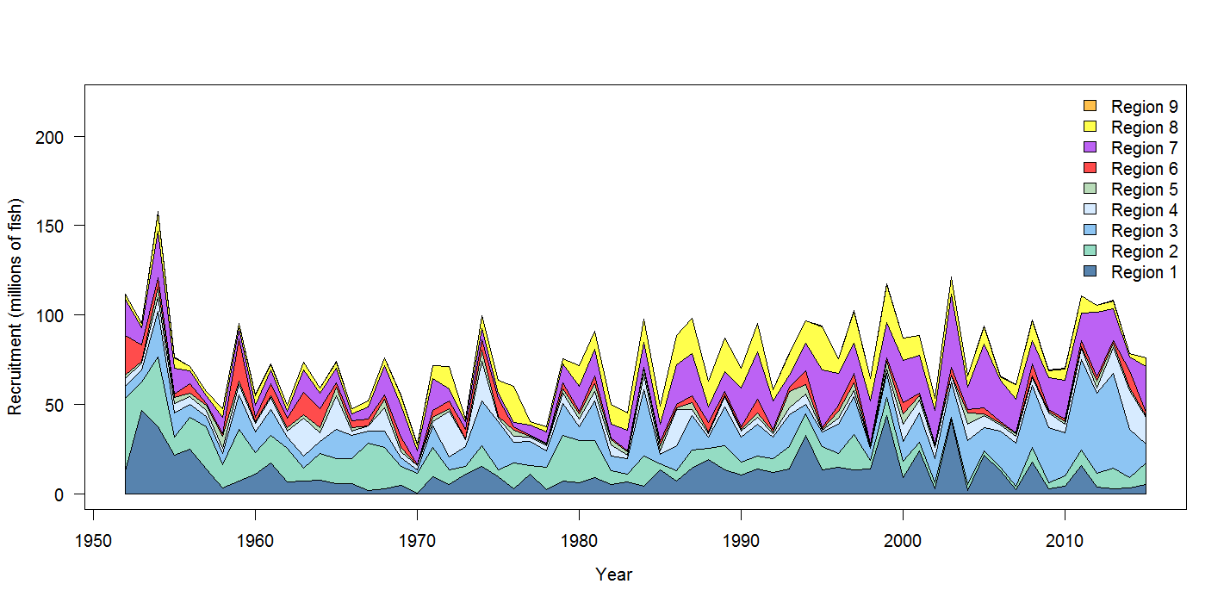
Figure BET-2. Estimated annual average recruitment by model region for the diagnostic case model, showing the relative sizes among regions.

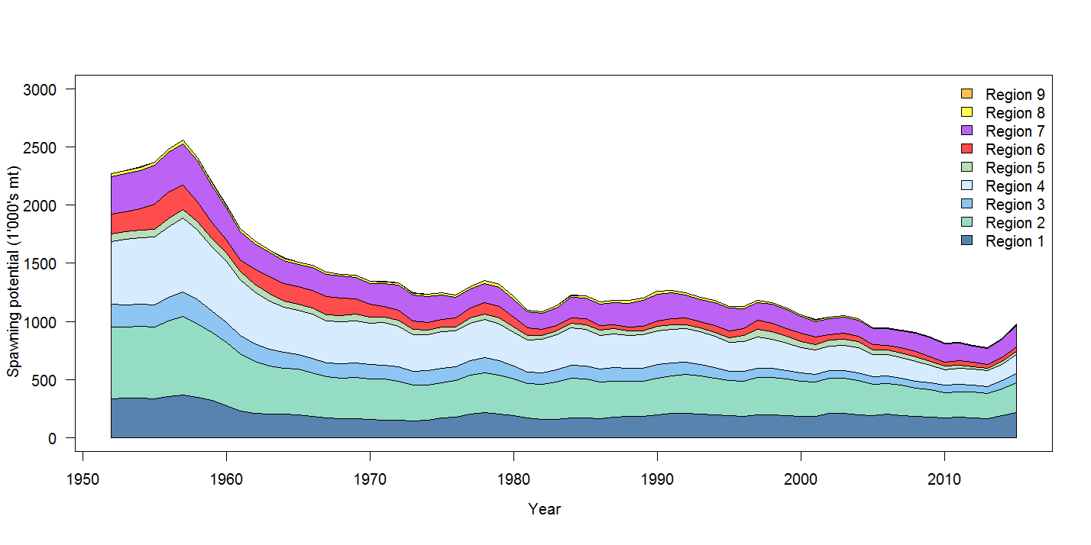
Figure BET-3. Estimated annual average spawning potential by model region for diagnostic case model, showing the relative sizes among regions

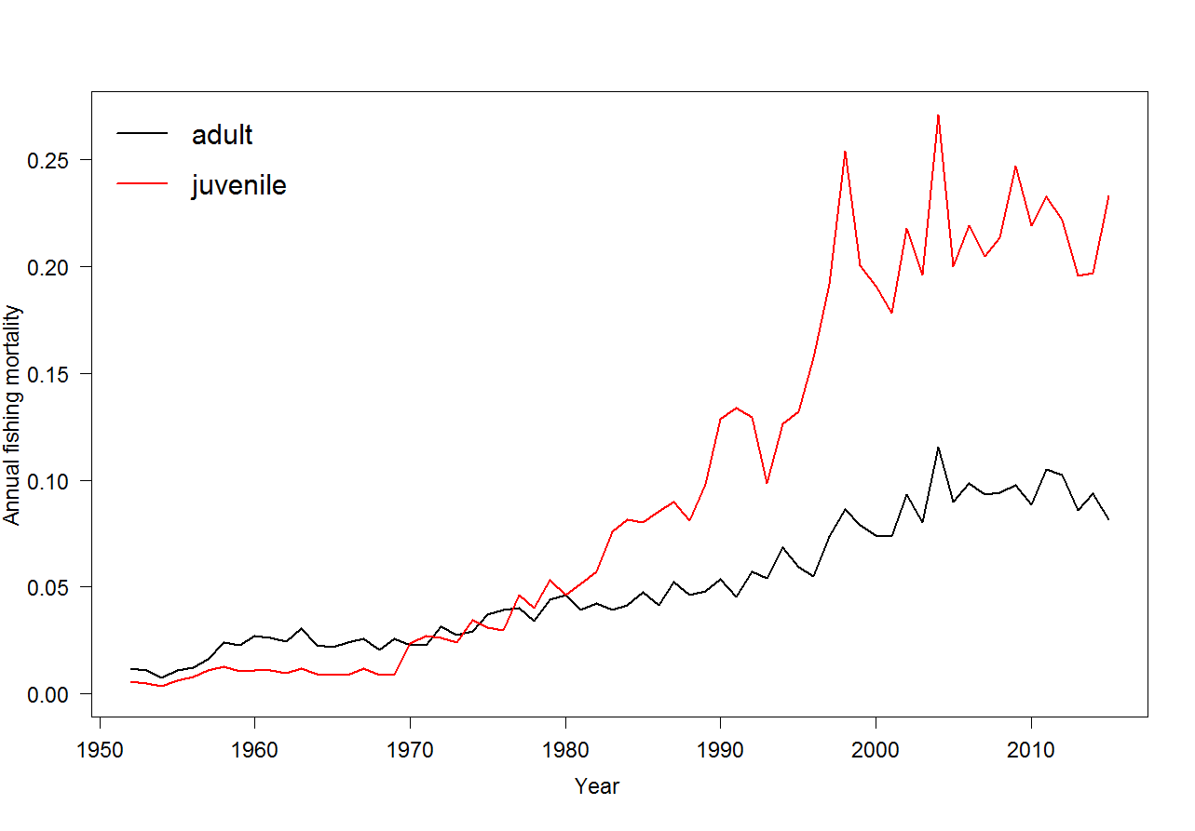
Figure BET-4. Estimated annual average juvenile and adult fishing mortality for the diagnostic case model.

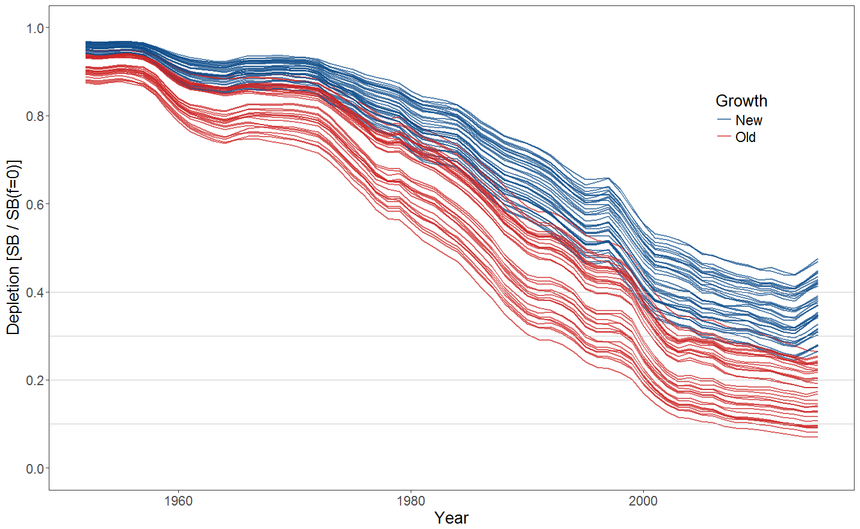
Figure BET-5. Plot showing the trajectories of fishing depletion (of spawning potential) for the 72 model runs included in the structural uncertainty grid. The colours depict the models in the grid with the new and old growth functions.

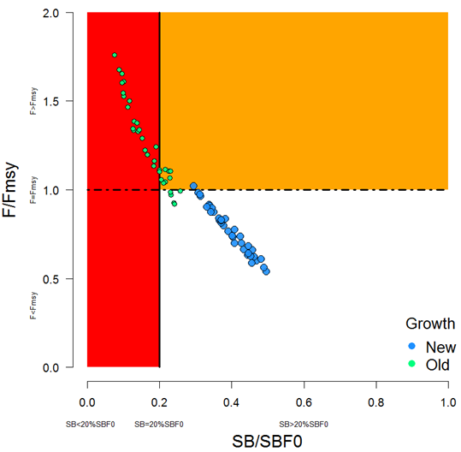 | 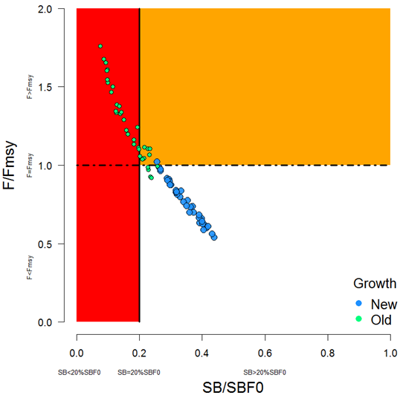
Figure BET-6. Majuro plot summarising the results for each of the models in the structural uncertainty grid. The plots represent estimates of stock status in terms of spawning potential depletion and fishing mortality. The red zone represents spawning potential levels lower than the agreed limit reference point which is marked with the solid black line. The orange region is for fishing mortality greater than F_{MSY} (F_{MSY} is marked with the black dashed line). The points represent SB_{latest}/SB_{F=0} (labelled as SB/SB_{F=0} above), and the colours depict the models in the grid with the new and old growth functions with the size of the points representing the decision of the SC to weight the new growth models three times higher than the old growth models. | Figure BET-7. Majuro plot summarising the results for each of the models in the structural uncertainty grid. The plots represent estimates of stock status in terms of spawning potential depletion and fishing mortality. The red zone represents spawning potential levels lower than the agreed limit reference point which is marked with the solid black line. The orange region is for fishing mortality greater than F_{MSY} (F_{MSY} is marked with the black dashed line). The points represent SB_{recent}/SB_{F=0} (labelled as SB/SB_{F=0} above), where SB_{recent} is the mean SB over 2012-2015 instead of 2011-2014 (used in the stock assessment report), at the request of the Scientific Committee. The colours depict the models in the grid with the new and old growth functions with the size of the points representing the decision of the SC to weight the new growth models three times higher than the old growth models.

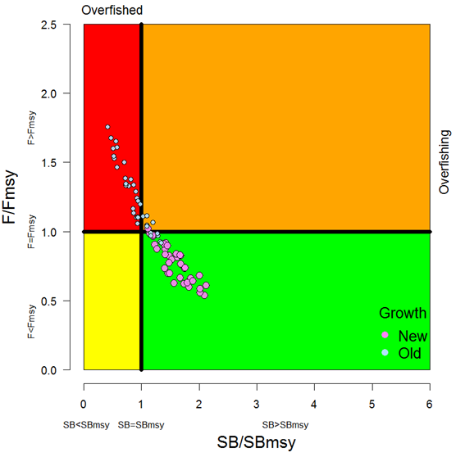 | 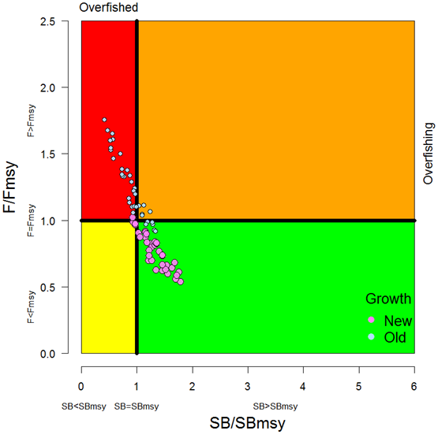
Figure BET8. Kobe plot summarising the results for each of the models in the structural uncertainty grid. The points represent SB_{latest} /SB_{MSY} , with the colours depicting the models in the grid with the new and old growth functions, and the size of the points representing the decision of the SC to weight the new growth models three times higher than the old growth models. | Figure BET-9. Kobe plot summarising the results for each of the models in the structural uncertainty grid. The points represent SB_{recent}/SB_{MSY}, with the colours depicting the models in the grid with the new and old growth functions, and the size of the points representing the decision of the SC to weight the new growth models three times higher than the old growth models.
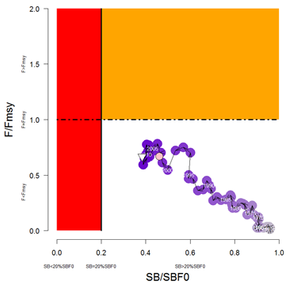 | 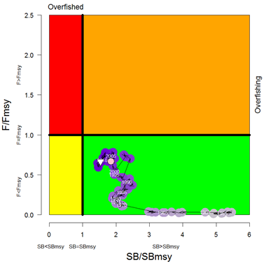
Figure BET-10. Estimated time-series (or “dynamic”) Majuro and Kobe plots from the bigeye ‘diagnostic case’ model run.

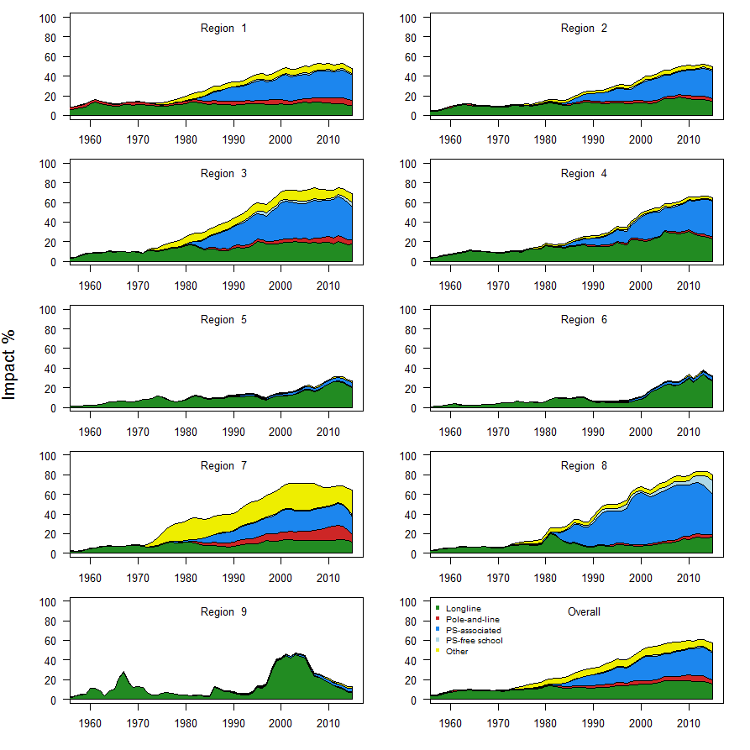
Figure BET-11. Estimates of reduction in spawning potential due to fishing by region, and over all regions (lower right panel), attributed to various fishery groups (gear-types) for the diagnostic case model.

Table BET-2. Summary of reference points over the 72 models in the structural uncertainty grid where the models using the new growth function are given three times the weighting of the models using the old growth function. Note that SB_{recent}/SB_{F=0} is calculated where SB_{recent} is the mean SB over 2012-2015 instead of 2011-2014 (used in the stock assessment report), at the request of the Scientific Committee.
 | Mean | Median | Min | 10% | 90% | Max
C_{latest} | 149,178 | 153,137 | 130,903 | 131,597 | 156,113 | 157,725
MSY | 156,765 | 158,040 | 124,120 | 137,644 | 180,656 | 204,040
Y_{Frecent} | 150,382 | 148,920 | 118,000 | 133,400 | 168,656 | 187,240
F_{mult} | 1.21 | 1.20 | 0.57 | 0.76 | 1.63 | 1.85
F_{MSY} | 0.05 | 0.05 | 0.04 | 0.04 | 0.05 | 0.06
F_{recent}/F_{MSY} | 0.89 | 0.83 | 0.54 | 0.61 | 1.32 | 1.76
SB_{MSY} | 457,162 | 454,100 | 219,500 | 285,530 | 598,210 | 710,000
SB₀ | 1,730,410 | 1,763,000 | 1,009,000 | 1,279,300 | 2,148,200 | 2,509,000
SB_{MSY}/SB₀ | 0.26 | 0.26 | 0.22 | 0.24 | 0.29 | 0.29
SB_{F=0} | 1,915,184 | 1,953,841 | 1,317,336 | 1,584,593 | 2,170,899 | 2,460,411
SB_{MSY}/SB_{F=0} | 0.24 | 0.24 | 0.17 | 0.18 | 0.27 | 0.29
SB_{latest} /SB₀ | 0.37 | 0.40 | 0.11 | 0.19 | 0.49 | 0.53
SB_{latest} /SB_{F=0} | 0.34 | 0.37 | 0.08 | 0.15 | 0.46 | 0.49
SB_{latest} /SB_{MSY} | 1.42 | 1.45 | 0.42 | 0.86 | 1.97 | 2.12
SB_{recent}/SB_{F=0} | 0.30 | 0.32 | 0.08 | 0.15 | 0.41 | 0.44
SB_{recent}/SB_{MSY} | 1.21 | 1.23 | 0.32 | 0.63 | 1.66 | 1.86

- SC13 noted that the central tendency of relative recent spawning biomass under the selected new and old growth curve model weightings was median (SB_{recent}/SB_{F=0}) = 0.32 with a probable range of 0.15 to 0.41 (80% probability interval). This suggested that there was likely a buffer between recent spawning biomass and the LRP but that there was also some probability that recent spawning biomass was below the LRP.

- SC13 also noted that there was a roughly 16% probability (23 out of 144 model weight units) that the recent spawning biomass had breached the adopted LRP with Prob((SB_{recent}/SB_{F=0}) < 0.2) = 0.16. This suggested that there was a high probability (roughly 5 out of 6) that recent bigeye tuna spawning biomass had not breached the adopted spawning biomass limit reference point of 0.2*SB_{F=0}.

- SC13 noted that the central tendency of relative recent fishing mortality under the selected new and old growth curve model weightings was median(F_{recent}/F_{MSY}) = 0.83 with an 80% probability interval of 0.61 to 1.31. While this suggested that there was likely a buffer between recent fishing mortality and F_{MSY}, it also showed that there was some probability that recent fishing mortality was above F_{MSY}.

- SC13 also noted that there was a roughly 23% probability (33 out of 144 model weight units as described in para. 6) that the recent fishing mortality was above F_{MSY} with Prob((F_{recent}/F_{MSY}) > 1) = 0.23. While this suggested that recent fishing mortality was likely below F_{MSY}, there was also a moderate probability (~ 1 out of 4) that recent fishing mortality has exceeded F_{MSY}.

- SC13 noted that the best available information on the stock status of WCPO bigeye tuna has changed in two ways from the previous assessment under the selected weighting of the 2017 assessment uncertainty grid. First, the stock status condition is more positive with a higher central tendency for SB_{recent}/SB_{F=0} in the 2017 assessment (median(SB_{recent}/SB_{F=0}) = 0.32) in comparison to the 2014 assessment ( (SB_{current}/SB_{F=0}) = 0.20) and a lower ratio of relative recent F in the 2017 assessment ( median(F_{recent}/F_{MSY}) = 0.83 ) in comparison to the 2014 assessment ( F_{current}/F_{MSY} = 1.57 ). Second, there is much greater uncertainty in the stock status of bigeye tuna in 2017 due to the fuller technical treatment of structural uncertainty through the use of the model uncertainty grid.

- SC13 noted that the positive changes for bigeye tuna stock status in the 2017 assessment are primarily due to three factors: the inclusion of the new growth curve information, the inclusion of the new regional assessment structure, and the estimated increases in recruitment in recent years. In terms of the cause of the recent increases in recruitment, SC13 commented that it was unclear whether the recent improvement was due to positive oceanographic conditions, effective management measures to conserve spawning biomass, some combination of both, or other factors. SC13 also noted the recent recruitment improvements for yellowfin and skipjack tunas. SC13 also noted recent recruitment improvements for bigeye tuna in the Eastern Pacific Ocean.

- SC13 also noted that, regardless of the choice of uncertainty grid, the assessment results show that the stock has been continuously declining for about 60 years since the late 1950’s, except for the recent small increase suggested in the new growth curve model grid.

- SC13 also noted the continued higher levels of depletion in the equatorial and western Pacific (specifically Regions 3, 4, 7 and 8 of the stock assessment) and the associated higher levels of impact, especially on juvenile bigeye tuna, in these regions due to the associated purse-seine fisheries and the ‘other’ fisheries within the western Pacific (as shown in Figures 35 and 46 of SC13-SA-WP-05).

- SC13 noted that there has been a long-term increase in fishing mortality for both juvenile and adult bigeye tuna, consistent with previous assessments.

- SC13 noted that there has been a long-term decrease in spawning biomass from the 1950s to the present for bigeye tuna and that this is consistent with previous assessments.

- Management advice and implications

- Based on the uncertainty grid adopted by SC13, the WCPO bigeye tuna spawning biomass is likely above the biomass LRP and recent F is likely below F_{MSY}, and therefore noting the level of uncertainties in the current assessment it appears that the stock is not experiencing overfishing (77% probability) and it appears that the stock is not in an overfished condition (84% probability).

- Although SC13 considers that the new assessment is a significant improvement in relation to the previous one, SC13 advises that the amount of uncertainty in the stock status results for the 2017 assessment is higher than for the previous assessment due to the inclusion of new information on bigeye tuna growth and regional structures.

- SC13 also noted that levels of fishing mortality and depletion differ between regions, and that fishery impact was higher in the tropical region (Regions 3, 4, 7 and 8 in the stock assessment model), with particularly high fishing mortality on juvenile bigeye tuna in these regions. SC13 therefore recommends that WCPFC14 could continue to consider measures to reduce fishing mortality from fisheries that take juveniles, with the goal to increase bigeye fishery yields and reduce any further impacts on the spawning potential for this stock in the tropical regions.

- Based on those results, SC13 recommends as a precautionary approach that the fishing mortality on bigeye tuna stock should not be increased from current level to maintain current or increased spawning biomass until the Commission can agree on an appropriate target reference point (TRP).

- Research Recommendations

- SC13 recognized that future work is required to improve the assessment and to reduce uncertainty. Future research should concentrate on the two axes (e.g. growth, regional structure) of uncertainty which are the most influential. The growth analysis should continue with the emphasis on providing length at age estimates for larger fish between 130 and 180 cm FL. Additional research is also required for the regional structure uncertainty to consider options in addition to the structures used in the 2014 and 2017 assessments, for example, by using statistical approaches (e.g. tree models).

- In addition, SC13 considers that the model ensemble or weighting will be increasingly important as SC moves to uncertainty grid approaches in stock assessments and requests the Scientific Services Provider to study those methods further.

- SC13 requested that SPC undertake projections of potential changes in spawning biomass in the future under current levels of fishing mortality. This would be similar to the projections delivered in SC13-SA-IP-22, but would be based on the weighted uncertainty grid as described above.

References

SC16-SA-WP-02 Age and growth of yellowfin and bigeye tuna in the western and central Pacific Ocean from otoliths https://www.wcpfc.int/node/46609

SC16-SA-WP-03 Stock assessment of bigeye tuna in the western and central Pacific Ocean (30July) - Rev.03 https://www.wcpfc.int/node/46610

SC16-SA-IP-06 Background analyses for the 2020 stock assessments of bigeye and yellowfin tuna https://www.wcpfc.int/node/46620

SC15- SA-WP-01 A compendium of fisheries indicators for tuna stocks. https://www.wcpfc.int/node/42927

SC15- SA-WP-02 Project 94: Workshop on yellowfin and bigeye age and growth. https://www.wcpfc.int/node/42928

SC15- SA-IP-19 Report of the Workshop on Age and Growth of Bigeye and Yellowfin Tunas in the Pacific Ocean. https://www.wcpfc.int/node/43329

SC14-SA-WP-01 Update on age and growth of bigeye tuna in the WCPO WCPFC Project 81 Rev 1. https://www.wcpfc.int/node/31012

SC14-SA-WP-03 Incorporation of updated growth information within the 2017 WCPO bigeye stock assessment grid, and examination of the sensitivity of estimates to alternative model spatial structures. https://www.wcpfc.int/node/31047

SC13-SA-WP-05 Stock assessment of bigeye tuna in the western and central Pacific Ocean Rev 1 (23 July 2017). https://www.wcpfc.int/node/29518

SC10-SA-WP-00 Minor revisions to the bigeye, skipjack and yellowfin assessment reports (25 July). https://wcpfc.int/node/19146

SC10-SA-WP-01 Stock assessment of bigeye tuna in the western and central Pacific Ocean Rev 1 (25 July 2014). https://wcpfc.int/node/18975

SC8-SA-WP-01 Independent (Peer) Review of 2011 WCPO Bigeye Tuna Assessment. https://wcpfc.int/node/3131

SC7-SA-WP-02 Stock assessment of bigeye tuna in the western and central Pacific Ocean. https://wcpfc.int/node/2785

SC6-SA-WP-04 Stock assessment of bigeye tuna in the western and central Pacific Ocean. https://wcpfc.int/node/2467

SC5-SA-WP-04 Stock assessment of bigeye tuna in the western and central Pacific Ocean. https://wcpfc.int/node/2157

SC4-SA-WP-01 Stock assessment of bigeye tuna in the western and central Pacific Ocean, including an analysis of management options. https://wcpfc.int/node/1219

SC4-SA-WP-02 A preliminary stock assessment of bigeye tuna in the western and central Pacific Ocean using stock synthesis 3 (SS3); A comparison with MULTIFAN-CL. https://wcpfc.int/node/1220

SC2-SA-WP-02 Stock assessment of bigeye tuna in the western and central Pacific Ocean, including an analysis of management options. https://wcpfc.int/node/1747

SC1-SA-WP-02 Stock assessment of bigeye tuna in the Western and Central Pacific Ocean. https://wcpfc.int/node/1883

